The synthesis, biological evaluation and structure–activity relationship of 2-phenylaminomethylenecyclohexane-1,3-diones as specific antituberculosis Agents
Ali Mohd Lone*, Muzafar Ahmad Rather
Department of Biochemistry, University of Kashmir, Hazratbal Srinagar, India-190006
Department of Chemistry, Govt. Degree College for Women Baramulla, Jammu Kashmir-193101 India

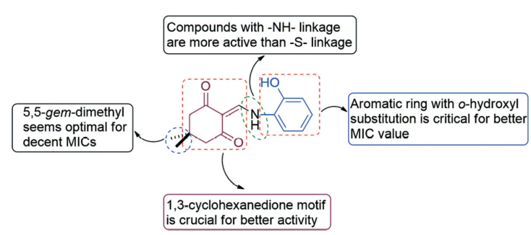
Abstract (300 word limit)
The present study utilised whole cell based phenotypic screening of thousands of diverse small molecules against Mycobacterium tuberculosis H37Rv (M. tuberculosis) and identified the two cyclohexane-1,3-dione based structures as hits. The selected hit molecules were used for further synthesis and a library of 37 compounds under four families was synthesized for lead generation. Evaluation of the library against M. tuberculosis lead to the identification of three lead antituberculosis agents. The most potential compound, 2-(((2-hydroxyphenyl)amino)methylene)-5,5-dimethylcyclohexane-1,3-dione showed an MIC of 2.5 μg mL⁻¹, which falls in the range of MICs values found for the known antituberculosis drugs ethambutol, streptomycin and levofloxacin. Additionally, this compound proved to be non-toxic (<20% inhibition at 50 μM concentration) against four human cell lines. Like first line antituberculosis drugs (isoniazid, rifampicin and pyrazinamide) this compound lacks activity against general Gram positive and Gram negative bacteria and even against M. smegmatis; thereby reflecting its highly specific antituberculosis activity.

Figure. SAR of 2-alkyl/aryl-aminomethylene cycloalkane-1,3-diones against M. Tuberculosis.
Recent Publications (minimum 5)
- Lone AM, Bhat BA, Mehta G (2013) A general, ﬂexible, ring closing metathesis (RCM) based strategy for accessing the fused furo[3,2-b]furanone moiety present in diverse bioactive natural products. Tetrahedron Letters 54: 5619-5623.
- Lone AM, Bhat BA (2014) Metal free stereoselective synthesis of functionalized enamides. Organic and Biomolecular Chemistry 12: 242–246.
- Lone AM, Bhat BA, Shah WA, Mehta G (2014) A concise synthesis of Hagen’s gland lactones. Tetrahedron Letters 55: 3610-3612.
- Lone AM, Dar NJ, Hamid A, Shah WA, Ahmad M, Bhat BA (2016) Promise of Retinoic Acid-Triazolyl Derivatives in Promoting Diﬀerentiation of Neuroblastoma Cells. 7: 82–89.
- Dar BA, Lone AM*, Shah WA, Qurishi MA (2016) Synthesis and screening of ursolic acid-benzylidine derivatives as potential anti-cancer agents. European Journal of Medicinal Chemistry 111: 26-32.
- Lone AM, Rather MA, Teli B, Bhat ZS, Singh P, Maqbool M, Shairgojray BAh, Dar MJ, Amin S, Yousuf SK, Amin S, Bhat BA, Parry ZA (2017) Synthesis, biological evaluation and structural-activity relationship of 2-phenylaminomethylene-cyclohexane-1,3-diones as specific anti-tuberculosis agents. Medicinal Chemistry Communications 8: 2133-2141.

Biography (150 word limit)
Prof. A M Lone completed his Ph.D in Medicinal Chemistry from Indian Institute of Integrative Medicine (IIIM) Jammu and is currently working as Assistant Professor in the Department of Chemistry Govt Degree College for Women Baramulla. He has expertise in the total synthesis of bioactive molecules, development of novel strategies and structural modification of natural molecules for lead optimization.
Email: loneali33@gmail.com

