Evaluation of the synergistic effect of EDTA-chitosan nanoparticles on imipenem delivery in Pseudomonas aeruginosa carbapenem-resistant strain AG1
Marilyn Porras, MSc. LANOTEC, Costa Rica

Abstract

Metallo-β-lactamases are bacterial zinc-dependent enzymes involved in the hydrolysis of β-lactamic antibiotics representing the main cause of bacterial resistance to carbapenems, drugs of last resort for treating infections caused by multiresistant bacteria. The hypothesis that it is possible to inhibit the enzymatic activity of metallo-β-lactamases by lowering the availability of zinc in the extracellular medium using metal chelating agents such as EDTA carried on nanoparticles was elaborated. On the other hand, chitosan, as linear cationic polysaccharide is frequently used in biomedical and pharmaceutical applications, has been studied as a biocompatible encapsulating agent in drug delivery systems and also chitosan is an ideal transport agent for bioactive molecular complexes in antibiotic applications due to its ability to associate with negatively charged substances. Novel nanoparticles were developed using chitosan as a transport matrix for β-lactamic antibiotics. These nanoparticles were synthesized according to the ion gelation using tripolyphosphate as crosslinking agent. The nanoparticles were functionalized in their surface by the adsorption of EDTA, which acts as complexifying agent for Zn²⁺ ions causing inhibition of metallo-β-lactamases activity. The antimicrobial effects of EDTA-functionalized nanoparticles with an imipenem cargo were evaluated on the clinical isolate P. aeruginosa AG1, a carbapenem-resistant high-risk clone ST-111 carrying both bla_{IMP-18} and bla_{VIM-2} metallo-β-lactamases genes. The in vitro effects of the nanoparticles encapsulating ampicillin were evaluated on E. coli ATCC 25922 strain as a control.

Image
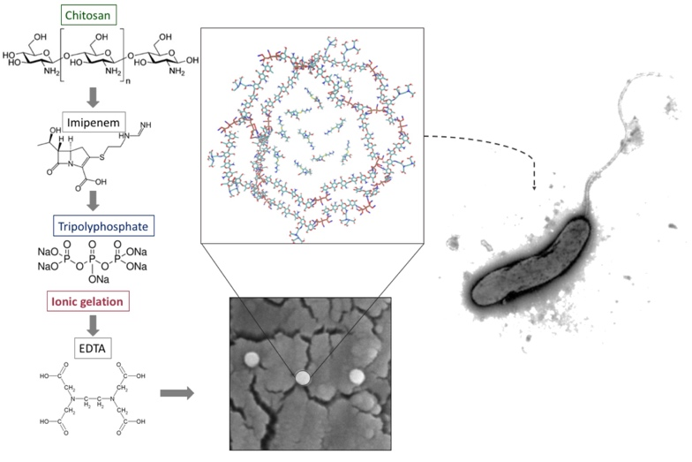
Recent Publications
- Porras, M., et al. (pending publication) Evaluation of the synergistic effect of EDTA-functionalized chitosan nanoparticles on imipenem delivery in Pseudomonas aeruginosa carbapenem-resistant strain AG1. To be submitted soon
- Patent. Porras, M. et al. (2016) Protocol for the synthesis of EDTA-Chitosan nanoparticles and compound to inhibit antibiotic resistance mechanisms (Costa Rica #2016-0158)
- Porras, M. et al. (2016) Synthesis of ampicillin-loaded chitosan nanoparticles and in vitro evaluation of antimicrobial properties on Escherichia coli. Submitted for publication to the International Journal of Nanoparticles. Submission code: IJNP-140799
- Porras M. and Vega, J. (2012) Synthesis and evaluation of functionalized chitosan nanoparticles as antimicrobial agents. Journal Nanotechnology Progress International 5:12-22
- Vega, J., Núñez, S. and Porras, M. (2012) Sustainable Nanotechnology Policies for Innovation in Costa Rica. Journal Nanotechnology Progress International 3:21-38
- Porras, M., Núñez, S. and Vega, J. (2011) Overview of multidrug-resistant Pseudomonas aeruginosa and novel therapeutic approaches. Journal of Biomaterials and Nanobiotechnology 3:519-527

Biography
Marilyn Porras has worked in design and synthesis of advanced soft materials including polymeric nanoparticles for biomedical applications, drug release studies, synergistic therapies against multidrug resistance bacteria. She has also work with physicochemical characterization techniques for analysis of nanostructured materials by local probe microscopy (atomic force microscopy), scanning electron microscopy, calorimetry, thermogravimetry infrared spectroscopy, laser diffraction particle analyzer, physicochemical surface analysis, among others.

Email: marilyn.ucr@gmail.com
Notes/Comments

