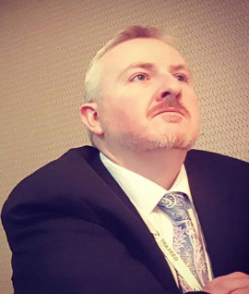
Title: Counterfeit Pharmaceuticals & Medical Devices – A Global Regulatory Overview and the Impact on the Industry
Name: Dr. Mark R. Willis, LP.D

The threat and proliferation of counterfeit pharmaceuticals has escalated over the last 15 years. In 2016, the World Health Organization estimated that 10 to 30 percent of all pharmaceuticals globally are counterfeit, though this number can increase up to 50 to 70 percent in some underdeveloped and in-transit nations. While WHO estimated that only 10 percent of the pharmaceuticals in the United States (U.S.) market are counterfeit, this was still a considerable amount. According to the IQVIA Institute for Human Data Sciences, in 2016 the United States dispensed a total of 4.453 billion prescription drugs. This quantity is estimated to grow to over five billion by 2021. If 10 percent of those prescriptions dispensed were counterfeit according to WHO’s estimates, then nearly 500 million counterfeit prescriptions were consumed throughout the United States in 2016.
Consumers are largely unaware of the risk of counterfeit pharmaceuticals. While the global health authoraties have focused on implementing laws and policies to mitigate the risk of counterfeit pharmaceuticals seeping onto the market, consumers are left unaware of the danger. As global economies implement laws and regulations to combat the growing epidemic, little has been done to understand the impact on the industry and, ultimately, the consumer. This program will take a broader look at the regulations that have been implemented, how they are impacting the entire drug / device supply chain, and the resulting effect on the consumer.

Biography
Dr. Willis is a seasoned Pharmaceuticals and Medical Device professional with over 20 years’ experience in the industry. With a doctorate in law and public policy, Dr. Willis has supported corporations with their regulatory compliance. As a professor at various US Universities, Mark has been training and mentoring the next generation of professionals for the future regulatory environment. Mark is currently working with global health authority agencies, the UN, and USAID to conduct research to secure the pharmaceutical supply chain. Dr. Willis is also the author of “Counterfeit Pharmaceuticals: Are the U.S. Consumers Aware of the Potential Risks?”

Presenting author details
Full name: Dr. Mark R. Willis, LP.D
Contact number: +1 (508) 272-9647
Twitter account: @WillisQSConsult
Linked In account: https://www.linkedin.com/in/dr-mark-willis-2713216/
Session name/ number: Counterfeit Pharmaceuticals & Medical Devices
Category: (Oral presentation)

