Enhanced inner ear drug delivery assisted by ultrasound-aided microbubbles
Chih-Hung Wang, MD, PhD, Tri-Service General Hospital, National Defense Medical Center, Taipei, Taiwan

Abstract
Sensorineural hearing loss (SNHL) can result from multiple causes, including aging, infection, noise exposure, ototoxic drugs, and immune-mediated inflammation. Clinical therapeutic strategies for SNHL may involve pharmaceutical medications, acoustic sound amplification, or implantable surgical devices. Pharmaceutical approaches are always considered as the first choice in treating hearing disorders, and most of them are prescribed as systemic delivery. However, the systemic medication route has limitations because the blood–cochlea barrier can limit inner ear drug absorption or penetration and because undesirable systemic side effects are possible. One alternative to the systemic route is delivery via the round window membrane (RWM), which, because of its exposure to the middle ear, can serve as a viable route for delivery of therapeutic medications to the inner ear via middle ear applications. Intratympanic injection therapies are now widely applied for the treatment of several hearing disorders; however, the therapeutic responses vary for ambiguous reasons. We have targeted the practical application of ultrasound microbubbles (US-MBs) to increase the RWM permeability, thereby facilitating medication delivery to the inner ear. Using guinea pigs as animal models, we showed that US-MB exposure can provide a 38-fold improvement of the inner ear absorption of biotin–FITC applied through the RWM when compared to spontaneous absorption. Cochlear hair cell uptake of gentamicin was also significantly enhanced using US-MBs. We also confirmed an increased permeability of the RWM in response to the acoustic cavitation effects of MBs by showing the passage of the tracer through the three-layered structure of the RWM. The US-MB approach did not damage the integrity of the RWM or cause any deterioration of the hearing thresholds, indicating a good safety margin. Our recent work now focuses on facilitating inner ear gene delivery using US-MBs. We believe that US-MB-mediated techniques have great potential for use in delivery of therapeutic medication or genes to the inner ear in future clinical applications.

Image 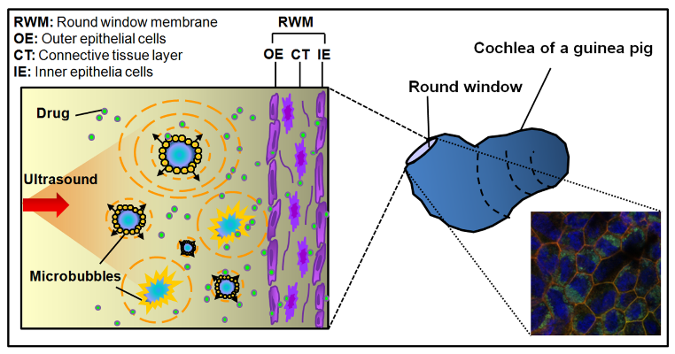
Recent Publications (minimum 5)
- Shih CP, Lee JT, Chen HK, Lin YC, Chen HC, Lin YY, Kuo CY, Chen YT, Wang CH*. Comparison of changes in mitochondrial bioenergetics between keratinocytes in human external auditory canal skin and cholesteatomas from normoxia to hypoxia. Sci Rep. 2018 Jan 9;8(1):125. doi: 10.1038/s41598-017-18536-y.
- Liao AH, Lu YJ, Lin YC, Chen HK, Sytwu HK, Wang CH. Effectiveness of a Layer-by-Layer Microbubbles-Based Delivery System for Applying Minoxidil to Enhance Hair Growth. Theranostics 2016 Apr11;6(6):817.
- Liao AH, Ho HC, Lin YC, Chen HK, Wang CH. Effects of Microbubble Size on Ultrasound-Induced Transdermal Delivery of High-Molecular-Weight Drugs. PLoS One. 2015 Sep 21;10 (9):e0138500.
- Liao AH, Hsieh YL, Ho HC, Chen HK, Lin YC, Shih CP, Chen HC, Kuo CY, Lu YJ, Wang CH. Effects of microbubble size on ultrasound-mediated gene transfection in auditory cells. Biomed Res Int 2014:840852.
- Shih CP, Chen HC, Chen HK, Chiang MC, Sytwu HK, Lin YC, Li SL, Shih YF, Liao AH, Wang CH. Ultrasound-aided microbubbles facilitate the delivery of drugs to the inner ear via the round window membrane. J Control Release 2013 Apr 28;167(2):167-74.

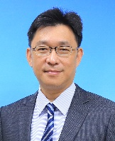 Biography
Chih-Hung Wang is a professor of Otolaryngology-Head and Neck Surgery at the National Defense Medical Center, Taipei, Taiwan. He received his M.D. and Ph.D. degrees from the National Defense Medical Center. After completing his doctoral degree, he completed a postdoctoral course with Prof. Yehoash Raphael at Kresge Hearing Research Institute and a visiting fellowship course with Dr. Steven A. Telian at the Department of Otolaryngology-Head and Neck Surgery, University of Michigan, in 2003–2004. His main research interest is in otology, focusing on developing strategies for inner ear protection and repair, including stem cell and gene therapy topics. Dr. Wang has also previously served as the director of the Department of Otolaryngology-Head and Neck Surgery, Tri-Service General Hospital, Taipei, Taiwan. He was promoted to major general on 1 July 2016 and served as the director of Medical Affairs Division, Army Logistics Command, ROCA.
Chih-Hung Wang
Tel: 886-2-87927192
Forms of Drug Delivery System/Number
Category: (Poster presentation)
Email: chw@ms3.hinet.net

Notes/Comments:

