Effect of oxaliplatin-loaded chitosan nanoparticles on in vitro viability of squamous cell carcinomas cells
Breno N. Matos, Martha O. Bravo, Marcílio Cunha Filho, Taís Gratieri, Felipe S. Araújo and Guilherme M. Gelfuso Laboratory of Food, Drug and Cosmetics (LTMAC), School of Health Sciences, University of Brasília, 70910-900, Brasília, DF, Brazil

Abstract
Head and neck carcinomas, including those originating from the oral cavity, oropharynx, rhinopharynx and larynx, are one of the most frequent types of cancer worldwide. Among them, 90% are squamous cell carcinomas (SCC). Due to the difficulties in surgical procedure, oral cancers are routinely treated with radiotherapy or chemotherapy. The high rates of adverse events induced by these therapies, though, represents a problem for the treatment success. To eliminate or reduce these effects, this work proposes nanoencapsulation of oxaliplatin (OXPt) using the cationic, mucoadhesive polymer chitosan to enable topical chemotherapy of oral tumors. Chitosan nanoparticles loaded with OXPt (OXPt-NPs) were prepared and characterized, presenting mean size of 188.4 ± 19.8 nm (PDI = 0.28 ± 0.02), positive zeta potential (+44.8 ± 2.8 mV) and entrapment efficiency of 96.5%. Images captured in a SEM confirmed size and spherical shape of OXPt-NPs. SCC-9 tongue cancer cell line viability was determined by colorimetric MTT assay to evaluate the inhibitory potential of the formulations. In addition, cell apoptosis/necrosis was assessed by annexin V/PI staining, using Flow Cytometry. In these experiments, SCC-9 was cultured in DMEM 10% FBS and exposed for 48 h to the formulations: (i) NP-OXPt, (ii) drug free-NPs and (iii) OXPt aqueous solution. Treatments of the cells with drug solutions and OXPt-NPs resulted in a pronounced decrease in viability when compared to the non-treated group (control); this decrease was more significant (p<0.005) in OXPt concentrations above 25 μg/mL. It was observed a trend in decreasing viable cells and increasing apoptotic cells. However, only the samples containing 25 μg/mL OXPt presented a statistical difference with strong evidence of apoptosis. Finally, OXPt-NPs provided a more intense increase in cell death compared to control, OXPt aqueous solution and drug free-NPs (p=0.001).

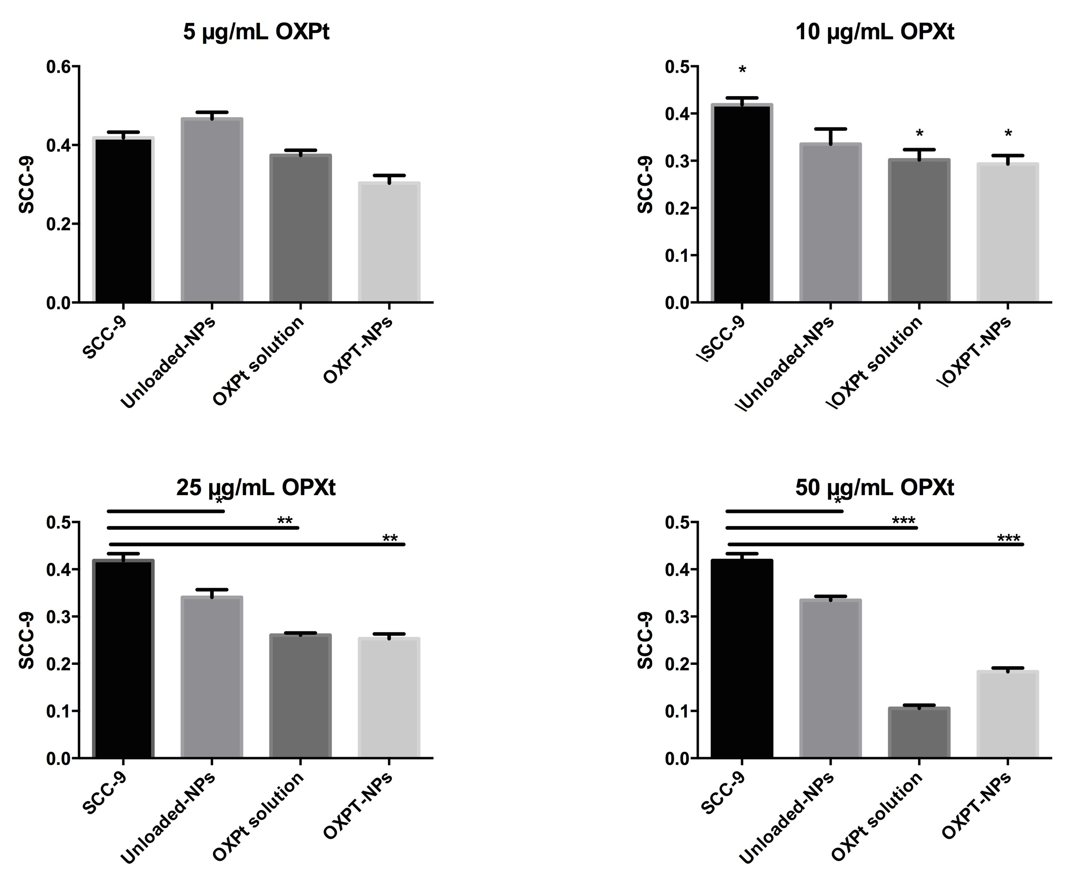
Recent Publications
- Reis TA, Matos BN, Lima EM, Chaker JA, Gratieri T, Cunha-Filho MSS, Gelfuso GM (2017) Oxaliplatin preformulation studies for the development of innovative topical drug delivery systems. Journal of Thermal Analysis and Calorimetry 1-11.
- Matos BN, Reis TA, Gratieri T, Gelfuso GM (2015) Chitosan nanoparticles for targeting and sustaining minoxidil sulphate delivery to hair follicles. International Journal of Biological Macromolecules 75:225-229.
- Gelfuso GM et al (2015) Iontophoresis of minoxidil sulphate loaded microparticles, a strategy for follicular drug targeting? Colloids and Surfaces. B Biointerfaces 134:408-412.
- Gelfuso GM et al (2013) Iontophoresis-targeted, follicular delivery of minoxidil sulfate for the treatment of alopecia. Journal of Pharmaceutical Sciences 102:1488-1494.
- Gelfuso GM et al (2011) The influence of positive or negative charges in the passive and iontophoretic skin penetration of porphyrins used in photodynamic therapy. European Journal of Pharmaceutics and Biopharmaceutics 77:249-256.

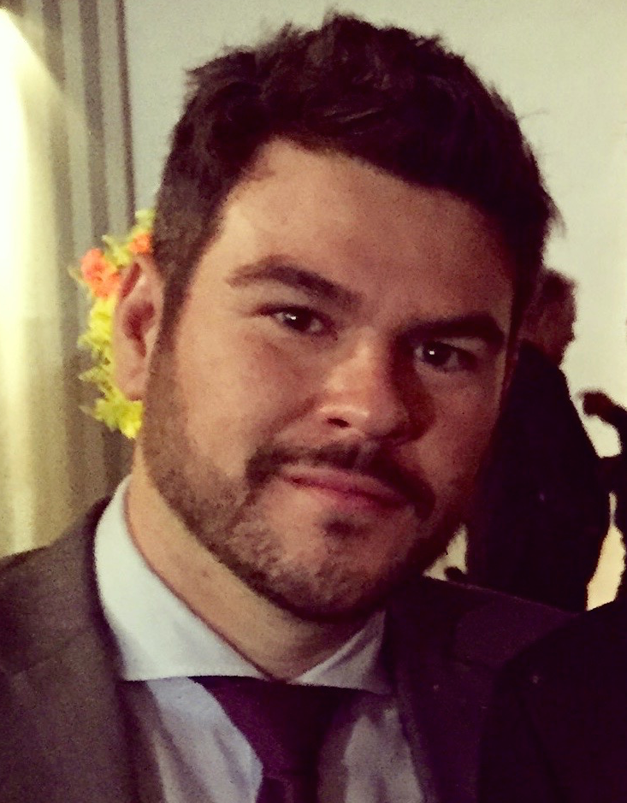 Biography
Guilherme M. Gelfuso, Ph.D., has his expertise in development and evaluation of topical drug delivery systems for the eye, skin and vaginal mucosa. During his Ph.D. in the University of São Paulo and a one-year period in the University of Bath, United Kingdom, he developed and evaluated follicular penetration of drugs topically applied by means of different technological strategies. Along his postdoc in the University of São Paulo, he developed and evaluated biodegradable nano and micro carriers for pulmonary delivery of biological molecules for controlling infections. Afterwards, as Professor and head of the Laboratory of Food Drugs and Cosmetics (LTMAC) at the University of Brasilia, he maintained his collaborations with both universities and focused his studies on formulations development for topical and pulmonary delivery of active natural extracts of the Brazilian Cerrado Biome and strategies to improve treatment of oral and skin cancers using topical chemotherapy or photodynamic therapy.
Guilherme M. Gelfuso
Tel: +55 61 983779679
Session Pharmaceutical Nanotechnology
Category: Poster presentation
Email: gmgelfuso@unb.br

