Nitric Oxide-Releasing Self-Assembled Nanoparticles as a Chemosensitizing Agent for Improved Anticancer Activity
Kyung Hyun Min, Da Eun Kim, Hong Jae Lee,
Sang Cheon Lee, Kyung Hee University,
Republic of Korea

Abstract
Statement of the Problem: Nitric oxide (NO) plays significant roles as a bioregulatory agent in apoptosis of cancer cells [1]. Recently, it was reported that NO treatment in combination with diverse anticancer drugs, such as doxorubicin and cisplatin, improved their anticancer activity [2,3]. To date, several classes of NO donors that can store and release NO in a controlled manner have been developed. S-Nitrosoglutathione (GSNO) is preferable over other classes of synthetic NO donors for intracellular NO delivery because it is an endogenous species. However, GSNO has low aqueous stability and insufficient specificity to target tumor tissues after i.v. injection. Thus, it is challenging to develop a delivery system that can efficiently improve stability and tumor-specificity of GSNO molecules [4,5]. Methodology & Theoretical Orientation: We aim to develop GSNO-conjugated hyaluronic acid-based assembled nanoparticles (GSNO-HANP) and demonstrate that such nanoparticles preferentially generate NO in response to intracellular hyaluronidase-1 (Hyal-1) and intracellular reducing environments. In addition, the combinative effect of NO-releasing nanoparticles on the anticancer activity of doxorubicin (DOX) against MCF-7 human breast cancer cells was examined. Findings: The GSNO-HANP greatly improved stability of GSNO in aqueous phase. The GSNO-HANP triggered NO release at cytosol through Hyal-1-induced degradation of nanoparticles and an intracellular reduction of GSNO by ascorbic acid. In vitro and in vivo experiments demonstrated that NO release by the GSNO-HANP efficiently improved the sensitivity of MCF-7 cells for DOX therapy. Conclusion & Significance: We have developed well-defined GSNO-conjugated hyaluronic acid-based assembled nanoparticles. The nanoparticles improved stability of GSNO in the aqueous phase and efficiently released NO into cytosols. The NO release by the GSNO-HANP in combination with DOX treatment resulted in improved apoptosis of the MCF-7 cells. This intracellular NO-releasing GSNO-HANP may serve as useful chemosensitizing agents to improve therapeutic activities of various anticancer drugs.

Image
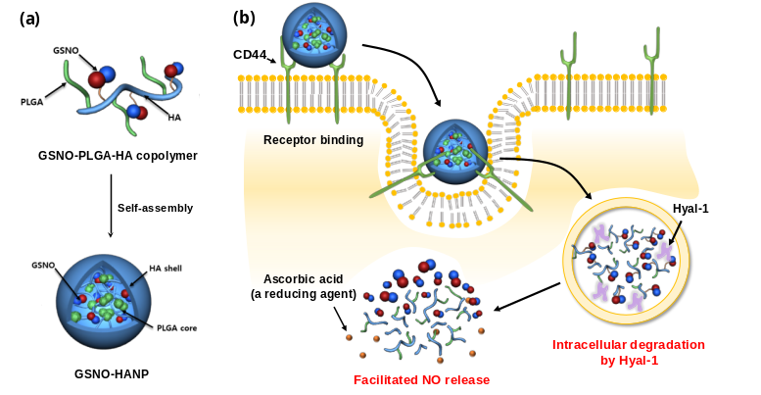
Figure 1. a) Assembly of GSNO-HANPs and b) Schematic illustration of NO release from the GSNO-HANPs at intracellular compartment by Hyal-1 and ascorbic acid.
Recent Publications
- Lu Y (2013) Nitric oxide-releasing amphiphilic poly(amidoamine) (PAMAM) dendrimers as antibacterial agents. Biomacromolecules 14:3589-3598.
- Munaweera I (2015) Nitric oxide- and cisplatin-releasing silica nanoparticles for use against non-small cell lung cancer. Journal of Inorganic Biochemistry 153:23-31.
- Evig CB (2004) Endogenous production and exogenous exposure to nitric oxide augment doxorubicin cytotoxicity for breast cancer cells but not cardiac myoblasts. Nitric Oxide 10:119-129.
- Lee HJ (2016) pH-Responsive mineralized nanoparticles as stable nanocarriers for intracellular nitric oxide delivery. Colloids and Surfaces B: Biointerfaces 146:1-8.
- Duong HTT (2013) Intracellular nitric oxide delivery from stable NO-polymeric nanoparticle carriers. Chemical Communications 49:4190-4192.

 Biography
Kyung Hyun Min received his Ph.D. degree in pharmacy from Kyung Hee University in Korea in 2013. He did research as a post-doctoral research associate at National Institutes of Health (NIH). In March of 2017, Dr. Min joined Prof. Sang Cheon Lee’s Laboratory of Kyung Hee University as a research professor. His current research interest focuses on the development of potent theranostic systems for diagnosis and therapeutics of various diseases.
Kyung Hyun Min
Tel: +82-2-961-2317
Smart Drug Delivery Systems
Category: Poster presentation
Email: sky1492@gmail.com

