EXECUTIVE SUMMARY
“BEVY” OR “THE APP”

What is Bevy or “The App”

Bevy Health or Bevy a patient-held record system (PHR) which puts users in control of all their medical information. Bevy is a platform on which patients and doctors can save and transfer medical data, and communicate with each other.

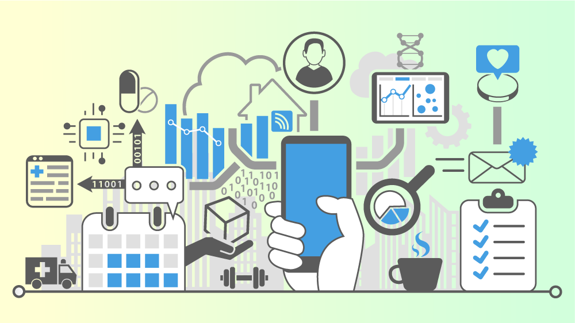

Why do we need The App ?

The Patient-held Record system, PHR, is taking off in the West, and although medical records are now online, the patient has very little access to them. Most western countries provide a unique patient ID that doctors can use to access the patient record, but the patient is not given full access.
In a country like India, where the cost of private healthcare is primarily paid at the point of use (hospital and clinic payment window), patients will naturally want ownership of their medical records. This is our primary market.

Healthcare providers, historically, have kept patients’ medical records in their possession, sharing them with patients in physical form, which is vulnerable, unsafe and time-consuming to access. Bevy returns ownership where it belongs: with the patient.

How do healthcare providers benefit ?

Studies have shown that a significant amount of a doctor’s appointment time is spent on activities unrelated to patient care.
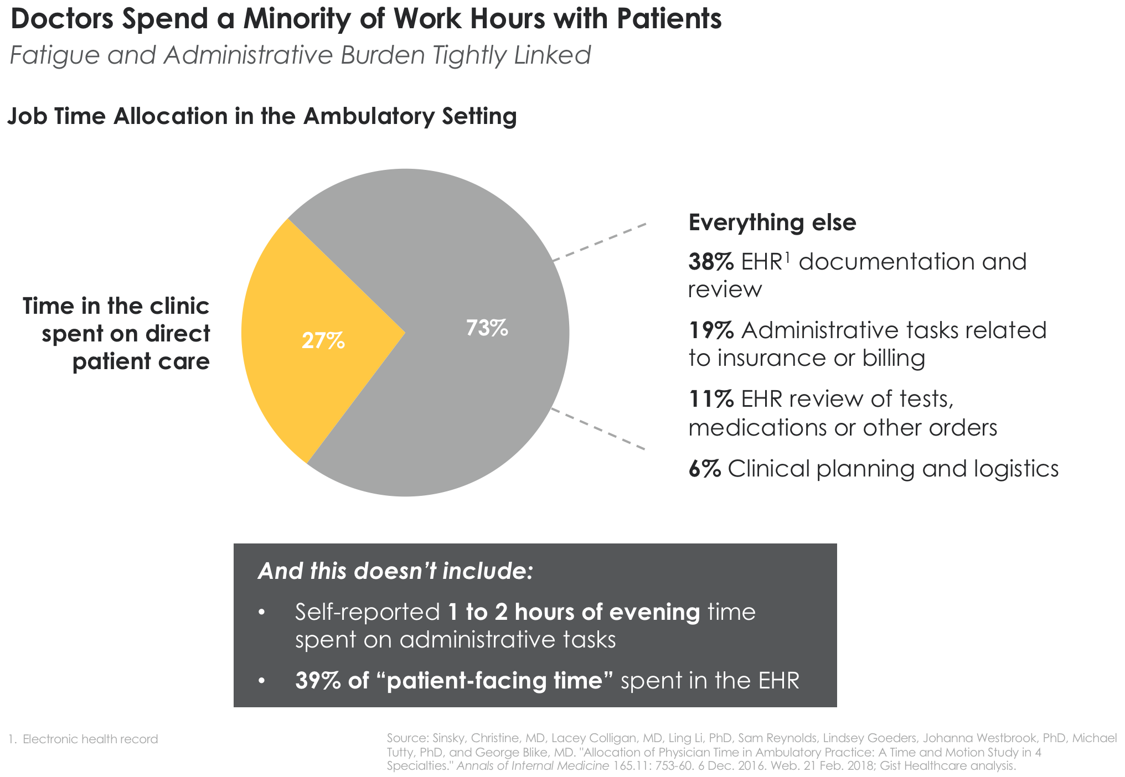
Bevy saves the clinician’s time, thereby reducing waiting lists and increasing profits for the healthcare provider.
What aspects of the current market are your target customers dissatisfied with? And how will they benefit?
As modern healthcare adopts to a population which is mobile, tech-savvy and demanding, Patient-held Records (PHR) will become the norm. Not only is this the most secure method, it is also a human instinct to be in control of our health. Only users decide who has access to their data, and at what level of security.
How much of a problem is this for your target customers?
Studies have shown valuable time and money is lost annually in the healthcare system, putting lives at risk.

The private health sector in India alone covers 82% of total outpatient care and 64% of total inpatient care. For the rest of the world, the problem is even greater.

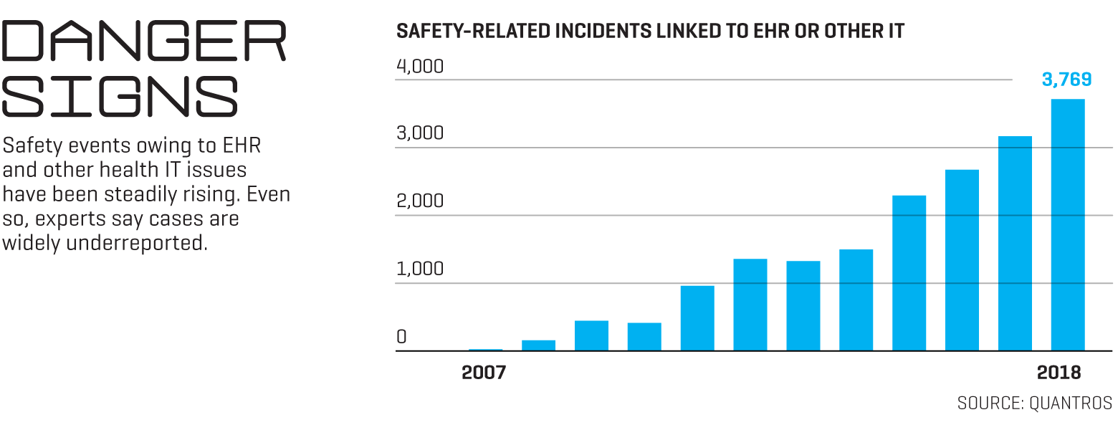
Who are our target subscribers?
- People who subscribe to private healthcare and health insurance
- Private healthcare providers, hospital chains, health insurers and medical labs.
- Private corporations whose policy is to keep employees fit and healthy to save costs.
- Health tourists visiting other countries.
What are healthcare providers currently doing to address this issue?
Some healthcare providers currently supply medical data in digital format, unsecure emails and messaging services. There are existing platforms which provide some of the services we offer, but they are complicated to use and have had poor take-up in the health market.
What are we doing differently to our competitors?
- Bevy is user-friendly, quick and easy to use, for busy doctors and patients.
- We aim to collaborate with healthcare providers and insurance companies, who in turn will offer Bevy to their clients. Bevy is free to download and use.
- Bevy will feature incentives to attract users who are in good health. These incentives might include promotions from healthcare providers, reward systems for keeping fit, and a messaging platform for exchanging information.
- In the long term, the Bevy platform will become integrated with various patient records and lab systems (such as PACS for medical imaging) in different hospitals and labs. We aim for Bevy to become a universal platform for sharing patient data between different hospitals in different formats and countries.
How it works

1. The App is a personalised storage, sharing and communication system that is customised for the individual subscriber, both patient and doctor. On registration, a unique ID is provided.

2. The App is secured with 16-bit encryption, and can only be accessed by the subscriber.

3. Patients can update their medical record whenever new data becomes available. The patient can also choose to update vital measurements, for example blood-pressure readings, or blood-sugar measurements, under the VITALS tab.

4. The doctor can access the individual record only when invited by the patient. Subscribers can decide levels of access to their health records. They can also choose the period for which the medical record is accessible: one day, for example, or one hour. This Snapchat-like function will give the patient full control of who has access, and for how long, to their medical information.

6. Test results can be uploaded either by the healthcare provider or the subscriber. The uploading is relatively simple. In the long term, Bevy could be integrated in all hospital systems, so an individual patient’s data will be transferred to their Bevy App by default, or by clicking a tab.

7. Vital data: subscribers can choose to upload their vital data every time a change is recorded; for example a blood-pressure measurement, blood-sugar level, or weight measurement.

Why us?

1. The App is created by a team of doctors with health professional and patients needs in mind .
2. Our team has good working relationships with a large number of hospitals, insurance companies and other health providers.

Difficulties ahead - and how we plan to overcome them

Acceptance: Healthcare industry is traditionally slow to adopt new technology. Bevy helps save time and money for the healthcare provider and doctor and this is a good motivation for early adoption.
At the same time we offer health benefits and healthy-living lifestyle promotions to users/patients.
Doctors are well known to be resistant to new technology, and an incentive programme may be needed to get Bevy accepted on a wider level by both patients and doctors.

Monetization

- The App is free to download and use for the subscriber.
- Hospital chains, insurance providers and labs would be offered “Freemium” model.
- Healthcare providers, insurance companies, health foods etc will be able to advertise their services direct to the user.
- The patient data generated will be anonymised and and may be used to generate revenues for clients such as pharma companies. Bevy has built-in functions that help us accurately analyse data (for example diabetic users’ dietary preferences) which can be used for further research.
Incentives
Bevy will offer incentives to subscribers who use it on a regular basis. For example, The App will offer Body Mass Index charts, where subscribers can see their health status and set goals. The rewards and incentives could be in the form of free health-checks from our partners, or discounts on merchandise.
What else?

- For a small subscription, subscribers will receive analysis, visual graphics and independent medical advice on their medical results. Subscription membership would also include free health-checks, discounts on health-related products, etc.
- Subscribers can save more than one patient’s information in their App, for example a young child or an elderly family member.
- There will be user categories at the time of signing in, for healthcare providers and consumers. Both types of users will have access according to security strategies.
- The App will offer a highly encrypted end-to-end chat function between all users. This chat function will have options such as time-limited view option (like Snapchat), calling, and file-sharing.
Objectives
The App is projected to hit 1 million subscribers in two years.
Exit Plan: In 3 years we plan to sell the App to a foreign healthcare business looking to enter private healthcare or the health insurance sector.
Company Overview
The company is incorporated in the UK. The board is made up of doctors from the UK and India.
How did we come up with the idea?
For Radhika, our founder, the idea for Bevy started on an emotional note. When Radhika was very close to her paternal grandmother and she fell ill in India, Radhika took charge of her health. While dealing with doctors, Radhika found she had to beg for the medical results and scans and medical records and then organise, digitise and share with many specialists in India and also with her uncle, who is a doctor in London. Radhika found most patients lost an invaluable amount of time in this process putting the patient in jeopardy.
Being a technology graduate, Radhika came up with an idea for Bevy health which puts the patient in control of her medical records.
Advisory Team
As well as highly qualified doctors, our board members also include the CEO of a leading pension fund, a Bollywood celebrity and a business leader.
MARKET
Although Bevy is available to download all over the world, we aim to launch it initially in India, owing to the size of the private health market.

Total Available Market (TAM) = total market demand for the product or service.

According to Deloitte, the revenue of India’s corporate healthcare sector is estimated to grow 15% in 2017-18.

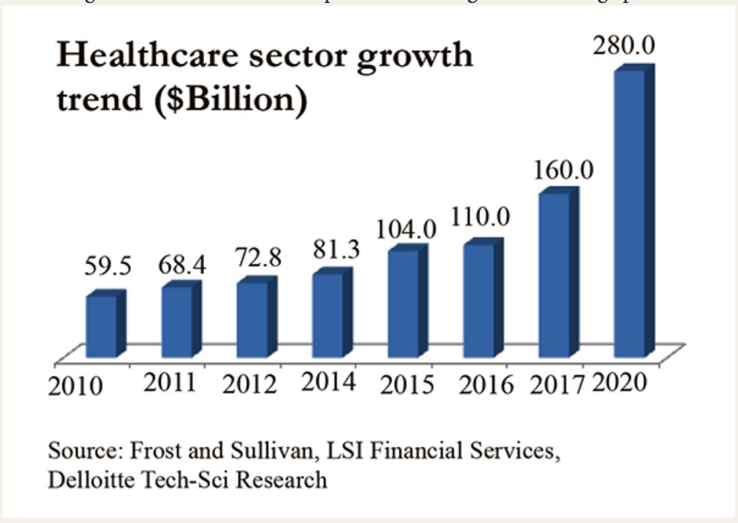

The private health sector in India covers 82% of total outpatient care and 64% of total inpatient care. The private medical sector remains the primary source of healthcare for 70% of households in urban areas and 63% of households in rural areas. The private sector comprises 58% of the hospitals in the country, 29% of beds in hospitals, and 81% of doctors.

The middle and upper classes and young professionals – people with access to smartphones – tend to use the private sector. This segment is likely to grow exponentially over the next 10 years. Private healthcare providers are more likely to spend money on investigations, compared to the public sector. This leads to more patient data being generated in the private sector.
Market Projections
According to the World Bank, about 25% of India's population had some form of health insurance in 2010. The number is projected to grow.
Over 10 million foreign tourists arrived in India in 2017. The number is projected to grow by 5% each year.

Medical tourism is expected to double in size from about $3 billion in April 2017 to $6 billion by 2020.

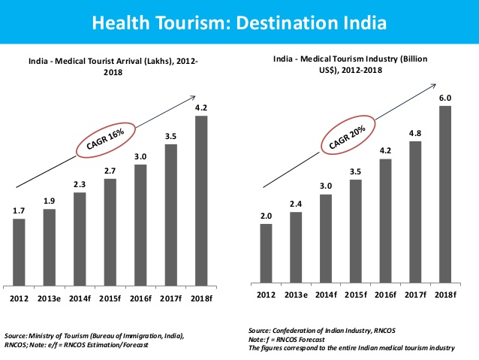

Re: http://businesseconomics.in/india’s-healthcare-sector-poised-higher-growth

Serviceable Available Market (SAM) = segment of the TAM that you can reach through your sales channel

A 1.25% penetration of the population who use private healthcare would see the App reaching 100 million subscribers in India.

STRENGTHS
The App is developed by a team of highly qualified internationally renowned doctors with the requirements of doctors and patients in mind.
WEAKNESSES
Not all patients have access to a smartphone. The healthcare sector is notoriously slow to adopt change.
OPPORTUNITIES
With mass travel between countries, people’s medical needs also change.
THREATS
There is a strong chance that a Silicon Valley giant will launch a Cloud-based healthcare platform. But it is obvious to us as doctors that for such an App to succeed in the medical field, doctors and other healthcare providers have to be partners: only then can a technology have a chance of success. With this in mind, we at Bevy build our base from the foundation upwards, from doctors to patients; from insurance companies to clients. And the motivation is simple: save money or make money by adopting Bevy.
Bevy is likely to become a target for acquisition by corporations looking to enter the health market in India or abroad in a couple of years time.
MARKETING STRATEGY
We plan to market the App directly to doctors and healthcare providers making them partners.
4.1 - Customer Acquisition Strategy
1. Free incentives – for example, offering a free medical consultation as a joining incentive.
2. Brand ambassadors - We have already been in touch with celebrities to front our campaign.
3. Advertising with QR codes in public places.
4. Attracting potential clients with free talks by specialists, then broadcasting the videos on YouTube to build brand identity.
5. Encourage social-media users to join our email list.
6. Create short teaser videos targeting our subscribers, to be shared on social media.
7. Social media: quick Twitter response. Find a YouTube influencer for the App
8. Free giveaways is to pick a prize that is very specific to our target audience (eg, free medical test for the first 10 email subscribers)
9. Creative pictures and videos on Instagram
10. Design snapchat geofilters for health problems
11. Answer questions on QUORA, Mumsnet and other portals
12. Roll out Facebook video ads
13. Implement PUSH notifications
14. Start Deep Linking
15. Make Bevy addictive with connections to social media.
16. Ask for reviews and offer rewards for feedback
17. Cross-promote with other health-related businesses
4.2 - Product Driven Growth
We will build in a referral programme, to increase our user-base. Users will get a coupon for a free consultation when they refer friends, and so on.
4.3 - Key Metrics
The key metrics would be the number of times Bevy is used every week. We expect users to use Bevy every day, entering vitals like blood pressure, home blood tests and blood sugar levels, which are then communicated to their healthcare provider in real time.

