Jab1-siRNA induces cell growth inhibition and cell cycle arrest in gall bladder cancer cells via targeting Jab1 signalosome
Dr. Pratibha Pandey, PhD, NIET Greater Noida, India
Dr. Fahad Khan, PhD, NIET, Greater Noida
Abstract
The aberrant alteration in Jab1 signalosome (COP9 Signalosome Complex Subunit 5) has been proven to be associated with the progression of several carcinomas. However the specific role and mechanism of action of Jab1 signalosome in carcinogenesis of gall bladder cancer (GBC) is poorly understood. In the current study, we have shown that overexpression of Jab1 stimulated the proliferation of GBC cells; whereas downregulation of Jab1 by using Jab1-siRNA approach resulted in the cell growth inhibition and apoptotic induction. Furthermore, we found that downregulation of Jab1 induces the cell cycle arrest at G1 phase and upregulated the expression of p27, p53 and Bax gene. Moreover, Jab1-siRNA induces apoptosis by enhancing ROS generation and caspase-3 activation. In addition, combined treatment with Jab1-siRNA and gemicitabine demonstrated an enhanced decline in cell proliferation which further suggested increased efficacy of gemcitabine at a very lower dose (5µM) in combination with Jab1-siRNA. In conclusion, our study strongly suggests that targeting Jab1 signalosome could be a promising therapeutic target for the treatment of gall bladder cancer.
Keywords: Gall bladder cancer; Jab1-siRNA; Jab1; Gemcitabine; Caspase-3; Gene silencing
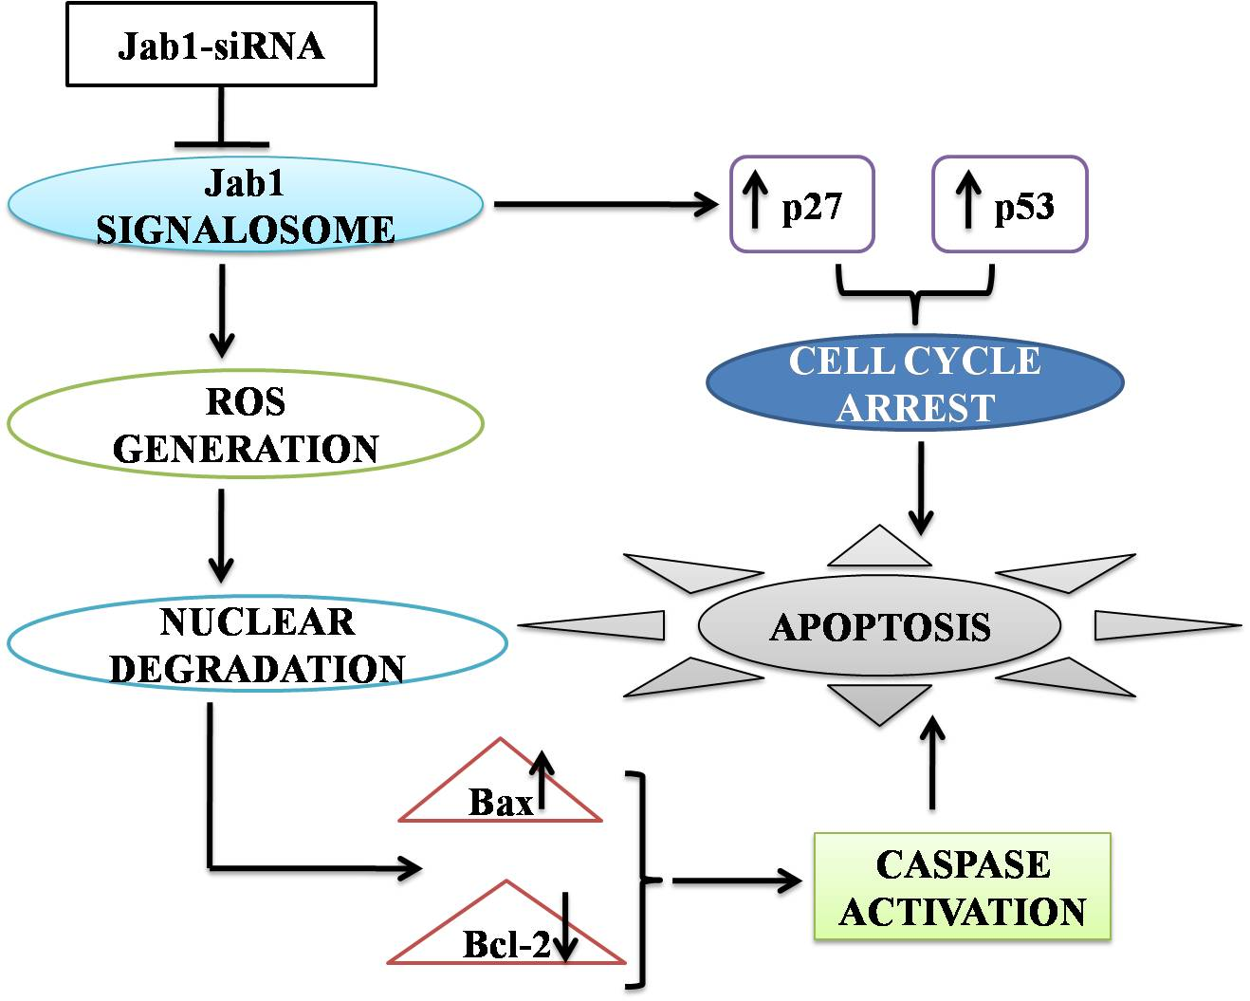
Recent Publications

Pandey, P., Khan, F., & Maurya, P. (2021). Targeting Jab1 using hesperidin (dietary phytocompound) for inducing apoptosis in HeLa cervical cancer cells. Journal of Food Biochemistry, e13800.

Pandey, P., & Khan, F. (2020). Jab1 inhibition by methanolic extract of Moringa oleifera leaves in cervical cancer cells: a potent targeted therapeutic approach. Nutrition and Cancer, 1-9.

Alam, M. W., Pandey, P., Khan, F., Souayeh, B., & Farhan, M. (2020). Study to Investigate the Potential of Combined Extract of Leaves and Seeds of Moringa oleifera in Groundwater Purification. International Journal of Environmental Research and Public Health, 17(20), 7468.

Khan, F., Pandey, P., Ahmad, V., & Upadhyay, T. K. (2020). Moringa oleifera methanolic leaves extract induces apoptosis and G0/G1 cell cycle arrest via downregulation of Hedgehog Signaling Pathway in human prostate PC‐3 cancer cells. Journal of Food Biochemistry, 44(8), e13338.

Pandey, P., Sayyed, U., Tiwari, R. K., Siddiqui, M. H., Pathak, N., & Bajpai, P. (2019). Hesperidin induces ROS-mediated apoptosis along with cell cycle arrest at G2/M phase in human gall bladder carcinoma. Nutrition and cancer, 71(4), 676-687.

Pandey, P., Siddiqui, M. H., Behari, A., Kapoor, V. K., Mishra, K., Sayyed, U & Bajpai, P. (2019). Jab1-siRNA induces cell growth inhibition and cell cycle arrest in gall bladder cancer cells via targeting Jab1 signalosome. Anti-Cancer Agents in Medicinal Chemistry (Formerly Current Medicinal Chemistry-Anti-Cancer Agents), 19(16).


Dr. Pratibha Pandey
Dr. Pratibha Pandey is an Assistant Professor working in the Department of Biotechnology at the Noida Institute of Engineering and Technology, Greater Noida, India. An ardent learner with PhD in Bioengineering (Biotechnology), M-Tech (Silver Medalist) (Biotechnology), MBA (HR) and B-Tech (Biotechnology) actively involved in research and development in the field of Biotechnology and Bioengineering. Awarded Young Women Scientist (WOS-A) with a project grant of 22 Lakhs from Department of Science and Technology, Government of India. Awarded Project grant of 3 Lakhs on the project under CRIP Programme of TEQIP III from AKTU, Lucknow. Her Research Area of Specialization includes Cancer Biology (Biomarkers and signalosomes in Gall bladder Cancer, Prostate cancer, Lung Cancer and Cervical cancer), Water Remediation, Chemoprevention using Natural Products via In silico and In vitro techniques.

