Calretinin Expression in Hirschsprung Disease – A Potential Marker of Ganglion Cells
By
Dr.Mishal Sikandar
M. Phil. Histopathology


Statement of problem:Hirschsprung disease (HSCR) or congenital intestinal aganglionosis, is a birth defect characterized by complete absence of neuronal ganglion cells from a portion of the intestinal tract, mostly in a segment of rectum and variable length of contiguous proximal, causing functional obstruction and colonic dilation proximal to affected segment. (Amiel and Lyonnet, 2001) Routine diagnostic modalities like Haematoxylin & Eosin (H&E) and Acetylcholine Esterase (AChE) staining as well as radiology-based clinical techniques have bee conventionally used for identification of aganglionosis and presence of hypertrophic nerve trunks in the affected segment as primary indicators of HSCR. (Kacar et al., 2012) However, these conventional methods have their inherent deficiencies as H&E requires multiple trans-mural biopsies and the interpretation of ganglion cells is often very difficult. (Tabbers et al., 2014) Similalry, AChE requires fresh frozen section for which the chances of technical error are very high and this facility is not commonly available in Pakistan. The number of misdiagnosed results with potential overtreatment stands in need for reliable staining to prevent harm from unnecessary surgery and mortality. Recently, Immunohistochemical markers are being increasingly used and evaluated in Pathology laboratories. No immunohistochemical marker, either alone or in combination, has emerged from those researches that is as promising as calretinin. Hence, this study was designed with an aim to observe the immunohistochemical expression of Calretinin as a marker for aganglionosis and to detect ganglion cells in the affected areas for better and more accurate diagnosis of the disease. Methodology: This study was conducted at University of Health Sciences Lahore, Pakistan from February to September,2016. Colonic Biopsy Specimens from 73 patients collected mostly from Mayo Hospital,Lahore with established histopathologic diagnosis of HSCR were considered for the study.Age range was 0.1-120months. . There were 48(65.8%) cases who were ≤12 months old, 20(27.4%) were 12.1-60 months old and 5(6.8%) of the cases were 60.1-120 month old. The mean age of patients was 12.52±9.21 months. There were 52(71.23%) male and 21(28.77%) female patients. The male to female ratio in this study was 2.48:1.According to sign and symptoms and clinical examination, 69(94.5%) cases had mostly long standing constipation, 47(64.4%) cases had fever, 68(93.2%) cases had vomiting, 31(42.5%) cases had failure to thrive, 20(27.4%) cases had Enterocolitis and 63(86.3%) of the patients had palpable abdominal masses.Methodology involved staining of fresh sections with H&E procedure for provisional histological diagnosis. The biopsies were then processed for immunohistochemical staining with Calretinin and were observed for presence of ganglion cells.Findings:All the ganglion cells took brownish-black stain and were easily identified,which were not being identified on H&E. Ganglion cells were present and absent in 42(57.53%) and 31(42.47%) respectively.The study revealed that the Calretinin immunohistochemistry was very sensitive and specific for detecting ganglion cells. Conclusion and significance :It was concluded that Calretinin provides a very reliable and cost effective adjunctive test to be routinely used with H&E in the evaluation of Rectal Section Biopsies (RSBs) for HSCR. The use of Calretinin may help the Pathologists in making accurate and reliable diagnosis for HSCR and consequently eliminating the need for repeated biopsies and unnecessary surgeries.

^{H&E Diagnosis:} | On H&E aganglionic colonic biopsy segments from diseased areas showed hypertrophied nerve fibers,chronic inflammation in which mast cells were predominanr and deep pink muscle fibers in addition to other components of bowel wall no ganglion cells were observed . | Ganglionic colonic biopsy segment either from control specimens or colostomy segments showed presence of numerous ganglions which mostly looked like nodular masses of neuronal cell bodies, in submucosa aswell as in between inner circular and outer longitudinal muscle layers.
^{Calretinin Diagnosis:} | Agnglionic colonic biopsy segments stained with Calretinin showed no ganglion cells in submucosal or myenteric plexus and other components like colonic glands ,blood vessels and muscles did not take any stain and appeared lightly bluish due to heamatoxylin stain. | Ganglionic colonic biopsy segment from colostomy portion showed ganglions which took deep nuclear and cytoplasmic stain of brownish black colour.

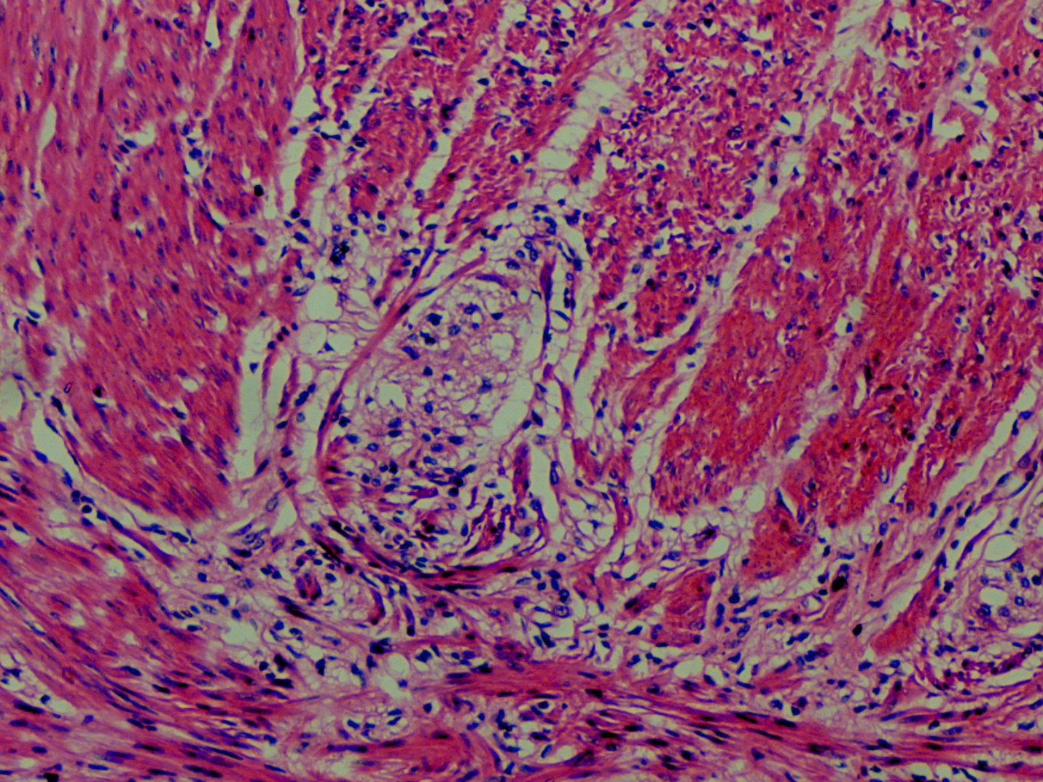
Phtomicrograpth of colonic biopsy stained with H&E showing numerous ganglion cells (X40)

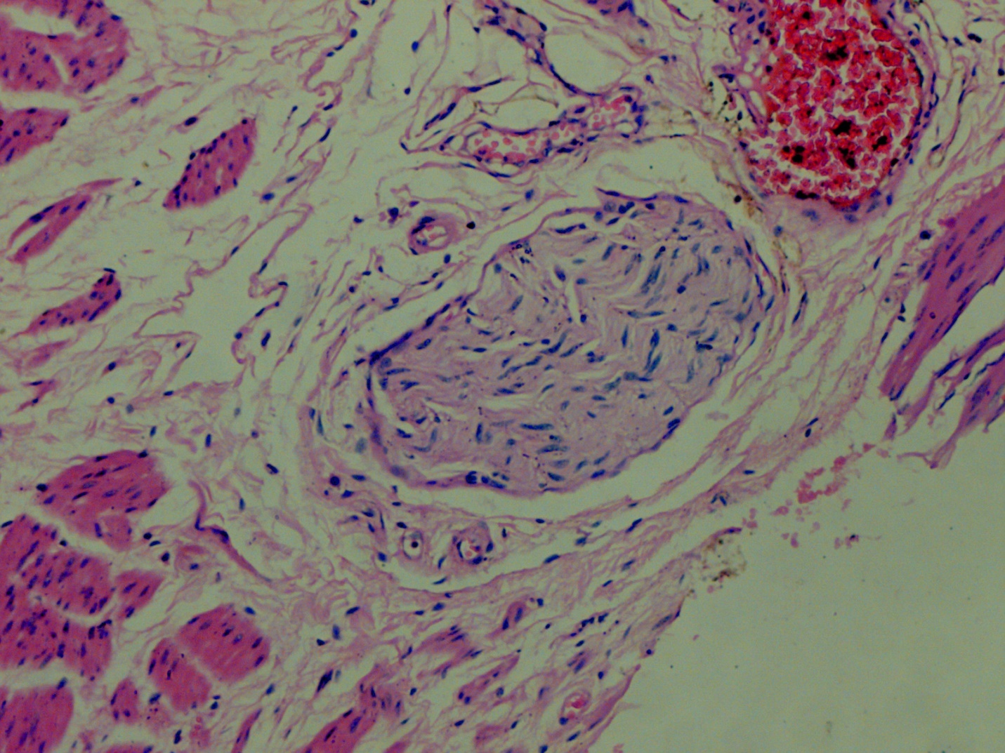
Photomicrograph of colonic biopsy showing hypertrophied nerve fibre (X10)

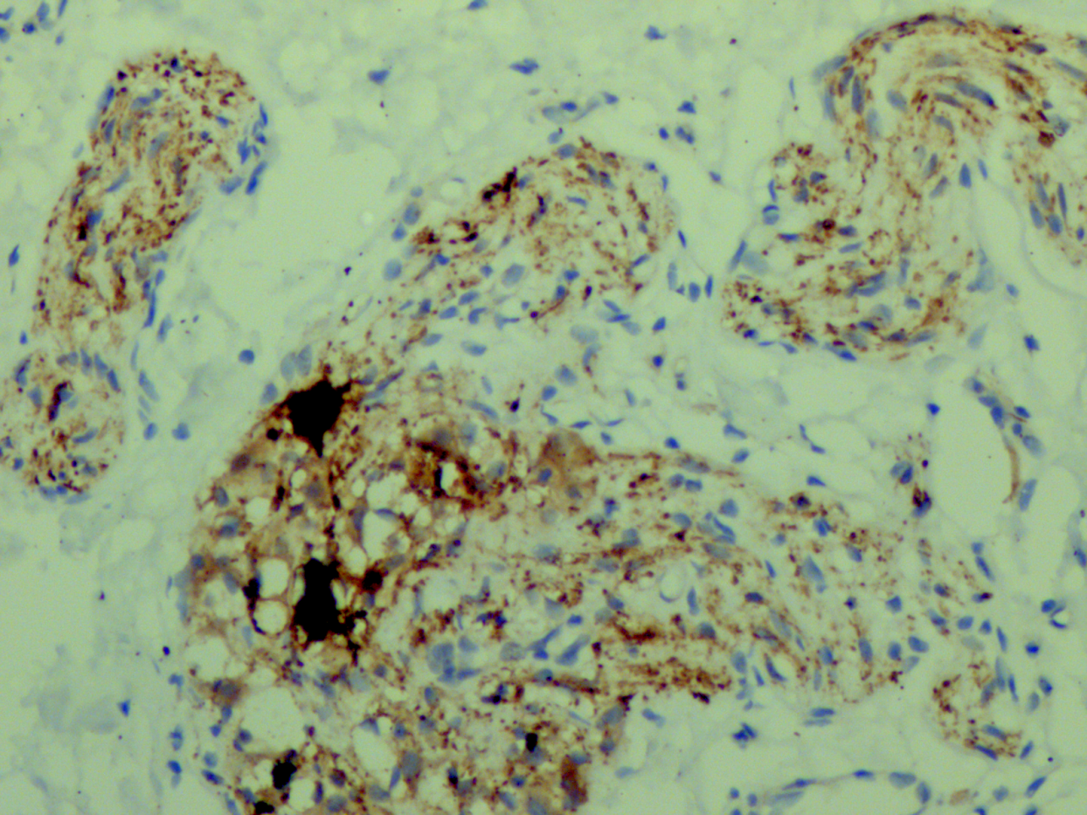

Phtomicrograpth of colonic biopsy stained with Calretinin showing numerous ganglion cells(X40)
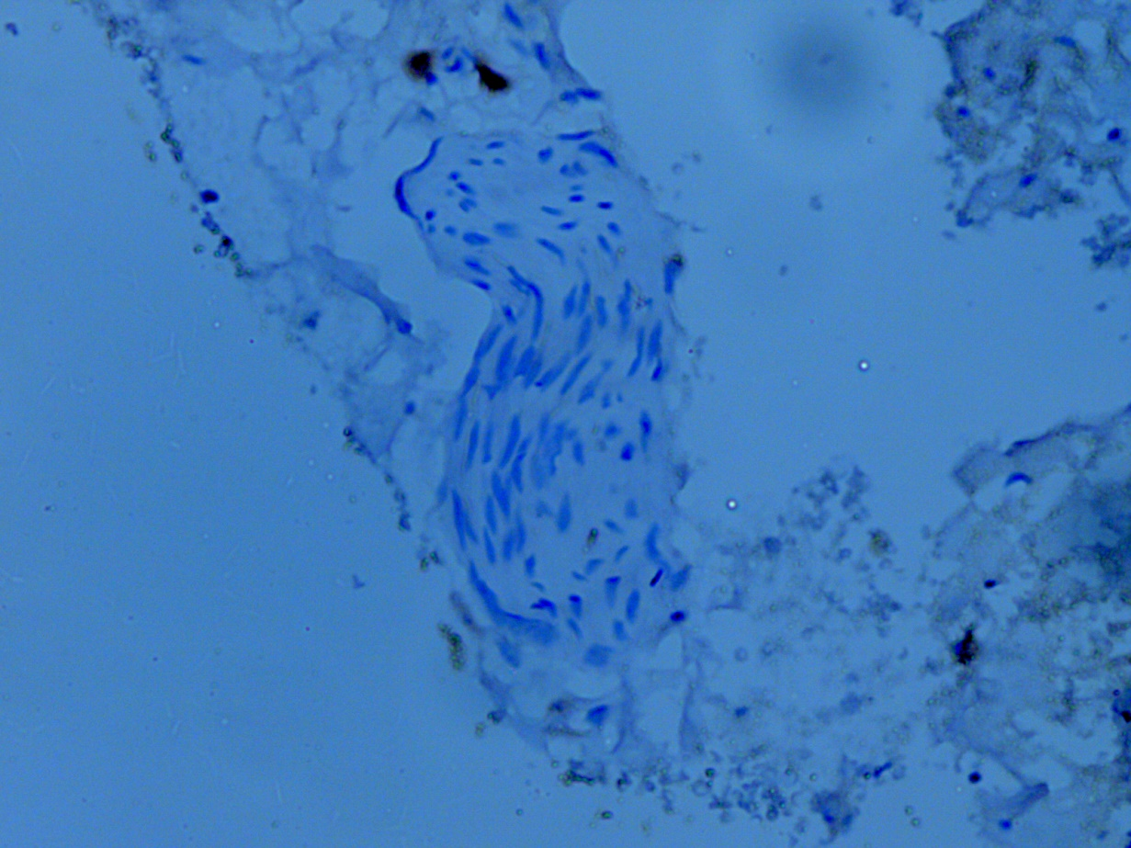
Phtomicrograpth of colonic biopsy stained with showing Hypertrophied nerve unstained with Calretinin (X40). On histopathological examination 47(64.38%) cases had hypertrophic nerve.

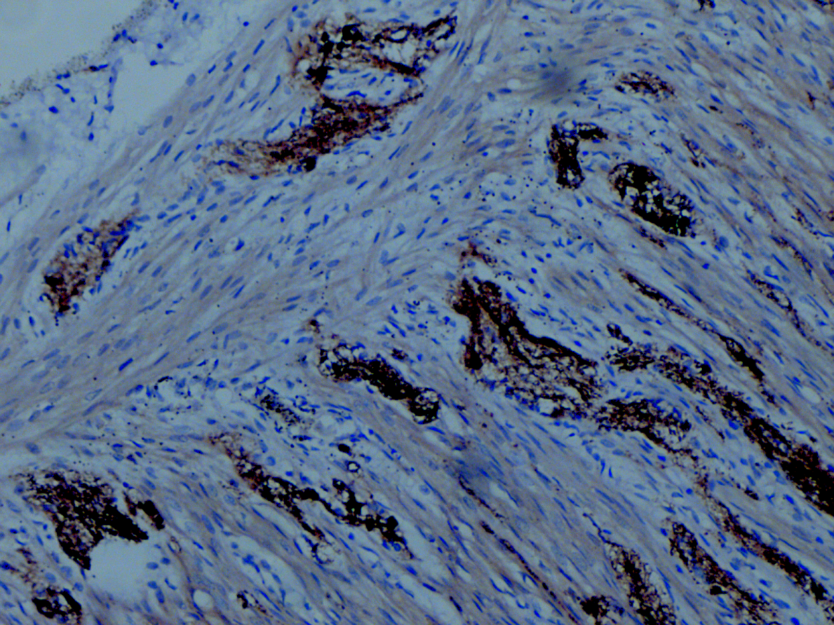
Phtomicrograpth of colonic biopsy stained with Calretinin showing numerous ganglion cells (X10)

^{References:}
AMIEL, J. & LYONNET, S. 2001. Hirschsprung disease, associated syndromes, and genetics: a review. Journal of medical genetics, 38, 729-739.

KACAR, A., ARIKÖK, A. T., AZILI, M. N., EKBERLI, A. G. & TIRYAKI, T. 2012. Calretinin immunohistochemistry in Hirschsprung's disease: An adjunct to formalin-based diagnosis. The Turkish journal of gastroenterology: the official journal of Turkish Society of Gastroenterology, 23, 226-233.

TABBERS, M., DILORENZO, C., BERGER, M., FAURE, C., LANGENDAM, M., NURKO, S., STAIANO, A., VANDENPLAS, Y. & BENNINGA, M. 2014. Evaluation and treatment of functional constipation in infants and children: evidence-based recommendations from ESPGHAN and NASPGHAN. Journal of Pediatric Gastroenterology and Nutrition, 58, 258-274.
HOLLAND, S. K., RAMALINGAM, P., PODOLSKY, R. H., REID-NICHOLSON, M. D. & LEE, J. R. 2011. Calretinin immunostaining as an adjunct in the diagnosis of Hirschsprung disease. Annals of diagnostic pathology, 15, 323-328.

CINEL, L., CEYRAN, B. & GÜÇLÜER, B. 2015. Calretinin immunohistochemistry for the diagnosis of Hirschprung disease in rectal biopsies. Pathology-Research and Practice, 211, 50-54.

^{Bibiliography:}
Name : Dr Mishal Sikandar
Designation: Doctor (M.B.B.S) , Family Physician , Consultant Histopathologist.
Date of Birth: 28-03-1988
PMDC,Pakistan registration number : 65451-p
CNIC: 35202 8936 985 4
Postal Address: Railway Officers Colony Walton ,Street number 3, house number 110-B, Lahore, Pakistan.
I am a Doctor by profession,i did M.B.B.S from UHS,Pakistan in 2012.
Work Experience: Then worked as House officer in Medicine, Cardiology and Obs & Gynae in 2013.Then worked in Obstretics and gynaecology for one year.Then started Post graduation in Morbid Anatomy and Histopathology, from UHS,Lahore,Pakistan, which is my area of work now.I started my session in 2015, cleared all exams with highest marks at University.Now i am done with research work and submitted my thesis. In couple of months i will get degree of M Phil Histopathology.
My research interests are Cardiology, female genital tract pathologies , carcinoma breast, Gastrointestinal pathologies, bone cancer ,Hirschsprung's Disease.

I published an articles in "Biomedica',an official publication of University of Health Sciences ,volume31, on
· Assessment of Dietary intake and Physical Activity Pattern of adult Girls students,Dr Mishal Sikandar : College of home economics Lahore, 2,4: Department of Medicine and Pathology, Fatima Jinnah Medical College, Lahore .

·Case series: Being written on a rare cardiac tumor, ‘Myxoma’ and Lympho-epithelial leisions.
·Case report: Being written on congenital cardiac anamoly ‘& ‘Pentology of Fallot’.
Regards

Respected Organizers,
I will get my abstract and paper published in conference proceedings and associated journals ,if i am invited to conference to read paper and will get certificate for it.So kindy ,send me a letter of acceptance and invitation as soon as possible so that I can arrange funds beforehand.
Regards

