Hierarchical 3D Materials with Vertically Aligned Carbon Nano-structures for Efficient Energy Applications
Rajib Paul, PhD, Case Western Reserve University, Cleveland, OH 44106, USA

Abstract (300 word limit)
Carbon based structural materials are attractive for energy application owing to their fascinating thermal and electrical conductivities, excellent mechanical properties and efficient catalytic activities. The sp² hybridization in graphitic carbon lattice are responsible for such properties. The defect-free graphitic carbon structure is crucial for superior transport and mechanical properties whereas the structural or heteroatom induced defective states are desirable for efficient catalytic activities. However, the catalytic activities in defect-rich carbon materials are not always straightforward and depends on various factors, such as, type of defect, its density, surface morphology, porosity, surface area and activeness of surface defects. Furthermore, in case of hierarchically porous and three-dimensional (3D) carbon materials with abundant junctions between sp² and sp³-hybridized carbon lattices, the understanding of catalytic and other physical properties is more difficult but important for advancement of energy storage technologies in 3 dimensions.
We have opted different experimental techniques to fabricate different hierarchical carbon materials. We have grown vertically aligned few-layer graphene and carbon nanotubes (CNTs) to increase the intrinsic surface area of 3D structures. Moreover, we established an innovative technique to effectively functionalize those structures to provide active surface defects through heteroatoms (N, B) doping, for enhanced sorption based thermal energy recycling and electrochemical energy storage applications. The active carbon surface demonstrated about 6-fold increase in methanol sorption enthalpy. We fabricated CNT, graphene and CNT-graphene hybrid-foams with ultra-low density (~4mg/cc) which showed ~200 % increased Li-ion storage capacity as binder-free anode. Vertically oriented CNTs grown on carbon-textiles and proper functionalization indicated high areal-capacitance of 107 mF/cm² with excellent flexibility. We conducted experiments to understand and correlate the thermal transport and catalytic properties with structural details. The porosity is not always a dictating factor for thermal transport in 3D carbon structures rather the crystallinity and junctional properties determines the transport properties.

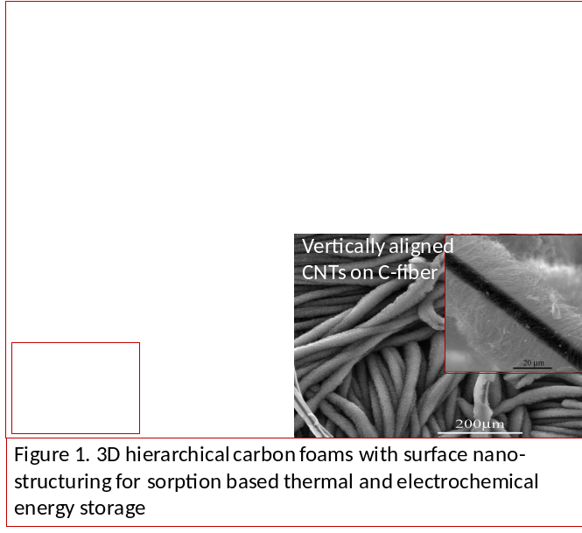
Recent Publications (minimum 5)
- Paul R, Voevodin AA, Zemlyanov D, Roy AK, Fisher TS (2012) Microwave-assisted surface synthesis of boron-carbon-nitrogen foam and its adsorption enthalpy. Adv. Funct. Mater. 22(17): 3682.
- Paul R, Zemlyanov D, Voevodin AA, Roy AK, Fisher TS (2014) Methanol wetting enthalpy on few-layer graphene decorated hierarchical carbon foam for cooling applications. Thin Solid Films 572: 169.
- Paul R, Reifenberger RG, Fisher TS, Zemlyanov D (2015) Atomic layer deposition of FeO on Pt(111) produced through ferrocene adsorption and oxidation. Chemistry of Materials, 27(17): 5915.
- Paul R, Etacheri V, Pol VG, Hu J, Fisher TS (2016) Highly porous three-dimensional carbon nanotube foam as a freestanding anode for a lithium-ion battery. RSC Advances 6(83): 79734-79744.
5. Chen X, Paul R, Dai L (2017) Carbon-based supercapacitors for efficient energy storage. National Science Review, nwx009. [doi: 10.1093/nsr/nwx0090-17].



Biography
Dr Rajib Paul has extensive expertise in carbon material synthesis, fabrication and rational designing for efficient energy storage and conversion applications. He has developed a facile microwave radiation assisted functionalization technique for carbon based 3D porous structures. He is pioneered in nano-structuring of carbon surface through various plasma induced and thermal CVD methods. His additional research interest is related to thermal and mechanical properties evaluation in 3D hierarchical carbon structures. The foundation is based on understanding the junctional interfaces in 3D hierarchical carbon materials which play crucial roles in dictating transport and catalytic properties. He has demonstrated that the surface morphology, surface active states, and availability of carbon lattice edges evaluate the overall properties in 3D carbon structures.
Email: rxp348@case.edu

