Carbon nanowalls, vertical nanographene network as platform for electrochemical application
Mineo Hiramatsu, Meijo University, Nagoya, Japan

Abstract
Carbon nanowalls (CNWs) are few-layer graphenes with open boundaries, standing vertically on a substrate. The sheets form a self-supported network of wall structures with thicknesses ranging from a few nanometers to a few tens of nanometers, and with a high aspect ratio. The maze-like architecture of CNWs with large-surface-area graphene planes would be useful as electrodes for energy storage devices, electrochemical and biosensors, and scaffold for cell culturing. From a practical point of view, structures of CNWs including spacing between adjacent nanowalls, crystallinity and alignment should be controlled according to the usage of CNWs. Moreover, post processes such as integration techniques including etching and coating of CNWs and surface functionalization should also be established. We report the current status of the control of the CNW structures during the growth processes as well as post treatment, together with examples of electrochemical applications using CNWs.
As an example of application, CNWs were used as platform for hydrogen peroxide (H₂O₂) sensing. This kind of application is based on the large surface area of conducting carbon and surface modifications including decoration with metal nanoparticles (NPs). It is known that H₂O₂ is a major messenger molecule in various redox-dependent cellular signaling transductions. Therefore, sensitive detection of H₂O₂ is greatly important in health inspection and environmental protections. For the H₂O₂ sensing, CNWs were grown on carbon fiber paper (CFP) using plasma-enhanced chemical vapor deposition with CH₄/Ar mixture to increase the surface area. Then, CNW surface was decorated with Pt-NPs by the reduction of H₂PtCl₆ in solution. Cyclic voltammetry results showed that the Pt-decorated CNW/CFP electrode exhibited excellent electrocatalytic activity to the reduction of H₂O₂. Electrochemical experiments demonstrate that nanoplatform based on vertical nanographene offers great promise for providing a new class of nanostructured electrodes for electrochemical sensing, biosensing and energy conversion applications.

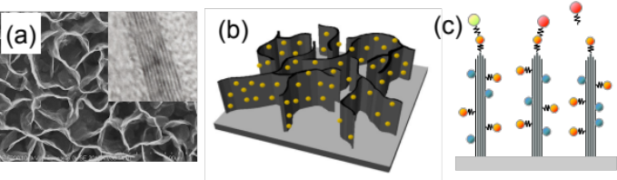
Figure 1: (a) Plane-view SEM image of carbon nanowalls, together with TEM image of carbon nanowall sheet showing few-layer graphene (inset), (b) schematic of Pt-nanoparticle decorated carbon nanowalls as electrode for electrochemical application, and (c) schematic illustration of application of carbon nanowalls as platform for electrochemical and bio-sensors.
Recent Publications
- Hiramatsu M, Hori M (2010) Carbon Nanowalls: Synthesis and Emerging Applications, Springer Verlag Wien.
- Hiramatsu M, Kondo H, Hori M (2015) Nanoplatform Based on Vertical Nanographene, Graphene - New Trends and Developments, Farzad Ebrahim, Ed. InTech: 145-178.
- Hiramatsu M, Shiji K, Amano H, Hori M (2004) Fabrication of vertically aligned carbon nanowalls using capacitively coupled plasma-enhanced CVD assisted by hydrogen radical injection, Applied Physics Letters, 84:4708-4710.
- Watanabe H, Kondo H, Okamoto Y, Hiramatsu M, Sekine M, Baba Y, Hori M (2014) Carbon nanowall scaffold to control culturing of cervical cancer cells, Applied Physics Letters, 105:244105.
- Cho HJ, Kondo H, Ishikawa K, Sekine M, Hiramatsu M, Hori M (2014) Density control of carbon nanowalls grown by CH₄/H₂ plasma and their electrical properties, Carbon, 68:380-388.

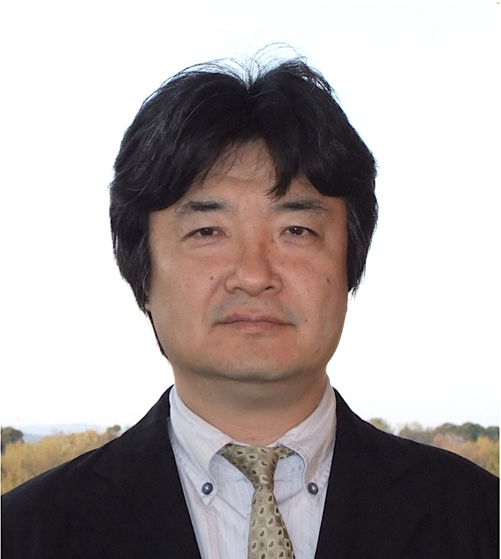 Biography
Prof. Mineo Hiramatsu is a Full Professor of Department of Electrical and Electronic Engineering and the Director of Nanocarbon Research Center, Meijo University, Japan. He also serves as the Director of Research Institute, Meijo University. He served as the Director of The Japan Society of Applied Physics. His main fields of research are plasma diagnostics and plasma processing for the synthesis of thin films and nanostructured materials. Author of more than 100 scientific papers and patents on plasma processes for materials science. Member of organizing and scientific committees of international conferences on plasma chemistry and plasma processing: International Conference on Reactive Plasmas, International Symposium on Advanced Plasma Science and its Applications for Nitrides and Nanomaterials, International Symposium on Dry Process, International Conference on Advanced Nanomaterials, THERMEC, International Conference on Processing & Manufacturing of Advanced Materials.
Email: mnhrmt@meijo-u.ac.jp

Notes/Comments:

