Revealing the role of anti-Mycobacterium tuberculosis (MTb) antibodies during natural infection in humans

Natalia Freund, Ph.D. Sackler Faculty of Medicine, Department of Clinical Microbiology and Immunology

Tel Aviv University, Tel Aviv, Israel

One of the major re-emerging public health threats is Mycobacterium tuberculosis (MTb). According to the WHO, one of every three individuals in the world was infected with MTb (1). This number is expected to increase due to an increasing population of patients with HIV-1, and the increasing incidence of drug-resistant MTb strains. The existing BCG vaccine, shows a very low efficacy in preventing new infections (1). Thus, MTb will pose an even higher threat in the future, requiring the development of new strategies to diagnose, treat and prevent MTb.

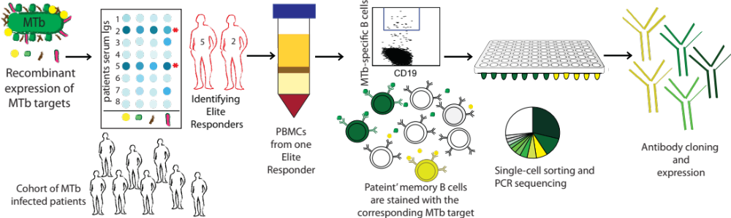
Previous studies of the natural immune response to MTb have focused mainly on the role of T cells. Recently, several reports suggested that anti-MTb antibodies could contribute to protection (2). While advancements were made, several major questions remain unanswered, including which B cell clones are elicited during infection, how different antibodies correlate with the different disease stages and what is the mechanism of anti-MTb antibody neutralization. Our goal is to reveal the role of B cell immunity to MTb and based on this, develop antibody-based diagnostics, therapeutics and immunogens against MTb. To achieve this goal we combine single-cell methods, human immunology and protein engineering. We cloned and express five MTb proteins, which are potential targets for antibodies. These antigens were used to screen sera from MTb-infected individuals by ELISA and identify “Elite Responders”, patients who exhibit high antibody responses against MTb. We then apply singe B cell sorting to identify and sort MTb-specific memory B cells and sequence the antibodies they express (3) (Figure 1).

Figure 1: MTb protein-targets will be used for screening serum by ELISA and for identifying “Elite Responders”. Then, the reactive protein-targets will be used as baits to purify memory B cells from Elite Responders. Next, MTb-specific memory B cells will be single-cell sorted, and their antibody genes will be sequenced. Lastly, antibodies from the most represented clones will be selected and produced.

References:
1. WHO, Global Tuberculosis Report 2016. Wourld Health Organization, (2016).
2. A. Casadevall, Antibodies to Mycobacterium tuberculosis. N Engl J Med 376, 283-285 (2017).
3. N. T. Freund et al., Coexistence of potent HIV-1 broadly neutralizing antibodies and antibody-sensitive viruses in a viremic controller. Sci Transl Med 9, (2017).


Dr. Natalia Freund is specializing in antibody response towards infectious diseases. Until recently she has been investigating the antibody response in HIV-1 infected patients at The Rockefeller University in New York. During her work, she isolated several anti-HIV-1 neutralizing antibodies that were found efficacious in pre-clinical studies. Recently, she moved to Tel Aviv University where she is continuing to carry out cutting-edge research on the antibody response during both Tuberculosis and HIV-1 infection.

