Diabetes mellitus is a strong predictor for post-surgical neuropathic pain: A population-based cohort study
Pei-Shan Tsai, PhD.
School of Nursing, College of Nursing, Taipei Medical University, Taipei, Taiwan

Abstract (300 word limit)
Post-surgical neuropathic pain (PSNP) is observed in herniorrhaphy, mastectomy, amputation or coronary artery bypass grafting (CABG) patients. We elucidated PSNP risk factors using LHID2010, a database includes medical claims data and registration files for 1 million enrollees randomly selected from approximate 24 million registry for beneficiaries of Taiwan’s National Health Insurance program. Patients undertook the surgery between January 2000 and December 2012 were included. Patients with a history of PSNP before surgery or age of less than 20 or more than 100 years were excluded. A total of 4647 patients (herniorrhaphy: 2564; mastectomy: 803; amputation: 902; CABG: 378) were included. Patients with at least two ambulatory visits for PSNP treatments were identified as the PSNP subjects. Patients without PSNP diagnosis were identified as the non-PSNP subjects. Subjects were tracked from surgery date until the end of 2013 or loss of follow-up. During 1-14 years of follow-up, PSNP incidence in patients undertook herniorrhaphy, mastectomy, amputation and CABG was 4.6%, 6.8%, 15.5% and 18.8%, respectively. After controlling for the potential confounders, multivariate logistic regression analyses revealed that diabetes mellitus was a strong risk factor of PNSP in patients undertook herniorrhaphy [odds ratio (OR)=30.71], mastectomy (OR=29.80), amputation (OR=54.62) and CABG (OR=209.62) (all P<0.001). In herniorrhaphy patients, PSNP risk factors also included hyperlipidemia, anxiety and use of anti-depressants and opioids (OR=1.81, 3.19, 2.35 and 1.78; all P<0.05). In mastectomy patients, risk factors also included hyperlipidemia, anxiety and use of anti-depressants (OR=3.84, 4.93 and 2.51; all P<0.05). In amputation patients, risk factors also included hyperlipidemia and use of non-steroid anti-inflammatory drugs and acetaminophen (OR=1.93, 12.49 and 13.05; all P<0.05). In CABG patients, risk factors also included hyperlipidemia, anxiety and use of anti-depressants (OR=6.06, 4.50 and 3.48; all P<0.05). Collectively, data from this population-based cohort study highlighted that diabetes mellitus is a strong predictor for PSNP.

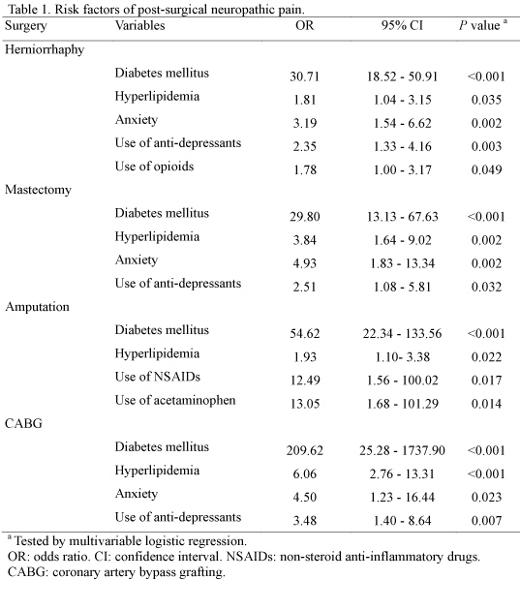
Recent Publications (minimum 5)

1. Sandblom G (2015). Is chronic post-herniorrhaphy pain always chronic? A literature review. J Pain Res 8: 241-5.

2. Humble SR, Dalton AJ, Li L (2015). A systematic review of therapeutic interventions to reduce acute and chronic post-surgical painafter amputation, thoracotomy or mastectomy.
Eur J Pain 19: 451-65.

3. Baron R (2009). Neuropathic pain: a clinical perspective.
Handb Exp Pharmacol. 194: 3-30.

Biography (150 word limit)
Pei-Shan Tsai, a distinguished professor at Taipei Medical University College of Nursing in Taiwan, focuses her research on the link between stress‐response systems and chronic illnesses and outcomes of care of patients with stress‐related illnesses. Tsai’s expertise includes using both physiological and behavioral measures in research for understanding the mechanisms and efficacy of interventions. She also plays a vital role in demonstrating important health factors, disease prevalence, and health care effectiveness in the general population in Taiwan through secondary analysis of health data. Tsai is a collaborator noted for bringing researchers from different fields together to collaborate on research projects that have important clinical and policymaking implications. To date, she has published more than 150 peer-reviewed articles in medical, psychology, and nursing journals, many of which have received a high number of citations from journal articles.
Email: ptsai@tmu.edu.tw
Presenting Author Details
Full name: Pei-Shan Tsai
Date of Birth: July 20, 1964
Email id: ptsai
Contact No.: +886 2 27338813
Current Affiliation: Taipei Medical University
Session name/ number:
Category: Poster

