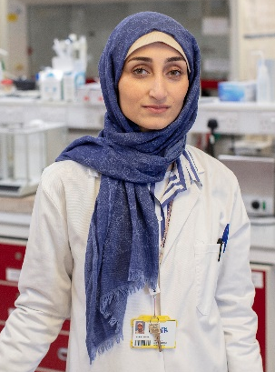

Title: The effect of nutrient-extraction blender preparation of raspberries on postprandial glucose response in adults

Name: Rabab Alkutbe
University of Plymouth, PL4 8AA , UK

Increasing fruit consumption may reduce the risk of several chronic diseases. The nutrient extraction blender is a new method to consume fruit; however, health risks remain unclear. Nutrient-extraction blenders are designed to homogenize the whole fruit without removing the fibre; conversely, old-style juicers squeeze the juice and remove the pulp. This study aimed to understand the effect of nutrient-extraction of raspberries on the glycaemic response in healthy weight adults and overweight/obese, who are at risk of glucose intolerance.
A total of 9 HW and 5 OW/OB adults were recruited to participate. Participants fasted for 12 h overnight and then consumed raspberries with mango as whole fruit (WF), nutrient-extracted (NE) or a glucose control (C) (all 25g total sugar/ serving). Blood glucose levels were obtained via finger prick blood samples with a minimum 3-day washout period between test days. Glycaemic index was calculated from the incremental area under the 2-h glucose response curve for each meal. Multiple comparisons post-hoc (Tukey HSD) were conducted to determine the difference between meals.
GI was significantly different between all conditions with mean ±SD (C, 100 ±37.07), (WF, 72.07 ± 28.54), (NE, 43.31 ±23.57), (p<0.001), but there were no differences between healthy weight and overweight / obese. The postprandial glucose response from NE raspberries was significantly lower than both WF and C. Whereas, other published findings demonstrated that the consumption of nutrient-extracted mango alone was not significantly different from the whole mango.
These results show that homogenized raspberries could be a potential approach for glycaemic control.
Biography

Dr Rabab Alkutbe is a researcher working with Dr Gail Rees at the University of Plymouth. Rabab received her bachelor degree in Nutrition food sciences in Saudi Arabia and then matriculated at Flinders University in Australia where she conducted her Masters study in public health in 2010. Rabab's graduate work focused on nutrition stream, food policy and determinants of health and wellbeing. She was awarded her PhD in 2017 from University of Plymouth, her thesis investigated obesity and its causes in children. Currently, she examines the effect of nutrient-extractior on postprandial glucose when consume different fruits in obese adults.

Presenting author details
Full name: Rabab Bade Alkutbe
Contact number: 07826325401
Twitter account: @RAlkutbe
Linked In account: Rabab Alkutbe
Session name/ number: Diabetes and Nutrition
Category: (Poster presentation)

