Diabetes and Zika: A complicated Partnership.
Karina Gonzalez Carta, MD, Mayo Clinic, USA

Statement of the Problem. Zika and diabetes have reached epidemic dimensions and pose a joint threat to a large population. There is only one report of Heart Failure (HF) and arrhythmias associated with Zika and none of the effect of diabetes on the presentation of Zika.
Objective: This study sought to describe severe cardiovascular complications of Zika in patients with diabetes.
Methods: We enrolled 5 diabetes patients that developed severe acute myocarditis within 10 days of disease onset in a prospective observational multicenter study. Clinical and laboratory evaluation including Zika confirmation, ECG, Holter, echocardiogram, coronary angiography (2 cases), and cMRI were performed.
Results: Of the 5 patients 60% (3) were males with a mean age of 61 ± 7. New arrhythmias were detected in all the cases including atrial fibrillation in 2 cases, non-sustained ventricular tachycardia in 2 patients, and atrial tachycardia in 2 cases. One patient died suddenly four days after the onset of the disease. Acute HF with low ejection fraction was present in 2 cases.
Conclusion and significance: This study suggests that the presence of diabetes and Zika warrant closer observation to reduce the risk for a severe clinical presentation of Zika

51 year-old male patient with papular-macular pruriginous rash, Acute Atrial Fibrillation and cMRI suggestive of Myocarditis.
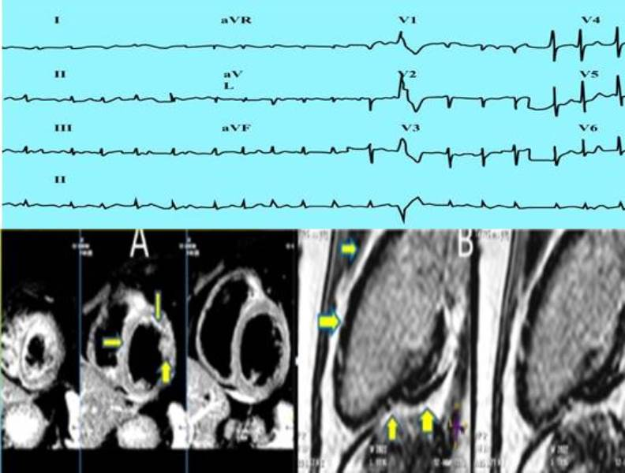
Recent Publications (minimum 5)
- Carta, K.A.G., et al., Zika Myocarditis, Risk Factors, Prior Arbovirus Infection Brings Out the Worst. 2017, Am Heart Assoc.
- Carta, K.A.G., et al., Myocarditis, heart failure and arrhythmias in patients with Zika. Journal of the American College of Cardiology, 2017. 69(11 Supplement): p. 906..
- Deng, Y., et al., [Experience of integrated traditional Chinese and Western medicine in first case of imported Zika virus disease in China]. Zhonghua Wei Zhong Bing Ji Jiu Yi Xue, 2016. 28(2): p. 106-9.
- Juan A Marques, I.M., Karina Gonzalez Carta, Igor Morr, Yolimar Meza, Vicente Finizola Flores, Ivan J Mendoza-Britto, Nahir Martinez, ZIKA AND HEART FAILURE: PRIOR DENGUE MAY BRING OUT THE WORST. Journal of the American College of Cardiology, 2018. 71(11): p. 1.
- Nielsen, K.K and I.C. Bygbjerg, Zika virus and hyperglycaemia in pregnancy. Lancet, 2016. 387(10030): p. 1812
- Wiwanitkit, S. and V. Wiwanitkit, Zika virus infection, blood glucose, and diabetes mellitus. Annals of Tropical Medicine and Public Health, 2017. 10(2): p. 484-485.


Dr. Karina Gonzalez Carta is an Internal Medicine and Cardiologist specialist from Venezuela. Dr. Gonzalez Carta holds an appointment as a Researcher at Mayo Clinic she is engaged in a variety of research efforts, including tropical infectious diseases affecting the cardiovascular system such as Dengue, Chikungunya, and Zika. Dr. Gonzalez Carta utilizes clinical and other databases in her ongoing research.
Email: carta.karina@mayo.edu

Notes/Comments:

