miRNA analysis in insulin resistant and T2D patients in Qatari population
Khaoula Errafii^{1,2}, Said Boujraf¹, Mohamed AbdulGhani³, Mohamed Chikri ^{1,2}
¹ University Sidi Mohamed Ben Abdallah USMBA, Fes, Morocco
² College of health and life sciences, Hamad Bin Khalifa University, Qatar Foundation, Doha, Qatar.
³ University of Texas Health Science Center at San Antonio, San Antonio, TX

*Corresponding author: Mohamed.chikri@usmba.ac.ma
Faculty of medicine and Pharmacy
University of Sidi Mohamed Ben Abdallah
Fes, Morocco

Background and Objective
Insulin resistance (IR) is type 2 diabetes (T2DM) hallmark. MiRNAs regulate many target genes which makes them attractive candidates for regulating insulin production,secretion and action. Thus, if miRNAs play a role in the pathogenesis of IR, we anticipate a change in the circulatory profile of miRNAs in IR subjects compared to normal glucose tolerance subjects. In the present study, we sought to identify the circulating miRNAs associated with IR as biomarkers in Qatari population. The circulating miRNA profile was assessed in a pilot study of healthy volunteers (n=22) whose insulin sensitivity was quantitated by euglycemic hyperinsulemic clamp. Moreover, in the validation phase (n=40) subjects were added including lean and obese T2D.
Methods
Insulin resistance was assessed using Euglyecemic clamp. miRNA transcriptomic profiling was performed for the insulin resistance individuals and healthy controls in the first phase of the study, and qPCR was performed in in the same group to confirm the NGS results, in addition to T2D lean group and T2D obese Group.
Results
MiR-186 showed a consistent significant increase in insulin resistance subjects compared to NGT in the discovery and validation phase analysis. In addition, intergroup comparison of circulating miRNA pinpointed 2 miRNAs: miR-122 increased substantially in obese T2D subjects, with diagnostic value to predict obesity in T2D subjects, and let-7b increased significantly in lean T2D subjects. Our results suggest that circulating miRNAs serve as biomarkers for IR, T2D and obesity in Qatari population. Further functional studies are warranted to better identify the targets of these miRNAs and understand the underlying molecular and cellular mechanisms.
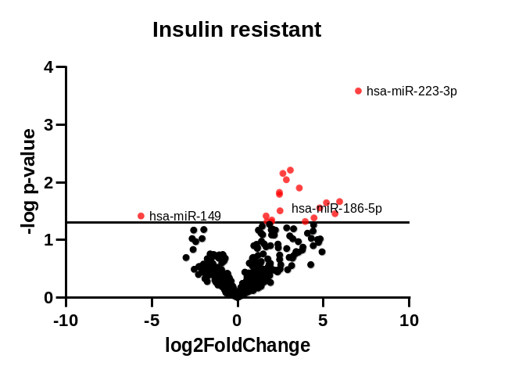
Figure 1. Differentially expressed miRNAs in insulin resistant group
Conclusion
In conclusion, our study describe the differentially expressed miRNAs between different groups: INR, T2D lean, and T2D obese. Studying the DEMs will advance our understanding of insulin resistance development mechanisms and provide an insight of how we can target certain molecules to reverse IR conditions. Further studies are required to validate our results.

References

Disclosures and acknowledgements:
The authors declare that there is no conflict of interest
Keywords: IR, microRNAs, transcriptomics profiling, type 2 Diabetes, obesity

