Using Math-Physical Medicine to Study the Probability of Having a Heart Attack or Stroke Based on Metabolism Index (MI)
Gerald C. Hsu, eclaireMD Foundation, USA

Abstract (300 word limit)

Background and Aim:
The author has extended his 8-year T2D research along with ~1.5 M collected data to examine the relationship among metabolism index (MI), general health status unit (GHSU: a 90-days moving average of MI), and the probability of having a heart attack or stroke.

Material and Method:
In 2014, he researched and built models for MI and GHSU to understand and measure the multiple interactions between four metabolic disease outputs and six lifestyle inputs.

He omitted genetic influences, personal habits, and past health conditions in order to focus on the dynamic changes of these 10 input and output categories with a total of ~500 elements. He utilized >1M data within the past 2,274 days to compute the probability of having a heart attack or stroke. He also conducted research work based on medical conditions output and lifestyle input separately. However, in this study, he performed an integrated input/output research. He used 80% of integrated results to compare with other two results objectively.

Results:
Comparing the results from a period between 2012 to 2018, the probability values are:

From 74% (2012) with a decrease to 33% (2018), with an average of 52%
(Normalization Range: 0% - 100%)

Conclusion:
The mathematical simulation results are validated by past health examination reports. This big data dynamic simulation approach using math-physical medicine will provide an early warning to patients with chronic disease of having a heart attack or stroke in the future.

Image

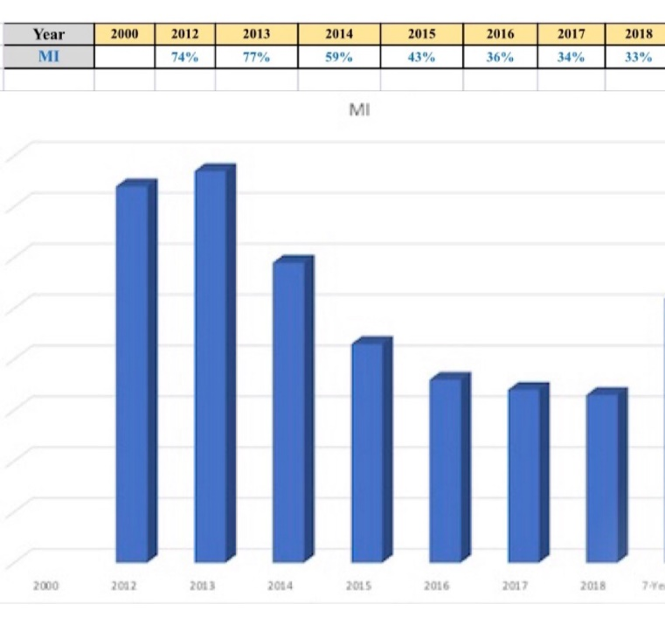

 Biography (150 word limit)
The author received an honorable PhD in mathematics and majored in engineering at MIT. He attended different universities over 17 years and studied seven academic disciplines. He has spent 20,000 hours in T2D research. First, he studied six metabolic diseases and food nutrition during 2010-2013, then conducted research during 2014-2018. His approach is “math-physics and quantitative medicine” based on mathematics, physics, engineering modeling, signal processing, computer science, big data analytics, statistics, machine learning, and AI. His main focus is on preventive medicine using prediction tools. He believes that the better the prediction, the more control you have.
Email: g.hsu@eclaireMD.com

Notes/Comments:

