Using Math-Physical Medicine to Study the Probability of Having a Heart Attack or Stroke Based on Lifestyle Management
Gerald C. Hsu, eclaireMD Foundation, USA

Abstract (300 word limit)

Background and Aim:
The author has extended his 8-year T2D research to focus on the relationship between lifestyle for managing metabolic diseases and the probability of having a heart attack or stroke.

Material and Method:
He has developed several big data numerical simulation models using ~1.5M data. Initially, he chose age, gender, race, family history, smoking, drinking, drug abuse, medical health conditions, and weight/waistline to establish a static baseline. He then developed a mathematical simulation model to combine all key elements of lifestyle management, including food, exercise, stress, sleep, water intake, life routine to conduct his dynamic computations. He utilized 295,620 data of these six categories within the past 2,274 days to compute the probability of having a heart attack or stroke in the near future. Finally, he conducted sensitivity analyses to cover the probability variance using different weighting factors (WF).

Results:
Comparing the results from the worst year, 2000, to the health-improving period of 2012-2018, the probability values are:

2000 with BMI 31: 83%
(Three episodes of chest pain during 2001-2006)
2012 with BMI 29: 70%
2018 with BMI 25: 33%
(Normalization Range: 0% - 100%)

In summary, within eight years, he has an average of 34% probability with +/- 18% variance of WF sensitivity.

Conclusion:

The mathematical simulation results are validated by past health examination reports. This big data dynamic simulation approach using math-physical medicine will provide an early warning to patients with chronic disease of having a heart attack or stroke in the future.

Image
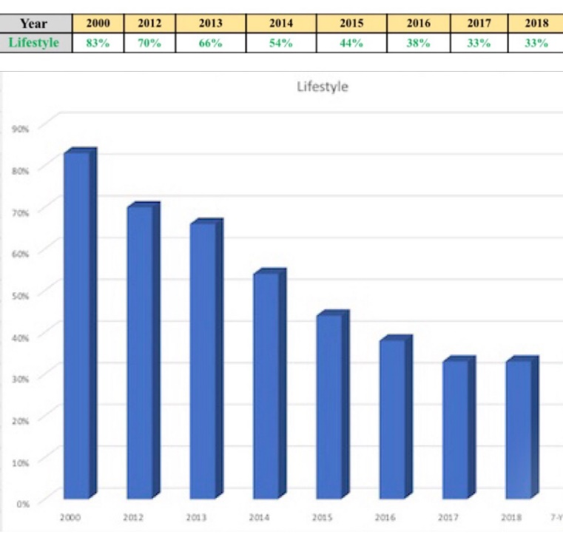

 Biography (150 word limit)
Gerald C. Hsu received an honorable PhD in mathematics and majored in engineering at MIT. He attended different universities over 17 years and studied seven academic disciplines. He has spent 20,000 hours in T2D research. First, he studied six metabolic diseases and food nutrition during 2010-2013, then conducted research during 2014-2018. His approach is “math-physics and quantitative medicine” based on mathematics, physics, engineering modeling, signal processing, computer science, big data analytics, statistics, machine learning, and AI. His main focus is on preventive medicine using prediction tools. He believes that the better the prediction, the more control you have.
Email: g.hsu@eclaireMD.com

Notes/Comments:

