IVGTT IN DIAGNOSING OF GLUCOSE KINETICS DIS-BALANCE IN
DIABETIC PATIENTS

Dreval A.V.
Methodology & Theoretical Orientation: Mathematical method (one compartment model of glucose kinetics) for the analysis of Intravenous Glucose Tolerance Test (IVGTT) data is proposed that simultaneously estimates the rate of glucose disappearance from the blood (the k-value) and index of hepatic glucose production (HGP) during the test.
Findings: This method was used for IVGTT data analysis from 107 subjects – 27 diagnosed with DM2, 13 DM1, and 67 healthy volunteers. Based on application of the model to IVGTT data, two discriminant functions were obtained: distinguishing DM2 from non-diabetic subjects and distinguishing DM1 from DM2 subjects. The 9% of non-diabetic subjects with high HGP estimates also had high k-parameter estimates. This is a pathological condition called “impaired glucose balance” (IGB) and could be considered as the earliest, pre-impaired glucose tolerance (pre-IGT) and pre-impaired fasting glucose (pre-IFG) stage of DM2. One can distinguish 4 variants of glucose disbalance in overt diabetics depending on the k and H parameter values. It is apparent that seven subtypes of overt DM can be distinguished when one considers a combination of 4 types of glucose disbalance and two types of DM (Fig.1).
Conclusion & Significance: It is theorized that various subtypes may be expected to respond in different manner to different types of therapeutic interventions. In the oral presentation will be discussed diabetes diagnosing failure in IVGTT and overcome it in our modified method. This method can be useful for in choosing particular diabetic drug, that modify hepatic glucose production in diabetic patients.
Recent publicatuins
- Dreval A.V., Ametov A. Impaired glucose balance and subtypes of diabetes mellitus revealed in glucose tolerance test. Diabetes Research and Clinical Practice, 78S, (2007), S68-S75
- Panunzi S., Palumbo P., A. De Gaetano. A discrete Single Delay Model for the Intra-Venous Glucose Tolerance Test. Theoretical Biology and Medical Modelling 2007, 4:35
- Hahn R.G., Ljunggren S., Larsen F., Nyström T. A simple intravenous glucose tolerance test for assessment of insulin sensitivity. Theor Biol Med Model. 2011; 8: 12.
- Greenbaum C.J., Buckingham B., HP Chase H.P., Krischer J. Metabolic Tests to Determine Risk for Type 1 Diabetes in Clinical Trials. Diabetes Metab Res Rev. 2011 Sep; 27(6): 584–589.
- Mari A, Tura A, Pacini G, Kautzky-Willer A, Ferrannini E. Relationships between insulin secretion after intravenous and oral glucose administration in subjects with glucose tolerance ranging from normal to overt diabetes. Diabet Med. 2008 Jun;25(6):671-7

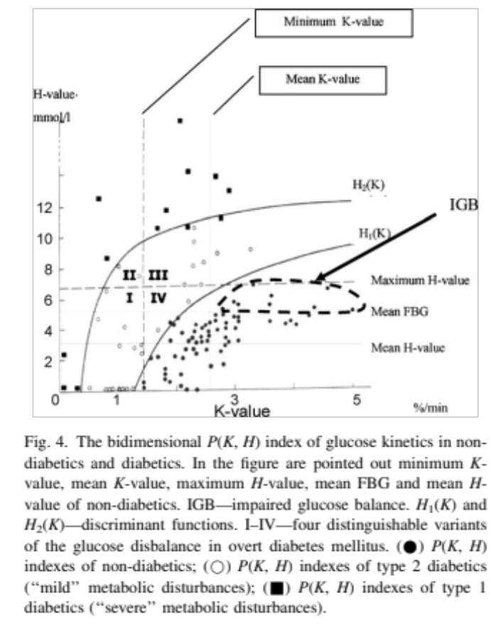

Prof.A.V.Dreval's main areas of research include: optimization of treatment and diagnostic methods for diabetes and its complications, mathematical modeling of endocrinous systems. Having received the qualification of a mathematician at M.V.Lomonosov MSU, since 1980 A.V.Dreval has been active in the field of mathematical modeling of insulin therapy of diabetes. He developed a number of genuine diabetes models revealing the key role of the liver in the development of some forms of diabetes. Using a mathematical approach, he suggested a unique method of analyzing the results of intravenous glucose tolerance tests, which provides for determining production of glucose in liver under normal conditions and with diabetes mellitus. These unique data allowed establishing a special category of patients, in which the leading mechanism for development of diabetes is overproduction of glucose in the liver.

