Adult Muscle-derived stem cells engraft and differentiate into insulin-expressing cells in pancreatic islets of diabetic mice relieving hyperglycemia.
Ned Lamb Ph.D. IGH, CNRS-UM 9002, France
Wendy Yeo Ph.D. IGH, CNRS-UM 9002, France
Anne Fernandez Ph.D. IGH, CNRS-UM 9002, France

Abstract (300 word limit)
Statement of the Problem: Pancreatic beta cells are unique effectors in the control of glucose homeostasis and their deficiency results in impaired insulin production leading to severe diabetic diseases. Here, we investigated the potential of a population of non-adherent Muscle-Derived Stem Cells (MDSC) from adult mouse or human muscle to differentiate in vitro into beta cells and when transplanted in vivo, as undifferentiated stem cells, differentiate in vivo and compensate for beta cell deficiency. Methodology & Theoretical Orientation: In vitro, MDSC were isolated on the basis of their poor adherence by serial preplating for 8 days. MDSC cultured for several weeks, spontaneously differentiated into insulin-expressing islet-like cell clusters as revealed using MDSC from transgenic mice expressing GFP or mCherry under the control of an insulin promoter. Differentiated clusters of beta-like cells co-expressed insulin with the transcription factors Pdx1, Nkx2.2, Nkx6.1 and MafA, and secreted significant levels of insulin in response to glucose challenges. In vivo, undifferentiated MDSC injected intraperitoneal into streptozotocin (STZ)-treated mice, engrafted within 48h specifically into damaged pancreatic islets and are shown to differentiate and express insulin 2-12 days after injection. In addition injection of MDSC to hyperglycemic diabetic STZ treated mice reduced their blood glucose levels for 2 to 10 weeks. Conclusion & Significance: These data show that muscle stem cells, MDSC, are capable of differentiating into mature pancreatic beta islet-like cells not only upon culture in vitro but also in vivo after systemic injection in STZ-induced diabetic mouse models. Being non teratogenic, MDSC can be used directly by systemic injection and this potential reveals a promising alternative avenue in stem cell-based treatment of beta cell deficiencies
.Image
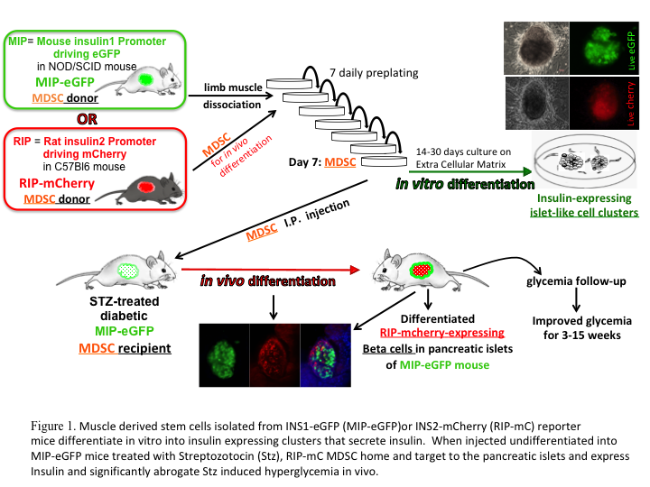
Recent Publications (minimum 5)
- Pietro Mesirca, et al. (2018) Bradycardic mice undergo effective heart rate improvement after specific homing to the sino-atrial node and differentiation of adult muscle derived stem cells. bioRxiv 203075;
- Mitutsova et al., (2017) Adult Muscle-derived stem cells engraft and differentiate into insulin-expressing cells in pancreatic islets of diabetic mice. Stem Cell Research and Therapy, 8:86
- Villalpando S, et al. (2016) Type II PKAs are anchored to mature insulin secretory granules in INS-1 β-cells and required for cAMP-dependent potentiation of exocytosis. Biochimie. 125:32-41
- Heron-Milhavet L, et al. (2013) Characterization of the Akt2 domain essential for binding nuclear p21cip1 to promote cell cycle arrest during myogenic differentiation. PLoS One. 8(10):e76987
- Heron-Milhavet L, Khouya N, Fernandez A, Lamb NJ. (2011). Akt1 and Akt2: differentiating the aktion. Histol Histopathol. 26:651-62.

Biography (150 word limit)
Ned Lamb has made his career in mammalian cell biology and molecular signaling in the insulin cascade. Recently with collaborator Anne Fernandez, he has turned his attention to studying a population of non-teratogenic multipotent stem cells niched in skeletal muscle. MDSC differentiate into several lineages in vitro including sino-atrial node pacemaker cells, neurons, myotubes and insulin secreting islet like clusters. Unlike induced pluripotent and embryonic stem cells, MDSC do not require pre-differentiation before use in vivo and home, differentiate and repair a broad range of tissue damage and lesions in the heart, muscles and pancreas. MDSC exist in human muscle and the completely non-teratogenic nature of MDSC and spontaneous capacity to home to damaged tissues imply that MDSC may be strong candidates for future cell therapies.
Email: ned.lamb@acrux.igh.cnrs.fr

Notes/Comments:

