Age and diabetes control in an HIV-endemic country: is there an association?
RR Chettyª and S Pillay^{b}
ªPhoenix Community Health Center, Durban, South Africa
^{b}Department of Internal Medicine, King Edward VIII Hospital, Durban, South Africa

Abstract

Background: The prevalence of diabetes mellitus (DM) in South Africa (SA) is 12.80% and is rising, while that of HIV infection remains the highest globally (13%). Literature varies on the associations between glycaemic control and age in patients living with DM (PLWD). Through effective anti-retroviral treatment (ART), HIV-infected patients can now live longer and develop co-morbidities as experienced by HIV-uninfected patients. Identification of challenges faced in diabetes control within the various age groups would help in developing strategies that can be implemented in order to provide effective diabetes care to patients as they age. Objectives: This study aimed to determine an association between age and diabetes control in an HIV endemic area. Methods: Data from standardised clinic sheets were used from the DM clinic at Edendale Hospital, Pietermaritzburg, South Africa, from January 1, 2019 to December 31, 2019. Statistical analysis was done. Results: This study had 957 PLWD with 146 PLWD who were HIV-infected (PLWDH). Older age was associated with improved mean glycated haemoglobin (HbA1c) levels after adjusting for glomerular filtration rate (GFR) (r = −0.141, p < 0.001; before adjustment: r = −0.108; p = 0.001). HIV-infected patients had lower mean HbA1c levels than their HIV-uninfected counterparts while age was positively associated with patients’ BMI (r = 0.246, p < 0.001). PLWDH with a mean HbA1c > 7% were significantly younger than those with HbA1c ≤ 7% (47.38 years vs. 52.77 years, p = 0.013). GFR declined with age: PLWD with GFR < 60 ml/minute were significantly older than those with GFR ≥ 60 ml/minute (62.72 years vs. 48.30 years, p < 0.001), this remaining significant after factoring in for HIV infection and hypertension. Conclusion: Younger PLWD have poorer glycaemic control and are likely to develop diabetes-related complications later in life. Notably, younger PLWDH also had poorer glycaemic control, which places them at increased cardio-metabolic risk from sequelae of both the HIV infection and DM. This study highlights that more emphasis needs to be placed on diabetes education and management in the younger age categories of both PLWD and PLWDH.
Image
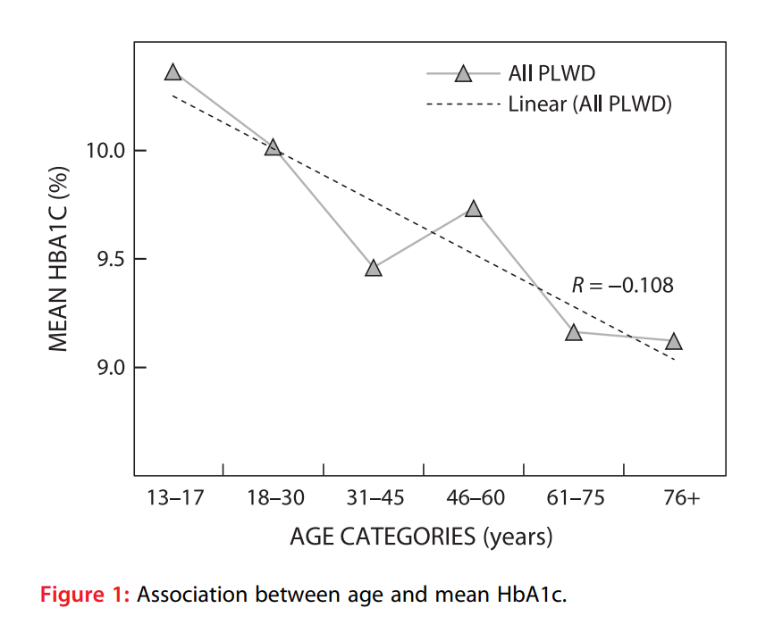
Recent Publications

- Quah JHM, Liu PY, Luo N, et al. Younger adult type 2 diabetic patients have poorer glycaemic control: a cross-sectional study in a primary care setting in Singapore. BMC Endocr Disord. 2013;13:18. Available from: http://www.biomedcentral.com/1472- 6823/13/18.
- Unnikrishnan R, Anjana RM, Deepa M, et al. Glycemic control among individuals with self-reported diabetes in India–the ICMR-INDIAB Study. Diabetes Technol Ther. 2014;16(9):596–603. https://doi.org/ 10.1089/dia.2014.0018.
- Khoza SP, Crowther NJ, Bhana S. The effect of HIV infection on glycaemia and renal function in type 2 diabetic patients. PLoS ONE. 2018;13 (6):e0199946. https://doi.org/10.1371/journal.pone.0199946.
- Kirkman MS, Briscoe VJ, Clark N, et al. Diabetes in older adults. Diabetes Care. 2012;35(12):2650–64.
- Chetty RR, Pillay S. The relationship between age and glycaemic control in patients living with diabetes mellitus in the context of HIV infection: a scoping review. JEMDSA. 2021;22:1–7. https://doi. org/10.1080/16089677.2021.1945767.


Biography
Rushern Chetty is a junior South African doctor. He has just completed his internship and is currently completing his community service at Phoenix Community Health Centre, Durban, South Africa. During his internship, he has been working closely with his mentor (Professor S. Pillay) to conduct research on Diabetes Mellitus (DM). Currently, he has published four articles on DM and aims to become a physician in the foreseeable future.

Email: rushern.r.chetty@gmail.com

