Machine Learning-based Hemorrhages Detection using Fundus Photography for the Classification of Diabetic Retinopathy
Tamoor Aziz, Ph.D. Scholar, Sirindhorn International Institute of Technology, Thammasat University, Thailand
Chalie Charoenlarpnopparut, Ph.D., Sirindhorn International Institute of Technology, Thammasat University, Thailand

Abstract
Diabetic retinopathy is retina-related pathology that causes vision loss. Repercussions of diabetic retinopathy can be prevented if the proper medication is adopted at the early phase of progression. Hemorrhage is one of the characteristics of DR that emerge at its early stage. The objective of this research is to develop an automated algorithm for hemorrhage detection. The proposed method comprises three stages. First, the image is preprocessed to improve the appearances of retinal structures, whereas the brightness levels of fundus images are corrected adaptively by a gradient-based adaptive gamma correction. In the second stage of the proposed work, the prospective hemorrhage candidates are identified. Hemorrhages are characterized as low-intensity structures surrounded by bright regions. This property leads to the design of a Gaussian based-matched filter to enhance the low retina structures. Entropy-based thresholding is employed to eliminate the low responses of the matched filter. The hemorrhages that are associated with blood vessels are isolated using morphological operation. Novel smart window-based adaptive thresholding is used to segment the hemorrhages. Lastly, the connected component, color, texture, and hand-crafted features are extracted from each candidate. The support vector machine is trained with the descriptors to discriminate hemorrhages from non-hemorrhage candidates. The classifier is tested, and hemorrhage candidates are segmented using a window-based segmentation. The method has experimented on DIARETDB1 and DIARETDB0 image datasets. The outcomes show the effectiveness of the propounded segmentation and are compared with state-of-the-art techniques. Precision, recall, and F1 score parameters are used to evaluate the performance of the algorithm. The proposed method achieves a high F1 score with 83.85% and 72.25% on the DIARETDB1 and the DIARETDB0, respectively.

Image
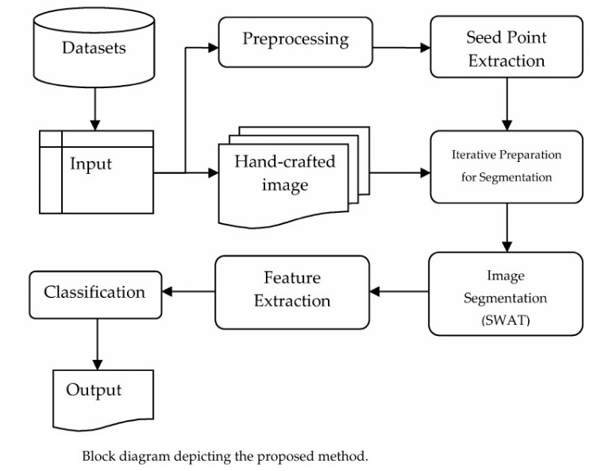
Recent Publications
- Aziz, T., Ilesanmi, A. E., & Charoenlarpnopparut, C. (2021). Efficient and Accurate Hemorrhages Detection in Retinal Fundus Images Using Smart Window Features. Applied Sciences, 11(14), 6391.



Biography
Tamoor Aziz is a Ph.D. scholar at Sirindhorn International Institute of Technology, Thammasat University Thailand. His research area includes object detection, fuzzy logic, feature extraction, segmentation, and classification using machine and deep learning. His recent publication aims at the early detection of hemorrhages in retinal fundus images for diabetic retinopathy analysis. His method is based on machine learning where the classifier is trained by the various categories of computed descriptors. The color, texture, and connected component properties of the hemorrhages are considered to extract features. The hallmark of his research is the novel segmentation technique that is capable to identify the hemorrhages associated with blood vessels. To deal with economic, social, and resource problems, his algorithm can assist in the field of medicine and may act as a second interpreter.
Email: tamoor.azi@dome.tu.ac.th

Notes/Comments:

