The Benefits of Using the I-Port System on Insulin-Dependent Patients
Amal M. Khan, MBBS¹;Khaled A. Alswat, MBBS, CCD, FACP, FACE²
¹Medical Intern,Taif University School of Medicine, Taif, Saudi Arabia
²Dean of Graduate Studies and Associate Professor of Medicine, Consultant Physician of Internal Medicine, Diabetes and Endocrinology in Taif University, Saudi Arabia.

Abstract
Background: Patients with insulin-dependent diabetes mellitus (IDDM) show low adherence to insulin injections, which results in poor glycemic control. The i-Port Advance is a new advanced injection method. Our aim is to evaluate patient satisfaction, glycemic control, and adherence while using this device.
Methodology: This prospective study examined IDDM patients. Baseline characteristics and Diabetes Treatment Satisfaction Questionnaire status (DTSQs) were collected at baseline and at the end of the follow up. All patients were trained to use the i-Port. We divided them into two groups: regular users of the i-Port who used it for >3 months, and irregular users who used it for <3 months. The local complications during use of the i-Port were recorded.
Result: Of the total of 55 patients, 92.7% had type I diabetes, the mean age was 14.96+8.95, 92.7% were used an insulin pen. The patients were divided into 27 regular users and 28 irregular users. Irregular users had a longer duration of DM (p=0.901) at baseline and compared to the regular users, and they were less likely to report non-compliance with insulin usage (p=0.338), more likely to self-inject insulin (p=0.038), and had lower HbA1c (p=0.056). There was no statistical difference in the mean DTSQs score or the mean glycemic control score between groups. At the end of the follow up, the regular i- Port usage improved compliance with insulin usage (p=0.028), reduced diabetes-related hospitalization (p <0.001), and reduced the frequency of hypoglycemia (p=0.184). Scarring at the i-Port site was the most common complication.
Conclusion: Regular i-Port usage improved compliance and decreased hospitalization and hypoglycemic episodes with a non-significant 0.73% reduction in HbA1c.
Image And Tables
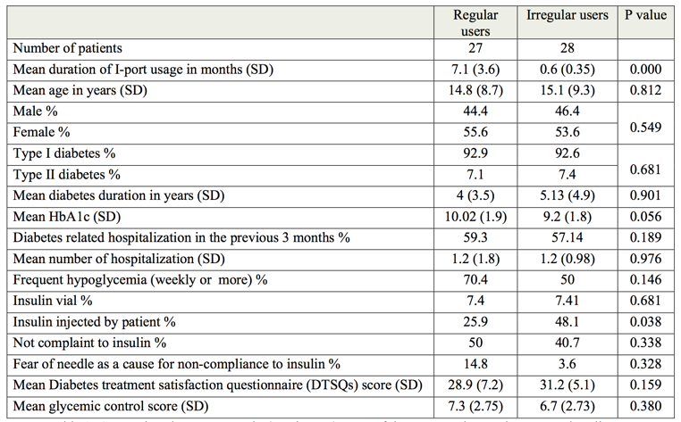
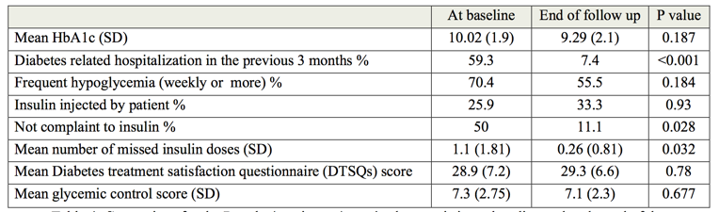
Comparison for the Regular(continuous) user’s characteristics at baseline and at the end of the follow up.
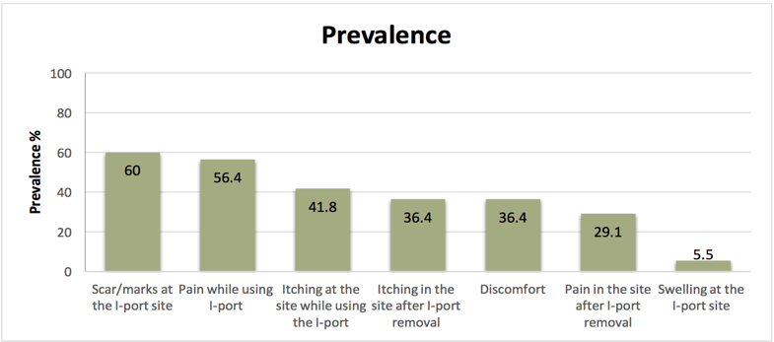Reported prevalence of local complications during and after I-port use.
Recent Publications (minimum 5)
- Control CfD, Prevention. Age-adjusted percentage of adults with diabetes using diabetes medication, by type of medication, United States, 1997–2011. 2015.
- Farsaei S, Radfar M, Heydari Z, Abbasi F, Qorbani M. Insulin adherence in patients with diabetes: Risk factors for injection omission. Primary care diabetes. 2014;8(4):338-45.
- Beckerle, Carla Moore, and Mary Ann Lavin. "Association of self-efficacy and self-care with glycemic control in diabetes." Diabetes Spectrum 26.3 (2013): 172-178.
- Randall, Lori, et al. "Recurrent Diabetic Ketoacidosis in Inner-City Minority Patients Behavioral, socioeconomic, and psychosocial factors." Diabetes Care 34.9 (2011): 1891-1896.
- Fu AZ, Qiu Y, Radican L. Impact of fear of insulin or fear of injection on treatment outcomes of patients with diabetes. Current medical research and opinion. 2009;25(6):1413-20.
- Rubin RR, Peyrot M, Kruger DF, Travis LB. Barriers to Insulin Injection Therapy Patient and Health Care Provider Perspectives. The Diabetes Educator. 2009;35(6):1014-22.
- Fu AZ, Qiu Y, Radican L. Impact of fear of insulin or fear of injection on treatment outcomes of patients with diabetes. Current medical research and opinion. 2009;25(6):1413-20.
Comparison between Regular(continuous) users of the I-port and Irregular users at baseline.

Biography
Amal Khan has completed her Bachelor of Medicine Bachelor of Surgery (M.B,B.S) at College of Medicine, Taif university, Taif, KSA. An amateur writer, enthusiastic, patient and hard worker Medical Intern. She adores the scientific research and she will contentioue the education in Family Medicin Residency program. She was a speaker at local and international conferences and was Best Young Researchers’ for oral presentation at the 14th International Conference and Exhibition on Targeting Diabetes and Novel Therapeutic, Malaysia. Dr.Khan published a lot of researches in a field of Diabetes. She attended and participate at a lot of conference and workshop in Endocrinology and medical field.
Email: dr.amal-khan@msn.com

Notes/Comments:

