

Mekelle University
College of Health Sciences
Evaluation of Antidiabetic Activity of Myrica salicifolia (Hochst. ex A. Rich.) Root Extract in Streptozotocin-Induced Diabetic Mice
A
Thesis Proposal
Submitted as a Partial Fulfillment for Degree of
Master of Science
In
Pharmacognosy
To
Department of Pharmacy, Pharmacognosy Course and Research Unit

Submitted By:
Yohannes Kelifa/B.Pharm/

Dec,2016
Mekelle, Ethiopia

Mekelle University
College of Health Sciences
Evaluation of In Vivo Antidiabetic Activity of Myrica salicifolia (Hochst. ex A. Rich.) Root Extract in Streptozotocin-Induced Diabetic Mice
A
Thesis Proposal
Submitted as a Partial Fulfillment for Degree of
Master of Science
In
Pharmacognosy
To
Department of Pharmacy, Pharmacognosy Course and Research Unit

Advisor: Submitted By:
Dr. P. Gomathi (PhD, Assistant professor) Yohannes Kelifa/B.Pharm/
Dr. Aman Karim (PhD, Assistant professor)

Dec, 2016
Mekelle, Ethiopia

Acknowledgement
First and above all, I praise God, the almighty for providing me this opportunity and granting me the capability to proceed successfully. I would like to offer my sincere thanks for those who were supported me during the development of this proposal.

Table of contents
Acknowledgement I
List of figures V
Abbreviations/acronyms VI
Summary VII
1 Introduction 1
1.1 Background 1
1.1.1 Diabetic mellitus 1
1.2 Epidemiology of diabetes 2
1.3 Classification and pathogenesis of DM 2
1.3.1 Type 1 diabetic mellitus (T1DM) 2
1.3.1.1 Pathogenesis of T1D 3
1.3.2 Type 2 DM (T2DM) 3
1.3.2.1 Pathogenesis of T2D 4
1.3.3 Gestational DM (GDM) 4
1.3.3.1 Pathogenesis of gestational diabetes 5
1.4 Statement of the problem 5
1.5 Rational and significance of the study 6
1.6 Management of DM 8
1.7 Herbal medicines for treatment of diabetes 9
1.8 Herbal formulations in market and plants in clinical trial for treatment of diabetes 14
1.9 The family Myricaceae 16
1.10 The genus Myrica 16
1.10.1 Ethnobotanical uses 16
1.10.2 Pharmacological activity of genus Myrica 17
1.10.2.1 Anti-inflammatory and analgesic activity 17
1.10.2.2 Antihypertensive activity 17
1.10.2.3 Antioxidant activity 18
1.10.2.4 Antimicrobial activity 18
1.10.2.5 Antiasthmatic activity 18
1.10.2.6 Anti-allergic activity 18
1.10.2.7 Anthelmintic activity 18
1.10.2.8 Hepatoprotective activity 19
1.10.2.9 Antidiabetic activity 19
1.10.3 Phytochemicals isolated from genus myrica 19
1.10.3.1 Flavonoid 19
1.10.3.2 Tannins 22
1.10.3.3 Diarylheptanoids 22
1.10.3.4 Terpenes 23
1.10.3.5 Lignans 25
1.11 Myrica salicifolia (Hochst. ex A. Rich.) 26
1.11.1 Description 26
1.11.2 Ethnobotanical uses 26
1.11.3 Pharmacological activities 27
1.11.3.1 Antibacterial activities 27
1.11.3.2 Analgesic activity 27
2 Objectives 28
2.1 General objective 28
2.2 Specific objectives 28
3 Materials and Methods 29
3.1 Instruments, chemicals and reagents 29
3.2 Collections, identification, and preparation of plant materials 29
3.3 Experimental animals 29
3.4 Extraction 30
3.5 Solvent fractionation 30
3.6 Chromatographic techniques 30
3.7 Acute toxicity test 30
3.8 Preliminary phytochemical screening 31
3.9 Induction of experimental diabetes 31
3.10 Experimental protocol 31
3.10.1 Evaluation of antihyperglycemic activity of crude extracts 31
3.10.2 Investigation of antidiabetic activity of different solvent fractions 32
3.10.3 Examination of antihyperglycemic potential of isolated active compounds 32
3.11 Collection of blood samples and glucose determination 32
3.12 Statistical analysis 32
4 Work Plane 33
5 Budget 34
References 35

List of figures
Figure 1 Pharmacological treatment of hyperglycemia according to site of action………...9
Figure 2 Some of selected antidiabetic plants and their mechanism of antihyperglycemic effect……………………………………………………………………………….11
Figure 3 Structure important antidiabetic phytochemicals ……………………………….14
Figure 4 Structure of myricetin Isolated from M. rubra Sieb. Et Zucc. Leaves ………….17
Figure 5 Image of M. salicifolia………………..................................................................26

Abbreviations/acronyms
ACEI Angiotensin I-Converting Enzyme
ADA American Diabetes Association
AIHR Australian Indigenous Health Reviews
ANOVA One-way Analysis of Variance
BGL Blood Glucose Level
DM Diabetes Mellitus
GDM Gestational Diabetic Mellitus
GLUT 4 Glucose Transporter Type 4
HbA1c Glycosylated Hemoglobin A1c
HLA-G Human Leukocyte Antigen-G
HPL Human Placental Lactogen
IDF International Diabetes Federation
IL6 Interleukin 6
NF-Κb Nuclear Factor-κB
OECD Organization for Economic Co-operation and Development
PGE2 Prostaglandin E2
S. D Standard Deviation
SPSS Statistical Package for Social Sciences
STZ Streptozotocin
T1D Type 1 Diabetes
T1DM Type 1 Diabetic Mellitus
T2D Type 2 Diabetes
T2DM Type 2 Diabetic Mellitus
TNFα Tumor Necrosis Factor alpha
WHO World Health Organization

Summary
Introduction: Diabetes mellitus is a major public health issue in the world by its increasing frequency, morbidity, mortality and its economic costs. A scientific investigation of traditional herbal remedies used for diabetes may provide valuable leads for the development of new alternative drugs and strategies. Myrica salicifolia is one of antihyperglycemic agents claimed to manage diabetic mellitus in Ethiopian traditional medicine. The finding will obtain from this experiment may shed light in future, not only control symptoms and modify the natural sequence of diabetes, but also potentially prevent or cure the disease.
Objective: The aim of this study will be to evaluate anti-diabetic activity of root extract of Myrica Salicifolia in Streptozotocin induced diabetic mice.
Methods: Total of six groups of animals of six animals each will be used for study. Group I–Normal control animals will have 2% v/v Tween-80, Group II–Streptozotocin (STZ) induced diabetic animals will receive 2% v/v Tween-80, Group III – V STZ induced diabetic animals will be received three different dose of extracts of M. salicifolia, VI– STZ induced diabetic animals will be received 1.25 mg/kg of glibenclamide. The doses will be selected based on the acute toxicity study. Blood samples will be collected from the tail tip of mice at 1th, 5th, 10th, and 15th day. Hypothesis testing methods will include One-way analysis of variance (ANOVA) followed by Dunnet’s post hoc test; P values < 0.05 will be considered to indicate statistical significance.
Budget: The estimated costs to conduct this study is 36,200, Ethiopian birr.
Keywords: Diabetes mellitus, Antihyperglycemic, Myrica Salicifolia, Streptozotocin, mice

Introduction

Background

Diabetic mellitus
Diabetes mellitus (DM) is one of the oldest diseases known to man. It was first mentioned in Egyptian manuscript about 3000 years ago, (Abdulfatai et al., 2012). The sweet taste of diabetic urine associated with polyuria were distinguished and clinically described first in 5th– 6th century AD. The word ‘diabetes’ (Ionian Greek; meaning to pass through) was used as a generic description for conditions causing increased urine output. In 1809 English physician John Rollo introduced the adjective ‘mellitus’ (Latin-Greek; meaning honey) to differentiate the conditions from other polyureic diseases, in which glycosuria does not occur and the urine is tasteless. Later, Matthew Dobson made it clear that serum as well as urine of a diabetic patient contained a sweet tasting substance called sugar (Sharma et al., 2010).
DM is defined as a metabolic disorder of multiple etiologies characterized by chronic hyperglycemia with disturbances of carbohydrate, fat and protein metabolism resulting from defects in insulin secretion, insulin action, or both (WHO, 1999). The source of the abnormalities in carbohydrate, fat, and protein metabolism in diabetes is deficient action of insulin on target tissues (ADA, 2014). In simpler terms, diabetes is a condition where the body does not produce enough insulin (AIHR, 2007).
Without enough insulin, the cells of the body cannot absorb sufficient glucose from the blood; hence blood glucose levels increase, which is knowns as hyperglycemia (Pari and Saravanan, 2004). The chronic hyperglycemia in diabetes is associated with long-lasting damage, dysfunction, and failure of different organs, especially the eyes, kidneys, nerves, heart, and blood vessels. The long-term hyperglycemia is an important factor in the development and progression of micro and macro vascular complications which include neuropathy, nephropathy, cardiovascular and cerebrovascular diseases (ADA, 2014).
According to the American Diabetic Association (ADA) DM presented with symptoms like excessive urination (polyuria), increased fluid consumption (polydipsia), weight loss, and sometimes it can also be accompanied with polyphagia, and blurred vision (ADA, 2014). DM and its associated complications have significant impact on health, quality of life and life expectancy of its sufferers (Adeneye and Adeyemi, 2009).

Epidemiology of diabetes
Globally, an estimated 422 million adults were living with diabetes in 2014, compared to 108 million in 1980 (WHO, 2016). In 2010, the world prevalence of diabetes among adults (aged 20–79 years) was estimated at 6.4%, affecting 285 million adults, and projected to increase to 7.7%, that is around 439 to 552 million adults by 2030 (Shaw et al., 2010; Whiting et al., 2011). The 2015 estimate by the International Diabetes Federation (IDF) shows that 1 in 11 adults have diabetes and the figure projected to rise to 1 adult in 10 in 2040 (IDF, 2015). In sub-Saharan Africa, it was estimated that 12.1 million people were living with diabetes in 2010 and this is projected to increase to 23.9 million by 2030 (Hall et al., 2011; Msyamboza et al., 2014). According to WHO estimation, the number of diabetics’ cases in the year 2000 was 800,000 and this number is predicted to increase to 1.8 million by the year 2030 in Ethiopia (Gebre, 2013).

Classification and pathogenesis of DM
DM is classified on the basis of the pathogenic process that leads to hyperglycemia (Kasper et al., 2011). There are three main types of diabetes – type 1 diabetes (insulin-dependent DM); type 2 diabetes (non-insulin-dependent DM); and gestational DM (WHO, 1999).

Type 1 diabetic mellitus (T1DM)
Type 1 diabetes (T1D) is a metabolic disorder that results from the progressive destruction of insulin secreting β-cells in the islets of Langerhans of the pancreas, leading to insulin insufficiency and hyperglycemia (Cristina et al., 2010). The rate of $β$-cell destruction is quite variable, being rapid in some individuals (mainly infants and children) and slow in others (mainly adults) (ADA, 2016). T1DM, accounts for only 5–10% of total diabetes (ADA, 2009).
The onset T1D is rapid and includes symptoms of increased thirst and hunger, excessive urination, dramatic weight loss, and devastating tiredness (AIHR, 2007). Children and adolescents may present with ketoacidosis as the first manifestation of the disease. Others have modest fasting hyperglycemia that can rapidly change to severe hyperglycemia and/or ketoacidosis with infection or other stress (ADA, 2016).
Risk factors for T1D are undecided, but intra-uterine nutrition and low birth-weight (small for gestational age) have been suggested as possible risk factors (Khan and Couper, 1994). More than 80% of people with T1D have no family history of the disease (CWDC, 1999), but approximately half of the life time risk of T1D has been attributed to a familial link (Khan and Couper, 1994). The remaining risk arises from viruses, chemical toxins, dietary components, and other environmental factors. Congenital rubella has been identified as having a causal link in T1D development (Colagiuri et al., 1998).

Pathogenesis of T1D
The autoimmune destruction of pancreatic β-cells, leads to a deficiency of insulin secretion which results in the metabolic derangements associated with T1DM (Ozougwu et al., 2013). Hyperglycemia accompanied by the classical symptoms of DM occurs only when 70-90% of β- cells have been destroyed (ADA, 2008). Deficiency in insulin leads to uncontrolled lipolysis and elevated levels of free fatty acids in the plasma, which suppresses glucose metabolism in peripheral tissues such as skeletal muscle. This impairs glucose utilization and insulin deficiency, also decreases the expression of a number of genes necessary for target tissues to respond normally to insulin such as glucokinase in liver and the Glucose transporter type 4 (GLUT 4) in adipose tissue (Ozougwu et al., 2013).

Type 2 DM (T2DM)
Type 2 diabetes (T2D) is the most common type of DM characterized by hyperglycemia, insulin resistance, and relative insulin deficiency (Abdulfatai et al., 2012). T2D, previously referred to as “non–insulin dependent diabetes” or “adult-onset diabetes,” accounts for 90–95% of all diabetes (ADA, 2016). T2DM is ‘late onset’ diabetes, and develops more commonly in people over 40 years of age (AIHR, 2007).
T2DM is a heterogenous disorder caused by a combination of genetic factors related to impaired insulin secretion, insulin resistance and environmental factors such as obesity, over eating, lack of exercise, and stress as well as aging (Ozougwu et al., 2013). T2D frequently goes undiagnosed for many years because hyperglycemia develops gradually and at earlier stages, is often not severe enough for the patient to notice the classic diabetes symptoms (ADA, 2016).

Pathogenesis of T2D
T2D is a bipolar disease characterized by a defect in both insulin secretion and insulin action whose complex interaction leads to a progressive increase of plasma glucose levels (Scheen, 2003). The two main pathological defects in T2D are impaired insulin secretion through a dysfunction of the pancreatic β-cell, and impaired insulin action through insulin resistance (Ozougwu et al., 2013). It is also well established that the development of T2D results from an interaction of a subject’s genetic makeup and their environment (Scheen, 2003).
The progress of T2D is clearly associated with a family history of diabetes. Significantly higher concordance rate in monozygotic twins than dizygotic twins. The genetic abnormalities that can be independent causes of pathogenesis, including those in glucokinase genes, mitochondrial genes, and insulin receptor genes (Kaku, 2010).
Several organs play a crucial role in the pathophysiology of T2D. Interruption of the cross-link between endocrine pancreas, liver, skeletal muscle, adipose tissue and, presumably, gut and central nervous system may lead to alteration of glucose homeostasis and progress of T2D (Scheen, 2003).

Gestational DM (GDM)
GDM is defined as any degree of glucose intolerance that was first documented during pregnancy, regardless of whether the condition may have preexisted the pregnancy or persisted after the pregnancy (ADA, 2016; Baz et al., 2016). More than 40% of women with GDM develop type 1 or T2D in the following 10 years. As well as having a greater risk of birth defects. Babies of women with GDM are more likely to develop obesity and impaired glucose intolerance and/or diabetes in later life (AIHR, 2007). GDM characterizes nearly 90% of all pregnancies complicated by diabetes. Deterioration of glucose tolerance occurs normally during pregnancy, particularly in the 3rd trimester (ADA, 2009).
The factors that have been hypothesized to influence the risk of GDM among mothers include obesity, a positive family history of diabetes, treatment for infertility, recurrent urinary tract infections, prematurity, preeclampsia, diabetes in previous pregnancy, and advancing maternal age (Thapa and Chitkara, 2014).

Pathogenesis of gestational diabetes
Insulin resistance and the decrease in insulin sensitivity during pregnancy is mainly associated to the increase levels of pregnancy-associated hormones as estrogen, progesterone, cortisol secretion (insulin antagonist), and human placental lactogen secretion (HPL), which promotes lipolysis. The level of these hormone production will increase as pregnancy progresses and the placenta grows. This process usually starts between 20 and 24 weeks of pregnancy (Thapa and Chitkara, 2014). In GDM, circulating tumor necrosis factor alpha (TNF$α$) and interleukin 6 (IL6) has been inversely correlated with insulin sensitivity suggesting a role of inflammatory factors in the pathogenesis (Baz et al., 2016).
On the other hand, recently, it has also been anticipated that events leading to the development of GDM are triggered by an antigenic load which is the fetus itself. Human leukocyte antigen-G (HLA-G) expression, which functions to protect the fetus from immune attack by down-regulating cytotoxic T cell responses to fetal trophoblast antigens, is postulated to protect pancreatic islet cells as well. The interaction between HLA-G and nuclear factor-κB (NF-κB) is suggested to be central in the events leading to GDM development (Kaaja and Rönnemaa, 2008).

Statement of the problem
DM is a major public health issue in the world by its increasing frequency, morbidity, mortality and its economic costs (Issa and Bule, 2015; Zeng et al., 2016; Istek and Karakurt, 2016). The hyperglycemia, decreased insulin production/insulin sensitivity along with some lifestyle related problems including poor dietary habits, and hypertensions are major causes of DM and its complications (Sultan et al., 2014; Forbes and Cooper, 2013).
Patients with diabetes have an increased incidence of atherosclerotic cardiovascular, peripheral arterial, and cerebrovascular disease (ADA, 2014). In DM, the human defense system responds slowly and the production of free radical tends to increase due to the decreased scavenging abilities of the body (Sultan et al., 2014).
The global prevalence of diabetes has nearly doubled since 1980, rising from 4.7% to 8.5% in the adult population in 2014. Over the past period, diabetes prevalence has risen faster in low- and middle-income countries than in high-income countries (WHO, 2016). Between 2010 and 2030, there will be a 69% rise in numbers of adults with diabetes in developing countries and a 20% increase in developed countries (Shaw et al., 2010; Whiting et al., 2011). The potential severity of increasing prevalence rate of diabetes on the African continent may be translated into severe economic burden, high morbidity and mortality rates (Obirikorang et al., 2016). An estimated 14.2 million adults aged 20-79 have diabetes in the Africa Region, representing a regional prevalence of 2.1-6.7%. In Ethiopia, according to WHO estimation, the number of diabetics’ cases in the year 2000 was 800,000 and this number is expected to increase to 1.8 million by the year 2030 (Gebre, 2013).
According to IDF estimate in 2015 diabetes caused 5.0 million deaths implying that every six seconds a person dies from diabetes (IDF, 2015). Approximately 90% of all diabetic persons suffer from T2D. The major reasons for this increase is the growing rates of obesity, physical inactivity, urbanization, aging and nutritional changes (Istek and Karakurt,2016; Hall et al., 2011; Istek and Karakurt, 2016).
Diabetes and its complications bring about substantial economic cost to people with diabetes and their families, and to health systems and national economies through direct medical costs and loss of work and salaries (WHO, 2016). It has been estimated that the direct annual cost of diabetes to the world is more than US$ 827 billion (Krug, 2016; Seuring et al., 2015). The estimates IDF revealed that total global health-care expenditure on diabetes more than tripled over the period 2003 to 2013 (IDF, 2013). The increase in total global diabetes health spending is expected to continue. Low- and middle- income countries will carry a larger share of this future global health-care expenditure burden than high-income countries (WHO, 2016).
Diabetes is a complex, chronic disease requiring continuous medical care with multifactorial risk-reduction approaches beyond glycemic control (ADA, 2016). Due to barriers in accessing diagnosis, lack of diagnostic tools, glucose monitoring equipment, high cost of diabetes treatment, insufficient drug therapies, poor patient compliance to therapy and inadequate management might be contribute to the increasing prevalence and complication of DM (Cristina et al., 2010; Msyamboza et al., 2014).

Rational and significance of the study
The health consequences of diabetes become progressively overwhelming the health care systems due to the severity of the chronic complications of diabetes (Perumal et al., 2015). It is also associated with a host of life threatening and macro- and micro-vascular complications. In future, there is a much larger burden in the form of loss of productivity as a result of restricted daily activity which consequences in high economic costs (Toma et al., 2015).
Different types of oral hypoglycemic agents are available along with insulin for the management of diabetes (Issa and Bule, 2015; Rao et al., 2010). Furthermore, many of antidiabetic medications have a number of serious adverse effects (Uzor and Osadebe, 2016; Rao et al., 2010). Current therapies become less effective over while as a result of progressive loss of β-cell function and number. Majority of T2D patients unable to attain current glycemic goals as replicated by glycosylated hemoglobin (HbA1c) greater than 7% in more than 60% of treated patients (Cristina et al., 2010). The low efficacy and the adverse effects of some of the modern antidiabetic agents together with the increasing global incidence of diabetes, demands the urgent search for more potent and safer alternatives from medicinal plants (Uzor and Osadebe, 2016). Medicinal plants have an advantage over conventional drugs because they have been tested for their long-term use by humans for various ailments (Benzie and Wachtel, 2011).
In developing countries, 70-95% of the population depend on herbal medicines for primary care mainly due to cost imperatives or unavailability of synthetic drugs (Chawla et al., 2013). However, use of traditional medicine is not limited to developing countries, and during the past two decades’ community interest in natural remedies has increased greatly in developed countries. In the United States, about 38% of adults and 12% of children were using some form of traditional remedy in 2007 (Benzie and Wachtel, 2011).
Numerous traditional medicinal plants have been used to treat patients with DM in various parts of the world especially in developing countries (Shewamene et al., 2015). At this time, several hundred plants have been reported to have useful effect in treatment of diabetes (Issa and Bule, 2015). Many of these plant-derived medicines against DM have received positive approval from WHO (Al-Shaqha et al., 2015). A large number of plants have evidenced their efficacy in the management of diabetes especially hyperglycemia. For example, the popular hypoglycemic drug glucophage (metformin) is discovered from Galega officinalis (Tesfaye et al., 2016). Myrica salicifolia is one of antihyperglycemic agents claimed to manage DM in Ethiopian traditional medicine.
A scientific investigation of traditional herbal remedies used for diabetes may provide valuable leads for the development of new alternative drugs and strategies. Therefore, it is necessary to evaluate plant species traditionally used against DM to discover new compounds that can be used effectively against this disease as well as lessen diabetic complications.
The finding will obtain from this experiment may shed light in future, not only control symptoms and modify the natural sequence of diabetes, but also potentially prevent or cure the disease. And also, it may provide the foundation for clinical research in order to establish way to new therapeutic option for those struggling with diabetes and its complications.

Management of DM
The goal of antidiabetic therapy is to lessen hyperglycemia to prevent or minimize the complications associated with the disease. For People with T1D the only available therapy is insulin (Cristina et al., 2010). Insulin increases glucose uptake in cells by stimulating the translocation of the glucose transporter GLUT4 from intracellular sites to the cell surface (Pandeya et al., 2013).
Diet and exercise are the first step of therapy for T2D; if these do not possess blood sugar at goal levels, then antihyperglycemic agents are added. Treatment of T2D has centered on (1) increasing insulin levels, either by direct insulin administration or oral hypoglycemic agents that promote insulin secretion (insulin secretogoues, such as oral sulfonylureas), (2) improving tissue sensitivity, with insulin sensitizer biguanide metformin or thiazolidinediones, or else (3) reducing the rate of carbohydrate absorption from the gastrointestinal tract by the usage of α-glucosidase inhibitors or mediators that decrease gastric motility (Madhu and Srivastava, 2015; Cristina et al., 2010). Drug therapy for T2D aims to control blood sugar levels both in the basal (starving) state and postprandial. Rational combinations of drugs with different mechanisms of action can be used to manage T2DM (Fig 1).
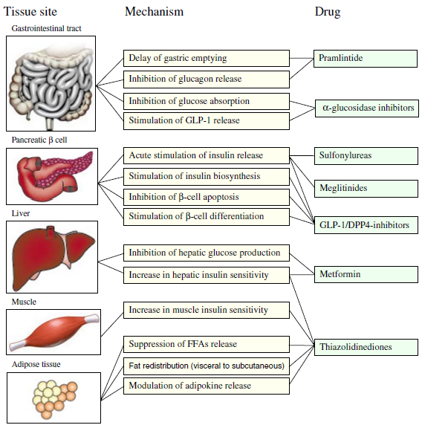
Fig. 1 Pharmacological treatment of hyperglycemia according to site of action (Cristina et al., 2010).

Herbal medicines for treatment of diabetes
Plants, herbs, and ethnobotanicals have been used meanwhile the early days of humankind, as a result is almost as old as life itself and still used throughout the world for primary health care and treatment of disease (Benzie and Wachtel, 2011; Chawla et al., 2013). Over the past 100 years, the development and mass manufacture of chemically synthesized drugs have transformed health care in most parts of the word. However, large sections of the global population still rely on traditional practitioners and herbal medicines for their primary care (Benzie and Wachtel, 2011). According to the report of World Health Organization (WHO), about 80% of the world population still uses herbs and other traditional medicines for satisfying their primary health care needs (Chawla et al., 2013). The most acceptable reasons for using traditional medicines are affordability, more faithfully corresponds to the patient’s ideology, alleviates concerns about the adverse effects of synthetic medicines, satisfies more personalized health care, and allows greater public access to the medicine (Benzie and Wachtel, 2011).
There are many antidiabetic plants known through the traditional stories (Ahmad et al., 2009). Over 1200 plants have been claimed to be remedies for diabetes. Among them, more than 400 plants have shown antidiabetic activities in vitro and in vivo animal models. Herbs are known to offer symptomatic relief and help in the prevention of the secondary complications of the disease (Chang et al., 2013). The plant phytoconstituents under the class of polysaccharides, peptides, alkaloids, glycopeptides, triterpenoids, amino acids, steroids, xanthones, flavonoids, lipids, phenolics, coumarins, iridoids, alkyl disulphides, inorganic ions and guanidines have been reported as potent antidiabetic agents (Chawla et al., 2013; Gaikwad et al., 2014; Shewamene et al., 2015). The use of these phytoconstituents may suppress the development of diabetic complications and could regulate the metabolic abnormalities through a variety of mechanisms (Gaikwad et al., 2014). The selected plants and Phytochemicals have been reported as antidiabetic agent described (fig 2 and 3), respectively in the following section.

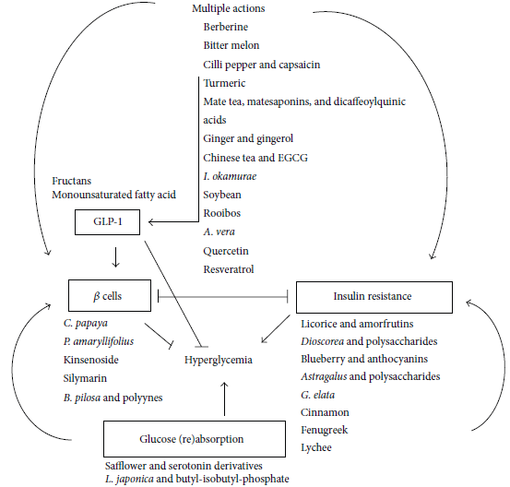
Fig. 2 Some of selected antidiabetic plants and their mechanism of antihyperglycemic effect (Chang et al., 2013).

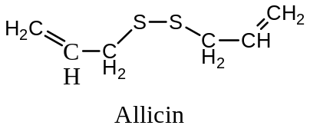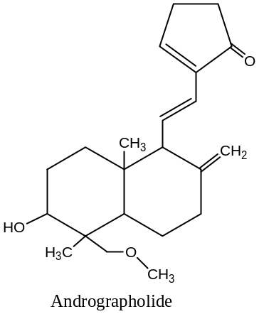

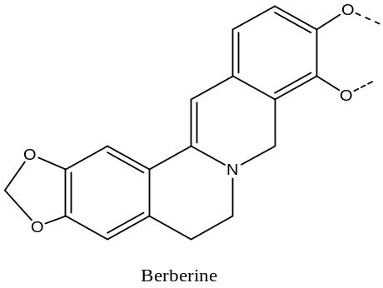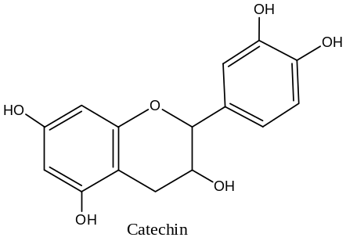

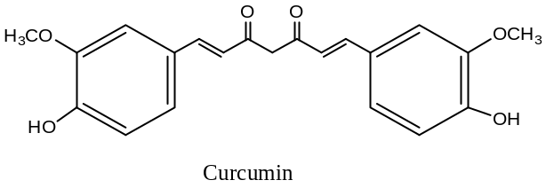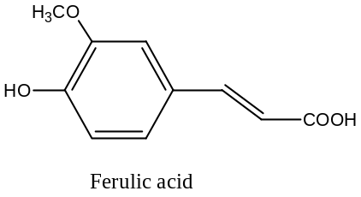

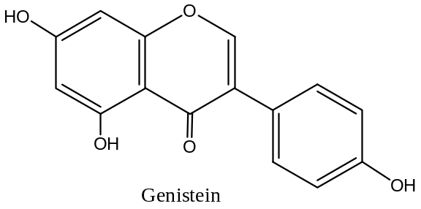
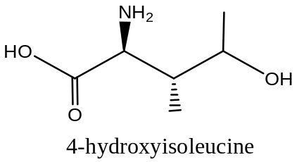

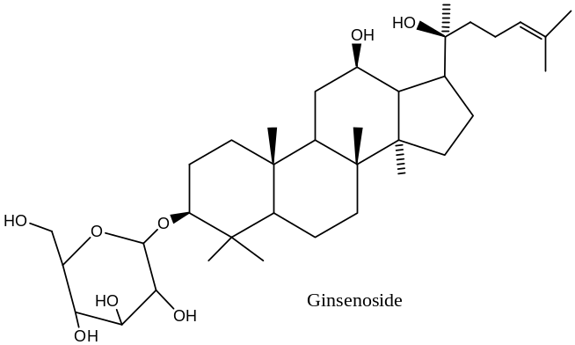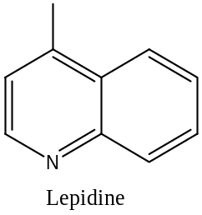

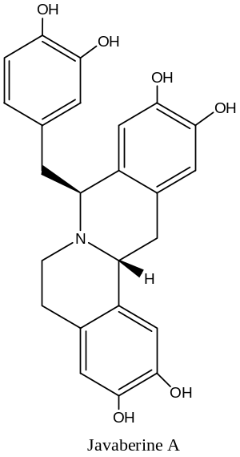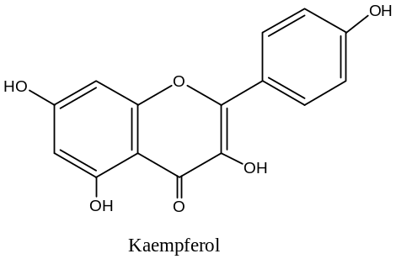

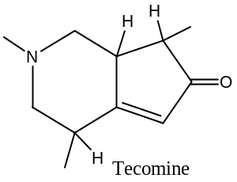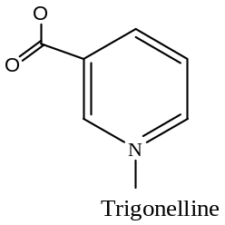

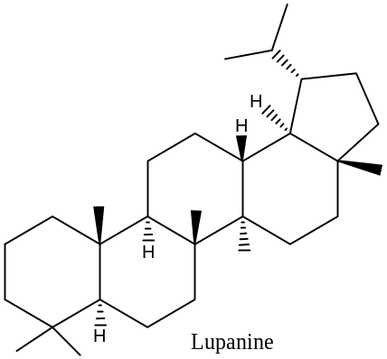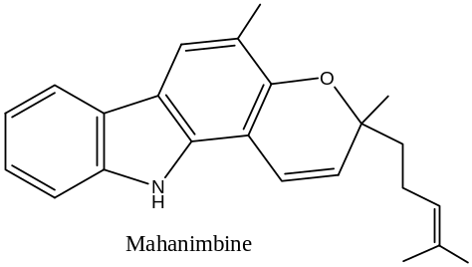
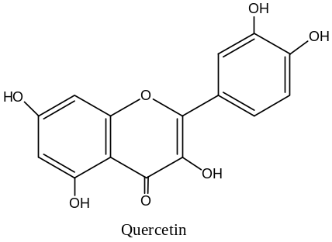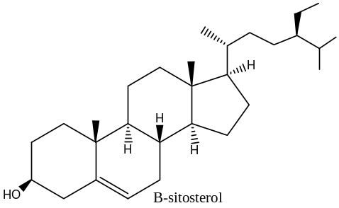
Fig. 3 Structure important antidiabetic phytochemicals (Gaikwad et al., 2014).

Herbal formulations in market and plants in clinical trial for treatment of diabetes
Ayurvedic physicians have managed diabetes for thousands of years by means of a combination of regulated lifestyle and herbal formulations (Sharma et al., 2010). The use of a medicinal herb, alone or in mixture with other herbs, can be believed as a type of combination therapy since plants consists a complexity of the phytochemicals and bioactivities therein. Consequently, a single antidiabetic herb with thousands of phytochemicals may have numerous benefits by targeting several metabolic pathways (Chang et al., 2013). Herbal formulation marketed for treatment of diabetes portrayed in (table 1) below.
Herbal drugs may be an evolving alternative of synthetic drugs to treat DM. Antidiabetic plants that stay under clinical trials are Clerodendron phlomoides, Cecropia obtusifolia, Marrubium vulgare, Asteracantha longifolia, Panox quinquefolius, Cephalandra indica, Caesaria indica, Caesaria esculenta, Cannabis indica, Withania somnifera, Silibum marianum (Chawla et al., 2013).
Table 1 Some marketed ayurvedic formulations and their ingredients used for treatment of diabetes (Sharma et al., 2010).
No. | Product Ingredients | Ingredients
1. | Madhumehhari | Syzygium cumini, Momordica charantia, Gymnema sylvestre, Pterocarpus marsupium, Tinospora cordifolia, Curcuma longa, Cinnamomum, Emblica officinalis, Plumbago zeylanica, Shilajit, Aegle marmelos, Acacia catechu, Azadirachta indica, Ficus racemosus/glomerata, Picrorrhiza kurroa, Trigonella foenum, Abhrak bhasma, Trivang bhasma, Swarna bhasma, Swarna makrnile bhasm.
2. | Madhuhari | Momordica charantia, Tinospora cordifolia, Styrax officinalis, Azadirachta indica, Phyllanthus emblica, Aegle marmelos, Acacia Arabica, Trivang bhasma
3. | Merciana | Syzygium cumini, Momordica charantia, Gymnema sylvestre, Tinospora cordifolia, Cassia auriculata, Glycyrrhiza glabra
4. | Diabecon | Syzygium cumini, Momordica charantia, Sphaeranthus indicus, Gymnema sylvestre, Gmelina arborea, Pterocarpus marsupium, Tinospora cordifolia, Phyllanthus emblica, Terminalia chebula, Terminalia belarica, Curcuma longa, Gossipium herbaceum, Aloe vera, Berberis aristata, Commiphora wighti, Ocimum sanctum, Asparagus racemosus, Swertia chirayata, Tribulus terrestris, Rumex maritimus, Casearia esculenta, Glycyrrhiza glabra, Boeharavia diffusa, Phyllanthus amarus, Piper nigrum, Abutilon indicum, Abhrak bhasma, Praval bhasma, Vang bhasma, Yashad bhasma, Vidangadi bhasma, Akik pishti, Shingraf
5. | Diabon | Momordica charantia, Styrax officinalis, Phyllanthus emblica, Terminalia chebula, Terminalia belarica, Ficus racemosus/ glomerata, Piper cubeba
6. | Dibex | Momordica charantia, Pterocarpus marsupium.
7. | Tribangshila | Momordica charantia, Gymnema sylvestre, Pterocarpus marsupium, Styrax officinalis, Azadirachta indica, Trivang bhasma
8. | Cogent db | Syzygium cumini, Azadirachta indica, Phyllanthus emblica, Terminalia chebula, Terminalia belarica, Curcuma longa
9. | Diabaquit | Syzygium cumini, Momordica charantia, Gymnema sylvestre, Tinospora cordifolia, Azadirachta indica, Phyllanthus emblica, Curcuma longa, Aegle marmelos, Trigonella foenum.

The family Myricaceae
The Myricaceae is a family of woody plants native mainly to the subtropical and warm temperate provinces of the world (Lutzow-Felling et al., 1995). This family consists of 133 genera and more than 3,800species (Vareda et al., 2014).
Members of the genus are naturally evergreen Shrubs or trees, usually aromatic; leaves simple, alternate or rarely opposite, flowers dioecious or monoecious, subtended by bracts, reduced to small clusters of stamens or to a solitary naked pistil, ovary one-celled, with one ovule, style very short, stigma cup-shaped, produced into two spreading flat lobes, fruit a drupe covered by waxy or fleshy peltate, containing a single seed (Fosberg and Sachet, 1975). They usually bear root tubercles comprising nitrogen-fixing bacteria. The nitrogen-fixing nature of the Myricaceae is especially noteworthy (Lutzow-Felling et al., 1995).

The genus Myrica
Myrcia is one of the largest genera in family of Myrtaceae with about 760 species (Vareda et al., 2014). Myrica was originally observed in Hawaii volcanoes national park in 1961 (Vitousck et al., 1987). The genus Myrica is native to east and southeast Asia, southern and tropical west Africa, the Macaronesian islands, and warm temperate and subtropical North, Central, and South America (Lutzow-Felling et al., 1995; Om Prakash et al., 2014). The highest concentration of species appears in South Africa (Fosberg and Sachet, 1975). Features of Myrica species that distinguish it from other species are that, it includes a greater grouping of vessels, shorter vessel elements, more numerous bars per perforation plate, presence of tracheid’s in latewood but fiber-tracheid’s in earlywood, predominance of uniseriate rays, and absence of crystals (Carlquist, 2002).

Ethnobotanical uses
Species of Myrcia have been used in traditional communities in Brazil for the treatment of diuretics, hypertension and DM (Vareda et al., 2014). Biological review indicates that the different organs of Myrica species has been widely used in asthma, coughs, bronchitis, throat complaints, cardiac failure, cardiac edema, liver diseases, anemia, fever, chronic dysentery, ulcers, tumors, epilepsy, and as gut stimulant (Tong et al., 2009; Akazawa et al., 2010; Pate et al., 2011; Kumar and Rana, 2012; Aleem et al., 2015; Silva et al., 2015).

Pharmacological activity of genus Myrica

Anti-inflammatory and analgesic activity
Ethyl-acetate and aqueous extract of M. nagi (100 and 200mg/kg/p.o.) showed significant percent inhibition against the histamine induced rat paw edema (Kumar and Rana, 2012). Myricetin (fig 4) inhibited prostaglandin E2 (PGE2) in the peritoneal fluid and platelet aggregation induced by collagen and arachidonic acid in vitro. Myricetin had potent analgesic activity in COX-1 sensitive chemical nociceptive models. These results collectively demonstrated that myricetin has possessed potent analgesic activity (Tong et al., 2009).
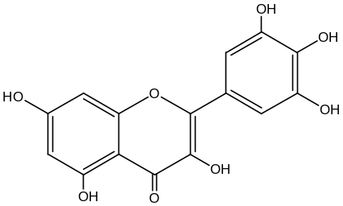
Fig. 4 Structure of myricetin Isolated from M. rubra Sieb. Et Zucc. Leaves

Antihypertensive activity
Two-active compounds; corchoionoside C (1) and (6S,9R)-roseoside (2), which isolated from methanol extract of M. esculenta leaves has shown antihypertensive efficacy by inhibiting Angiotensin I-Converting Enzyme (ACE) with rates of 29.97% and 25.63%, respectively in vitro animal model (Nhiem et al., 2012). The crude extracts of M. nagi possessed vasodilator activities (Aleem et al., 2015).

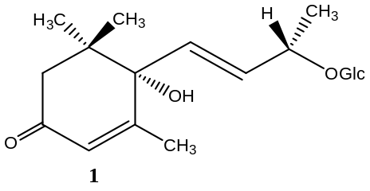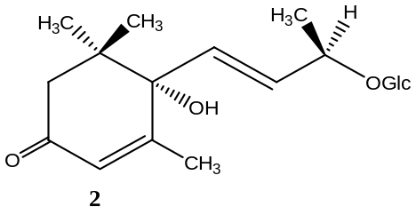

Antioxidant activity
On evaluation of the radical-scavenging activity of bark of M. rubra exhibited potent radical-scavenging activity (Akazawa et al., 2010). Extract of the leaves of M. gale var has been exhibited scavenging activities for hydroxy and superoxide radical in the aqueous phase (Nakata et al., 2013).

Antimicrobial activity
The essential oil prepared from leaves of cultivated M. gale var. tomentosa showed antibacterial activity against S. aureus, B. subtilis, S. cerevisiae, and C. albican with a 3.0-mm inhibition zone in the paper disc assay (Nakata et al., 2013). A study by Chandra et al. (2012) has been carried out to evaluate the anti-bacterial and anti-fungal activity of M. nagi fruit pulp. Ten bacterial strain (Escherichia coli, Klebsiella pneumonia, Enterobacter gergoviae, Salmonella entericatyphim, Shigella flexneri, Staphyloccus aureus, Staphyloccus epidermidis, Streptococcus pyogenes and Bacillus cereus) and three fungal (Candia albicans, Aspergillus flavus and Aspergillus parasiticus) were investigated by using disc diffusion method. Ethanolic extracts at all doses (10mg/ml and 50mg/ml) showed significant antimicrobial activity (Kumar and Rana, 2012).

Antiasthmatic activity
The effects of ethyl acetate and aqueous extract of M. nagi bark at 100 and 200 mg/kg showed slightly better protection of mast cell degranulation with percentage of 45 and 62%, respectively. These extracts also showed better mast cell stabilizing activity 70 and 78%, respectively (Pate et al., 2011; Kumar and Rana, 2012; Aleem et al., 2015).

Anti-allergic activity
The stem bark of M. esculenta has been studied for anti-allergic activity and it was concluded that it can be used in the allergic disorders. The ethanolic extract of the stem bark possessed potential anti-allergic activity when studied on mice. In the experiment, allergic pleurisy and vascular permeability were induced by acetic acid in mice (Kharkwal and Bahuguna, 2012).

Anthelmintic activity
Vibhor et al. (2010) carried out antihelmintic activity of bark of M. esculenta using 50% aqueous ethanolic extract. It was observed that aqueous ethanolic extract of M. esculenta is more potent than reference control piperazine citrate. The result showed the anthelmintic properties of aqueous ethanolic extract of M. esculenta bark (Kumar and Rana, 2012).

Hepatoprotective activity
The protective effects of M. rubra Sieb. Et Zucc against carbon tetrachloride (CCl4)-induced liver damage was investigated. Pretreatment with fruit extract significantly blocked the CCl₄-induced increase in both serum aspartate aminotransferase (sAST) and serum alanine aminotransferase (sALT) levels in mice (Xu et al., 2011).

Antidiabetic activity
The hypoglycemic properties of ethanol extract of the leaves of M. bella in streptozotocine induced diabetic mice has been noticed by Vareda and its co-workers in 2014. The chemical fingerprinting of the 70% EtOH extract characterized as main constituents flavonoid aglycones, flavonoid-O-glycosides, and acylated flavonoid-O-glycosides derivatives of quercetin and myricetin (Vareda et al., 2014).

Phytochemicals isolated from genus myrica

Flavonoid
The two flavonoids, myricetin (3), and myricitrin (4) were isolated from the dried leave extract of M. esculenta and bark of M. rubra (Nhiem et al., 2012; Akazawa et al., 2010). Also, Tong et al. (2009) isolated myricetin from M. rubra Leaves extract (Tong et al., 2009). Spínola et al. (2014) isolated flavones (5), flavonols (6), and flavanols (7) from leaves and berries of M. faya (Spínola et al., 2014). Myricetin 3-O-(2-O-galloyl)-α-Lrhamnopyranoside (8), Myricetin 3-O-(2-O-galloyl)-β-Dgalactopyranoside (9), Quercetin 3-O-(2-O-galloyl)- β-D-galactopyranoside (10), Myricetin-3′-O-sulfate (11), Ampelopsin 3′-O-sulfate (12), Myricitrin (4), Procyanidin B2 (13), (−)-Epicathechin (14), and Cyanidin 3-O-glucopyranoside (15) were elucidated from leaves part of M. rubra (Silva et al, 2015).
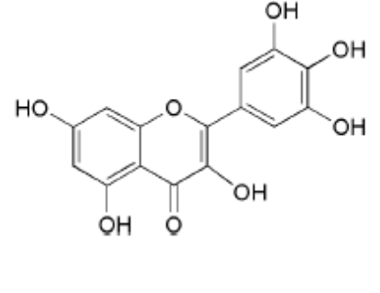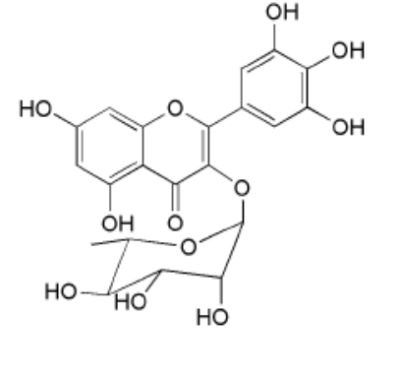
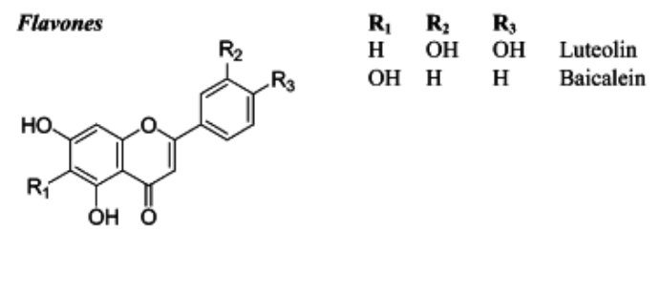
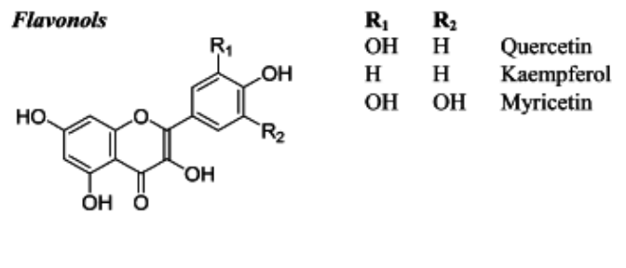
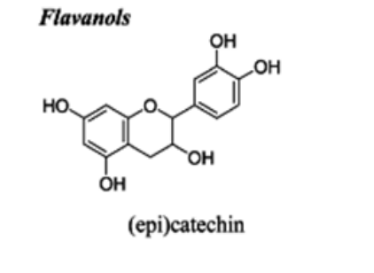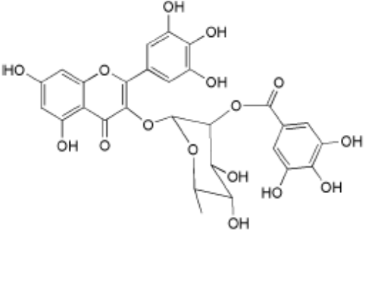

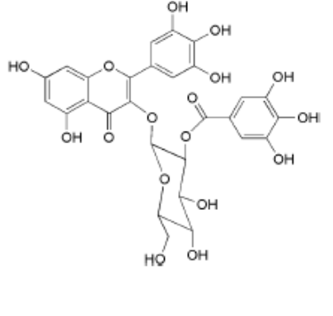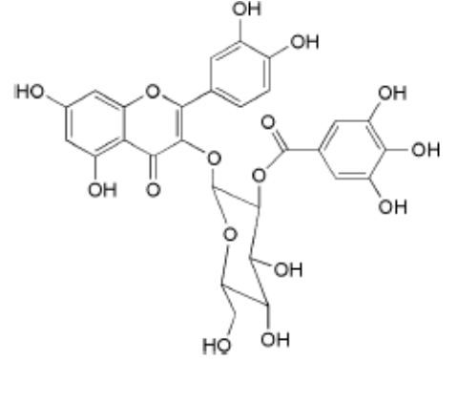
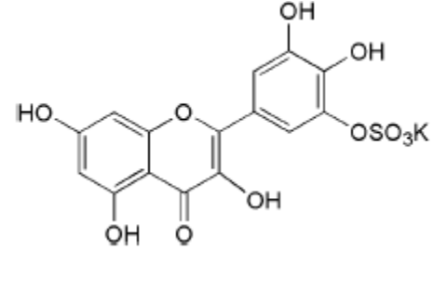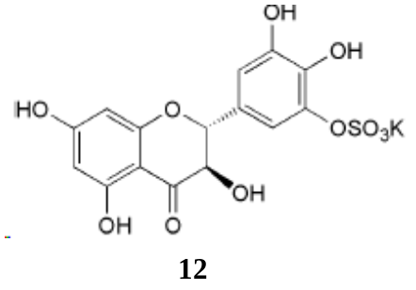

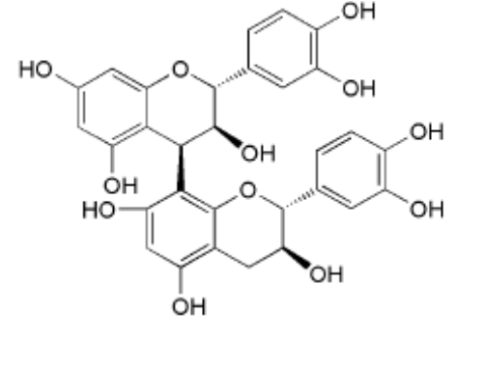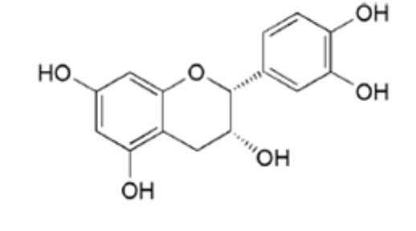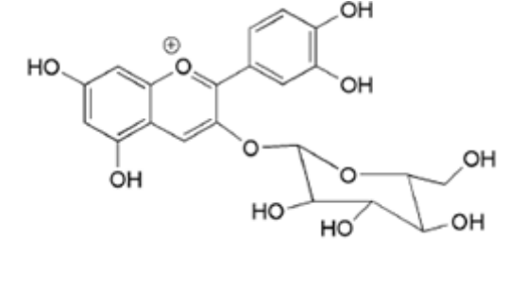

Tannins
Sun et al. (1988) made an investigation of the bark of M. esculenta that led to the isolation and identification of the hydrolysable tannin castalagin (16) (Kumar and Rana, 2012).
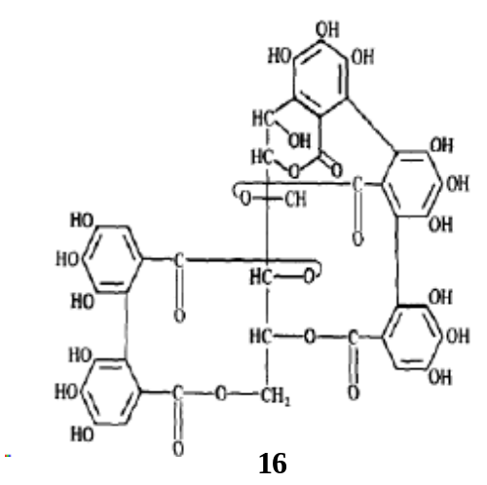

Diarylheptanoids
Myricanone (17), 12-Hydroxymyricanone (18), Porson (19), and Galeon (20) were isolated from M. gale var. tormentosa and M. cerifera Bark (Silva et al, 2015; Zhang et al., 2016). Myricanol (21), Myricanol 11-O-β-D-glucopyranoside (22), Myricanol 5-O-β-D-glucopyranoside (23), Myricanol 5-O-β-D-(6′-O-galloyl) glucopyranoside (24), and Juglanin B-11(R)-O-sulphate (25) were fractionated and characterized from the bark of M. rubra (Silva et al, 2015; Akazawa et al., 2010; Kumar and Rana, 2012).

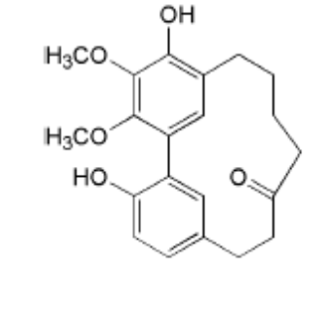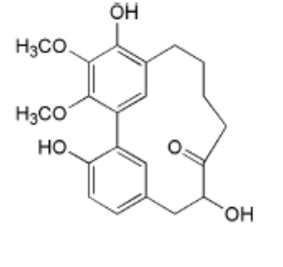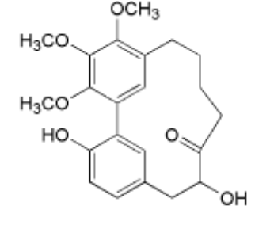
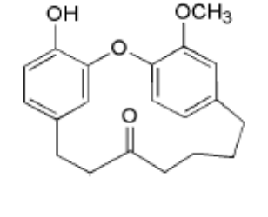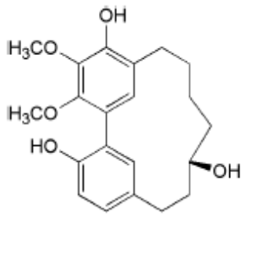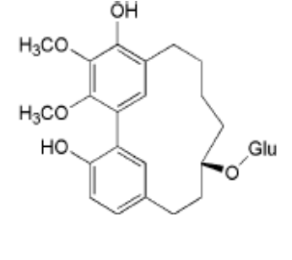
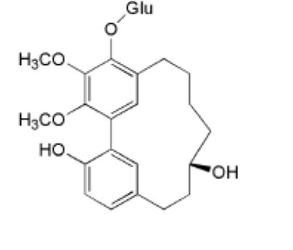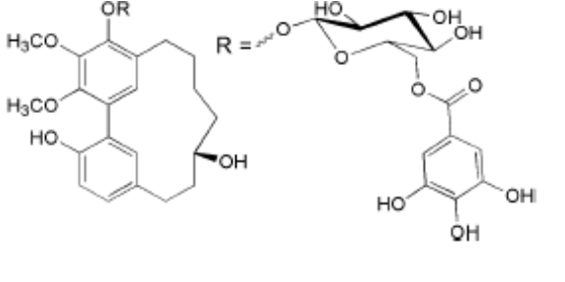

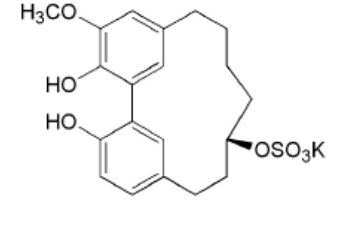

Terpenes
In 2016, Zhang et al. isolated seven triterpenoid compounds from the hexane and MeOH extracts of the bark of M. cerifera namely, betulin (26), multiflor-7-en-12$α$-ol (27), ursolic acid (28), 3$β$,12$β$-dihydroxyursan-28-oic acid 28,13-lactone (29), 11$α$,12$α$-epoxy-3b-hydroxyoleanan- 28-oic acid 28,13-lactone (30), arjunolic acid (31), and erythrodiol (32) (Zhang et al., 2016). Another two terpenoids Drovomifoliol-O-B-D-glucopyranoside (33) and Lactiflorin (34) were isolated methanolic extracts from M. faya leaves and berries (Spínola et al., 2014).
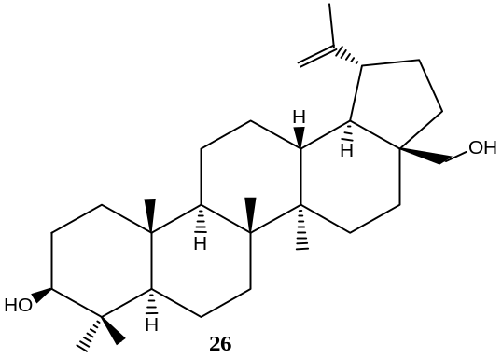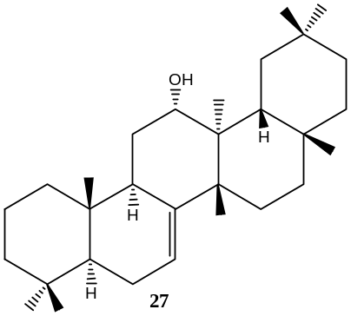
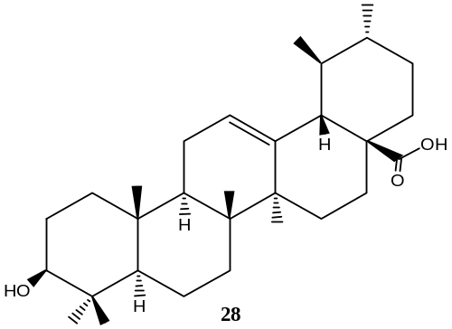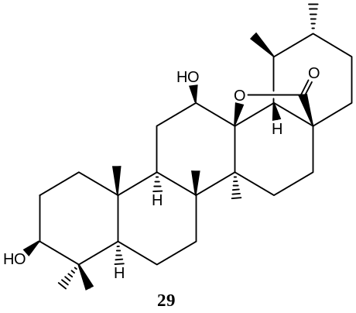
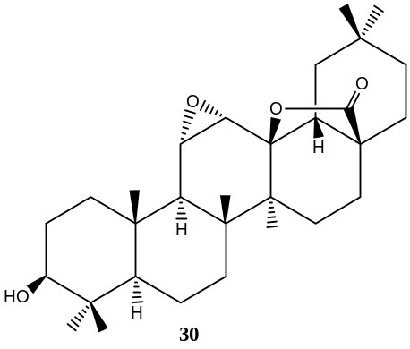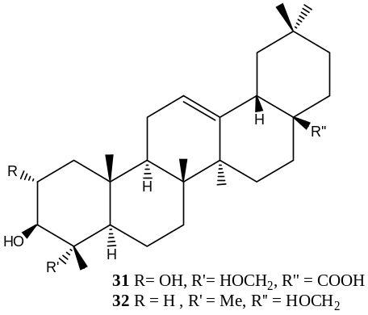
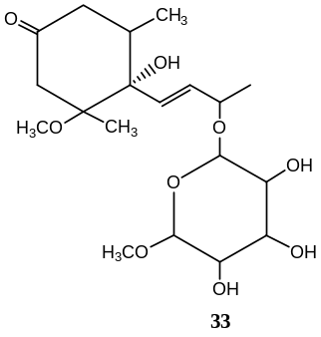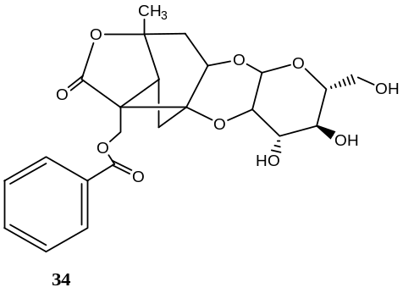

Lignans
The methanolic extracts from M. faya leaves and berries was given the three lignan compounds namely, conidendrin (35), phylligenin (36), and 2,7-anhydro-2-octulopyranosonic acid (37) (Spínola et al., 2014).

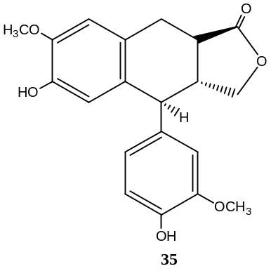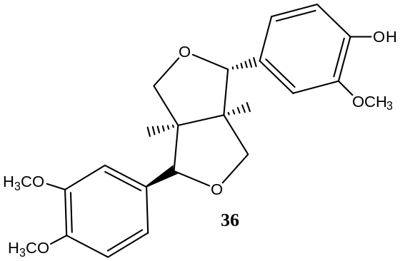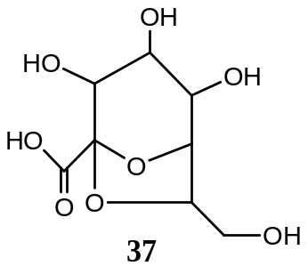

Myrica salicifolia (Hochst. ex A. Rich.)

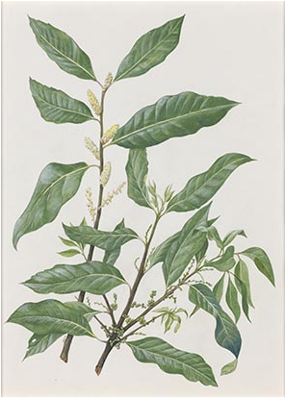
Fig. 5 Image of M. salicifolia

Description
M. salicifolia is a shrub of 1 m in height but can grow into a tree of up to 20 m, usually aromatic and resinous (Njung et al., 2002; Kariuki et al., 2014). It belongs to the family Myricaceae found in Southeast Africa, Ethiopia and Saudi Arabia (Kariuki et al., 2014, Silva et al., 2015). It is commonly known as Shinet (Amharic) in Ethiopia (Luleka, 2014).

Ethnobotanical uses
The plants known as “pedra-hume-ca’a” or insulin plants have been used for the treatment of diabetes according to the empirical African and Brazilian culture. M. salicifolia is one of the species related to “pedra-hume-ca’a” (Vareda et al., 2014). Similarly, the root extract has been used for the treatment of diabetes in Ethiopia and Tanzania (Moshi et al., 2003; Luleka, 2014).
Traditionally, the root extracts of M. salicifolia consumed by Maasai warriors to prime themselves for battle. They believed that consumption of this extract would produce feeling like detachment from the environment, short-temperedness, emotional incontinence, catalepsy, unjustifiably sharp responses to extraneous sounds, feelings of invisibility and aggressiveness (Njung et al., 2002; Kariuki et al., 2014). The root infusion has been used to treat gastro-intestinal disorder, bilharzia, and malaria (Moshi et al., 2003; Silva et al., 2015), while roots and bark used in the treatment of chest congestion, pneumonia diarrhea, nervous disorder, hypertension, respiratory disease, headache, pain, and inflammation (Maara, 2014; Silva et al., 2015).

Pharmacological activities

Antibacterial activities
The chloroform extracts of M. salicifolia exhibited activities against E. coli, K. pneumonaie, and S. typhi with an inhibition diameter of 6.86, 5.50 and 8.25, respectively. Its water extract has shown inhibition activity against P. aeruginosa with an inhibition diameter of 5.60 (Kariuki et al., 2014).

Analgesic activity
M. salicifolia methanolic root extract (100 mg/kg) showed potent analgesic effects on the hot plate and tail pressure tests in mice (Njung et al., 2002).

Objectives

General objective
The aim of this study will be to evaluate anti-diabetic activity of root extract of Myrica Salicifolia in Streptozotocin induced diabetic mice.

Specific objectives
To assess the safety profile of the root extract of M. salicifolia.
To carry out qualitative phytochemical screening of M. Salicifolia root extracts
To evaluate the effect of M. Salicifolia on fasting blood glucose level of diabetic mice
To investigate antihyperglycemic activity of the fractionated fractions
To evaluate antidiabetic potential of isolated active compounds

Materials and Methods

Instruments, chemicals and reagents
Instruments, chemicals and reagents will be used in this experiment are: rodent cages, 1.5-ml micro centrifuge tubes, Aluminum foil, 1-ml syringes, glucose standard strip/kits, One Touch Basic blood glucose monitoring system, NMR, Mass spectrum, Streptozotocin (STZ), Glibenclamide, sodium citrate buffer (PH= 4.5), Tween-80, Hydrochloric acid, Sulphuric acid, Acetic anhydride, Ferric chloride, Potassium ferrocyanide, Ferric sulphate, Lead acetate, Ethyl acetate, n-Hexane, Petroleum ether, acetone, Ethanol, Chloroform, and Methanol.

Collections, identification, and preparation of plant materials
The roots of M. Salicifolia will be collected from North Gondar, Amhara Region, 738 kilometers North West of Addis Ababa. The plants will be identified and authenticated at the National Herbarium, Department of Biology, Science Faculty, Addis Ababa University and voucher specimens will be deposited therein. The roots of plant will thoroughly be washed with distilled water to remove dirt and soil, and dried under shade with optimal ventilation. Eventually, the plant material will be pulverized and the powdered for extraction.

Experimental animals
Healthy Male Swiss albino mice (weighing 20–30 g and age of 8–12 weeks) will be obtained from the animal house of University of Gondar. Animals will be housed in polypropylene cages (6-10 animals per cage) (Shewamene et al., 2015), maintained under standard condition at 24°C $±$ 1°C and 55% $±$ 5% humidity, with a 12-hr light-dark cycle and allowed free access to standard pellet diet and water ad libtum (Furman, 2015). Before and during the experiment, the animal will have allowed free access to standard pellet diet and water. After randomization into various groups and before initiation of the experiment, the animal will be acclimatized to the animal house conditions (Tsegaye et al., 2009) at School of Pharmacy, Mekelle University College of Health Science. Prior to each study, the animals will have made to fast for 12-14 h, but allow free access to water (Vareda et al., 2014). All procedures will be undertaken according to The Guide for the Care and Use of Laboratory Animals (Amgen and PreLabs, 2010). Ethical clearance will be approved by the Institutional Review Board of Mekelle University.

Extraction
The powdered plant materials of M. Salicifolia will be extracted with methanol for 72 h by maceration. The filtrate will be separated from the mark using filter paper and the mark will be re-macerated three times. The collected filtrates will be dried in an oven at the temperature not exceeding 40 $℃$. The dried extracts will then be transferred to vials and kept in a refrigerator until further use.

Solvent fractionation
The extract will be fractionated by soxhlet extraction with different solvents of increasing polarity. Soxhlet extraction with each of the solvent will be carried out for 48 h. The different fractions will be concentrated under reduced pressure and dried on water bath at a temperature not exceeding 40 $℃$. In the case of the aqueous fraction lypholizer will be used for drying. The dried fractions will then be transferred to vials and stored in a refrigerator for further use.

Chromatographic techniques
Among those fractions will be tested, the fraction exhibited the highest antihyperglycemic activity in STZ-induced diabetic mice, will then be subjected to column chromatography packed with silica gel and will be eluted with increasing order of polarity. The isolated homogeneous compounds will be characterized by spectroscopy techniques like ¹H NMR, ¹³C NMR and Mass Spectrum.

Acute toxicity test
Acute toxicity test will be done based on the limit test recommendations of Organization for Economic Co-operation and Development (OECD) 425 Guideline (OECD, 2008). On day one Swiss albino mouse will fast for 3-4 h and then will have given 2000 mg/kg of the extract orally. The mouse will then be kept under strict observation for physical or behavioral changes for 24 h, with special attention during the first 4 h. Following the results from the first mouse, other four mice will be recruited and fasted for 3-4 h and administered a single dose of 2000 mg/kg and will be observed and weighted in the same manner. These observations continued for further 14 days for any signs of overt toxicity.

Preliminary phytochemical screening
The freshly prepared extracts will qualitatively be tested for the presence of chemical constituents. Phytochemical screening of the extracts being performed using the following reagents and chemicals: Alkaloids with Dragendrorff’s reagent, phenolics with ferric chloride solutions, terpenoids with appropriate proportion of chloroform, acetic anhydride and concentrated H₂SO₄, flavonoids with the use of Mg and HCl, tannins with ferric chloride and potassium dichromate solutions and saponins with ability to produce stable foam, Cardiac glycosides with glacial acetic acid containing one drop of ferric chloride solution and concentrated H₂SO_{4,} and steroids with Libermann-Burchard reagent. These will be identified by characteristic color changes using standard procedure (Ashafa, 2013).

Induction of experimental diabetes
After fasting male Swiss albino mice overnight for 12-14 h, their weight and fasting blood glucose level will be recorded. Diabetes will then be induced intraperitoneally with a single dose of 150 mg/kg STZ after dissolving it in freshly prepared 0. 1 M of ice-cold sodium citrate buffer (pH 4.5) (Tsegaye et al., 2009). Following 30 minute after the injection of STZ, they will have free access to feed and water. The development of diabetes will be confirmed after 72 h of the STZ injection. The mice having fasting blood glucose level greater than 200 mg/dL will be selected for experimentation (Kumar et al., 2008; Tsegaye et al., 2009).

Experimental protocol
Male Swiss albino mice will be used for the antidiabetic studies, because female mice are less sensitive to this islet-cell toxin, most STZ-induced diabetic mice studies are conducted on male animals (Furman, 2015). The animals will be divided in three sets; evaluation of antihyperglycemic activity of crude root extracts of M. salicifolia, investigation of antidiabetic activity of different solvent fraction, and examination of antihyperglycemic potential of isolated active compounds.

Evaluation of antihyperglycemic activity of crude extracts
Previously, STZ-induced diabetic male Swiss albino mice (blood glucose level >200 mg/dl) and normal non-diabetic mice will be used. Total of six groups of animals of six animals each will be used for study. The treatment for all groups will be administered po daily for 15 day. Group I–Normal control animals will have 2% v/v Tween-80, Group II–STZ induced diabetic animals will take 2% v/v Tween-80, Group III – V STZ induced diabetic animals will be received three different dose of crude extracts of M. salicifolia, VI– STZ induced diabetic animals will have 1.25 mg/kg of glibenclamide. The doses will be selected based on the acute toxicity study. Animals will be fasted overnight for 12-14 h prior to drug administration allowing them access only to water. Blood samples will be collected from the tail tip of mice at 1th, 5th, 10th and15th day to determine blood glucose level (BGL) (Kumar et al., 2008).

Investigation of antidiabetic activity of different solvent fractions
The various solvent fractions of the dried root extract of M. salicifolia will be administered orally at different doses for each respective group of six mice each, after induction of experimental diabetes. All procedures will be proceeded thoroughly as protocols described above.

Examination of antihyperglycemic potential of isolated active compounds
Examination of antihyperglycemic activity of the isolated compounds will be carried out using the above established procedure and protocols. The animals will have the test compounds in various different doses.

Collection of blood samples and glucose determination
Using aseptic conditions, blood sample will be collected by end tail vein cutting method and BGL will be determined by one touch glucometer using glucose strips. Measurement of BGL will be done in triplicate and the average value will have taken (Kumar et al., 2008; Tamiru et al., 2012).

Statistical analysis
All the results will be expressed as the mean $±$ standard deviation (S.D) for six animals in each group. All data will then statistically be evaluated with statistical package for social sciences (SPSS) software. Hypothesis testing methods will include One-way analysis of variance (ANOVA) followed by Dunnet’s post hoc test; P values < 0.05 will be considered to indicate statistical significance (Kumar, 2006).

Work Plane
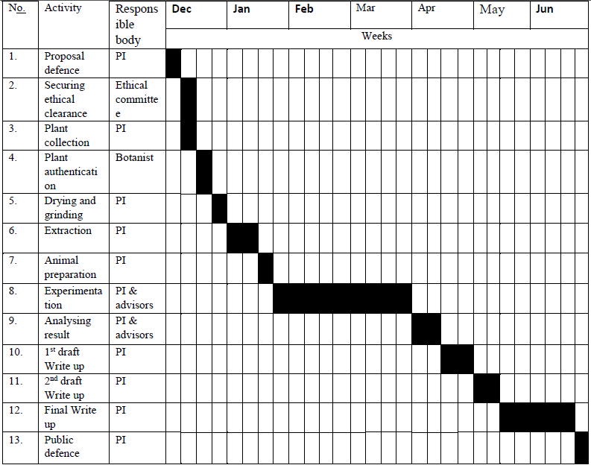
PI = Principal Investigator

Budget
No. | Cost Materials / Items | Unit | Quantity | Cost (Birr)
1. | Stationary cost  - Printing paper, pen, pencil, ruler, note book, flash disk | Pcs | - | 1500
2. | Equipment’s
2. | - 1ml syringe | Pcs | 20 | 600
2. | - Glucometer and strips | Pcs | 1 | 500
2. | - Filter paper | Pk | 2 | 200
2. | - Muslin cloth | Pcs | 2 | 200
2. | - Petri dishes | Pcs | 10 | 500
3. | Reagents and chemicals
3. | - Methanol | Litter | 5 | 500
3. | - Ethanol | Litter | 5 | 500
3. | - n-Hexane | Litter | 3 | 300
3. | - Petroleum ether | Litter | 3 | 300
3. | - acetone | Litter | 3 | 300
3. | - Chloroform | Litter | 3 | 300
3. | - Distilled water | Litter | 6 | 150
3. | - Tween 80 | Vial | 7 | 700
3. | - Sodium citrate 0.1 M | Litter | 1 | 200
3. | - 5% glucose | Tube | 20 | 400
3. | - Streptozotocine | Vial | 2 | 13000
3. | - Glibinclamide | PK | 2 | 100
3. | - Reagents for phytochemical screening: Ferric chloride, acetic anhydride, Potassium ferrocyanide, Lead acetate 10%, Dragendrroff reagent, sulfuric acid, hydrochloric acid, ethyl acetate, Form aldehyde, KCL powder, etc. |  |  | 2000
4. | Lab Animals and housing
4. | - Swiss albino male mice of 20-30gm | No. | 100 | 1000
4. | - Wister albino male rats of 150-300gm |  | 30 | 450
4. | - Separated animal housing cages |  | 10 | 3000
5. | Transport and communication cost |  |  | 8000
6. | Structural elucidation of active compounds |  |  | 1500
Total |  |  |  | 36,200

References
Abdulfatai, B.O., Olusegun, A.O. and Lateefat, B.O., 2012. Type 2 DM: A Review of Current Trends. Oman Medical Journal, 27(4), pp.269-273.
Adeneye, A.A. and Adeyemi, O.O., 2009. Hypoglycaemic effects of the aqueous seed extract of Hunteria umbellata in normoglycaemic and glucose-and nicotine-induced hyperglycaemic rats. International Journal of Applied Research in Natural Products, 2(1), pp.9-18.
Ahmad, M., Qureshi, R., Arshad, M., Khan, M.A. and Zafar, M., 2009. Traditional herbal remedies used for the treatment of diabetes from district attock (pakistan). Pakistan Journal of Botany, 41(6), pp. 2777-2782.
Akazawa, H., Fujita, Y., Banno, N., Watanabe, K., Kimura, Y., Manosroi, A., Manosroi, J. and Akihisa, T., 2010. Three New Cyclic Diarylheptanoids and Other Phenolic Compounds from the Bark of Myrica rubra and Their Melanogenesis Inhibitory and Radical Scavenging Activities. Journal of Oleo Science, 59(4), pp. 213-221.
Aleem, A., Janbaz, K.H, Mehmood, M.H., Bashir, S., Jawed, F., Rehman, N. and Gilani, A., 2015. Pharmacological Studies on Antidiarrheal, Gut Modulatory, Bronchodilatory and Vasodilatory Activities of Myrica nagi. International Journal of Pharmacology, 11 (8), pp.888-898.
Al-Shaqha, W.M., Khan, M., Salam, N., Azzi, A. and Chaudhary, A.A., 2015. Anti-diabetic potential of Catharanthus roseus Linn. and its effect on the glucose transport gene (GLUT-2 and GLUT-4) in streptozotocin induced diabetic wistar rats. BMC complementary and alternative medicine, 15(1), p.1
American Diabetic Association (ADA), 2009. Diagnosis and classification of DM. Diabetes Care, 32(1), pp. 193-203.
American Diabetic Association (ADA), 2016. Standards of Medical Care in Diabetes. Diabetes Care, 39(1), pp, 13–22.
American Diabetic Association (ADA), 2008. Diagnosis and Classification of DM. Diabetes Care, 31, pp.62-67.
American Diabetic Association (ADA), 2014. Diagnosis and Classification of DM; Diabetes Care, 37(1), pp.581-191.
Amgen, M.B. and PreLabs, P.J.R., 2010. Guide for The Care and Use of Laboratory Animals. Washington, DC: The National Academies Press, 2010, 8th ed.
Ashafa, A.O.T., 2013. Medicinal potential of Morella serata (Lam.) Killick (Myricaceae) root extracts: biological and pharmacological activities. BMC Complementary and Alternative Medicine, 13, p.163.
Australian Indigenous Health Reviews (AIHR), 2007. Background information of diabetes among Indigenous peoples. From the Australian Indigenous HealthInfoNet. Available from: http://www.healthinfonet.ecu.edu.au/diabetes_review.
Baz, B., Riveline, J. and Gautier, J., 2016. Gestational DM: definition, etiological and clinical aspects. European Journal of Endocrinology, 174(2), pp.43 51.
Benzie, I.F.F. and Wachtel,G.S, 2011. Herbal medicine: biomolecular and clinical aspects. New York: CRC Press, 2011, 2nd ed.
Carlquist, S., 2002. Wood and bark anatomy of myricaceae: relationships, generic definitions, and Ecological interpretations. Aliso, 21(1), pp.7—29.
Chang, C.L., Lin, Y., Bartolome, A.P., Chen, Y.C., Chiu, S.C. and Yang, W.C., 2013. Herbal therapies for type 2 diabetic mellitus: chemistry, biology, and potential application of selected plants and compounds. Evidence-Based Complementary and Alternative Medicine, 2013.
Chawla, R., Thakur, P., Chowdhry, A., Jaiswal, S., Sharma, A., Goel, R., Sharma, J., Priyadarshi, S.S., Kumar, V., Sharma, R.K. and Arora, R., 2013. Evidence based herbal drug standardization approach in coping with challenges of holistic management of diabetes: a dreadful lifestyle disorder of 21st century. Journal of Diabetes & Metabolic Disorders, 12(1), p.1.
Colagiuri, S., Colagiuri, R. and Ward, J., 1998. National diabetes strategy and implementation plan. Diabetes Australia, Canberra, pp.1-281.
Commonwealth Department of Health and Aged Care, Australian Institute of Health and Welfare (CWDC), 1999. National health priority areas report: DM. Canberra: Australian Institute of Health and Welfare.
Cristina, M.S., Carla, F.B., Paulo, P. and Raquel, S., 2010. DM: new challenges and innovative therapies. EPMA Journal, 1, pp.138–163.
Forbes, J.M. and Cooper, M.E., 2013. Mechanisms of diabetic complications. Physiological reviews, 93(1), pp.137-188.
Fosberg, F.R. and Sachet, M.H., 1975. Flora of Micronesia: 2. Casuarinaceae, Piperaceae, and Myricaceae.: Smithsonian Contrib. Bot, (24).
Furman, B.L., 2015. Streptozotocin-Induced Diabetic Models in Mice and Rats. Current protocols in pharmacology, 70, pp.5.47.1-5.47.20.
Gebre, M.W., 2013. DM and associated diseases from Ethiopian perspective: Systematic review. Ethiopian Journal of Health Development, 27(3), pp.249-253.
Hall, V., Thomsen, R.W., Henriksen, O. and Lohse, N., 2011. Diabetes in Sub Saharan Africa 1999-2011: epidemiology and public health implications. A systematic review. BMC public health, 11(1), p.1.
Hung, H.Y., Qian, K., Morris-Natschke, S.L., Hsu, C.S. and Lee, K.H., 2012. Recent discovery of plant-derived anti-diabetic natural products. Natural product reports, 29(5), pp.580-606.
International Diabetes Federation (IDF), 2013. diabetes atlas. Brussels, Belgium: International Diabetes Federation.
International Diabetes Federation (IDF), 2015. diabetes atlas. Brussels: 2015, 7th ed. Available from: http://www.diabetesatlas.org/key-messages.html
Issa, I.A. and Bule, M.H., 2015. A Comparative Study of the Hypoglycemic Effect of Aqueous and Methanolic Extracts of Myrtus communis on Alloxan Induced Diabetic Siwis Albino Mice. Med Aromat Plants, 4(3), p.190.
Istek, N. and Karakurt, P., 2016. Effect of Activities of Daily Living on Self-Care Agency in Individuals with Type 2 Diabetes. Journal of diabetic mellitus, 6, pp. 247-262.
Kaaja, R. and Rönnemaa, T., 2008. Gestational diabetes: pathogenesis and consequences to mother and offspring. Rev Diabet Stud, 5(4), pp.194-202.
Kaku, K., 2010. Pathophysiology of Type 2 Diabetes and Its Treatment Policy. JMAJ, 53(1), pp. 41–46.
Kariuki, D.K., Miaron, J.O., Mugweru, J. and Kerubo, L.O., 2014. Antibacterial activity of five medicinal plant extracts Used by the maasai people of Kenya. International Journal of Humanities, Arts, Medicine and Sciences, 2(7), pp.1-6.
Kasper, D., Fauci, A., Hauser, S., Longo, D., Loscalzo, J. and Jameson, J., 2011. Harrison's Principles of Internal Medicine. 18th ed. New York: McGraw-Hill campanies Inc.
Khan, N. and Couper, J., 1994. Low birth-weight infants show earlier onset of IDDM. Diabetes Care, 17(7), pp.653-656.
Kharkwal, H. and Bahuguna, P.P., 2012. Myrica nagi: A review on active constituents, biological and therapeutic effects. International Journal of Pharmacy and Pharmaceutical Science, 4(5), pp.38-42.
Krug, E.G., 2016. Trends in diabetes: sounding the alarm. The Lancet, 387(10027), pp.1485-1486.
Kumar, A. and Rana, A.C., 2012. Pharmacologic and pharmacological profile of traditional medicinal plant: Myrica nagi. International research journal of pharmacy, 3(12), pp.32-37.
Kumar, A., Ilavarasan, R., Jayachandran, T., Deecaraman, M., Aravindan, P., Padmanabhan, N. and Krishan, M. R. V., 2008. Anti-diabetic activity of Syzygium cumini and its isolated compound against streptozotocin-induced diabetic rats. Journal of Medicinal Plants Research, 2(9), pp. 246-249.
Kumar, G.P.S., Arulselvan, P., Kumar, D.S. and Subramanian, S.P., 2006. Anti-Diabetic Activity of Fruits of Terminalia chebula on Streptozotocinn Induced Diabetic Rats. Journal of Health Science, 52(3), pp.283-291.
Lulekal, E., 2014. Plant Diversity and Ethnobotanical Study of Medicinal Plants in Ankober District, North Shewa Zone of Amhara Region, Ethiopia (Doctoral dissertation, Addis Abeba University).
Lutzow-Felling, C.J., Gardner, D.E., Markin, G.P. and Smith, C.W., 1995. Myrica faya: review of the biology, ecology, distribution, and control, including an annotated bibliography.
Maara, T.N., 2014. A rewiew of traditional knowledge, usage and status of the medicinal trees amongst the tugens of eldama ravine and esageri divisions, koibatek county, kenya. Journal of Health, Medicine and Nursing, 5, pp.113-128.
Madhu, S.V. and Srivastava, S., 2015. DM: Diagnosis and Management Guidelines. Journal of the Institute of Mathematics and its Applications, 28(1), pp.47-50.
Msyamboza, K.P., Mvula, C.J. and Kathyola, D., 2014. Prevalence and correlates of DM in Malawi: population-based national NCD STEPS survey. BMC endocrine disorders, 14(1), p.1.
Nakata, M., Myoda, T., Wakita, Y., Sato, T., Tanahashi, I., Toeda, K., Fujimori, T. and Nishizawa, M., 2013. Volatile component of essential oil from cultivated Myrica gale var. tomentosa and its antioxidant and antimicrobial activities. Journal of oleo science, 62(9), pp.755-762.
Nhiem, N.X., Kiem, P.V., Minh, C.V., Tai, B.H., Cuong, N.X., Thu, V.K., Tuan, H.L.A., JO, S., Jang, H.D., Kwon, Y. and Kim, Y.H., 2012. A New Monoterpenoid Glycoside from Myrica esculenta and the Inhibition of Angiotensin I-Converting Enzyme. Chemical and Pharmaceutical Bulletin, 58(10), pp.1408-1410.
Njung, K., Muriuki, G., Mwangi, J.W. and Kuria, K.A.M., 2002. Analgesic and Antipyretic Effects of Myrica salicifolia (Myricaceae). Phytotherapy research, 16, pp.73–74.
Obirikorang, Y., Obirikorang, C., Anto, E.O, Acheampong, E., Batu, E.N., Stella, A.D., Constance, O. and Brenya, P.K., 2016. Knowledge of complications of DM among patients visiting the diabetes clinic at Sampa Government Hospital, Ghana: a descriptive study. BMC Public Health, 16 (1), p.637.
Om Prakash, G.P., Chandra, M., Sethi, S., Dixit, H.P.S. and Pant, A., 2014. Biochemical analysis, pharmacological activity, antifungal activity and mineral analysis in methanolic extracts of Myrica esculenta and Syzygium cumini: the Indian traditional fruits growing in Uttarakhand Himalaya. Indian Journal of Pharmaceutical and Biological Research, 2(1), pp.26-34.
Organization for Economic Co-operation and Development, OECD, 2008. Guidance document on Acute Oral Toxicity: Up-and-down-procedures. Environmental health and safety monograph series on testing and assessment. Environment, health and safety publications. No 425, OECD.
Ozougwu, J.C., Obimba, K.C., Belonwu, C.D. and Unakalamba, C.B., 2013. The pathogenesis and pathophysiology of type 1 and type 2 DM. Journal of Physiology and Pathophysiology, 4(4), pp.46-57.
Pandeya, K.B., Tripathi, I.P., Mishra, M.K., Dwivedi, N., Pardhi, Y., Kamal, A., Gupta, P., Dwivedi, N. and Mishra, C., 2013. A Critical Review on Traditional Herbal Drugs: An Emerging Alternative Drug for Diabetes. International Journal of Organic Chemistry, 3, pp.1-22.
Pari, L. and Saravanan, R., 2004. Antidiabetic effect of diasulin, an herbal drug, on blood glucose, plasma insulin and hepatic enzymes of glucose metabolism in hyperglycaemic rats. Diabetes, obesity and metabolism, 6(4), pp.286-292
Pate, T., Rajshekar, C. and Parmar, R., 2011. Mast cell stabilizing activity of Myrica nagi bark. Journal of Pharmacognosy and Phytotherapy, 3(8), pp.114-117.
Perumal, V., Khoo, W.C., Abdul-Hamid, A., Ismail, A., Saari, K., Murugesu, S., Abas, F., Ismail, I.S., Lajis, N.H., Mushtaq, M.Y. and Khatib, A., 2015. Evaluation of antidiabetic properties of Momordica charantia in streptozotocin induced diabetic rats using metabolomics approach. International Food Research Journal, 22(3), pp.1298-1306.
Rao, M.U., Sreenivasulu, M., Chengaiah, B., Reddy, K.J. and Chetty, C.M., 2010. Herbal medicines for DM: a review. International Journal of PharmTech Research, 2(3), pp.1883-1892.
Scheen, A.J., 2003. Pathophysiology of type 2 diabetes. Acta Clinica Belgica, pp. 58-6.
Seuring, T., Archangelidi, O. and Suhrcke, M., 2015. The economic costs of type 2 diabetes: a global systematic review. Pharmacoeconomics, 33(8), pp.811-831
Sharma, N., Sharma, M. and Bindal, M.C., 2010. Potential Antidiabetic Herbal Drugs: A Comparative Review of Marketed Products. Research Journal of Pharmacognosy and Phytochemistry, 2(2), pp.115-121.
Shaw, J.E., Sicree, R.A. and Zimmet, P.Z., 2010. Global estimates of the prevalence of diabetes for 2010 and 2030. Diabetes research and clinical practice, 87(1), pp.4-14.
Shewamene, Z., Abdelwuhab, M. and Birhanu, Z., 2015. Methanolic leaf exctract of Otostegia integrifolia Benth reduces blood glucose levels in diabetic, glucose loaded and normal rodents. BMC complementary and alternative medicine, 15(1), p.1.
Silva, B.J.C., Seca, A.M. L., Barreto, M.C. and Pinto, D.C.G.A., 2015. Recent Breakthroughs in the Antioxidant and Anti-Inflammatory Effects of Morella and Myrica Species. International Journal of Molecular Sciences, 16, pp.17160-17180.
Spínola, V., Llorent-Martínez, E.J., Gouveia, S. and Castilho, P.C., 2014. Myrica faya: A New Source of Antioxidant Phytochemicals. Journal of Agricultural and Food Chemistry, 62, pp. 9722−9735.
Sultan, M.T., Butt, M.S., Karim, R., Iqbal, S.Z., Ahmad, S., Zia-Ul-Haq, M., Aliberti, L., Ahmad, A.N. and De Feo, V., 2014. Effect of Nigella sativa fixed and essential oils on antioxidant status, hepatic enzymes, and immunity in streptozotocin induced diabetic mellitus. BMC complementary and alternative medicine, 14(1), p.1.
Tamiru, W., Engidawork, E. and Asres, K., 2012. Evaluation of the effects of 80% methanolic leaf extract of Caylusea abyssinica (fresen.) fisch. & Mey. on glucose handling in normal, glucose loaded and diabetic rodents. BMC Complementary and Alternative Medicine, 12, p.151.
Tesfaye, A., Makonnen, E. and Gedamu, S., 2016. Hypoglycemic and antihyperglycemic activity of aqueous extract of Justicia Schimperiana leaves in normal and streptozotocin-induced diabetic mice. International Journal of Pharma Sciences and Research, 7, pp.107-113.
Thapa, A. and Chitkara, E., 2014. Review article: gestational DM. Indian Journal of Basic and Applied Medical Research, 3(3), pp.275-280.
Toma, A., Makonnen, E., Mekonnen, Y., Debella, A. and Adisakwattana, S., 2015. Antidiabetic activities of aqueous ethanol and n-butanol fraction of Moringa stenopetala leaves in streptozotocin-induced diabetic rats. BMC complementary and alternative medicine, 15(1), p.1.
Tong, Y., Zhou, X.M., Wang, S.J., Yang, Y. and Cao, Y.L., 2009. Analgesic Activity of Myricetin Isolated from Myrica rubra Sieb. Et Zucc. Leaves. Archives of pharmacal research, 32(4), pp.527-533.
Tsegaye, W., Urga, K. and Asres, K., 2009. Antidiabetic Activity of Samma (Urtica simensis Hochst. ex. A. Rich.) in Streptozotocin-Induced Diabetic Mice. Ethiopian Pharmaceutical Journal, 27, pp.75-82.
Uzor, P.F. and Osadebe, P.O., 2016. Antidiabetic activity of the chemical constituents of combretum dolichopetalum root in mice. EXCLI Journal, 15, pp.290-296.
Vareda, P.M.P., Saldanha, L.L., Camaforte, N.A., Violato, N.M., Dokkedal, A.L. and Bosqueiro, J.R., 2014. Myrcia bella Leaf Extract Presents Hypoglycemic Activity via PI3k/Akt Insulin Signaling Pathway. Evidence-Based Complementary and Alternative Medicine, 2014.
Vitousck, P.M., Walker, L, R., Whiteaker, L.D., Matson, D.M.P., 1987. Biological invasion by Myrica faya alters ecosystem development in Hawaii. Science, new series, 238 (4828), pp.802-804.
Whiting, D.R., Guariguata, L., Weil, C. and Shaw, J., 2011. IDF diabetes atlas: global estimates of the prevalence of diabetes for 2011 and 2030. Diabetes research and clinical practice, 94(3), pp.311-321.
Wild, S., Roglic, G., Green, A., Sicree, R. and King, H., 2004. Global prevalence of diabetes estimates for the year 2000 and projections for 2030. Diabetes care, 27(5), pp.1047-1053.
World Health Organization (WHO), 1999. Definition, diagnosis and classification of DM and its complications. Part 1: diagnosis and classification of DM. Geneva: World Health Organization.
World Health Organization (WHO), 2016. Global report on diabetes. World Health Organization. Available from: http://www.who.int.
Xu, L., Gao, J., Wang, Y., Yu W., Zhao, X., Yang, X., Zhong, Z. and Qian, Z.M., 2011. Myrica rubra Extracts Protect the Liver from CCl₄-Induced Damage. Evidence-Based Complementary and Alternative Medicine, 2011.
Zeng, Z., Shuai, T., Yi, L., Wang, Y. and Song, G., 2016. Effect of case management on patients with type 2 DM: a meta-analysis. Chinese Nursing Research, 3, pp.71-76.
Zhang, J., Yamada, S., Ogihara, E., Kurita, M., Banno, N., Qu, W., Feng, F. and Akihisa, T., 2016. Biological Activities of Triterpenoids and Phenolic Compounds from Myrica cerifera Bark. Chemistry and Biodiversity, 13, pp.1601-1609.

