Design, Simulation, and Optimization of a Novel Cascade Electroosmotic Micropump
Zahra Zarei¹, Yousef Bazargan-Lari¹
1. Department of Mechanical Engineering, Shiraz Branch, Islamic Azad University, Shiraz, Iran.
zahra.zarei519@gmail.com
bazarganlari@iaushiraz.ac.ir
Abstract— lab-on-a-chip microfluidics platforms expand their range of application in different biomedical and biochemical processes. Electroosmotic (EO) micropumps are widely employed for fluid inducing in lab-on-a-chips because they have lower pressure drop comparing to mechanical micropumps. Therefore, various types of EO micropumps have been introduced by researchers. In this paper, a cascade micropump in which two trapezoidal microchannels are replaced with rectangular ones. Results demonstrated that the new configuration results in higher flow rate and lower pressure drop. Then, this prototype is optimized using Nelder-Mead optimization algorithm and efficient dimensions are presented.

Keywords—Micropump, Electroosmotic flow, cascade micropump, Optimization.

INTRODUCTION
Microscale pumping is one of the challenges in microfluidic devices and various types of micropumps have been presented to address this major need for various lab-on-a-chip microfluidics applications. In one type of the micropumps the fluid flow induces by applying a pressure difference along the microchannel. This type is called pressure-driven micropumps. The major disadvantage of this category is their high pressure drop requirement [1]. Another type of micropumps is known as electroosmotic (EO) micropumps. EO pumps operate based on applying an electric field to liquids carrying free charges. The main reason for fluid movement through EO micropump is the induced electric double layer (EDL) near the microchannel wall. When the electric field is exerted through the microchannel, opposite charges are absorbed by the wall due to the wall zeta potential and generated the well-known static stern layer. The stern layer results in movement of other ions near the wall and creates the EDL which leads to motion of the liquid in the microchannel [2]. The main advantages of EO micropumps are their simple configuration, high controllability, have no moving part, high accuracy, and have no noise [3]. Therefore, a large number of researchers have delved into proposing EO micropumps with high efficiency for different applications.
Gallah et al. [4] proposed a novel design of EO micropump in a droplet based microfluidics device. In their prototype, water was pumped into a cross-flow droplet generation device in which the oil was entered and droplets were generated. The main advantages of their prototype comparing with pneumatic, piezoelectric or mechanical micropump is the high controllability of the EO micropump. Gallah et al. [5] also employed their prototype for water quality monitoring and demonstrated the capability of their device for this application. Jahanshahi et al. [6] presented an EO micropump which was biocompatible and was highly suitable in drug delivery applications. Hadigol et al. [3] in their numerical investigation studied non-Newtonian fluid (e.g. blood) flow through an EO micropump. They mainly considered parameters such as fluid and microchannel characteristics effects on fluid flow. They demonstrated that non-Newtonian power law liquid with power law index (n) lower than 1 had like blood higher flowrate inside the microchannel in comparison with other type of liquids.
In order to increase flow rate through the micropump some of the researches employed porous media. This is mainly because in the porous medium the fluid-wall interaction increases which lead to flow rate enhancement. For example, Ai et al. [7] introduced an EO micropump in which an anodic aluminum oxide (AAO) nano-porous membrane was employed to increase flow rate though the micropump. They mentioned that their prototype was highly applicable for lab-on-a-chip applications. Kwon et al. [8] utilized a porous polymer membrane in order to enhance flow rate in the micropump. Another type of micropumps are cascade micropumps. In this type, parallel microchannels were employed to increase pumping flow rate. This type of EO micropump was introduced by Takamura et al. [9]. They proved that their prototype was enabled to increase pumping efficiency without any need to increase the applied electric potential. Then, other researcher studied different aspects of this prototype further in their investigations. Brask et al. [10] analyzed this configuration analytically. Park and Lim [11] found the zeta potential distribution in the sub-microchannels numerically which was important parameter to control EO flow through the pump. Kamali et al. [12] studied non-Newtonian fluid flow (e.g. blood) through this micropump. However, this prototype can be improved further. For instance, Safaifar et al. [13] proposed a new cascade micropump and demonstrated the high flow rate of it. The same prototype also employed by Gallah et al. [4, 5] for the above-mentioned applications.
In the present numerical investigation, a novel EO cascade micropump is propose and its efficiency is compares to the conventional cascade micropumps. In addition, this prototype is optimized using Nelder-Mead optimization algorithm.

Math
Fluid flow and electric field are the main physics which should be solved coupled in order to find electroosmotic flow through the microchannels. Fluid flow through the channel is defined by solving Navier-Stokes (Eq. 1) and continuity equations (Eq. 2).
$ρ\left(u∙∇\right)u=-∇p+∇∙[μ\left(∇u+{\left(∇u\right)}^{T}\right)+F$ (1)
$ρ∇∙u=0$ (2)

where ρ (Kg/m³) is density, u (m/s) is velocity, p (Pa) is pressure, µ (Pa.s) is fluid viscosity, F (N/m³) is volume force. The volume force for EO flows is originated from the interactions between ions and the electric potential. This force is calculated from:

$F=ρ_{e}E$ (3)

In which E is the electric field obtained which is obtained from electric potential Ø by:

$E=-∇∅$ (4)

And ρ_{e} is calculated from [3]:

$ρ_{e}=2ezn_{∞}sinh⁡(\frac{zeψ}{k_{B}T})$ (5)

Where e is initial charge, z is ion valance, n∞ is bulk number of ions, k_{B} is Boltzmann constant, T is absolute temperature, and $ψ$ is electroosmotic potential. $ψ$ is found by solving Poisson-Boltzmann equation [2]:

$∇^{2}\left(\frac{ψ}{ζ}\right)=\frac{-4πh^{2}ρ_{e}}{Dζ}$ (6)

Where $ζ$ the zeta potential, D is the dielectric constant, h is characteristic length.
In addition to the above procedure to find EO flow, there is also an approximation for electrolyte flow near the microchannel wall. Scince the EDL layer is in the order of micrometer and also lower, the velocity distribution near the wall can be obtained from Helmholtz-Smoluchowski approximation [14]:
$$u_{slip}=\frac{εε_{0}ζ}{µ} E$$
.
ɛ relative permittivity, ɛ₀ the vacuum permittivity

Numerical models
In this paper, different models are investigated. The first model is a simple microchannel in which EO flow is studied in two different flow inducing conditions including Helmholtz-Smoluchowski slip velocity and Poisson-Boltzmann analytical equation in order to verify the reliability of numerical results (see figure 1).

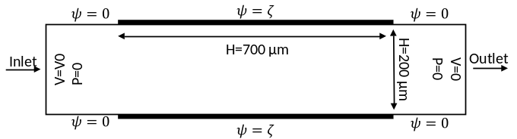
Figure 1. Schematic representation of microchannel for validation purpose.

The other models are a simple cascade micropump, conventional cascade micropump, and a cascade micropump with trapezoidal microchannels. The simple model with its dimensions is depicted in figure 2.
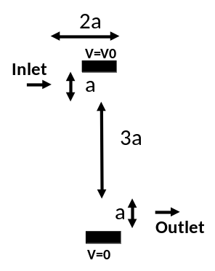
Figure 2. A simple cascade micropump schematic (a=200 µm).

These models are simulated by COMSOL Multiphysics. In the following section the results are presented.

Results
The most important procedure in numerical simulations is verifying the results. In the present paper, these results are compared with analytical ones to demonstrate the validity of simulation procedure. Duta and Beskok [2] proposed an analytical solution for zeta potential distribution and EO flow in microchannels. Herein, the simplified Helmholtz-Smoluchowski slip velocity and the analytical solution is used to find velocity field in the microchannel of figure 1. Figure 3 shows the results from these two solution methods. Figure 3A and Figure 3B present zeta potential distribution in the microchannel when $ζ=-0.08$ and the applied electric field strength is 45 (V/cm). Figure 3C shows velocity distribution of water in the microchannel width for the analytical and numerical results. This figure demonstrated the validity of the numerical results for further simulation of EO flows. It should be noted that since the numerical procedure is based on finite element method, mesh independency test also is performed for all of the cases. For instance, 100000 number of elements is used for the model shown in figure 1.

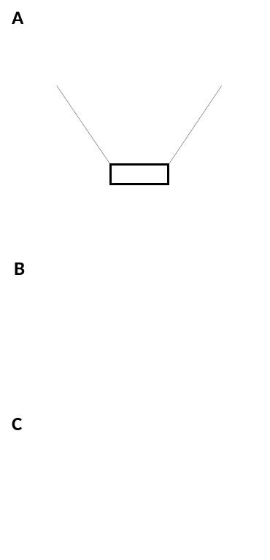
Figure 3. EO flow in microchannel. A) zeta potential distribution profile from analytical equations, B) zeta potential in the microchannel width from analytical equations, C) comparing analytical and numerical slip velocity results.

After validating the numerical results, three cascade micropumps are simulated. Figure 4 shows velocity distribution in these models.
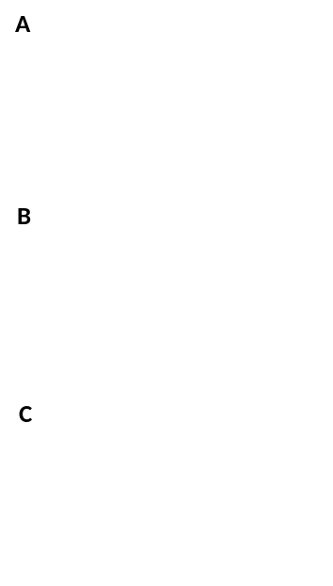
Figure 4. velocity profile in the: A) simple, B) rectangular, and C) trapezoidal cascade micropumps.

According to figure 4A, in a simple channel, velocity magnitude maximum occurs near the main channel walls where the slip velocity is defined. Figure 4B and figure 4C show that the maximum velocity increases due to the employing the side channels. Figure 5 shows these micropump flowrates in different applied electric potential.

Figure 5. Flow rate of the three different cascade micropumps.

Figure 5 demonstrates that the trapezoidal cascade micropump has higher flow rate comparing with the other studied cases. This is mainly because, this configuration leads to reducing pressure drop through the channel. To illustrate, 10 Pa pressure is introduced at the inlet of the conventional cascade micropumps and the trapezoidal one. Figure 6 compares the flow rates through these configurations. According to this figure, trapezoidal cascade micropump has higher flowrate due to the lower pressure drop.

Figure 6. Pressure drop effects on flow rate through the rectangular and trapezoidal cascade micropumps.

Thereafter determining that the trapezoidal configuration results in higher flowrate, it is optimized to find the dimensions which lead to higher efficiency. Nelder-Mead algorithm is used for this purpose. Micropump flow rate is the objective function and the control variables are shown in figure 7. Lower bond and upper bond for "b" are 200 and 600 µm respectively and "c" is studied in the range of 25 to 75 µm.

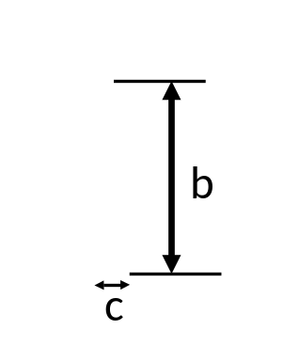
Figure 7. Control variables for optimization of the trapezoidal cascade micropumps.
After optimization the "b" and "c" dimensions are found to be 600 µm and 45 µm respectively. Figure 8 shows the iteration process by the optimization algorithm.

Figure. Iteration process to find optimized dimensions.

Conclusion
In the present numerical study, a novel cascade EO micropump based on employing trapezoidal microchannels is presented. In the first place, numerical results are compared with the analytical ones in order to validate numerical procedure. The numerical results show very good agreement with the analytical data. Then, three different cascade micropump are modeled and the results are compared with each other. It is found that a cascade micropump with two trapezoidal microchannel has higher flow rate comparing with simple cascade micropump and conventional ones. after finding the efficient prototype, its dimensions are optimized using Nelder-Mead optimization algorithm.

REFERENCES

1. Laser, D.J. and J.G. Santiago, A review of micropumps. Journal of micromechanics and microengineering, 2004. 14(6): p. R35.
2. Dutta, P. and A. Beskok, Analytical solution of combined electroosmotic/pressure driven flows in two-dimensional straight channels: finite Debye layer effects. Analytical chemistry, 2001. 73(9): p. 1979-1986.
3. Hadigol, M., R. Nosrati, and M. Raisee, Numerical analysis of mixed electroosmotic/pressure driven flow of power-law fluids in microchannels and micropumps. Colloids and Surfaces A: Physicochemical and Engineering Aspects, 2011. 374(1-3): p. 142-153.
4. Gallah, N., N. Habbachi, and K. Besbes, Design and modelling of droplet based microfluidic system enabled by electroosmotic micropump. Microsystem technologies, 2017. 23(12): p. 5781-5787.
5. Gallah, N. and K. Besbes. Electroosmotic micropump analysis for lab on chip water quality monitoring. in Systems, Signals & Devices (SSD), 2016 13th International Multi-Conference on. 2016. IEEE.
6. Jahanshahi, A., F. Axisa, and J. Vanfleteren, Fabrication of a biocompatible flexible electroosmosis micropump. Microfluidics and nanofluidics, 2012. 12(5): p. 771-777.
7. Ai, Y., et al., A low-voltage nano-porous electroosmotic pump. Journal of colloid and interface science, 2010. 350(2): p. 465-470.
8. Kwon, K., C.-W. Park, and D. Kim, High-flowrate, compact electroosmotic pumps with porous polymer track-etch membranes. Sensors and Actuators A: Physical, 2012. 175: p. 108-115.
9. Takamura, Y., et al., Low‐voltage electroosmosis pump for stand‐alone microfluidics devices. Electrophoresis, 2003. 24(1‐2): p. 185-192.
10. Brask, A., G. Goranović, and H. Bruus, Theoretical analysis of the low-voltage cascade electro-osmotic pump. Sensors and Actuators B: Chemical, 2003. 92(1-2): p. 127-132.
11. Park, H. and J. Lim, A reduced-order model of the low-voltage cascade electroosmotic micropump. Microfluidics and nanofluidics, 2009. 6(4): p. 509-520.
12. Kamali, R., M.K.D. Manshadi, and A. Mansoorifar, Numerical analysis of non Newtonian fluid flow in a low voltage cascade electroosmotic micropump. Microsystem Technologies, 2016. 22(12): p. 2901-2907.
13. Safaifar, F., N. Talebzadeh, and H. Veladi. Design, simulation and optimization of a novel DC electroosmotic micro-infusion pump. in Robotics and Mechatronics (ICRoM), 2014 Second RSI/ISM International Conference on. 2014. IEEE.
14. Wall, S., The history of electrokinetic phenomena. Current Opinion in Colloid & Interface Science, 2010. 15(3): p. 119-124.

