Simulation and Optimization of an Electrokinetic-Based Micromixer
Abdolhossein Zare¹, Yousef Bazargan-Lari¹
1. Department of Mechanical Engineering, Shiraz Branch, Islamic Azad University, Shiraz, Iran.
abdolhosseinzare@gmail.com
bazarganlari@iaushiraz.ac.ir
Abstract— Micromixing has a wide range of biomedical and biochemical applications. therefore, a large number of researchers have studied this microfluidic device and they have tried to propose a mixer with high efficiency. Micromixers are classified as passive and active based on their mixing method. The active micromixers have attracted the attentions due to their simple configuration and higher efficiency comparing with passive ones. induced charge electrokinetic (ICEK) micromixers are the active mixers which have introduced in the recent decade. Most of the previous investigations studied the polarizable obstacles near the microchannel wall. In the present paper, an ICEK micromixer is presented in which two hurdles are placed in the microchannel. After determining the efficient configuration for the hurdles, the optimized distance among them is determined by Nelder-Mead optimization algorithm.

Keywords— Microfluidics, Micromixer, ICEK, Optimization, CFD.

INTRODUCTION
Lab-on-a-chip Microfluidics field of research expands its range of application in biomedical diagnostics, drug development, and food and chemical industries due to the increase in surface to volume ratio [1]. One of the important component in in lab-on-a-chips are micromixers. homogeneous mixing of liquid samples is one the significant requirements for spectroscopic detection of glucose-catalyst reactions [2], soap free emulsifier [3], DNA purification [4], and post-reactors [5]. According to the literature, micromixers have been classified as passive and active. In the former category, mixing process is enhanced by designing microchannel in a way to increase turbulences in the mixing path. In contrast, in the active micromixers, an external energy source is employed to produce the turbulences. Both of these micromixers have some advantage and disadvantages. The passive micromixers facilitates integration, but they have complex configuration and lower mixing efficiency comparing with the active one. The main advantage of active mixers is their simple construction and high mixing efficiency. [6]. A large number of researchers have proposed different active micromixers employing acoustic [7] or magnetic field [8] as the external energy source to enhance mixing efficiency. One of the promising external energy sources to increase mixing is electric field and the resultant electrokinetic effect.
When an electric field applies through an electrolyte, it will be moved due to charge distribution in the liquid. This phenomena is known as electokinetics [9]. If a polarizable obstacle presents in the electric field, a non-uniform charge distribution will be generated on its surface. This will be caused some chaotic advection around the obstacle because of the attracting negative charges to one side and positive charges to the other side which is known as induced charge electrokinetic (ICEK) [10]. The resultant chaotic advection due to the ICEK effect have been widely employed in micromixers by many researchers.
Wu and Li [11] proposed a correction method to find charge distribution on a conducting hurdle in the electrolyte flow for numerical simulation. They compared their relation result with theoretical one and demonstrated the high accuracy of their equation. Then, they employed their method to model an ICEK micromixer in which two triangular conducting obstacles where presented. The resultant microvortexes around the obstacles result in enhancing mixing efficiency. Wu and Li [12] in their further investigation compared their numerical results with experimental ones. They demonstrated very good agreement between these results. In addition, they studied some additional cases to find the effects of hurdle geometry and position on the mixing performance in the microchannel. Daghighi and Li [13] proposed a novel micromixer in which a conducting particle was placed in a microchamber and as the resultant of the generated ICEK microvortexes around the particle, mixing occurred in the chamber. They demonstrated that their proposed method leaded to enhance mixing index to 100%. Zhang et al. [14] employed ICEK phenomenon to control concentration of species in a microchannel. They proved that ICEK flow have the potential to control species movement in the desired channel. Harnett et al. [15] utilized ICEK flow in a micromixer for sample preparation and demonstrated the high capability of this phenomenon for mixing.
According to the literature, some of the scholars have employed optimization methods to find the most efficient prototype for passive micromixers. For example, Chen et al. [16] did many numerical case studies to optimize a micromixer in which obstacles were used to enhance mixing passively. Chen and Li [17] employed method of moving asymptotes (MMA) to optimize a passive zigzag micromixer. Although in most of ICEK micromixers conducting obstacles were employed, there is no investigation on employing optimization algorithm to optimized the distance or geometry of these obstacles. In this work, we present a novel ICEK micromixer and employ Nelder-Mead optimization algorithm to optimize the proposed micromixer. This method have also employed for designing self-optimizing reactor system [18, 19]. In the first place, different conducting prototypes are placed in a microchannel and the configuration which lead to the maximum mixing in the microchannel is selected. Thereafter, two hurdles with the obtained geometry in the previous step is located in the microchannel and the optimum distance between them where results in mixing efficiency increasing is selected.

math
ICEK phenomena consists of two main physics. The first one is fluid flow. In order to find fluid flow in the microchannel momentum and continuity equations should be solved. These equations are:

$ρ\left[\frac{∂u}{∂t}+u∙∇u\right]=-∇p+η∇^{2}u+F$ (1)
$∇∙u=0$ (2)

Where ρ (kg/m³) is density, u is velocity, p (Pa) is pressure, $η$ (pa.s) is viscosity, and F (N/m³) is volume force. This force is due to the electric field interactions with the electrolyte. For the non-conducting wall, an approximated Helmholtz-Smoluchowski equation could be used to find fluid velocity in the microchannel [20]:

$u_{slip}=\frac{εε_{0}ζ}{µ} E$ (3)

Where ɛ is relative permittivity, ɛ₀ is vacuum permittivity, $ζ$ (V) is zeta potential, E (V/m) is the electic field, and µ (Pa.s) is fluid viscosity. For the conducting walls, Wu and Li [11] proposed a correction relation for the zeta potential. This equation is [11]:

$ζ_{i}=-∅_{e}+∅_{c}$ (4)

Where Ø_{e} is external electric potential and Ø_{c} is a constant correction potential which is obtained from:

$∅_{c}=\frac{\int_{S}{∅_{e}dA}}{A}$ (5)

In which A (m²) is conducting surface area.

For the mixing phenomena diffusion equation is solved to find concentration field of electrolytes in the microchannel. This equation is [12]:

$\frac{∂C}{∂t}+\left(u+u_{ep}\right)∇C=D∇^{2}C$ (6)

After finding the concentration, mixing efficiency should be calculated. This parameter is calculated from [12]:

$I=(1-\frac{\int_{0}^{W}{\left|C-C_{∞}\right|dx}}{\int_{0}^{W}{\left|C_{0}-C_{∞}\right|}dx})×100$ (7)
.

model definition
The equations in the previous section are solved by COMSOL Multiphysics software. This is a software which able to calculate ODEs based on finite element method [17]. Therefore, before investigating the main objectives of this paper, the numerical procedure is validated by comparing the simulation results and analytical ones. the model which is used for this purpose is a cylindrical polarizable obstacle in an electric field which was also used by Wu and Li for validation in their study [11]. Fig. 1 shows a schematic of this model.
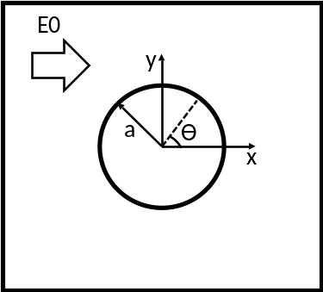
Fig. 1. Schematic illustration of the polarizable cylinder (a=15µm, E0=10 (V/cm)).

After verifying the reliability of the numerical results, an ICEK micromixer proposed in which a hurdle is placed within the microchannel. This model and the boundary conditions are shown in Fig. 2.
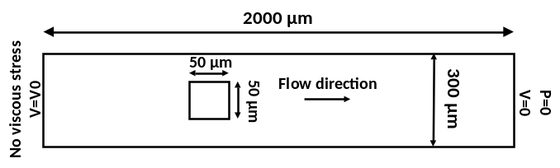
Fig. 2. Schematic illustration of the investigated mixer.

Electroosmotic fluid flow is induced in the microchannel considering The fluid flow in the microchannel is induced considering Helmholtz-Smoluchowski slip velocity on the microchannel wall [20]. In the nest section results of the studied models are presented.

results
As mentioned above, in the first place, validation of the numerical results is investigated. Squires and Banzant [21] proposed that the zeta potential distribution around a polarizable cylindrical obstacle in an electrolyte could be obtained from:

$ζ_{i}=2E_{0}a×cos⁡(θ)$ (8)

Wu and Li [11] proposed the general equation 3 to find zeta potential distribution around any desired polarizable obstacle in the electric field. In this paper, the obtained results from equation 3 are compared with the analytic results obtained from equation 8 for the model of Fig. 1. This comparison is shown in Fig. 3.

Fig. 3. Validation

Fig. 3 demonstrates that the numerical results of this paper are in very good agreement with the analytical ones. In addition, these results are also in good agreement with the obtained ones by Wu and Li [11]. It should be also mentioned that since the numerical procedure is based on finite element method, grid independency test is also performed for all of the cases. For example, for the cylindrical model of Fig. 1, almost 62000 number of elements are used.
After validating the numerical results, circular, rectangular, and triangular obstacles are placed in the microchannel of Fig. 2 to find which one results in higher mixing. In these cases, wall zeta potential is -50 (mV), diffusion coefficient is 1×10⁻¹⁰ (m²/s), and the applied electric field strength is 10 (V/cm). Fig. 4 shows concentration profile and velocity field stream lines for three different obstacle prototypes. The mixing indices for the circular, rectangular, and triangular obstacles are 67.65%, 84.15%, and 86.9% respectively. Previously Wu and Li [12] demonstrated that employing rectangular near wall obstacles leaded to higher mixing efficiency. However, our results show that when the obstacle is placed within the microchannel, triangular configuration results in higher mixing efficiency.
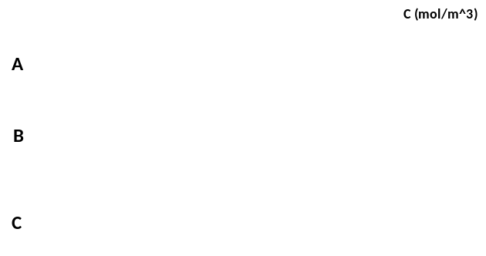
Fig. 4. Comparing the effects of obstacle with A) circular, B) rectangular, C) triangular configurations.

According to Fig. 2, the main reason for higher mixing index of triangular obstacle is higher microvortexes power around it. The mixing index in the case which the obstacle is not polarizable is about 20%. One of the methods which enhances the mixing efficiency in the microchannel is employing two obstacles. However, the distance between these two obstacles are important. Fig. 3 shows a parametric sweep for the distance between the obstacles and the concentration profile in the case which the mixing index is maximum (d=300 µm).

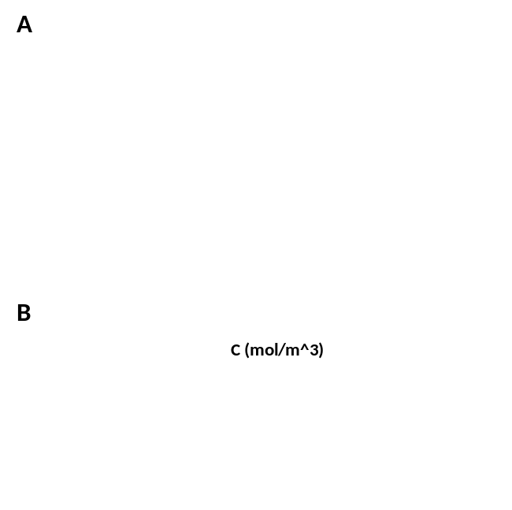
Fig. 5. Effects of initial distance of the obstacles on the mixing efficiency. A) mixing index regarding the obstacle distance, B) concentration profile when d=300 µm

Although Fig. 5A shows that the mixing index is maximum when d is 300 µm, since the step between the parametric sweep of the distances is 100 µm the maximum may occur in another place. Therefore, Nelder-Mead optimization algorithm is employed to find the position in which the mixing index is maximized in the range of 10 to 400 µm. Table 1 shows the iterations and mixing indices for each iterate. According to this table, d= 320 µm leads to higher mixing efficiency in the mixer.

Table 1. Nelder-Mead iterations
d(µm) | Mixing index
200.00 | 0.91965
320.00 | 0.92952
400.00 | 0.91806
240.00 | 0.91648
360.00 | 0.92115
280.00 | 0.91956
340.00 | 0.92605
300.00 | 0.92293
330.00 | 0.92791
310.00 | 0.92273
325.00 | 0.92230
315.00 | 0.92746
317.50 | 0.92685
320.00 | 0.92952

Conclusion
A novel active ICEK micromixer is investigated in the present paper. This mixer is based on employing two polarizable hurdles within the microchannel. The resultant microvortexes around them result in mixing enhancement. Results of previous investigation demonstrated that near wall rectangular obstacle leaded to higher mixing efficiency. However, the present results prove that triangular obstacle which is located inside the microchannel leads to better mixing in the microchannel (86.9%). This mixing index is also about 66% higher than the case in which the obstacle is not polarizable. In addition, employing two obstacles can be increase the mixing efficiency almost 8% more than the case in which one obstacle is used. In addition, Nelder-Mead optimization algorithm is utilized to find optimum distance between the hurdles. The results proved that 320 µm distance between the triangular obstacles leads to maximum mixing efficiency (almost 93%).

REFERENCES

1. Lee, C.-Y., et al., Microfluidic mixing: a review. International journal of molecular sciences, 2011. 12(5): p. 3263-3287.
2. Kim, D., et al., An easily integrative and efficient micromixer and its application to the spectroscopic detection of glucose-catalyst reactions. Analyst, 2005. 130(3): p. 293-298.
3. Mae, K., et al., Development of a new micromixer based on split/recombination for mass production and its application to soap free emulsifier. Chemical Engineering Journal, 2004. 101(1-3): p. 31-38.
4. Lee, N.Y., M. Yamada, and M. Seki, Development of a passive micromixer based on repeated fluid twisting and flattening, and its application to DNA purification. Analytical and bioanalytical chemistry, 2005. 383(5): p. 776-782.
5. Deshmukh, S. and D. Vlachos, Novel micromixers driven by flow instabilities: Application to post‐reactors. AIChE journal, 2005. 51(12): p. 3193-3204.
6. Cai, G., et al., A review on micromixers. Micromachines, 2017. 8(9): p. 274.
7. Tseng, W.-K., et al., Active micro-mixers using surface acoustic waves on Y-cut 128 LiNbO3. Journal of Micromechanics and Microengineering, 2006. 16(3): p. 539.
8. Chen, X. and L. Zhang, A review on micromixers actuated with magnetic nanomaterials. Microchimica Acta, 2017. 184(10): p. 3639-3649.
9. Bazant, M.Z. and T.M. Squires, Induced-charge electrokinetic phenomena. Current Opinion in Colloid & Interface Science, 2010. 15(3): p. 203-213.
10. Ren, Y., et al., Induced-charge electroosmotic trapping of particles. Lab on a Chip, 2015. 15(10): p. 2181-2191.
11. Wu, Z. and D. Li, Mixing and flow regulating by induced-charge electrokinetic flow in a microchannel with a pair of conducting triangle hurdles. Microfluidics and Nanofluidics, 2008. 5(1): p. 65-76.
12. Wu, Z. and D. Li, Micromixing using induced-charge electrokinetic flow. Electrochimica Acta, 2008. 53(19): p. 5827-5835.
13. Daghighi, Y. and D. Li, Numerical study of a novel induced-charge electrokinetic micro-mixer. Analytica chimica acta, 2013. 763: p. 28-37.
14. Zhang, F., Y. Daghighi, and D. Li, Control of flow rate and concentration in microchannel branches by induced-charge electrokinetic flow. Journal of colloid and interface science, 2011. 364(2): p. 588-593.
15. Harnett, C.K., et al., Model based design of a microfluidic mixer driven by induced charge electroosmosis. Lab on a Chip, 2008. 8(4): p. 565-572.
16. Chen, X. and Z. Zhao, Numerical investigation on layout optimization of obstacles in a three-dimensional passive micromixer. Analytica chimica acta, 2017. 964: p. 142-149.
17. Chen, X. and T. Li, A novel passive micromixer designed by applying an optimization algorithm to the zigzag microchannel. Chemical Engineering Journal, 2017. 313: p. 1406-1414.
18. Sans, V., et al., A self optimizing synthetic organic reactor system using real-time in-line NMR spectroscopy. Chemical science, 2015. 6(2): p. 1258-1264.
19. Poscharny, K., et al., Machine assisted reaction optimization: A self-optimizing reactor system for continuous-flow photochemical reactions. Tetrahedron, 2018. 74(25): p. 3171-3175.
20. Wall, S., The history of electrokinetic phenomena. Current Opinion in Colloid & Interface Science, 2010. 15(3): p. 119-124.
21. Squires, T.M. and M.Z. Bazant, Induced-charge electro-osmosis. Journal of Fluid Mechanics, 2004. 509: p. 217-252.

