

Towards design and manufacturing of biomedical implants with biological fixation: development of an integrated numerical model
Michal Krzyzanowski, Faculty of Computing, Engineering & the Built Environment, Birmingham City University, UK

Abstract
In recent years, orthopaedic implant research has been driven by biological fixation. In this type of fixation, a layer of biologically active material on the implant surface generates interfacial bonding between the implant and bone. The presence of bio-active material with appropriate level of porosity and crystallinity influences host bone regeneration by creating an environment allowing for cell spreading, proliferation and subsequent bone formation integrating the implant into the body. Their clinical applications are limited to non-load bearing implants due to brittleness and relatively poor mechanical properties. Multilayered coating of a mechanically tough substrate is an alternative route to reduce the risk of early implant failure. Faster and cheaper fabrication of such implants is expected with laser-assisted densification of multiple materials via additive manufacturing (AM) technology. The process is being developed to fabricate implants made of multiple materials in one operation without part-specific tooling and human intervention. Such implants having increased longevity provide more secure fixation using tailored properties, which cannot be achieved by conventional manufacturing techniques.
There are many factors that can influence a laser assisted AM of the implants reflecting in enhancement of their biological fixation. There appears to be no clear understanding of the cooperative relationships between different physical phenomena taking place in the manufacturing process on different scales of consideration. There is also lack of mathematical models, which could predict and link them with the macro- response of the multi-layered structures. This lack of relevant knowledge is the serious obstacle on the way toward reliable manufacturing and successful clinical use of such multi-layered implants made by AM methods.
The paper presents resent advances on development of an integrated model including specific mechanical, optical, thermal, thermo-mechanical, metallurgical and chemical phenomena taking place in the laser-assisted multi-material AM (Fig. 1). Most importantly, the development of such multiscale numerical model, which can support the design and manufacture of suchnovel implants, is multidisciplinary enterprise involving material design, implant design and fabrication, biological and clinical assessment among others. An establishment of an appropriate platform for cooperation between relevant institutions including universities, hospitals

and enterprises to facilitate research, development, preclinical and clinical studies is crucial.
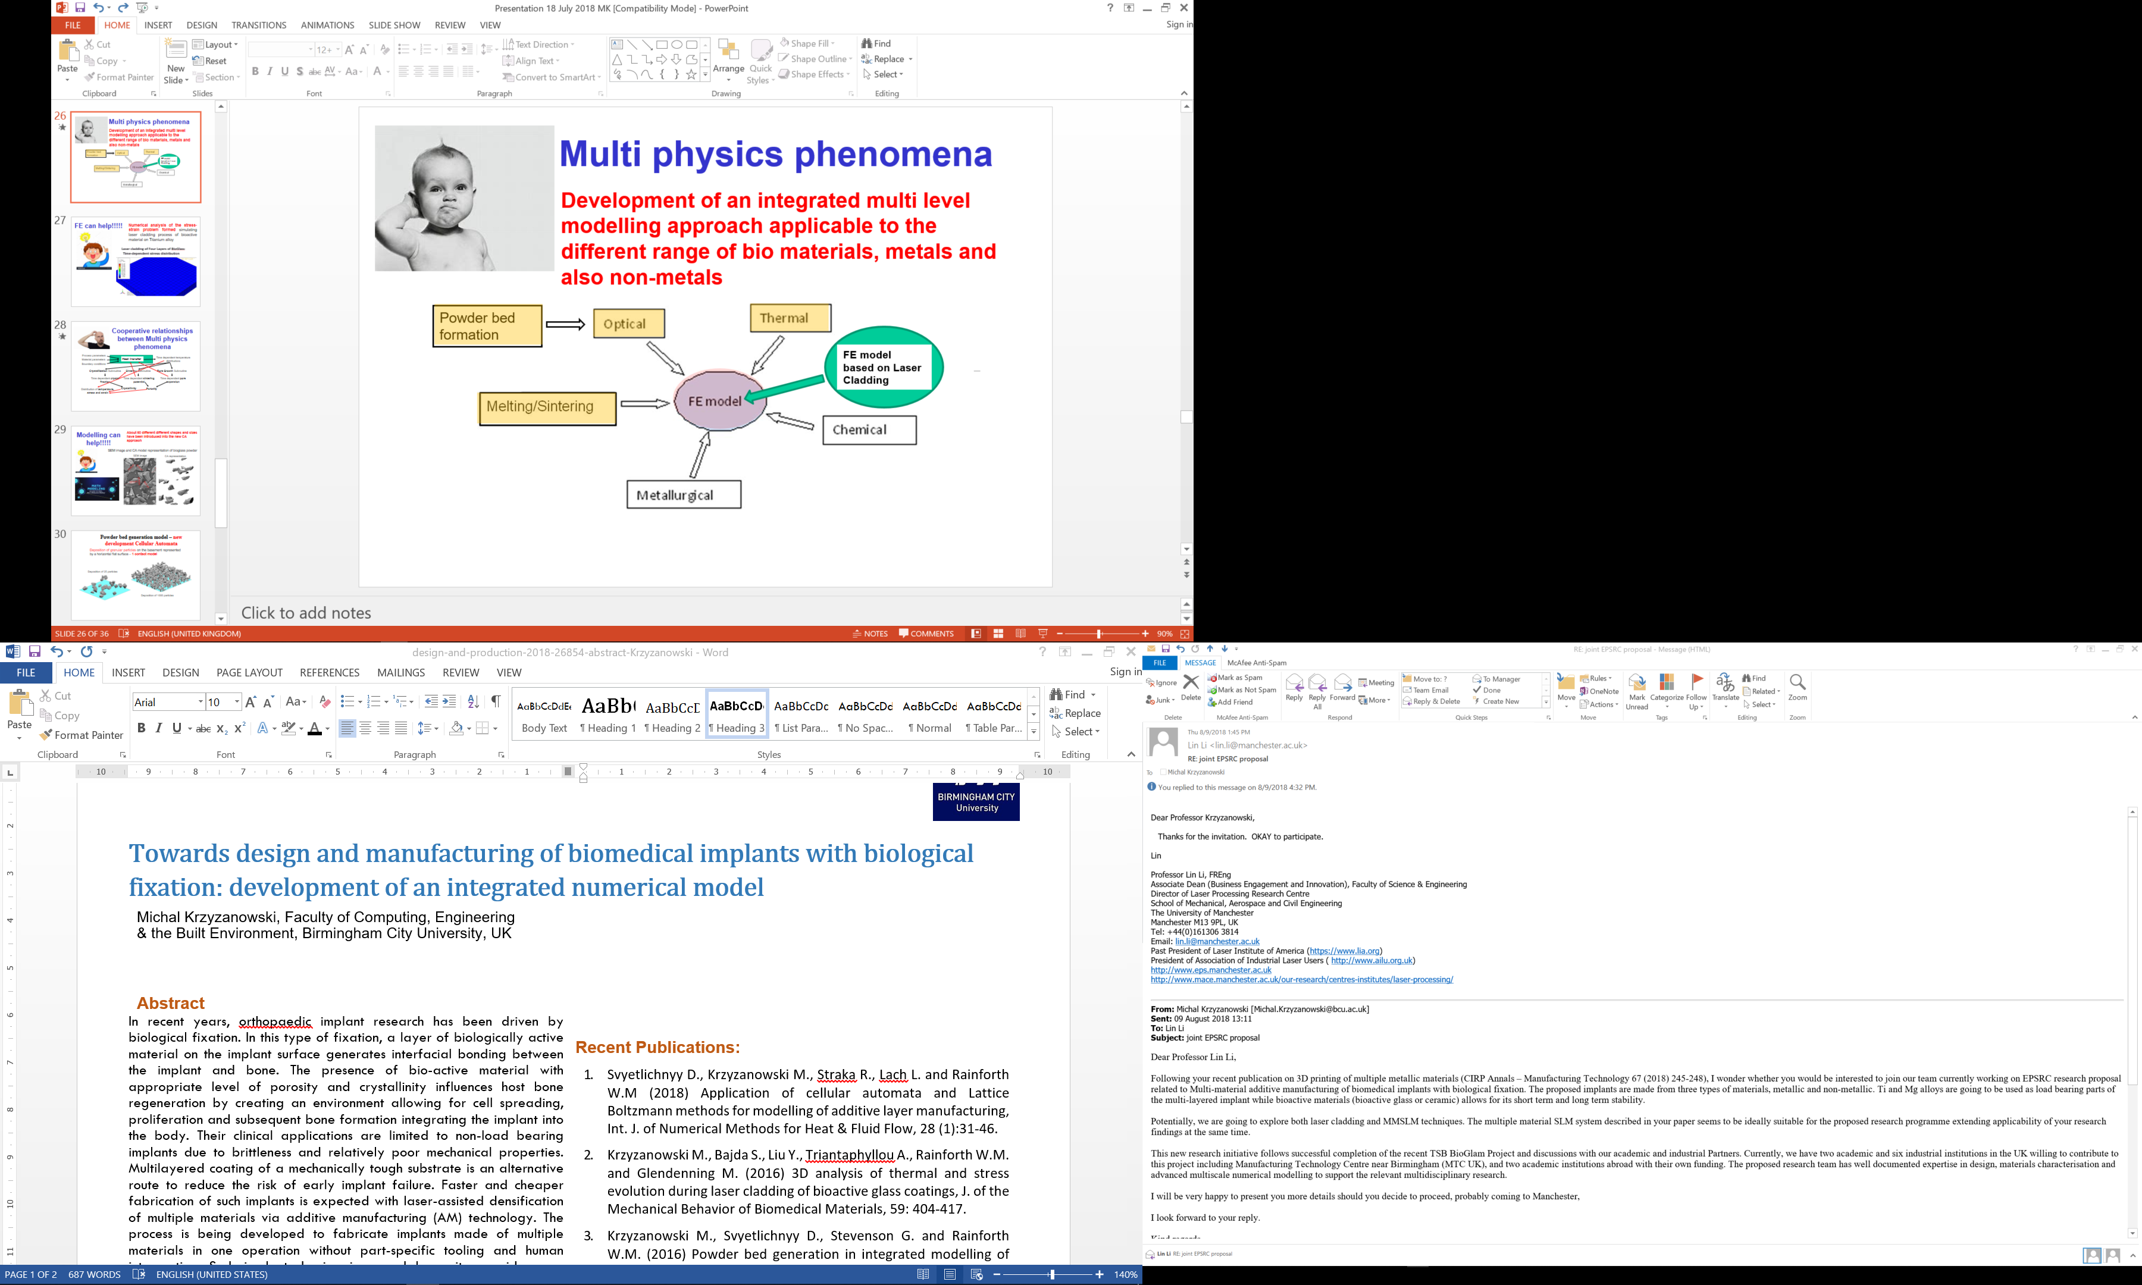
Key words: biomedical implants, bioactive materials, additive manufacturing, multiscale numerical analysis, finite element, cellular automata and Lattice Boltzmann methods.
Figure 1: Schematic representation of the integrated multiscale numerical approach applied for AM process development

Recent Publications:
- Svyetlichnyy D., Krzyzanowski M., Straka R., Lach L. and Rainforth W.M (2018) Application of cellular automata and Lattice Boltzmann methods for modelling of additive layer manufacturing, Int. J. of Numerical Methods for Heat & Fluid Flow, 28 (1):31-46.
- Krzyzanowski M., Bajda S., Liu Y., Triantaphyllou A., Rainforth W.M. and Glendenning M. (2016) 3D analysis of thermal and stress evolution during laser cladding of bioactive glass coatings, J. of the Mechanical Behavior of Biomedical Materials, 59: 404-417.
- Krzyzanowski M., Svyetlichnyy D., Stevenson G. and Rainforth W.M. (2016) Powder bed generation in integrated modelling of additive layer manufacturing of orthopaedic implants, J. of Advanced Manufacturing Technology, 87(1-4): 519-530.

Biography
Michal Krzyzanowski PhD DSc CEng FIMMM is a professor of Engineering and Materials Science at Birmingham City University, UK. He has served or is currently on many International Conference Scientific/Executive Committees and is a Fellow Member of the Institute of Materials and Mining, UK. He has co-authored of over 150 publications including one book, research monograph and several book chapters. His current research interests include also processing of nanocrystallised multilayered metallic structures and development of physically based modelling methodologies for investigation of multiphysical phenomena in additive manufacturing.

Presenting author details
web: http://www.bcu.ac.uk/built-environment/about-us/our-staff/michal-krzyzanowski

