

Rapid Alloy Prototyping for Steels
Stephen GR Brown, Swansea University, UK
Jonathan CT Cullen, Swansea University, UK
Shahin Mehraban, Swansea University, UK
Nicholas P Lavery, Swansea University, UK

Abstract (300 word limit)
Steel is the most widely used structural material in the world. Continuous innovations for new steel grades enables advances in important manufacturing sectors including automotive, packaging, defence and construction. However, the development of new steel alloys is a notoriously slow, iterative procedure which often results in significant business risk and requires expensive trials. Such trials may involve many 100s of tonnes of steel. This paper describes a high throughput approach to trials where small scale samples (grams as opposed to tonnes) are prepared and their properties and processability are quantified using materials characterization techniques and mechanical testing. The effectiveness of this small sample methodology is assessed by comparison to properties of well-known steel grades. The methodology has the potential of much faster development of improved steel grades and greater opportunity for their optimization.

Key words: Rapid Alloy Prototyping, Steel, High-Throughput Testing.

Image
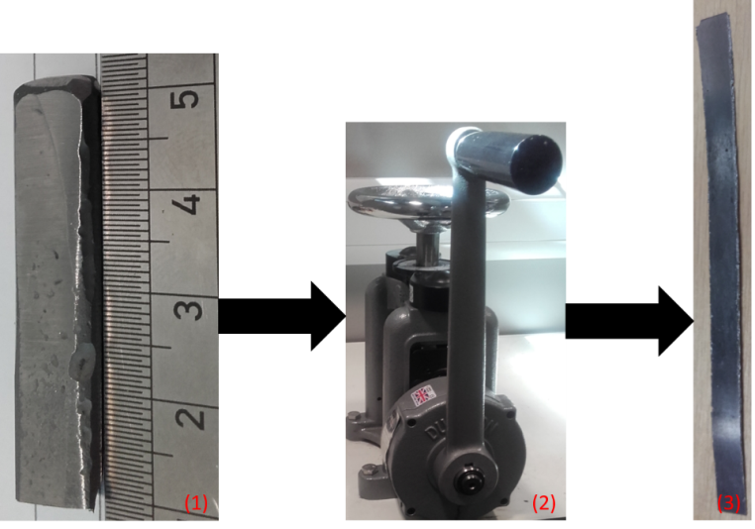
1. Small scale as-cast steel sample. 2. Bench-top rolling. 3. Sample after 80% reduction.
Recent Publications (minimum 5)
- Lavery NP, Mehraban S, Pleydell-Pearce C, Brown SGR, Jarvis DJ, Voice W & Brunnock M. (2015). Combinatorial development and high throughput materials characterisation of steels. Ironmaking & Steelmaking 42(10), 727-733.
- Riva S, Yusenko K, Lavery NP, Jarvis DJ & Brown SGR. (2016). The scandium effect in multicomponent alloys. International Materials Reviews 61(3), 203-228.
- Calvo-Dahlborg M & Brown SGR. (2017). Hume-Rothery for HEA classification and self-organizing map for phases and properties prediction. Journal of Alloys and Compounds 724, 353-364.
- Riva S, Tudball A, Mehraban S, Lavery NP, Brown SGR & Yusenko K. (2018). A novel High-Entropy Alloy-based composite material. Journal of Alloys and Compounds 730, 544-551.
- Riva S, Mehraban S, Lavery NP, Schwarzmüller S, Oeckler O, Brown SGR & Yusenko K. (2018). The Effect of Scandium Ternary Intergrain Precipitates in Al-Containing High-Entropy Alloys. Entropy 20(7), 488.

Biography
Stephen Brown completed his PhD in 1986 at Swansea University. He is Professor and Head of the College of Engineering at Swansea University. He has published more than 100 papers. He has spent his career in the field of computational modelling of materials processing. Current collaborative research with UK and international companies includes advanced Discrete Element Modelling of granular flows, Combinatorial Metallurgy approaches for alloy discovery and Additive Manufacturing of metallic components (both modelling and experimentation).

Presenting author details
Full name (As per the passport): Stephen GR Brown
University/Industry/Organization name: Swansea University
Designation (Director/Prof/Assistant or Associate prof/Researcher/Student): Professor
Country: Wales, UK
Mobile number (country code – number): +44 (0) 7960 725055
Email: s.g.r.brown@swansea.ac.uk
Track number: 11
Category (Oral presentation/ Poster presentation/Young researcher forum/E-poster): Oral presentation
Research interest: Computational Materials Science, Metal Additive Manufacture
Your profile page URL in your department: http://www.swansea.ac.uk/staff/engineering/s.g.r.brown/
Year of birth: 05/07/60
Linked In/Facebook/twitter account: www.linkedin.com/in/prof-stephen-brown-33814038

Note: Please fill up the Red mark fields so that it would be easier for us to cite your details in the conference particulars. (Please do not forget to fix your photo and Logo above the title)

