 Official Photo  University/Organization Logo
Consideration of Human Factors in A Design of Fire-rescue Widow
Yan Zhao, Luxun academy of fine arts, school of industrial design, Shen yang, 110004
Fang Bin Guo, Liverpool John Moores University, Faculty of Engineering and Technology, Liverpool, L3 3AF
Haibin Du, Luxun academy of fine arts, school of industrial design, Shen yang, 110004

Abstract (300 word limit)
Fire-rescue window is a NPD (new product development) project that aims to increase the successful rate of fire rescue. The concept attempts being used in residential buildings and public constructions. The project places greater emphasis on providing a safe space for sufferers such as elder people, children and disables. It intended to insulate people from a fire through easy operations and to enhance safety and usability. After several tests, it is proofed that the product appears to be an effective and creative solution in fire rescue.
Human factors knowledge has been considered over the NPD process at both physical (anthropometric) and psychological (cognitive) levels. Based on background research and application of new material & technology, the concept learned from mechanism principle and assimilated into understanding of environment/system design, Kansei engineering and material technology. Driven by user centred design, the design conducted various research methods in terms of observation, recording and analysis. Sufferers’ data and information have been discovered/ collected, in particular disables. This helps to determine a proper route of escaping. A prototype of concept simulated the window’s covetable structure and function, as well as testified the rationality of special usage.
The fire-rescue window is named as - ‘Harbour’, which won the gold medal of ‘Janus Design Award 2016’ in France. ‘Harbour’ has been recognized as one of the successful solutions in the field of fire rescue.

Key words: fire-rescue window; rescue and self-rescue; design innovation; user centred design; human factors; ergonomics

Image
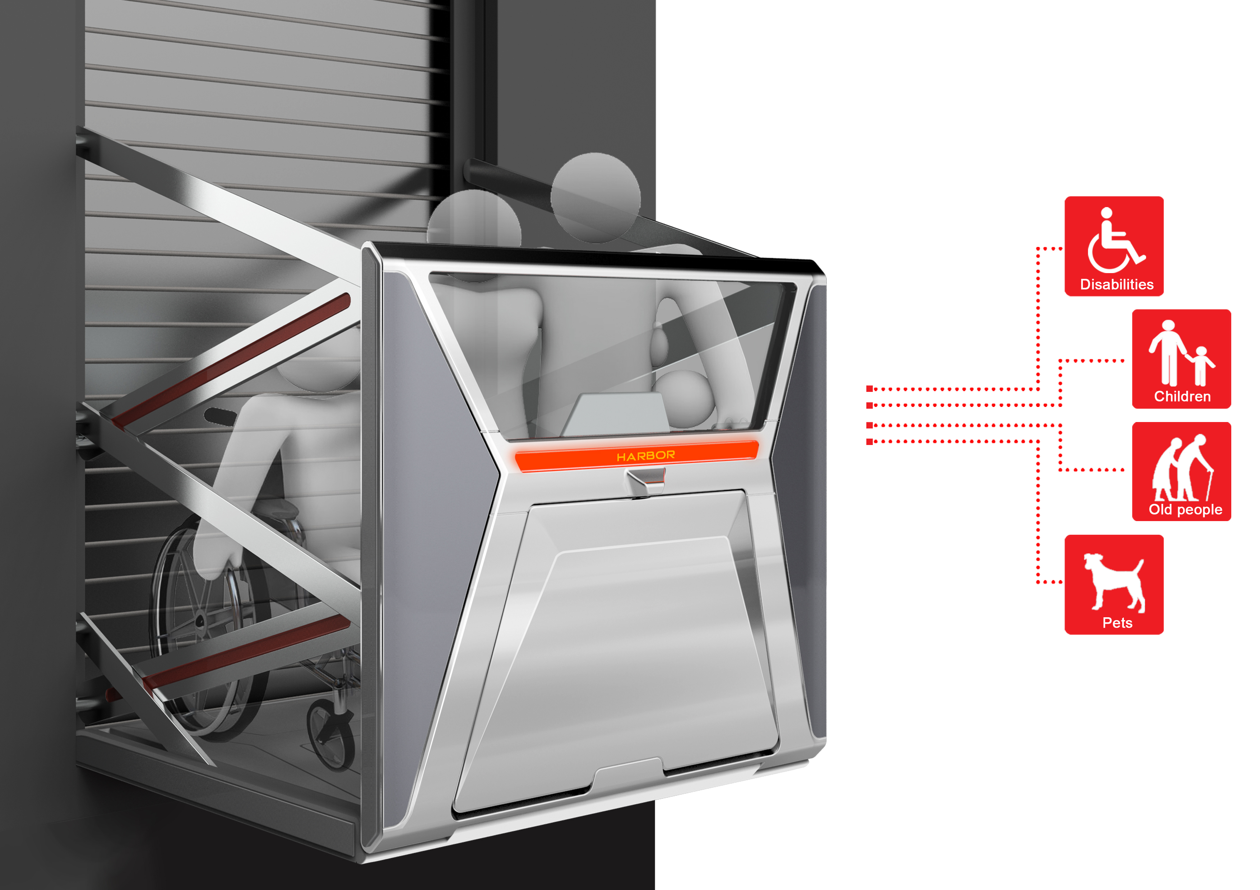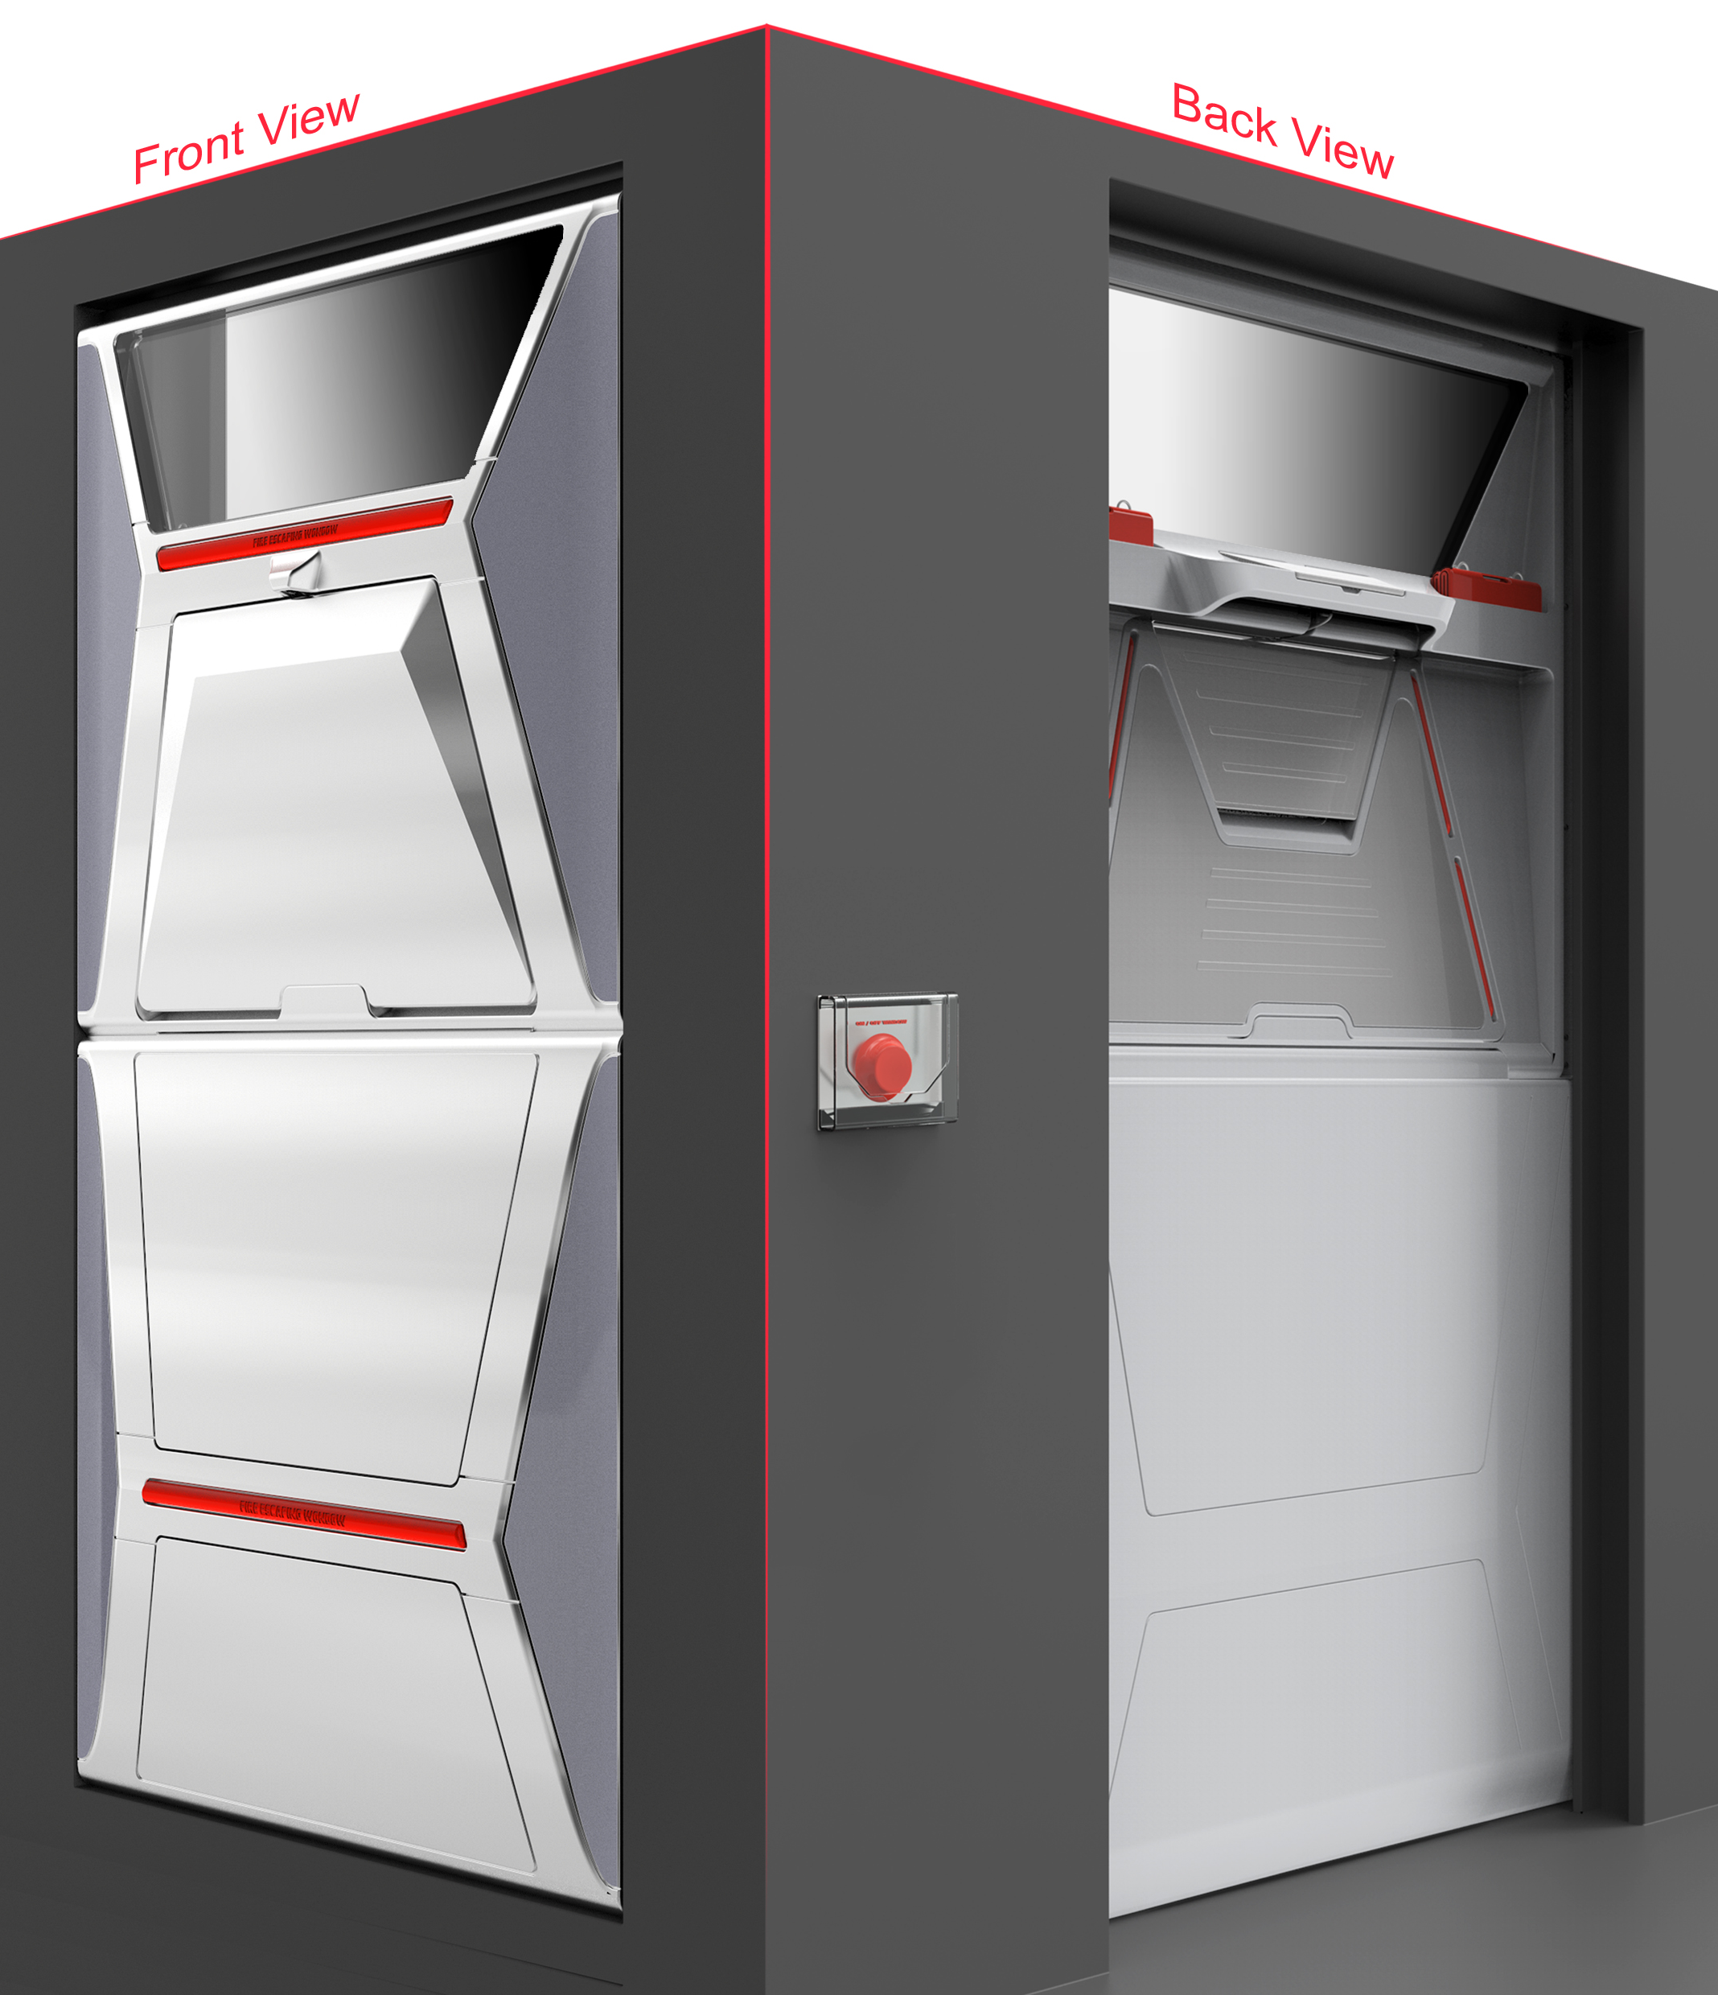
Recent Publications (minimum 5)
- Fangbin Guo (2017). Capturing Imagination: A Shift from Teaching to Learning. The proceeding of ICERI2017, Seville, Spain
- Delft College of industrial design and engineering(2014). Technische Universiteit Delft, Design method and strategy[M]. Wuhan: Huazhong University of Science and Technology Press, 2014. p137-p141.
- Experience design studio(2015). Experience design, Beijing: Communication University of China Press, 2015. p31-p37, p90-p112.

Biography
Ms ZHAO Yan is a lecturer of industrial design at Luxun Academy of Fine Arts. She holds BA & MA degrees in Industrial Design. She won lots of well-known international design awards include: two “Best of Best” medals in Reddot Award (Germany), three A' Design Awards (Italy), one Gold medal of IDA Award (US), one Gold medal and one Silver medal in Janus Awards (France). Together with over 15 design awards in China. In 2017, the IDA Gold award. Huanghai” coach design has been manufactured and particularly exported to Thailand.

Presenting author details
Full name (As per the passport): G56048502
University/Industry/Organization name: Luxun Academy of Fine Arts
Designation (Director/Prof/Assistant or Associate prof/Researcher/Student): Lecturer
Country: China
Mobile number (country code – number): 86-13898918585
Email: ZZHAOYANN@163.com
Track number: http://design-production.conferenceseries.com/call-for-abstracts.php (For track number follow this link)
Category (Oral presentation/ Poster presentation/Young researcher forum/E-poster): Oral presentation
Research interest: Industrial and product design, Ergonomics
Your profile page URL in your department:
Year of birth:
Linked In/Facebook/twitter account:

Note: Please fill up the Red mark fields so that it would be easier for us to cite your details in the conference particulars. (Please do not forget to fix your photo and Logo above the title)

