Cutaneous Amyloidosis: A case report and literature review

M Moatamedi, Department of Dermatology, Salford Royal Hospital NHS Foundation Trust, UK

Mohammad H Derakhshan, College of MVLS, University of Glasgow, UK

Clinical Finding:

A 63 years old female presented with a 6-year history of discoloured areas on right palm, right middle and ring fingers. She was asymptomatic except for one episode of bleeding following minor trauma. She was right handed.

Past medical history included premature labour followed by total abdominal hysterectomy, irritable bowel syndrome, essential hypertension, duodenal ulcer, CVA and depression. She was an ex-smoker. Her current medication included Aspirin. There was no drug allergy.
Examination revealed dull red, flat, non-pulsatile areas on palm (Fig 1 and 2). There was no hyperkeratosis or ulceration. Small venous lake on right upper lip was noted.

Investigations:

Blood tests including FBC, BCP, LFT and CRP reported within normal values. Immuno-electrophoresis resulted in slight increase in IgM but no para-protein band. There was no evidence of Bence Jones proteinuria.
Skin biopsy was performed with following findings (Fig 3):
Epidermis: thick keratin
Dermis: eosinophilic material, probably fibrin with loose stroma and loose red cells, some ectasia of small blood vessels but no haemosiderin.
Histology sample re-examined. Patient declined to have rectal biopsy.
Diagnosis: Cutaneous Amyloidosis

Discussion:

Amyloidosis is defined by extra-cellular deposition of proteinaceous substance or various insoluble proteins that results in considerable tissue dysfunction. It may affect heart, kidney, gastrointestinal tract, nervous system and skin (dermal layer). It was first reported by Rudolph Virchow, German physician in 1854. Amyloidosis is usually classified as primary or secondary according to the underlying cause. Recent classification is based on biochemical findings (Table 1).

In this case, clinical findings suggested Primary Localised Cutaneous Amyloidosis (PLCA). In this condition there is deposition of amyloid in previously normal skin with no evidence of deposits in internal organs. It is associated with chronic friction or epidermal damage - friction amyloidosis. According to the clinicopathological observations, PLCA is classified as Macular, Papular or Lichen Amyloidosis, Nodular or Tumefactive and Familial (dyschromic).
Macular form is presented with flat dusky-brown or grey macules that may coalesce with variable degree of itchiness. It is usually symmetrical and affects upper back, chest and occasionally arms. It presents in early adult life with female to male predominance. Pathological finding includes amyloid in papillary dermis with no involvement of blood vessels or adnexal structures. There are small amorphous globules. Epidermis has normal thickness.

Papular or Lichen Amyloidosis is the most common form. It presents with intense itchiness and multiple scaly red or brown papules that may coalesce into plaques. It is more common male, between 50-60 years. Pathological finding includes focal deposit, large enough to expand dermal papillae displaced rete ridges.
Epidermis has irregular acanthosis and hyperkeratosis.

This case suggests Macular form of PLCA although it differs from some usual clinical and pathological presentations.

Primary cutaneous amyloidosis has been reported in different body areas including eyelid (1) and the auricular concha (2). Cutaneous amyloidosis may be associated with systemic amyloidosis. There are case reports of sarcoidosis and IgA nephropathy in association with extensive macular amyloidosis. At least a subset of PLCA patients, especially those with extensive involvement, may have associated autoimmune/immune disorders raising the possibility of a common underlying immune-mediated mechanism (3).

Familial PLCA shows autosomal dominant inheritance, but there is clinical and genetic heterogeneity and variable clinical penetrance (4).

Management of PLCA is challenging. In this case, patient was treated with potent topical steroid with no significant improvement. Other options include: Calcipotriol, Phototherapy, DMSO (dimethyl sulfoxide), Etretinate, Acitretin, Cyclophosphamide, Ciclosporin, Cryotherapy, Dermabrasion, CO2 laser and Surgical measures.

REFERENCES:

1. Mun KS, Pailoor J, Reddy SC. Primary localised deep cutaneous amyloidosis of the eyelid. Malays J Pathol. 2005; 27: 113-5.
2. Shimauchi T, Shin JH, Tokura Y. Primary cutaneous amyloidosis of the auricular concha: case report and review of published work. J Dermatol. 2006; 33: 128-31.

3. Dahdah MJ, Kurban M, Kibbi AG, Ghosn S. Primary localized cutaneous amyloidosis: a sign of immune dysregulation? Int J Dermatol. 2009; 48: 419-21.

4. Sakuma TH, Hans-Filho G, Arita K, Odashiro M, Odashiro DN, Hans NR, Hans-Neto G, McGrath JA. Familial primary localized cutaneous amyloidosis in Brazil. Arch Dermatol. 2009; 145: 695-9.

Table 1: Classification of Amyloidosis

Clinical type of Amyloidosis | Amyloid fibril protein | Precursor substance
Primary  (immuno-cytodyscrasia) | AL (amyloid L chain) | Monoclonal immunoglobulin light chain
Secondary (chronic active disease) e.g. Rheumatoid arthritis, osteomyelitis | AA (amyloid A) | Serum amyloid A protein (SAA)
Haemodialysis associated | β2 –macroComparison of globulin
Heredo-familial (commonly affected kidney), rare | various e.g. Transthyretin (TTR)

Fig 1: Erythematous discolouration

of right palm, compared to normal left palm

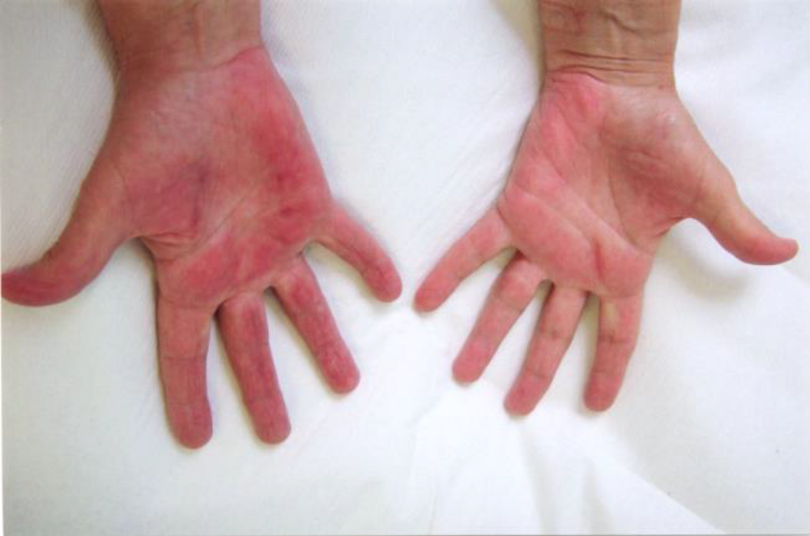

Fig 2: Close up of skin changes on right palm

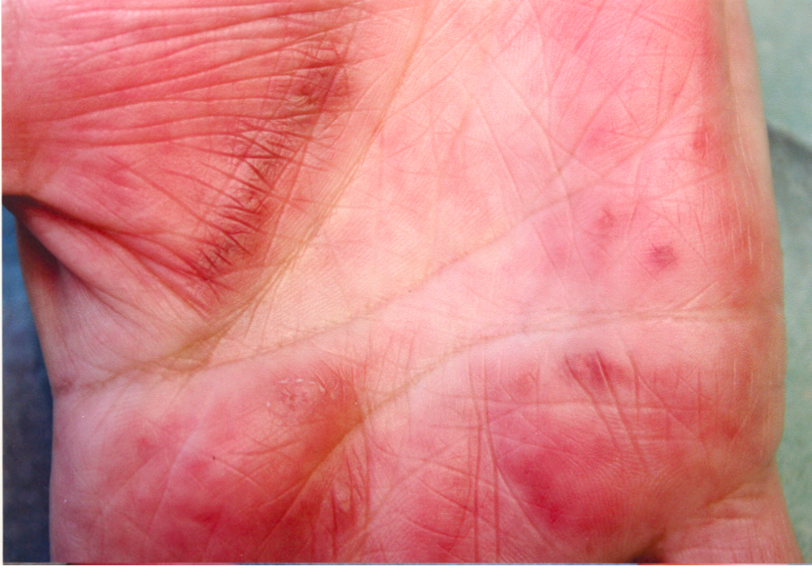

Fig 3: Photomicrograph of skin biopsy, note the thick keratin in epidermis and fibrinoid material in dermis associated with small vessel ectasia

