Nuisance of Complexion Lightening Ads
Dr. Asma Tariq, Senior Registerar, Department of Dermatology
Faisalabad Mediacal University, Pakistan
Abstract:
A case series of 12 patients is documented; 4 males and 8 females with mean age of 23 years (range 13 to 38 years). These presented to the Out-Patient Department of Dermatology, DHQ Hospital, Faisalabad during the month of November, 2013.
The main complaint was spontaneous development of erythema, telengiectasias, acne-form eruption, burning, photosensitivity, pigmentary changes and thinning of skin. Face was predominately involved followed by hands, neck, and even feet. On detailed scrutiny, it was disclosed that they were in habit of using different whitening/skin lightening creams available in the market. They were using these alone and/or after mixing these with moderate to potent steroids. These preparations were either selfprescribed on seeing commercials on print and electronic media or were advised by some friends, family member, beauticians, local quacks or even by their physicians.
These individuals were motivated/thrilled for fair complexion by every-day advertisements/commercials endorsing that fair is lovely and white skin tone is the key towards personal and professional successes. Teenagers were particularly much overwhelmed by this discriminating message conveyed by excellently filmed television commercials and it was very difficult to stop their craving for skin lightening creams.
It is high time and need of the day that these sorts of commercials and advertisements may be banned as has been done with tobacco smoking so to save our youngsters from inferiority complex and to pacify the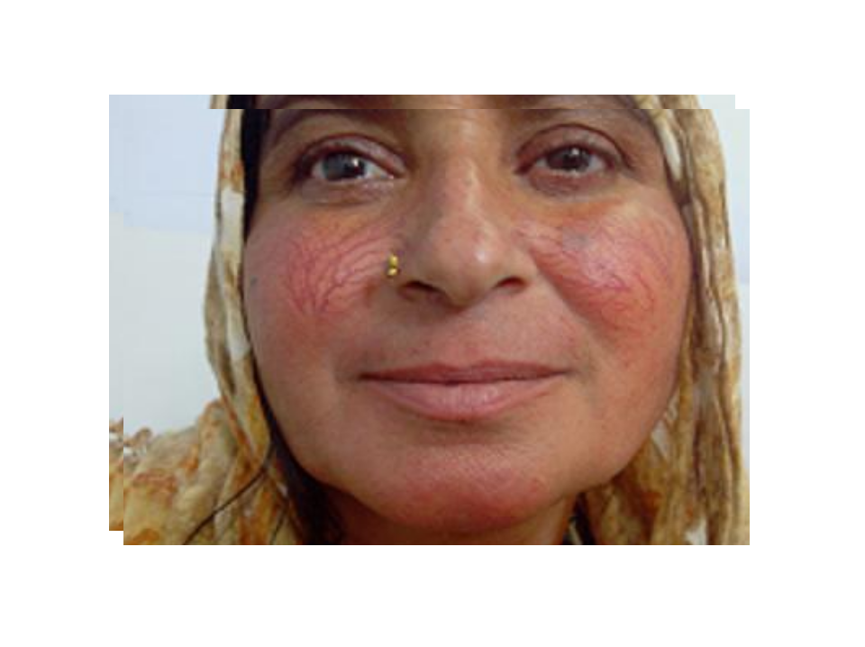ir urge for fair complexion. 