Autologous Adipose Derived Stem Cell Versus Platelet Rich Plasma Injection In The Treatment Of Androgentic Alopecia: Efficacy, Side Effects And Safety
Mostafa Hamed Kadry ¹,Wael Abou El-Kheir²,Mamoun El-Sayed Shalaby³, Ahmed Rashad El Shahid³, and Hala Gabr Metwally⁴

Randomized controlled prospective single blinded comparative clinical study was conducted
1
Dermatology Department, Faculty of Medicine, Helwan University Cairo, Egypt.
e-mail: dr_mostafa_kadry @yahoo.com
tel: (+2) 01003020600
2
Immunology Department, Military Medical Academy. Cairo, Egypt.
e-mail: dr.wael2008@yahoo.com
tel: (+2) 01006029310
3
Dermatology Department, Faculty of Medicine, Al-Azhar University. Cairo, Egypt.
4
Clinical pathology Department, Faculty of Medicine, Cairo University Cairo, Egypt.

Keywords:

Platelet Rich Plasma, Autologous Activated Platelet Rich Plasma, Adipose tissue adult stem cells, Adipose derived stem cells, Androgenetic alopecia, Stromal vascular fraction.

BACKGROUND
Platelet Rich Plasma (PRP) is based on the release of growth factors stimulating the initiation/extension of anagen phase as well as promoting vascularization, Adipose Derived Stem Cell (AT-ADSCs) treatment were recently introduced as an alternative potential therapeutic application for hair growth.

OBJECTIVE
The aim of this study was to assess the efficacy side effects and safety of AT-ASCs and PRP in the treatment of androgentic alopecia.
.

PATIENTS AND METHODS
Sixty randomized patients were treated by PRP, and AT-ASCs. Each patient was evaluated, and each lesion was treated by those modalities, patients received three sessions with one month interval for 3 months, follow up after 3 months.

RESULTS
A highly significant improvement <0.001 in terminal hair count of AT-ASCs group evaluated by videodermoscopy assessment of AGA. That were confirmed by highly significant improvement in inter-mediate hair count and mean caliber (<0.001) associated with high incidence of side effects especially headache and erythema.
In contrast, PRP group showed significant improvement 0.037 in terminal hair count and non signanficant improvement in inter-mediate hair count and of mean caliber with minimum side effects.
AT-ASCs showed a significant improvement in terminal hair count than PRP, Highly significant improvement in Inter-mediate hair count and hair caliber.
Also, side effects of AT-ASCs showed highly significant pain, headache and erythema but no serious adverse events.

CONCLUSION
Our study suggests that the There was significant improvement in AGA after PRP and highly significant after AT-ASCs therapy with significant difference of ADSC in terminal hair count and highly significant in caliber. Both modalities could effectively and safely be used to treat AGA.

AGA is a skin disorder occurring in about 80% of men and 50% of women during their lifetime ¹. The Treatment of choice is still controversial. which include medical treatments or surgical hair transplantation ². The goal for treating alopecia with AT-ADSCs includes increasing the number of existing follicles ³. Platelet Rich Plasma (PRP) is characterized by a high concentration of platelets with high concentration of growth factors ⁴. This may help in stimulation and proliferation of stem cells, development of new follicles and promoting neovascularisation ⁵.
Platelet-rich plasma (PRP) injections for hair restoration has emerged to a popular practice, because both highly demanding patients and surgeons are seeking for minimally invasive and cost efficient treatment modalities for androgenic alopecia ⁶.
Adipose-derived stem cell-conditioned medium have already used to treat alopecia and reported good results ⁷.
None of the current modalities of treatment can improve Androgenic alopecia (AGA) completely. That’s why AT-ASDCs and PRP were used in this study. The aim of the present study was to evaluate the efficacy, side effects and safety of autologous adipose derived stem cell versus Platelet Rich Plasma injection in the treatment of androgentic alopecia.
Randomized controlled prospective single blinded comparative clinical study will be conducted
.

Patients and Methods
This is a prospective randomized comparative controlled study. Ninety three patients presented with Androgenic Alopecia (AGA). They were assessed for eligibility according to defined inclusion and exclusion criteria ⁸. Sixty patients were eligible to participate in this study. They were recruited from Dermatology Outpatient Clinic, at Al-Hussien Hospital Al Azhar University (Cairo), Egypt. Al Azhar research ethical committee approval was obtained. The study was conducted from November 2015 till October 2016. The study protocol conformed to the guidelines of the declaration of Helsinki. A written and informed consent was obtained from patients before study enrollment.
A detailed history and routine laboratory investigations were done.
The patients were instructed to avoid using any other modalities of treatment for AGA during the course of the study. Patients were included if they were older than 20 years, and presenting different grades of patterns hair loss Hamilton-Noorwood and Ludwig classification. Patients were excluded if they were on local medications six month prior to their enrollment, pregnancy, bleeding disorders, history of keloid formation and malignancy ⁸.
Patients received three sessions with 1 month interval for 3 months and followed up after 3 months.
All patients were randomized by lottery and divided into 2 groups and subjected to the following treatment: AT-ASCs and PRP.
PRP (Platelet Rich Plasma) group, thirty lesions were treated by Sterfile European Conformity (CE) marked RegenLab® kit (Regen Lab., Le Mont-sur-Lausanne, Switzerland) was used for preparation of PRP. Eight ml blood sample was aspirated from the patient's peripheral vein, the test tube centrifuged at 1,500 rpm for 5 minutes. A 30 G needle was used for superficial microinjections. Injections were spaced about 1 cm apart. The injections were intradermal (ID) administered. Injection amount was 0.1 ml per injection ⁴.
AT-ADSCs group, thirty patients were treated by AT-ADSC and stromal vascular friction SVF, Fat will be harvested by syringe aspiration with a long atraumatic cannula from the lower abdomen Fig. (1) and Fig.(2).
Fat will be harvested by syringe aspiration minimally 250 ml Fig. (1). Adipose-derived stem cells washing with sterile phosphate buffered saline (PBS) to remove the blood cells, saline, and local anesthetics. Adipose-derived stem cells will be separated from adipose tissue by digestion with 0.075% collagenase at 37 C for at least 30 min with agitation. Collagenase then is inactivated by the addition of an equal volume of Dulbecco’s modified Eagle medium (DMEM) containing 10% fetal bovine serum (FBS) and 1% penicillin–streptomycin (Gibco, Carlsbad, CA, USA). The stromal vascular fraction (containing the ADSC) will be separated by centrifugation at 1200×g (1,500) rpm for 5 min for five minutes. The stromal vascular fraction located in the pellet derived from the centrifuged fat at the bottom of the lipoaspirate will be collected in syringes and will be injected intra-dermal in the scalp Fig.(2).
Antibiotic will start 48 hours before the procedure and continue for 1 week after the procedure. Topical Fucidin cream ® (Fusidic 2%) (LEO Pharmaceuticals) was applied twice daily for 1 week.
Patients were asked to notice and report any adverse effects.

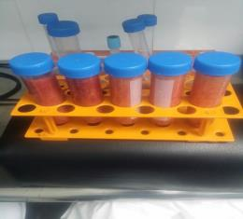
Fig. (1): Fat will be harvested by syringe aspiration.
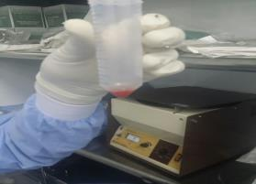
Fig.(2): The stromal vascular fraction located in the pellet derived from the centrifuged fat at the bottom of the lipoaspirate will be collected in syringes and will be injected intra-dermal in the scalp.

Videodermoscopic Assessment
The videodermoscopic system is basically composed of the Colored video camera and Computer software for hair analysis which connected to computer where a software program by using the TricohSciencePro version 1.5 special edition (Trilogic and B&B, Boston, MA, USA) is opened to make a new file for every patient specified with a profile data and picture elicited Analysis of hair count including terminal hair (per square centimeter) and Analysis of hair diameter.

Photographic Assessment

Determination of the grade of alopecia

By taking 2 pictures by using a Nikon D5300 camera (Nikon corp., Tokyo, Japan) 24.2 megapixels DSLR digital single-lens reflex Camera with 18-55 mm Lens. Photographs were obtained at baseline and at each session and 3 months after the end of treatment for follow up using identical camera settings, lighting and patient positioning., one for the frontal and the other for the vertical area and then to determine it resemble which grade of Hamilton-Noorwood Classification in male pattern and according to Ludwig classification in female pattern.

Determination of the Degree of improvement
Degree of improvement was assessed according to grade of change in Hamilton-Noorwood classification types as follow: Mild and moderate improvement means there is improvement but still within the same grade.Good improvement if there is changing in the grade. Excellent: if improvement results in changing the type to type I or to normal.

Statistical Analysis
Data were coded and entered using the statistical package SPSS version 24. Data was summarized using mean and standard deviation for quantitative variables and frequencies (number of cases) and relative frequencies (percentages) for categorical variables. Comparisons between groups were done using unpaired t test in normally distributed quantitative variables while non-parametric Mann-Whitney test was used for non-normally distributed quantitative variables. For comparison of serial measurements within each patient paired t test or the non-parametric Wilcoxon signed rank test were used ⁹. For comparing categorical data, Chi square (χ2) test was performed. Exact test was used instead when the expected frequency is less than 5 ¹⁰. P-values less than 0.05 were considered as statistically significant.

Results
Sixty patients participated in this randomized comparative study Table (1). 30 healthy volunteers served as PRP. Their age ranged from 20 - 35 years with a mean of 27.6 years with 20.3 mean age at the start of AGA.
In addition, 30 healthy volunteers served as ADSC. Their age ranged from 20 - 35 years with a mean of 26.8 years and 22.3 mean age of startof AGA. There was no significant difference between PRP and ADSC as regard personal and medical characteristics Table( 2).
Table (1) :Demographic data of patients
 | Number | Percentage
Age (years):  Mean + SD  (Range) | 27.2± 4.1  (20-35)
Family history:  Negative  Positive | 8  52 | 13.3%  86.7%
Sex | Male=28 | Female=32
AGA type:  Norwood classification  Grade II:  Grade III:  Grade IV: | 10  8  10 | 16.6%  13.3%  16.6%
Ludwig classification  Female pattern hair loss  Grade II:  Grade III: | 20  12 | 33.3%  20%
Duration:  Mean + SD  Range | 7.2±3.84  ( 1- 15 Y)
SD= Standard deviation, Y= Years
Table( 2): Comparison between PPP and ADSC cases as regard personal and medical data
 |  | PRP | ADSC | t/x²# | Sig
Age (years) |  | 27.67±4.62 | 26.80±3.65 | 1.045 | 0.593
Sex
Male |  | 15 (50%) | 13 (43.3%) | 0.067# | 0.795
Female |  | 15 (50%) | 17 (56.7%) | 0.067# | 0.795
Duration |  | 6.7±2.95 | 7.2±3.84 | 0.730 | 0.574
Alopecia starting age |  | 20.33±3.59 | 22.30±2.95 | 1.391 | 0.127
Hamilton-  Norwood | 2 | 7 (23.3%) | 3 (10%) | 5.900# | 0.211
Hamilton-  Norwood | 3 | 3 (10%) | 5 (16.6%) | 5.900# | 0.211
Hamilton-  Norwood | 4 | 5 (16.6%) | 5 (16.6%) | 5.900# | 0.211
Ludwig  grade | 1 | 12 (40%) | 8 (26.6%) | 5.900# | 0.211
Ludwig  grade | 2 | 3 (10%) | 9 (30%) | 5.900# | 0.211
Independent Sample t-test; x²: Chi-square test

Photographic assessment:

Determination of the Degree of improvement (Comparison of photographic findings between PRP and ADSC cases)

Photographic assessment before and after PRP cases injection Table (3).

Degree of improvement was assessed according to grade of change in Hamilton-Noorwood classification and Ludwig classification as follow:
- Fourteen patients (46.66%) showed no improvement with photographic assessment.
- Twelve patients (40%) showed mild photographic improvement but still in the same grade.
- Four patients (13.3%) showed moderate photographic improvement in hair thickness and density but still in the same grade.

Photographic assessment before and after ADSC cases injectionTable (3).
Degree of improvement was assessed according to grade of change in Hamilton-Noorwood classification and Ludwig classification as follow:
- Nine patients (30%) showed no improvement with photographic assessment.
- Nine patients (30%) showed mild photographic improvement but still in the same grade.
- Eight patients (26.6%) showed moderate photographic improvement in hair thickness and denisty but still in the same grade.
- Four patients (13.4%) showed good improvement, their grade changed to the preceding grade as follow:
- 1 patients changed from grade III to grade II.
- 1 patient changed from grade IV to grade III.
- 2 patient changed from grade II female pattern hair loss to grade I female pattern hair loss according to Ludwig classification
Table (3):Results of photographic assessment.
 | PRP |  | ADSC |  | P value | Sig.
 | No. | % | No. | % | P value | Sig.
No improvement | 14 | 46.6% | 9 | 30.0% | 6.849 | 0.077 (NS)
Mild improvement | 12 | 40.0% | 9 | 30.0% | 6.849 | 0.077 (NS)
Moderate improvement | 4 | 13.3% | 8 | 26.6% | 6.849 | 0.077 (NS)
Good improvement | 0 | 0% | 4 | 13.4% | 6.849 | 0.077 (NS)
Chi-square test

Results of Videodermoscopic:
The mean Terminal hair count in PRP group was 68.87% ± 34.61 before treatment and increased to 79.6% ± 38.27, 3 months after last session of treatment and mean change of terminal hair density was 10.73±3.66. Also hair width showed significant progressive increase where it was 100 µm before treatment and increased to 120 µm 3 months after last session.
The mean Terminal hair count in ADSC group was 58.3%±20.98% before treatment and increased to 77.6%±7.33%, 3 months after last session of treatment and mean change of terminal hair density was 19.30±13.65. Also hair width showed significant progressive increase where it was 70 µm before treatment and increased to 120 µm 3 months after last session as illustrated in Table (4) and Fig.(3)
Table (4): Results of videodermoscopy assessment.
 | PRP |  |  |  | ADSC |  |  |  | t-test
 | Mean±SD | Mean of Change | Paired t-test |  | Mean±SD | Mean of Change | Paired t-test |  | t | P-value
Terminal hair count |  |  | t | p-value |  |  | t | p-value
Before treatment | 68.87±34.61% | 10.73±3.66% | 2.095 | 0.037  (S) | 58.30±20.98% | 19.30±13.65% | 4.757 | <0.001*  (HS) | 3.321 | 0.002 (S)
3 months after the 3rd session | 79.60±38.27% | 10.73±3.66% | 2.095 | 0.037  (S) | 77.60±7.33%
Inter-mediate hair count
Before treatment | 49.87±18.72% | 1.56±0.73% | 0.447 | 0.656  (NS) | 41.70±20.98% | 18.80±6.31% | 4.633 | <0.001*  (HS) | 14.8633 | <0.001 (HS)
3 months after the 3rd session | 51.43±19.50% | 1.56±0.73% | 0.447 | 0.656  (NS) | 22.90±7.33%
Hair Diameter in µm
Before treatment | 100.56±100.45% | 20.05±10.5% | 1.465 | 0.145  (NS) | 70±30% | 50.±0.00% | 9.083 | <0.001*  (HS) | 15.553 | <0.001 (HS)
3 months after the 3rd session | 120±90% | 20.05±10.5% | 1.465 | 0.145  (NS) | 120±30%
*Independent Sample t-test; P<0.05: significant

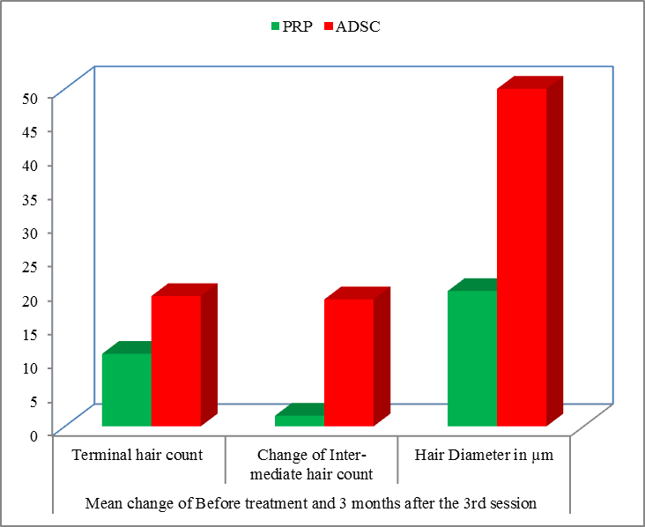
Fig.(3): Comparison between before and after treatment terminal hair density and caliber between PRP and ADSC groups.
Photographic examples of videodermoscopy assessment in patients within each group are demonstrated in Fig. (4).

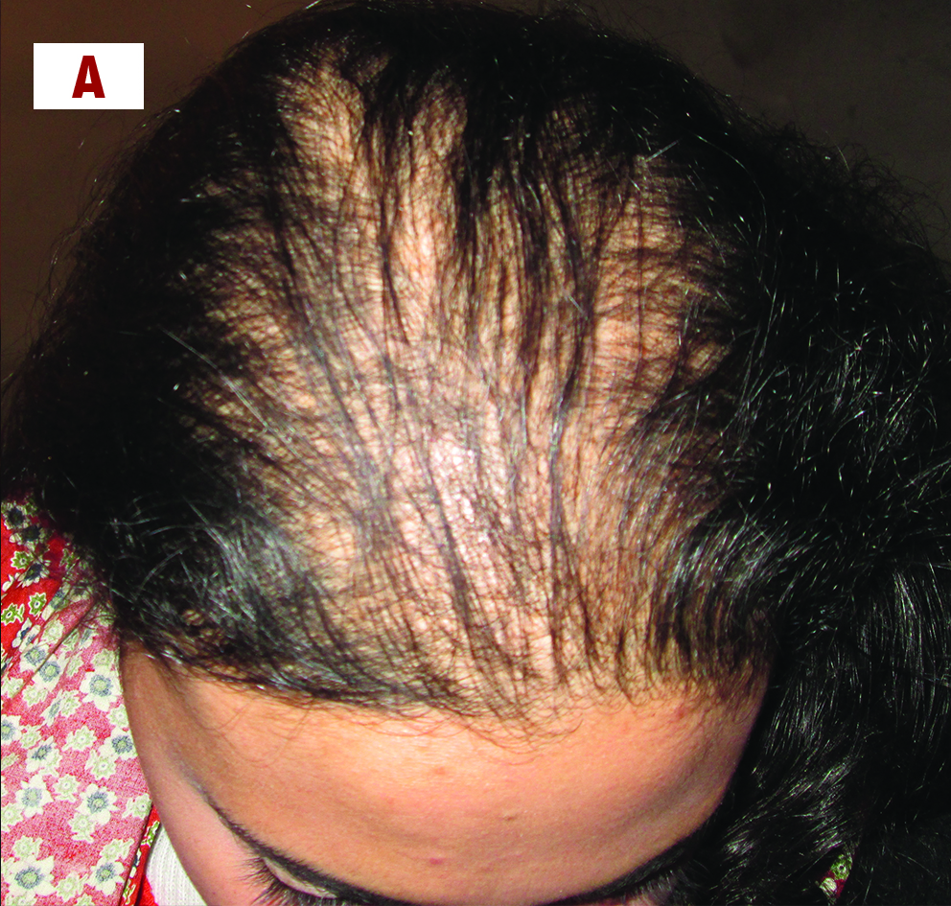 | 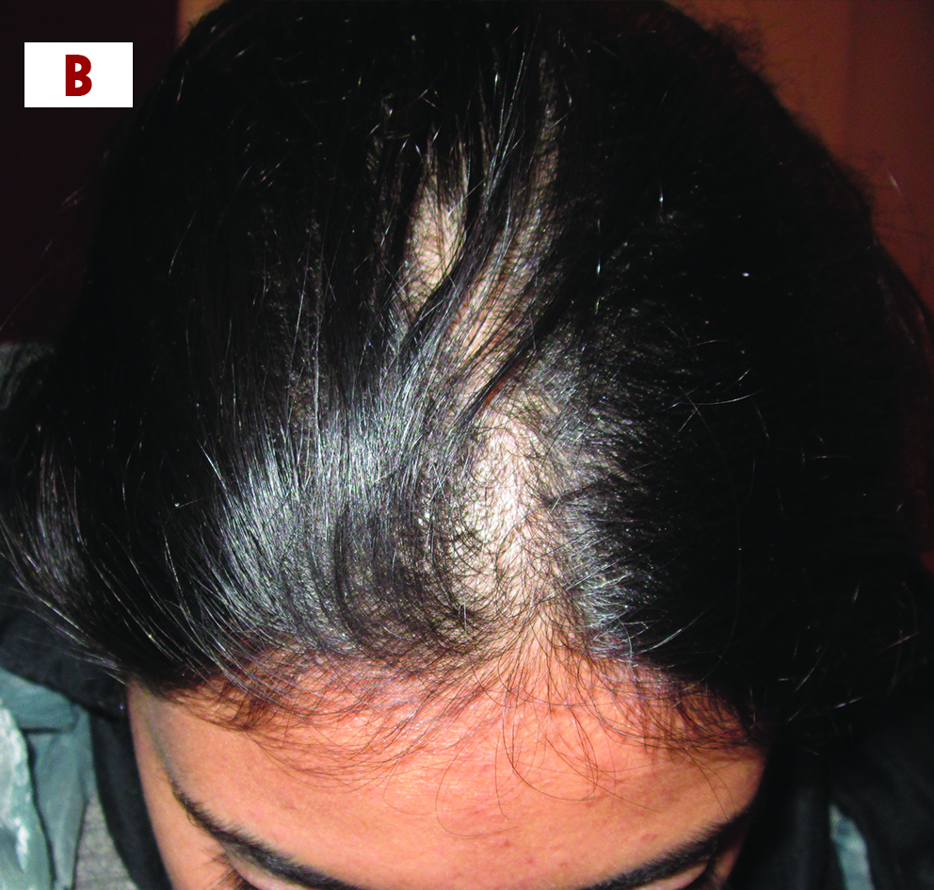
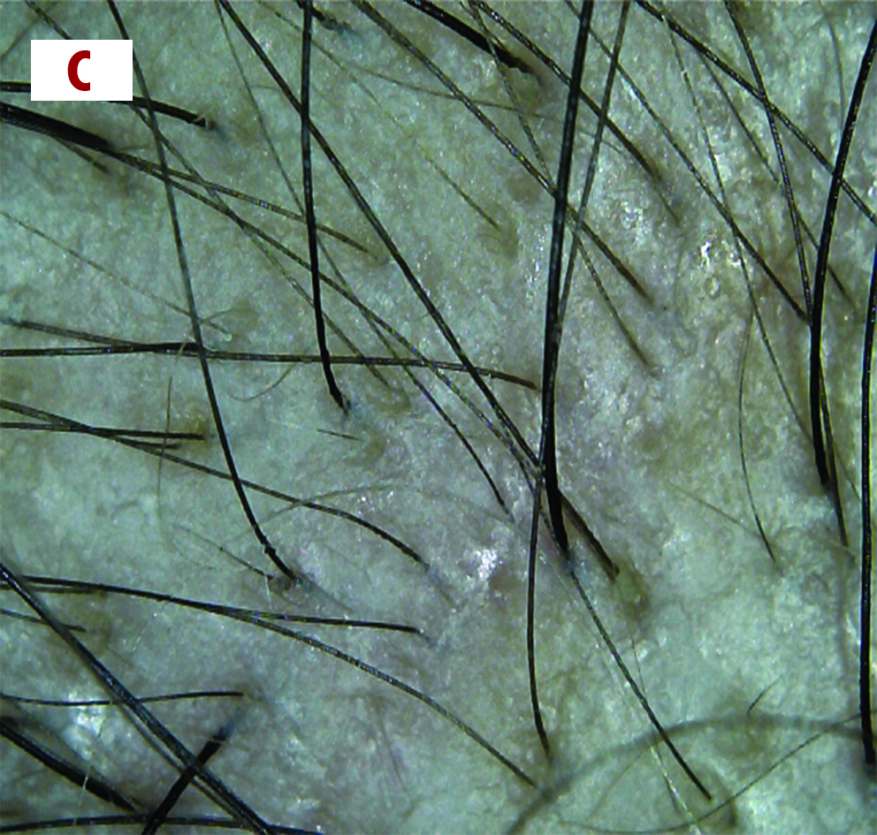 | 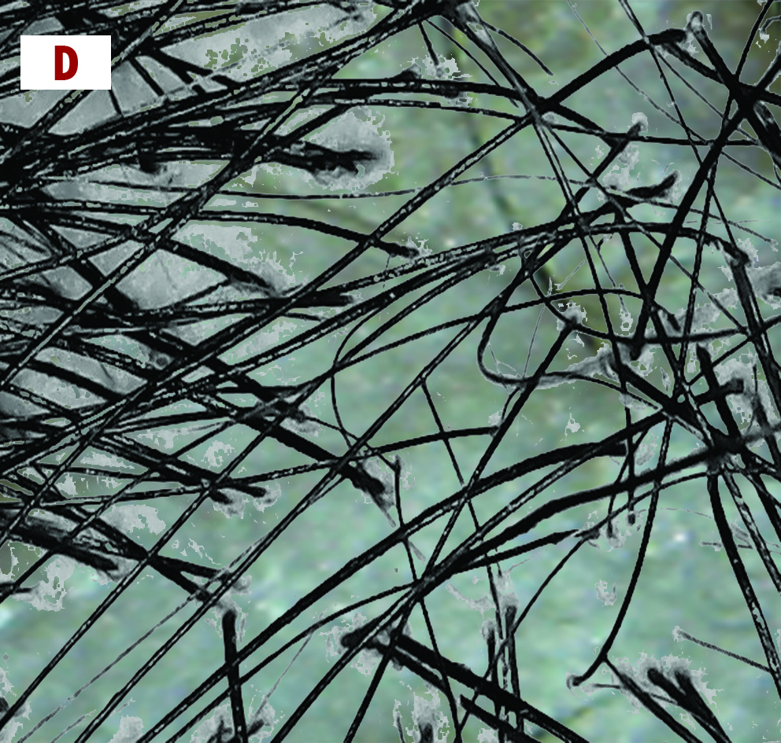
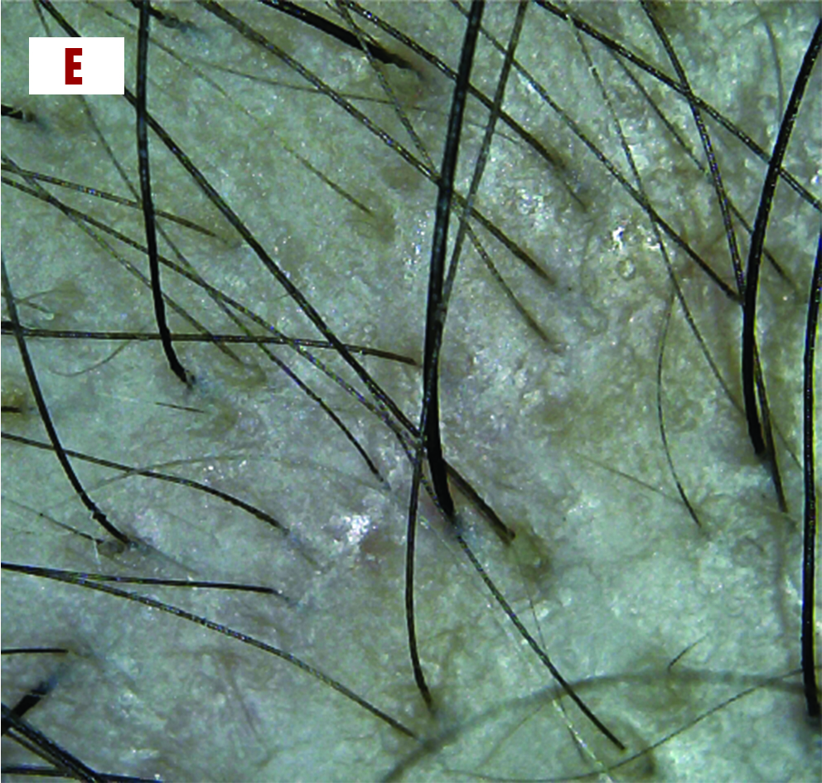 | 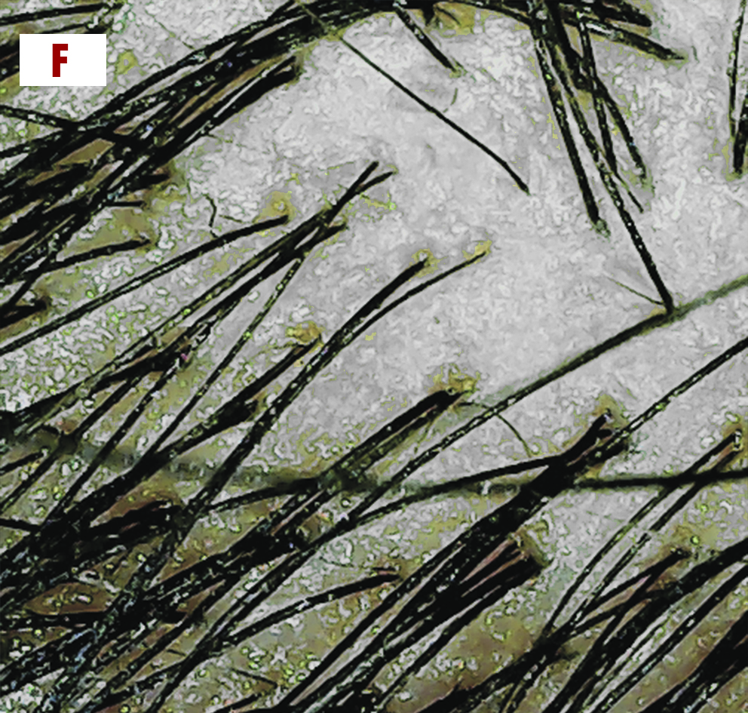
Before | After
Fig. (4): ADSCs 21years male patient, female pattern hair loss grade II with 2 years duration of AGA, showing good improvement.
A&B) Clinical photos before and after treatment.
C&D) Videodermoscopic photos measuring hair width before (70 µm) and after treatment (200 µm).
E&F) Videodermoscopic photos measuring terminal hair count before (79.4%) and after treatment (83.3%) per square centimeter.

Report the Side Effects
As regarding side effects reported during the treatment procedure, a statistical significant difference was found between both groups in pain, headache and erythema while no statistical significant difference was found in itching as showed in Table (5).
Table (5): Percentage of side effects of PRP and ADSC.
 | PRP |  | ADSC |  | x² | Sig
 | No. | % | No. | % | x² | Sig
Pain  Pain that lasts for few hours  Pain lasted up to 2 days | 30  21  9 | 100%  70%  30% | 30  12  18 | 100%  40%  60% | 5.455 | 0.020*
Headache | 6 | 20% | 24 | 80% | 19.267 | <0.001*
Itching | 4 | 13.3% | 6 | 20% | 0.123 | 0.488*
Erythema | 0 | 0% | 9 | 30% | 8.366 | 0.002**
Chi-square test; p-value <0.05
Pain was reported in all cases. Pain at the treated area with PRP and ADSCs subsided shortly after the session with 21 (70%) and 12 (40%) respectively and lasted several hours to two days with 9 (30%) and 18 (60%) respectively.
Headache was reported in both PRP and ADSC 6 (20%) and 24 (80%) respectively. Headache lasted for maximum 24 hours.
Itching was reported only in 4 (13.3%) cases of PRP and 6 cases of ADSC (20%).
No cases of erythema reported with PRP. Where's 9 cases (30%).

Discussion
To the best of our knowledge, no trials compared PRP & ADSC in the treatment of AGA.
Androgenic alopecia, also known as androgenetic alopecia, is a common disorder that affects men and women. Prevalent in approximately 70% of men, androgenic alopecia is the loss of hair in the crown combined with an "M"shaped hairline recession. It also is seen in approximately 40% of women as diffuse thinning of hair ¹.
Hair loss can have a considerable influence on psychological stress and quality of life. Common associations with hair loss include feelings of low self-esteem, depression, feeling unattractive, neuroticism, and introversion. Therefore, the development of a safe and effective treatment modality can be of great benefit to patients ¹¹.
There has been a relative lack of new therapeutic options for the treatment of hair loss in the last 30 years. While a significant amount of research and capital have been invested in the sector, investigated treatments have not proven effective enough to replace current treatment modalities ¹².
Platelet-rich plasma (PRP) injections for hair restoration has emerged to a popular practice, because both highly demanding patients and surgeons are seeking for minimally invasive and cost efficient treatment modalities for androgenic alopecia ⁶.
adipose-derived stem cell-conditioned medium have already used to treat alopecia and reported good results ⁷.
Multipotent stem cells within adipose tissue, termed adipose-derived stem cells (ADSCs), are one of the most promising stem cell population identified, since human adipose tissue is easily obtained in large quantities with little patient discomfort and secretory factors from ADSCs have been considered as a promising therapy for skin aging. Therefore, the use of autologous ADSCs can be promising for hair loss ¹³.
Studies have reported that adipose-derived stem cells promote hair growth via growth factor secretion ¹⁴.

Studies with Postive Results

Anitua et al. (2017) evaluated the use of plasma rich in growth factors in 19 subjects with AGA. Subjects were given 5 injections of PRP enhanced with platelet-rich growth factor (PRGF), Anitua postulated a similar results¹⁵.

Alves and Grimalt (2016), postulated that Platelet-rich plasma was also found to increase hair density when comparing with the control side (p < .05) in 25 subject randomized, blinded, half-head investigation, among which 22 completed the trial ¹⁶.
Also, Gentile et al. (2015) found similar results to our study in randomized, blinded, half-head study performed by evaluated treatment outcomes of PRP in 20 male subjects ¹⁷.
Our findings are in agreement with the study of Cervelli et al (2014), main limitation in their study that they overlooked the high vascular communication in the scalp that may allow injected material in one half to cross and convey effect on the other half doubting their results¹⁸.
Moreover, Sclafani (2014) performed a series of three intradermal platelet-rich fibrin matrix injections and he observed a significant increase in hair density. This is a well-designed study with relative objective evaluation methods, but no controls ¹⁹.
Our findings are in agreement with Gkini et al. ( 2014) , who examined the efficacy of PRP injection in treatment of different types of hair loss including AGA and their results showed an overall patients satisfaction more in patients suffering from AGA for less than 2 years and poorer results in AGA stage IV, V and VI according to Hamilton- Noorwood classification but the main limitation in their study was the lack of objective measurements and their evaluation was based on patients satisfaction and clinical photos before and after instead of evaluation with dermoscope or folliscope as we used videodermoscopy in our study. No remarkable adverse effects were noted ²⁰.
Also, Perez-Meza et al. (2017) found that patients undergoing treatment of fat plus SVF. Showed a mean increase of hairs/cm² of scalp. And that was parallel with our results ⁸.
In contrast of our study to Shin et al. (2015), who published a retrospective clinical case series on the use of ASCs and ADSCs for the treatment of female pattern hair loss. Treatment was administered under a 12 week protocol where subjects received ADSCs applications once per week with a microneedling roller. They reported an increase in mean hair density ²¹.
These improvements were going parallel with our results of ADSC from 58.3 hairs/cm² to 77.7 hairs/cm², which represented a 33.1 % increase. mean hair thickness increased from 70 µm to 120 µm, an 71.3% increased and we refered that to use of commercial ADSC product.
Furthermore, Fukuoka and Suga (2015) reported favorable outcomes using ADSCs in 22 patients (11 male, 11 female) received intradermal injections of ADSCs every 35 weeks for a total of 6 sessions. Trichogram captures were taken before treatment and 13 months after the last treatment session.
Overall, they noted a significant increase in the number of hairs in both male and female patients. Male patients showed an average increase ⁷.
Although, Anderi et al. (2017) studied the effect of ADSCs therapy. They found significantly improvement (P<0.0001) after treatment with ADSCs ²².
Ibrahim et al. (2016), described mean percentage of improvement in AGA patients was in AGA subjects receiving autologous Bone marrow mesenchymal stem cells "BM-MSCs" and autologous Fetal stem cells "FSC" with non-statistically significant difference ²³.

Studies with Negative Results
Two studies did not show statistically significant improvement in the outcomes assessed.
Puig et al (2016), carried out a double-blind, randomized, placebo controlled, multi-center trial. They showed no statistically significant difference between treatment and control groups in terms of hair count and hair mass index. PRP treated subjects reported improvement in hair loss, rate of hair loss, hair thickness, and ease of hair styling, which none of the placebo treated subjects noted.. In this study, however, only one treatment was administered, the PRP used was not activated, thereby impeding its full therapeutic potential. Nevertheless, they did document subjective improvement (such as less hair loss and improved hair thickness)²⁴.
The second study was by Mapar et al. (2016) prospective, half head comparative pilot study carried out by on 17 men with AGA. They concluded that PRP was not effective in treating AGA through analysis of terminal and vellus hair count. In contrast to this study, only 2 treatments were administered, and outcomes were assessed under magnifying glass, which may not be the best method to measure results ²⁵.
The body of evidence in favor of the use of adipose derived Stem cells and ASC based therapies for male/female pattern hair loss is steadily growing. These therapies offer the benefit of reduced side effects compared to the current treatment modalities and appear to be effective in both males and females. With relatively no new formally approved treatments for hair loss in the last 20+ years, the future of hair restoration may lie in adipose derived stem cell based therapies.
There was significant improvement in AGA after both PRP and AT-ASCs therapies, with significant difference between both in terminal hair count and highly significant in caliber.

Conclusion:
Our study suggests that the There was significant improvement in AGA after both PRP and highly significant after AT-ASCs therapy, with significant difference between both in terminal hair count and highly significant for caliber. Both modalities could effectively and safely be used to treat AGA.
In conclusion, treatment using adipose-derived stem cells injection appears highly effective for alopecia and may represent a new avenue of therapy for hair regeneration. ADSC’s injection promotes a good stability of the hair by increasing the hair density, the hair diameter and decreasing the pull test to almost zero. Furthermore, patients must be very well selected depending on their lifestyle, the cause of hair fall and baldness grade to obtain a good result with this procedure. No serious adverse events were associated with the treatment. The study lacks significant long term follow-up data, as a majority of subjects were followed only for the 3 months course of treatment.

Acknowledgments
None
Compliance with ethical standards
Role of the sponsors
None.
Funding source/support Funding/support
None.
Informed consent
Informed consent was obtained from all individual participants included in the study and the study was approved by the ethical committee of the dermatology department.
Conflict of Interest:
The authors declare that they have no conflict of interest.

References:
1. Rodrigues M, Antunes I, Magalhaes S, Pereira N. Androgenic alopecia: an entity to consider in adolescence. BMJ Case Rep 2017;2017.
2. Goren A, Shapiro J, Roberts J, McCoy J, Desai N, Zarrab Z, Pietrzak A, Lotti T. Clinical utility and validity of minoxidil response testing in androgenetic alopecia. Dermatol Ther 2015;28(1):13-6.
3. Kaliyadan F, Nambiar A, Vijayaraghavan S. Androgenetic alopecia: an update. Indian J Dermatol Venereol Leprol 2013;79(5):613-25.
4. Abuaf OK, Yildiz H, Baloglu H, Bilgili ME, Simsek HA, Dogan B. Histologic Evidence of New Collagen Formulation Using Platelet Rich Plasma in Skin Rejuvenation: A Prospective Controlled Clinical Study. Ann Dermatol 2016;28(6):718-724.
5. Ibrahim ZA, El-Ashmawy AA, El-Tatawy RA, Sallam FA. The effect of platelet-rich plasma on the outcome of short-term narrowband-ultraviolet B phototherapy in the treatment of vitiligo: a pilot study. J Cosmet Dermatol 2016;15(2):108-16.
6. Cervantes J, Perper M, Wong L, Eber A, Villasante A, Wikramanayaka F, Jimenez J. Effectiveness of Platelet-Rich Plasma for Androgenetic Alopecia: A Review of the Literature. Skin Appendage Disord 2018:4:1–11.
7. Fukuoka H, Suga H. Hair Regeneration Treatment Using Adipose-Derived Stem Cell Conditioned Medium: Follow-up With Trichograms. Eplasty 2015;15:e10.
8. Perez-Meza D, Ziering C, Sforza M, Krishnan G, Ball E, Daniels E. Hair follicle growth by stromal vascular fraction-enhanced adipose transplantation in baldness. Stem Cells Cloning 2017;10:1-10.
9. Chan YH. Biostatistics 102: quantitative data--parametric & non-parametric tests. Singapore Med J 2003;44(8):391-6.
10. Chan YH. Biostatistics 103: qualitative data - tests of independence. Singapore Med J 2003;44(10):498-503.
11. Wirya CT, Wu W, Wu K. Classification of Male-pattern Hair Loss. Int J Trichology 2017;9(3):95-100.
12. Lockhart R, Hakakian C, Birnbaum Z, Aronowitz J. Adipose derived stem cell based therapies or male/female
pattern hair loss. J Stem Cell Res Med 2016;1:59-63.
13. Dumbre DM, Ansari GN. A SYSTEMATIC OVERVIEW OF STEM CELLS. ACTA UNIVERSA LIFE DE PHARMACIE SCIENCES 2017;2:13-17.
14. Festa E, Fretz J, Berry R, Schmidt B, Rodeheffer M, Horowitz M, Horsley V. Adipocyte lineage cells contribute to the skin stem cell niche to drive hair cycling. Cell 2011;146(5):761-71.
15. Anitua E, Pino A, Martinez N, Orive G, Berridi D. The Effect of Plasma Rich in Growth Factors on Pattern Hair Loss: A Pilot Study. Dermatol Surg 2017;43(5):658-670.
16. Alves R, Grimalt R. Randomized Placebo-Controlled, Double-Blind, Half-Head Study to Assess the Efficacy of Platelet-Rich Plasma on the Treatment of Androgenetic Alopecia. Dermatol Surg 2016;42(4):491-7.
17. Gentile P, Garcovich S, Bielli A, Scioli MG, Orlandi A, Cervelli V. The Effect of Platelet-Rich Plasma in Hair Regrowth: A Randomized Placebo-Controlled Trial. Stem Cells Transl Med 2015;4(11):1317-23.
18. Cervelli V, Garcovich S, Bielli A, Cervelli G, Curcio BC, Scioli MG, Orlandi A, Gentile P. The effect of autologous activated platelet rich plasma (AA-PRP) injection on pattern hair loss: clinical and histomorphometric evaluation. Biomed Res Int 2014;2014:760709.
19. Sclafani AP. Platelet-rich fibrin matrix (PRFM) for androgenetic alopecia. Facial Plast Surg 2014;30(2):219-24.
20. Gkini MA, Kouskoukis AE, Tripsianis G, Rigopoulos D, Kouskoukis K. Study of platelet-rich plasma injections in the treatment of androgenetic alopecia through an one-year period. J Cutan Aesthet Surg 2014;7(4):213-9.
21. Shin H, Ryu HH, Kwon O, Park BS, Jo SJ. Clinical use of conditioned media of adipose tissue-derived stem cells in female pattern hair loss: a retrospective case series study. Int J Dermatol 2015;54(6):730-5.
22. Anderi R, Makdissy N, Rizk F, A. H. Hair quality improvement in alopecia patients following adipose-derived stem cell treatment JPRAS Open. Volume JPRAS Open: JPRAS Open; 2017. p 20.
23. Ibrahim ZA, Elmaadawi IH, Mohamed BM, Abdou SM, El Attar YA, Youssef A, Shamloula MM, Taha A, Gabr Metwally H, El Afandy MM and others. Stem cell therapy as a novel therapeutic intervention for resistant cases of alopecia areata and androgenetic alopecia. J Dermatolog Treat 2016:1-30.
24. Puig CJ, Reese R, Peters M. Double-Blind, Placebo-Controlled Pilot Study on the Use of Platelet-Rich Plasma in Women With Female Androgenetic Alopecia. Dermatol Surg 2016;42(11):1243-1247.
25. Mapar MA, Shahriari S, Haghighizadeh MH. Efficacy of platelet-rich plasma in the treatment of androgenetic (male-patterned) alopecia: A pilot randomized controlled trial. J Cosmet Laser Ther 2016;18(8):452-455.

