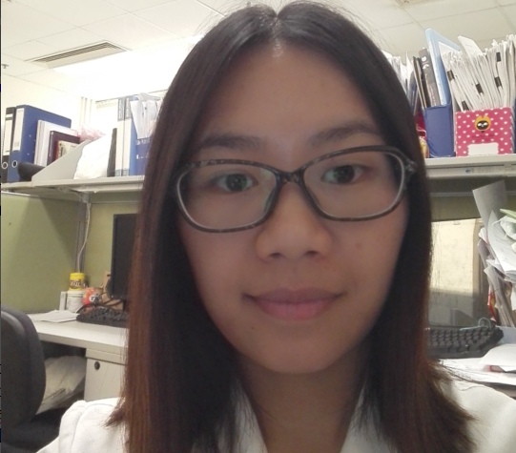


Title: Antimelanoma properties of a herbal formula comprising Sophorae Flos and Lonicerae Japonicae Flos
LI Ting, Fu Xiuqiong, Guo Hui, Zhu Peili, Li Yaxi, Yu Zhiling

School of Chinese Medicine, Hong Kong Baptist University, Kowloon Tong, Hong Kong

Constitutively activated signal transducer and activator of transcription 3 (STAT3) plays a critical role in melanoma development. A formula (SL) consisting of Sophorae Flos (SF) and Lonicerae Japonicae Flos (LJF) is documented as a remedy for subcutaneous ulcer, skin carbuncle and abscess. Plenty of active constituents in SF and LJF have been shown to inhibit STAT3 signaling and possess antimelanoma property. This study aims to investigate whether SL exerts antimelanoma activities by targeting STAT3 signaling.
B16F10 melanoma allograft model was employed to examine the effects of SL on tumor growth. Human A375 and murine B16F10 melanoma cells were utilized to evaluate the effects of SL on cell proliferation, apoptosis, migration and invasion. A375 cells stably expressing STAT3C, a constitutively active variant of STAT3, were used to determine the involvement of STAT3 signaling in SL-afforded antimelanoma effects. Oral administration of SL (1.2 g/kg) significantly inhibited tumor growth in B16F10 melanoma-bearing mice and inhibited phosphorylation of STAT3 and Src in tumor tissues. In melanoma cells, SL potently inhibited cell viability, induced apoptosis, and suppressed migration and invasion. SL also remarkably suppressed activation of STAT3 and Src, and STAT3 nuclear localization in melanoma cells. SL significantly lowered mRNA and protein levels of STAT3-regulated Mcl-1, Bcl-xL, MMP-2 and MMP-9. Overexpression of STAT3C in A375 cells diminished the effects of SL on cell proliferation, apoptosis and invasion.
These results indicated that SL exerted potent antimelanoma effects, and these effects are partially due to the inhibition of STAT3 signaling. This work was partially supported by HKBU12125116.

Biography

LI Ting is a 2nd year PhD student in School of Chinese Medicine, Hong Kong Baptist University. She is now working on exploring effective and safe traditional Chinese medicines or natural products against melanoma.

