TITLE-
A learning module in hair restoration surgery, a simple and economic method to learn all steps of strip method of hair follicles harvesting and implantation.
AUTHOR
^{Anil Kumar Garg1,, Seema garg1}
- Rejuvenate Plastic, Cosmetic and Hair transplant centre,
2/1 R.S.Bhandari marg , Indore, India 452003
Tel. 91 731 2544351, 91 9827023351
E mail anilgrag61@yahoo.com

ABSTRACT
BACKGROUND: There is global increase in demand for hair transplant as well as increasing demand for trained assistants and surgeons. It is a fact that permanent donor hair follicles are limited and any loss during learning is permanent and irreversible, so there is no place to learn and/ or practice on patient.
OBJECTIVE: To develop a learning module in hair restoration surgery to learn all steps of strip method of hair follicles harvesting and methods of implantation.
MATERIAL AND METHOD
In this learning module the materials used are paper, pencil, plant leaf, foam and thread. Last step is on Goat skin. Module has been divided in multiple steps. First step is training of micro surgery position, Second step is training of movement at wrist using paper and pencil, third step is strip harvesting and slivering on foam model, fourth step is learning of follicle dissection on leaf model, step V is thread follicle implantation on leaf bed. After practicing on non-living model lastly all steps are practiced on Goat skin, starting from slivering, follicle dissection and implantation of Goat follicles on leaf.

CONCLUSION—This is very economical and user friendly system to learn all steps of strip method of hair follicle harvesting and methods of implantation as well. The material used are available around us and any one can learn as well as train his or her technicians in very short time.

AKey words learning hair transplant, slivering, Implantation, leaf model, Goat model
The demand for hair transplantation is constantly increasing, and new hair transplant centres are opening all over the world. However, there are very few training centres & fellowship programs globally to fulfil the demand for trained assistants and technicians.
The author has developed a very effective, user friendly, and economical model to learn and practice all steps of hair transplantation. Materials required for this training model are readily available. Materials like foam, money plant leaf (thick leaf), simple stitching black thread, needles, and wooden spatula are needed for this model. The second stage of the model utilizes goat skin and a helmet.
1.1 MICROSURGERY POSITION
The entire process of hair transplantation is microsurgery. All basic principles of microsurgery should be followed, including magnification, proper position of surgeon, instrument quality, and range of hand movements.
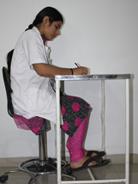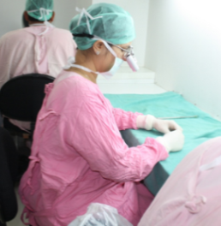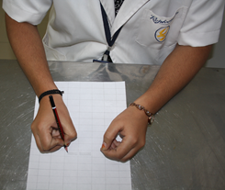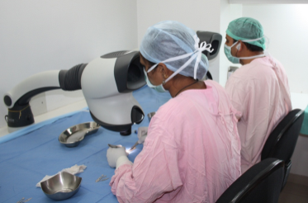
Fig. 1.1 A Fig. 1.1 B Fig. 1.1 C Fig. 1.1 D
Fig. 1.1 A, B Micro surgery position Fig. 1.1 C, D Forearm resting on dissection table
The position of the surgeon or assistant should be such that all body joints are at a functional position. Feet should rest on the floor, the leg and thigh at a 90 degree angle, the spine straight and supported, the forearm should rest on the dissection table and all movement should be at the wrist. This position allows the surgeon or assistant to work for a longer period. Poor posture invites early fatigue and affects surgeon’s performance and efficiency.
1.2 PAPER MODEL
TRAINING OF MOVEMENTS AT WRIST
Proper microsurgery hand position allows the surgeon to isolate movements at the wrist. Follicle dissection requires wrist movements in a forward and backward direction, while slivering and implantation needs downward and upward wrist movements. No side to side movements are required during the entire process of hair transplantation. These motions can be learned and practiced by making straight lines on paper using pencil or pen.
MATERIAL----Plane paper and a pencil, suitable magnification
METHOD—Make small rectangle/square boxes on paper. Require assistant to make straight parallel equidistant lines in box while maintaining proper microsurgery position. Begin without magnification then add magnification. Assistant should complete 15 sheets under magnification.
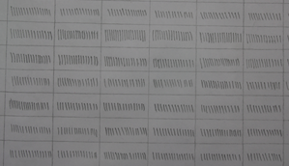
Fig. 1.2 A Making straight equidistance parallel lines Fig. 1.2 B Practice sheet

1.3 FOAM MODEL
STRIP HARVESTING
This model is used to learn how to hold the scalpel, identify which part of the blade is needed in strip harvesting, and how to raise strip while dissecting in one plane of tissue.

MATERIAL- Once inch thick high density foam piece 8 X 10 cm in size, wooden platform, marking pen, scalpel, and toothed forceps.
METHOD- Fix foam to wooden platform or other surface. Mark strip area with skin marking pen. Hold scalpel in dominant hand in pen holding position. Keeping sharp edge of scalpel almost parallel to surface of foam a partial thickness cut is made over marking. The depth of incision should be same all around; this is only possible when you apply equal pressure over scalpel. Direction of incision is slightly oblique, as hair direction in scalp is oblique and we need to follow the direction of the hair follicle. Next, using toothed forceps hold one end of strip and pull it up and cut underneath with scalpel taking care to cut in same plane and thus harvesting uniform thickness of foam strip. This must be practiced multiple times to achieve a foam strip of uniform thickness.

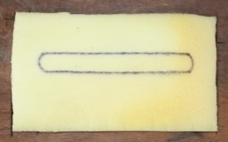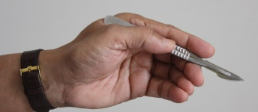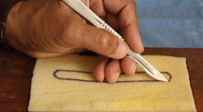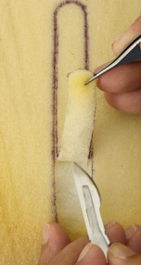
Fig. 1.3 A Fig. 1.3 B Fig. 1.3 C Fig. 1.3 D
Foam with marking scalpel in pen holding position Incision strip harvesting.

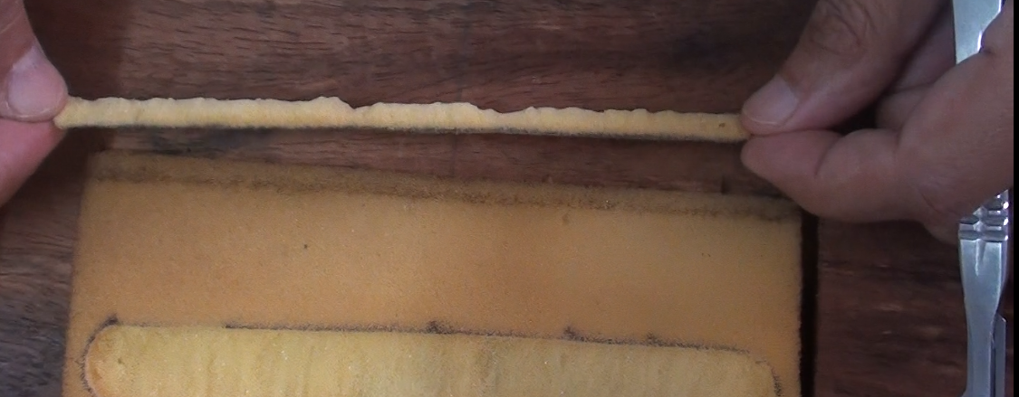
Fig. 1.3 E Harvested strip of uniform thickness

SLIVERING- Slivering training is divided into two phases. First we learn to move the scalpel in an up and down direction while creating thin slices of foam. Next we practice slivering on a foam strip woven with thread .Black thread with a knot symbolises the graft, and during this phase the should not be cut.

Material-One inch thick foam, black stitching thread, sewing needles, skin marker.

METHOD
A:-Cut small pieces of foam 1 cm thick, 2 cm wide and 7 to 10 cm long. Using skin marker make multiple straight parallel lines at 2-3 mm intervals on surface of foam. The foam strip represents a sliver and the marked lines represent rows of hair follicles. Fix this foam sliver on wooden spatula using needles. Start slivering with a fine tooth forceps in non-dominant hand and scalpel in dominant hand. Toothed forceps should grab upper edge of foam sliver while scalpel cuts between two lines from top surface of foam to bottom. While scalpel is cutting pull foam sliver outside and slightly upward so there is increased gap between two rows. Very thin equal uniform slices of foam should be created.
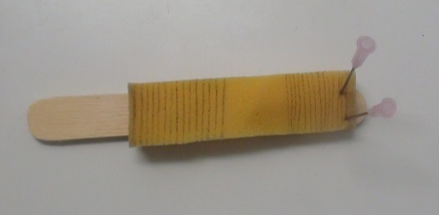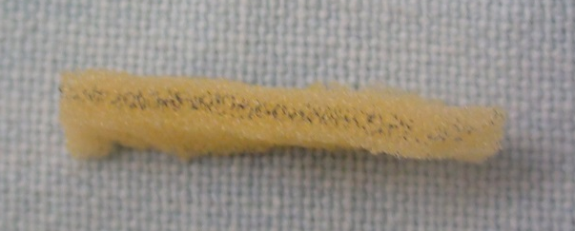
Fig. 1.3 F Foam strip.Markings for rows of hair Fig. 1.3 G Foam sliver. Marking indicates rows of hair
B: - Black stitching thread is used to represent the hair follicle and a single knot of thread represents the hair bulb. Using a needle, multiple threads are sewn in rows on a foam strip, with a knot on the underside, leaving small free ends of threads on the other as shown in figure.

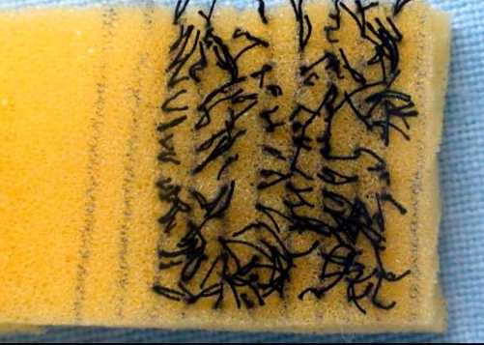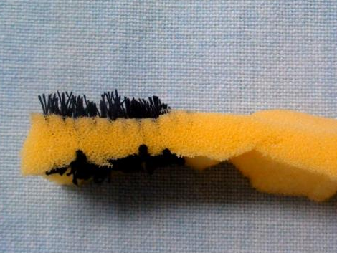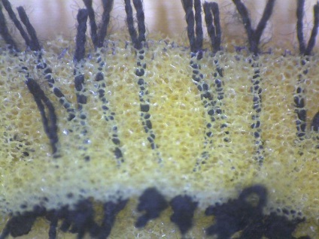
Fig.1.3 H Fig. 1.3 I Fig. 1.3 J
Fig. 1.3 H, I thread woven foam strip Fig. 1.3 J Foam sliver
Slivering is started as explained in A, taking care not to cut thread or its knot.
1.4 LEAF MODEL
FOLLICLE DISSECTION
MATERIAL
Thick plant leaf such as leaf of Money plant (Epipremnum Aureum). These are thick and have texture similar to skin. Marking pen, scalpel and forceps, magnification.
METHOD
Prepare 5 X 2 cm pieces of thick leaf. Create 10 mm long parallel lines in centre of leaf strip. These lines represent hair follicles. Begin follicle dissection under microscope or other magnification. Assistant cuts between lines and makes small pieces of leaf having a line in centre of each piece. Each line represents a hair and hair bulb and leaf part is peri follicle tissue. During this step the assistant also practices coordination of scalpel and forceps. Any indentation of forceps over leaf surface warns assistant that the grip of the forceps should be softer so as to avoid crushing follicle. Assistant should cut at least 100 such plant slivers.
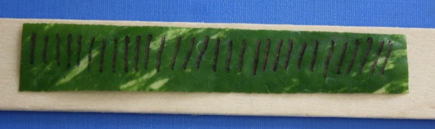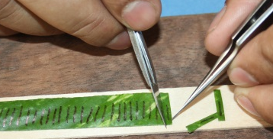
Fig. 1.4 A Plant leaf sliver Fig. 1.4 B Follicle dissection

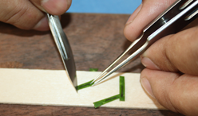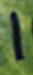
Fig. 1.4 C Trimming of follicle Fig. 1.4 D Follicles

IMPLANTATION
Both stick place and slit method of implantation can be practiced.
MATERIAL- Money plant leaf (leaf of any plant which is thick and soft), wooden spatula, slit making knife, needles, black thread and diluted adhesive solution (e.g. Fevicol solution, a synthetic resin adhesive).
Method- Create a scalp model by stacking multiple pieces of leaf of equal length and width until an 8 to 10 mm thick layer of leaf bed is formed, and secure them to a wooden spatula. Now create hair follicles using black thread. Immerse black thread in a diluted adhesive solution, then allow the thread to dry, making it stiff. Next cut thread into multiple 8 mm long pieces. Thread follicles are now ready to implant. To teach implantation into pre-made slits, first make multiple slits into bed of leaf scalp model using either needle or slit knife blade, then use preferred technique with one or two forceps and one needle. Dilate the slit using forceps and implant thread into hole.
To teach the stick and place technique, insert needle in leaf model 3-4 mm deep and implant thread by sliding it along bevel portion of needle.
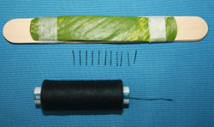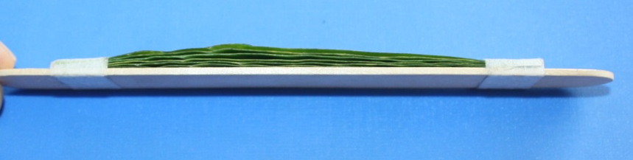
Fig. 1.4 E Fig. 1.4 F
Fig. 1.4 E, F Preparing thread follicles and leaf scalp. Multiple leaf strips are put over each other to make it as thick as scalp.

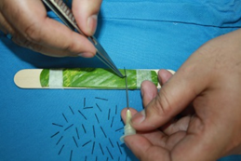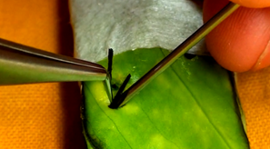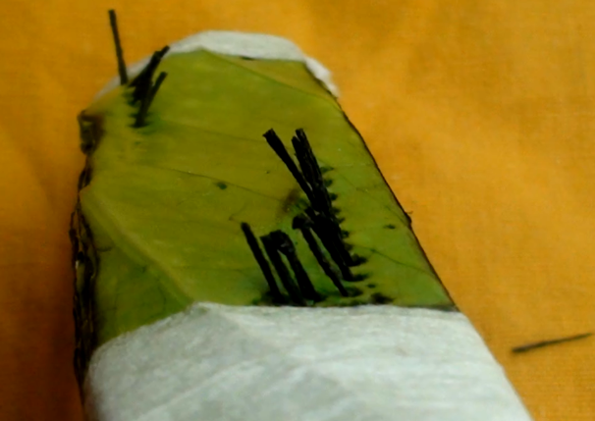
Fig. 1.4 G Fig. 1.4 H Fig. 1.4 I
Fig. 1.4 G, H, I Stick and place technique. Implantation of thread follicles on ‘leaf scalp’ using needle and forceps.
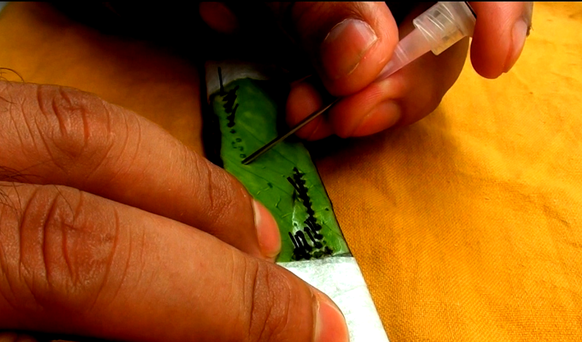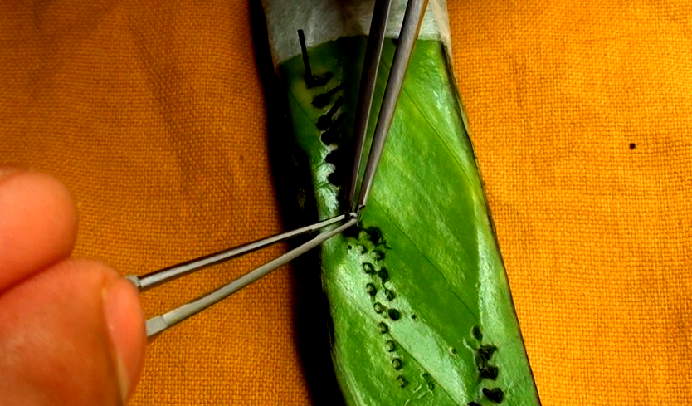
Fig. 1.4 J Fig. 1.4 K
Fig. 1.4 J, K Premade slit and Implantation. Implantation of thread follicles in pre made slits using two forceps. Slits made using needle.

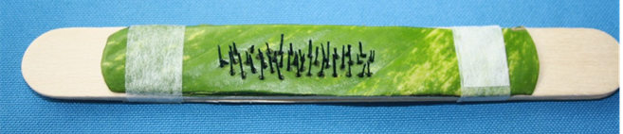
Fig. 1.4 L Final appearance.
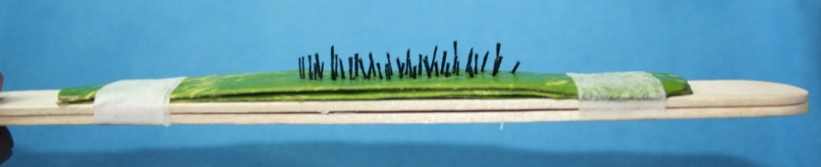
Fig. 1.4 M Final appearance.
1.5 GOAT MODEL
Human hair follicles are precious, as they are limited and not reproducible. Damage to follicles causes permanent loss, which is bad for our patients, so practice with the goal of achieving zero transection of human follicles. Goat skin is readily available and inexpensive, and is a very versatile model to practice on before starting on human skin. Goat skin gives you the feel of human skin, and although goat follicles are shorter and have higher density then human follicles, this can be an advantage when learning.
Material- Black goat fresh skin measuring 10×2 centimetres
Method- Clean the skin with tap water, shave it and then again clean it with tap water. This goat skin piece is ready for slivering practice.
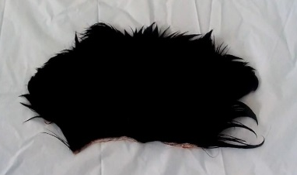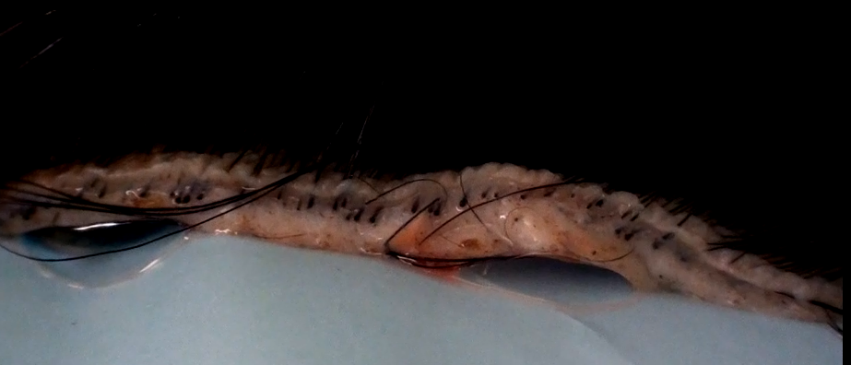
Fig. 1.5 A Fresh Goat skin Fig. 1.5 B Goat skin side view
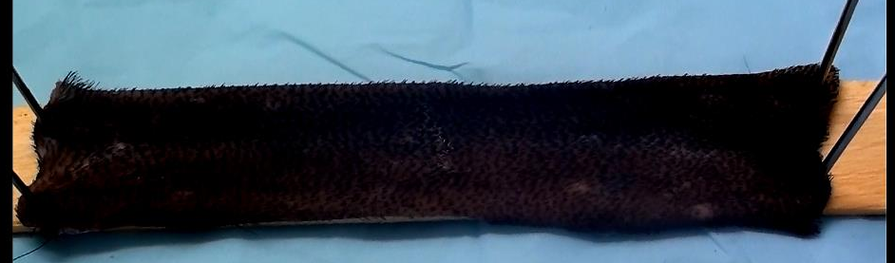
Fig. 1.5 C Goat skin piece shaved and mounted over wooden spatula for slivering
SLIVERING OF GOAT SKIN STRIP---After attaching goat skin to wooden spatula, slivering is performed under magnification as we learned on the foam model. This goat skin feels like human skin, but with greater density with shorter length of follicles. Excess fat is trimmed away.
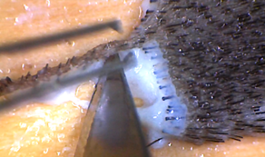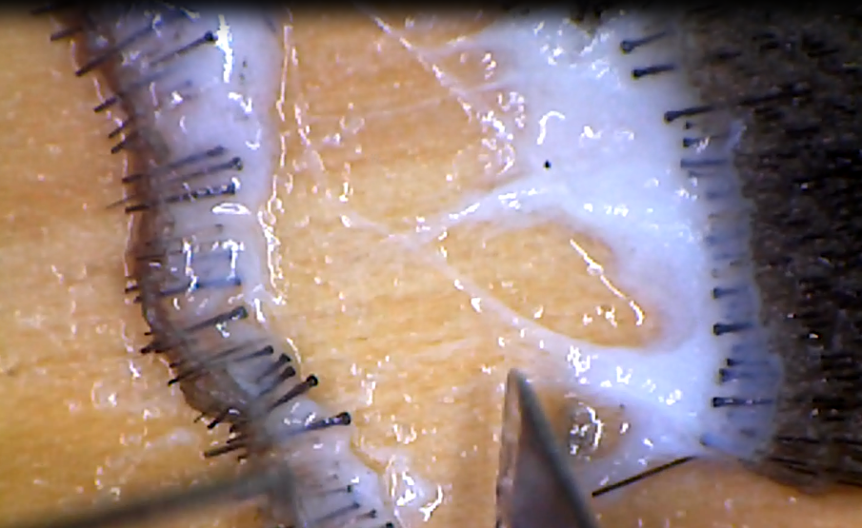
Fig. 1.5 D Fig. 1.5 E
Fig. 1.5 D, E Slivering of goat skin under Stereo microscope.
FOLLICLE DISSECTION OF GOAT SLIVER
Goat slivers are then dissected under the microscope or any magnification of your choice. All precautions are taken and practiced as if human follicles were being dissected, including de-epithelization, trimming, and irrigation. Goat follicles are now ready for implantation into leaf scalp model.
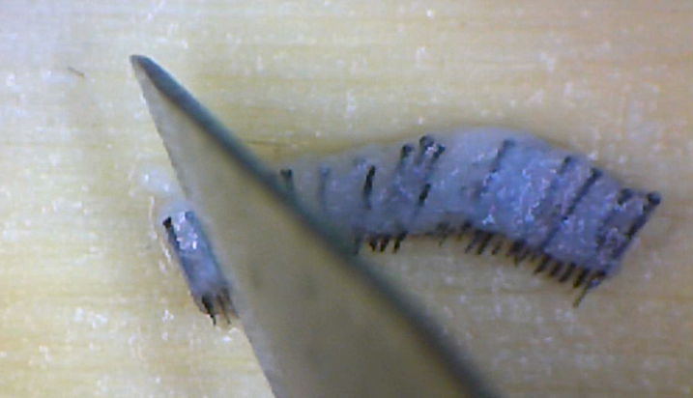
Fig. 1.5 F Follicle dissection of goat sliver under stereo microscope.
IMPLANTATION OF GOAT FOLLICLES
MATERIAL-Goat follicles, leaf, adhesive tape, helmet
METHOD
Mount 5-6 layers of leaf on the front side of a helmet or other similar model of a human head. This provides a curve and surface similar to human scalp except that it is little larger in size. Practice implanting goat follicles either by slit method or stick and place method.
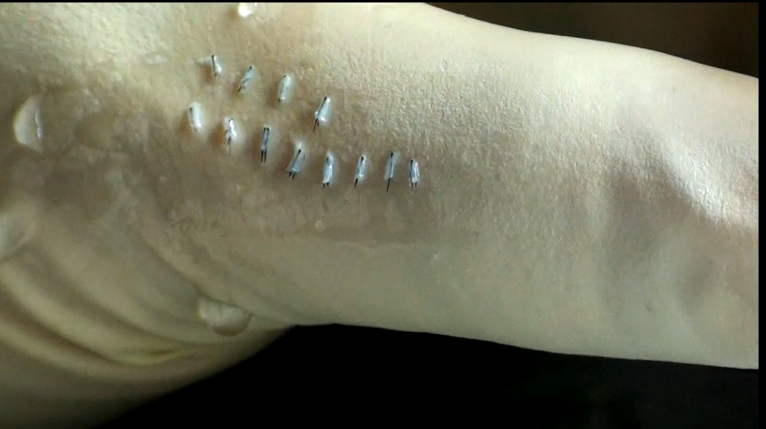
Fig. 1.5 G Goat follicles over thumb

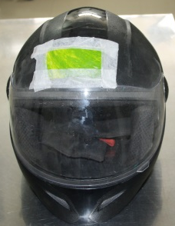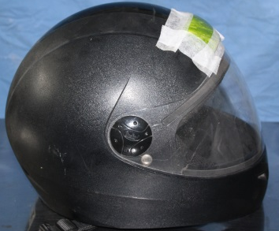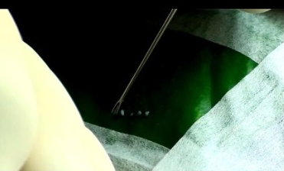
Fig. 1.5 H Fig. 1.5 I Fig. 1.5 J
Fig. 1.5 H, I Leaf mounted over helmet Fig. 1.5 J Goat follicles implanted.

Summary
The steps outlined in this training module are versatile, user friendly, and economical for learning all steps of the hair transplant. The author has used this to train all his team members. Two hours per day for three to four weeks can train a technician in basic knowledge of the hair transplant procedure, follicle care, and the importance of graft hydration, ischemia, and temperature control. The delicacy of the hair follicle should be repeatedly explained, and we help them realise how important their job is.. Hair transplantation requires teamwork and every step should be performed with the optimum results for the patient in mind.

Reference
This technique is authors own innovation. This has been presented in annual congress of International society of hair restoration surgeons in 2015.
Garg Anil. An Innovative Module To Learn All Steps of Strip Method of Follicle Harvesting and Implantation Video presented at; 2015; 23rd ISHRS annual meeting at Chicago.
Garg Anil. ISHRS video library [video file].2015 available from: http://www.ishrs.org/members-only/video-library-0

