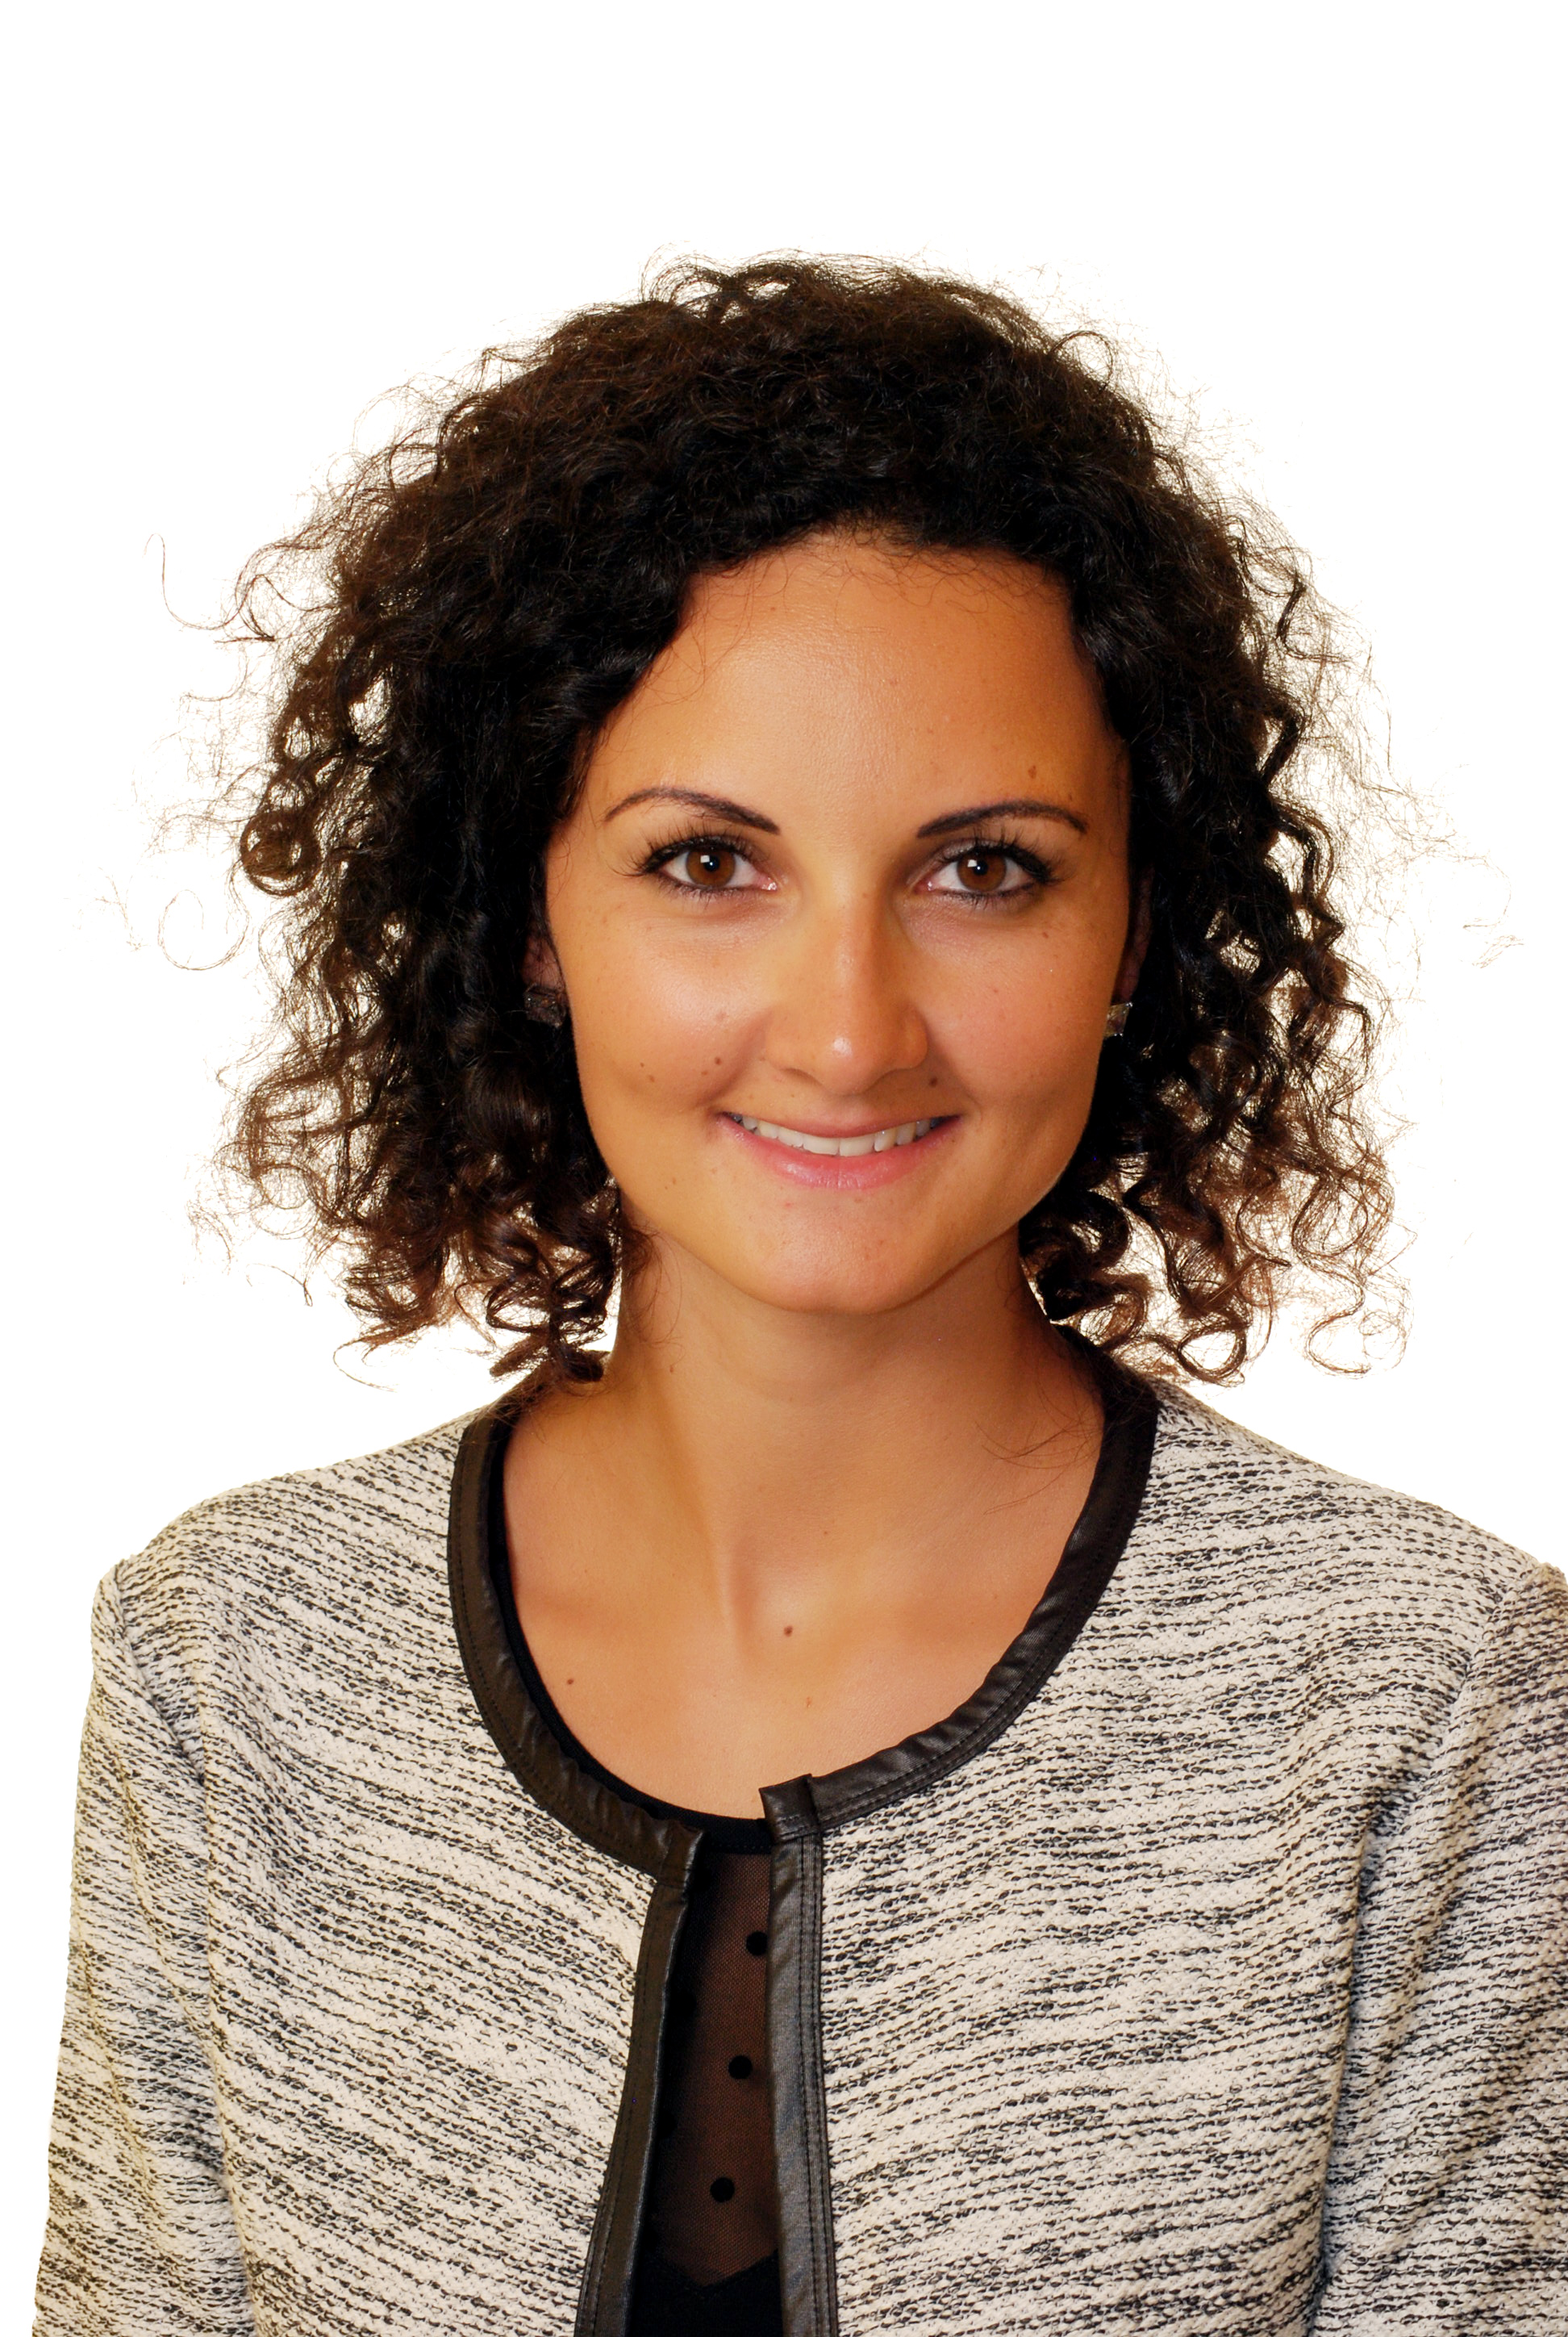

Cutaneous Scarring after Herpes Zoster: what is the risk and the incidence?

Name: Dr Lara el Hayderi
University of Liege, Belgium

Abstract
Skin scars after herpes zoster (HZ) have not been often reported. However, after chickenpox, 20% of children in average have cutaneous scars. Risk factors for scars post-HZ remain undetermined. This 3-year prospective study aimed to highlight the incidence of the risk factors for post-HZ scarring. Patients with a history of HZ attending a tertiary university hospital were included. Baseline data that were collected included: age, sex, immunosuppression, prior history of scarring or abnormal scarring, severity and extension of HZ lesions, afflicted HZ dermatome, and antiviral treatment received. Once HZ skin lesions had healed, patients were screened for skin scars at the prior HZ site at 1 month. The follow up of the subjects was performed every 2 months during 6 months.
Our results show that at 6 months,11(9.7%) of 113 HZ patients still had post-HZ scarring. Nine out of 11 patients were immunocompromised. In fair-skinned patients, the results show: hypopigmented (n=3), hyperpigmented (n = 2), atrophic cicatricial (n=3), and hypertrophic cicatricial (n=1); whereas in dark-skinned patients: 2 cases of severe hyperpigmented hypertrophic scarring were observed. In all cases, HZ was severe and extensive. Three cases had a history of hypertrophic/keloid scarring without post-varicella scars. The most frequent location of post HZ scars was the trunk (n = 5), followed by the cervical region (n = 3) and the face (n = 3). It is probable, due to the study setting, that the severe HZ immunocompromised patients were overrepresented.
The conclusion of this study is that scarring after HZ is probably overlooked. Severe HZ and immunosuppression are the main risk factors. Prompt initiation of antiviral treatment for HZ as well as HZ vaccination could help reduce post-HZ scarring incidence.

Table: Main characteristics of the 11 patients with post-herpes zoster scarring
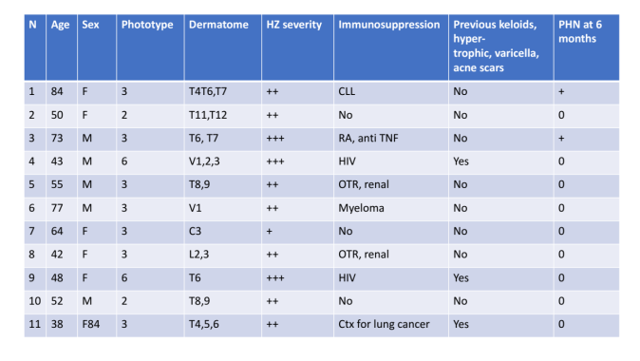
C cervical dermatome, CLL chronic leucocytic leukemia, Ctx chemotherapy, F female, HZ herpes zoster, L lumbar dermatome, M male, OTR organ transplant recipient, PHN post-herpetic neuralgia, RA rheumatoid arthritis, S sacral dermatome, T thoracic dermatome, TNF tumor necro- sis factor, V1, 2, 3 Gasser ganglion 1, 2, 3

References:
- De Mozzi P, Graham-Brown RA, Alexandroff AB. A case of widespread hypertrophic scarring in a child after chickenpox. Clin Exp Dermatol. 2011; 36: 916–7.
- Park GH, Rhee DY, Bak H, Chang SE, Lee MW, Choi JH, Moon KC, Bang JS, Kim BJ, Kim MN, Lee SY. Treatment of atrophic scars with fractional photothermolysis: short-term follow-up. J Dermatol Treat. 2011; 22: 43–8.
- Nikkels AF, Piérard GE. The Tzanck smear: heading the right way! J Am Acad Dermatol. 2009; 61:152–3.
- Kasper DA, Cohen JL, Saxena A, Morganroth GS. Fillers for post- surgical depressed scars after skin cancer reconstruction. J Drugs Dermatol. 2008; 7: 486–7.
- Onunu AN, Uhunmwangho A. Clinical spectrum of herpes zoster in HIV-infected versus non-HIV infected patients in Benin City, Nigeria. West Afr J Med. 2004; 23: 300–4.
- Nikkels AF, Debrus S, Sadzot-Delvaux C, Piette J, Delvenne P, Rentier B, Piérard GE. Comparative immunohistochemical study of herpes simplex and varicella-zoster infections. Virchows Arch A Pathol Anat Histopathol. 1993; 422: 121–6.

Biography:

Dr Lara el Hayderi has completed her PhD at the age of 31 years from Liège University and is currently clinical chief at University of Liège in Belgium. She has published more than 20 papers in reputed journals and has given numerous national and international conferences. She has done clinical research in the field of viral infectious diseases on herpes simplex and varicella zoster virus. She actively gives lectures on cosmetic and dermatology at the University and develops the field.

E-mail:laraelhayderi@hotmail.com
Presenting author details
** Full name: Lara el Hayderi
**Mobile Number:00 32 497 887 566 and 00971 50 2490071
**Twitter account:/
**Linked In account : Lara el Hayderi
**Session name/ number:
**Category: (Oral presentation/ Poster presentation) Oral presentation
**Date of Birth: 12/06/1985

