

Incidence of and Risk Factors for Cutaneous Scarring after Herpes Zoster

Name: Dr Lara el Hayderi
University of Liege, Belgium

Abstract
About 20% of children have cutaneous scars following chickenpox. In contrast, skin scars are not often reported after herpes zoster (HZ). Risk factors for post-HZ scarring remain undetermined. Objective Our objective was to prospectively study the incidence of and risk factors for post-HZ scarring. Methods This was a 3-year prospective study of patients with HZ attending a tertiary university hospital. Baseline data, including age, sex, immunosuppression, prior history of scarring, severity and extension of HZ, afflicted HZ dermatome, and antiviral treatment received, were recorded. At 1 month after the HZ skin lesions had healed, patients were screened for skin scars at the prior HZ site. These patients were followed every 2 months for 6 months.
At 6 months,11(9.7%) of 113 HZ patients still had post-HZ scarring (fair-skinned patients: hypopigmented[n=3], hyperpigmented [n = 2], atrophic cicatricial [n = 3], and hypertrophic cicatricial [n = 1]; dark-skinned patients: severe hyperpigmented hypertrophic scarring [n = 2]). HZ was extensive and severe in all cases. Nine of the 11 patients were immunocompromised. Three cases had a history of hypertrophic/keloid scarring but no post-varicella scars. The most frequent location was the trunk (n = 5), followed by the cervical region (n = 3) and the face (n = 3). Given the study setting, it is possible that immunocompromised patients with severe HZ were overrepresented in this study.
Scarring after HZ is probably overlooked. The principal risk factors seem to be severe HZ and immunosuppression. Hence, prompt instigation of antiviral treatment for HZ and HZ vaccination could help reduce the incidence of post-HZ scarring.

Table: Main characteristics of the 11 patients with post-herpes zoster scarring
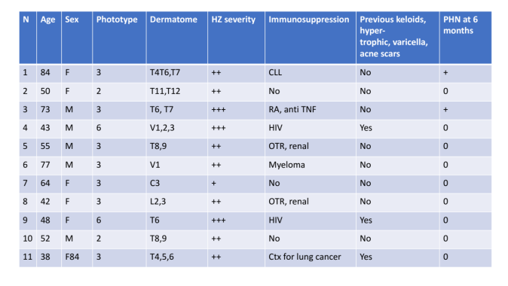
C cervical dermatome, CLL chronic leucocytic leukemia, Ctx chemotherapy, F female, HZ herpes zoster, L lumbar dermatome, M male, OTR organ transplant recipient, PHN post-herpetic neuralgia, RA rheumatoid arthritis, S sacral dermatome, T thoracic dermatome, TNF tumor necro- sis factor, V1, 2, 3 Gasser ganglion 1, 2, 3

References:
- De Mozzi P, Graham-Brown RA, Alexandroff AB. A case of widespread hypertrophic scarring in a child after chickenpox. Clin Exp Dermatol. 2011; 36: 916–7.
- Park GH, Rhee DY, Bak H, Chang SE, Lee MW, Choi JH, Moon KC, Bang JS, Kim BJ, Kim MN, Lee SY. Treatment of atrophic scars with fractional photothermolysis: short-term follow-up. J Dermatol Treat. 2011; 22: 43–8.
- Nikkels AF, Piérard GE. The Tzanck smear: heading the right way! J Am Acad Dermatol. 2009; 61:152–3.
- Kasper DA, Cohen JL, Saxena A, Morganroth GS. Fillers for post- surgical depressed scars after skin cancer reconstruction. J Drugs Dermatol. 2008; 7: 486–7.
- Onunu AN, Uhunmwangho A. Clinical spectrum of herpes zoster in HIV-infected versus non-HIV infected patients in Benin City, Nigeria. West Afr J Med. 2004; 23: 300–4.
- Nikkels AF, Debrus S, Sadzot-Delvaux C, Piette J, Delvenne P, Rentier B, Piérard GE. Comparative immunohistochemical study of herpes simplex and varicella-zoster infections. Virchows Arch A Pathol Anat Histopathol. 1993; 422: 121–6.

Biography:

Dr Lara el Hayderi has completed her PhD at the age of 31 years from Liège University and is currently clinical chief at University of Liège in Belgium. She has published more than 20 papers in reputed journals and has given numerous national and international conferences. She has done clinical research in the field of viral infectious diseases on herpes simplex and varicella zoster virus. She actively gives lectures on cosmetic and dermatology at the University and develops the field.

E-mail:laraelhayderi@hotmail.com
Presenting author details
** Full name: Lara el Hayderi
**Mobile Number:00 32 497 887 566 and 00971 50 2490071
**Twitter account:/
**Linked In account : Lara el Hayderi
**Session name/ number:
**Category: (Oral presentation/ Poster presentation) Oral presentation
**Date of Birth: 12/06/1985

