Title : “ Dermoscopy of congenital dermatoses in pediatric age group- An observational study”
Authors name: Dr. Prachi Chetankumar Gajjar
Affiliation: Resident doctor, Department of Dermatology, Government medical college, Bhavnagar, Gujarat.
Corresponding author: Dr. Hita H. Mehta
Affiliation: Professor and Head, Department of Dermatology, Government medical college, Bhavnagar, Gujarat.
Country- India
Statement of the Problem
Dermoscopy is an ex-vivo noninvasive technique for analysing subsurface skin structures.Pediatric population attends the dermatology OPD in large proportion. Sometimes, routine examination and procedures becomes difficult in children as they are uncooperative.So dermoscopy provides an useful diagnostic clues to ease our routine practice.Objective of our study is to determine the dermoscopic features of various congenital dermatoses in pediatric age group.
Methodology & Theoretical Orientation:
149 children with congenital dermatoses were enrolled in a study conducted between August 2017 to January 2018 in dermatology OPD.After proper history and examination, gross and dermsocopic(DS) images were captured using Dermlite DL IV after written informed consent from guardian.Data were expressed in frequency and percentage.
Findings:
149 DS images of 22 congenital dermatoses were studied including 80 males and 69 femlaes(Table 1).Homogenous pattern(80%) was the most common pattern observed in melanocytic nevus(26).Mongolion spots(25) had greenish hue (100%) on dermoscopy.Hemangioma(13) and portwine stains(5) showed cherry red vacuoles and red dots on a pink background respectively.Criss cross, rhomboid and lamellated pattern of scales were observed in congenital icthyosis(8).Dermoscopy of adenoma sebaceum in Tuberous sclerosis(5) exhibited yellowish globules of varying size while that of reactive perforating dermatoses showed classic ‘Three zones’.We also analysed dermoscopy of congenital bullous and few rare miscellaneous conditions.Trichoscopy of short anagen syndrome and monilethrix revealed tipped points and beaded hair shafts respectively.
Conclusion & Significance:
Dermoscopy is a noninvasive diagnostic tool which enables visualisation of deeper structures of skin which are invisible with naked eyes.Melanocytic nevus if disorganised indicates increased risk for melanoma in situ. Dermoscopy of vascular structures helps to determine the level of vessel dilatation.We observed classic “Hypopyon” in lymphangioma circumscriptum.Dermoscopy of hair disorders helps in differentiating from other hairs shaft disorders.Few drawbacks of our study are our inability to take histopathology in all children due to lack of consent from parents. Dermoscopy not only helps in diagnosis but also in differentiation, classification and detecting early premalignant changes.Thus,Dermoscopy fills gap between histopathology and gross examination especially in children.

Name- Dr. Prachi Chetankumar Gajjar
Email- prachi93gajjar@gmail.com

Dermoscopy of Congenital dermatoses
Congenital melanocytic nevi (CMN)
Globular pattern | Reticular pattern | Homogenous pattern | Halo nevus  Central globular CMN with peripheral white rim
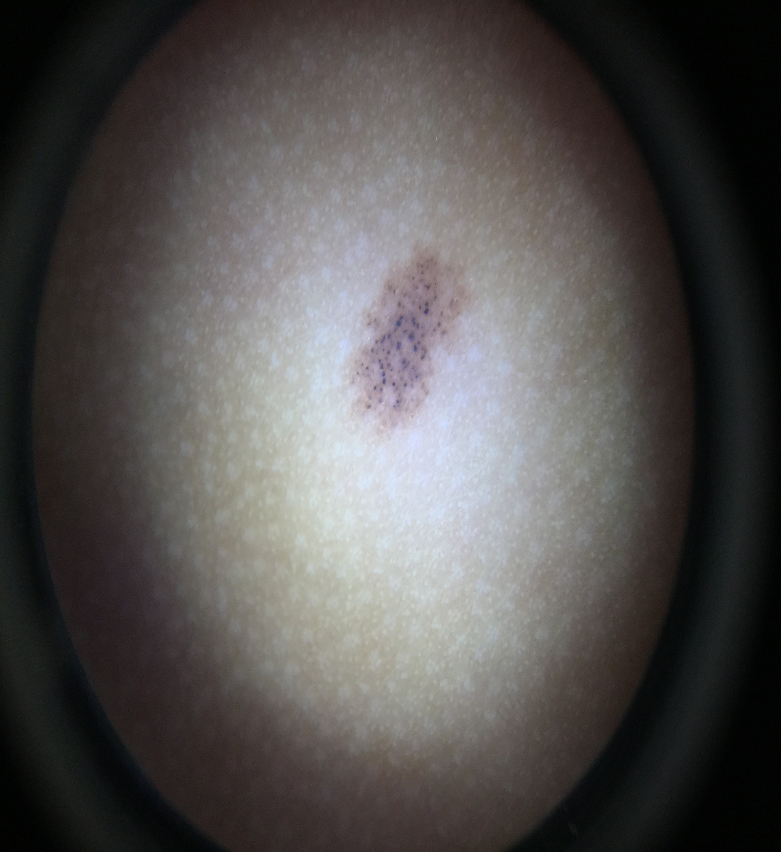 | 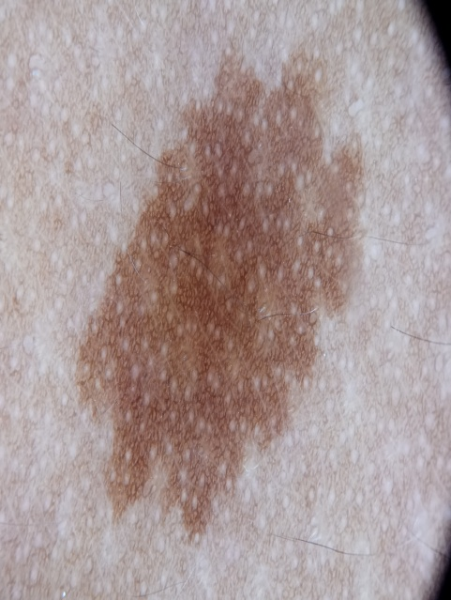 | 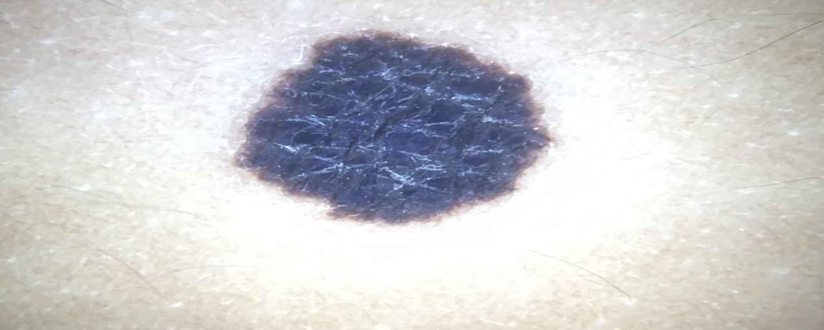 | 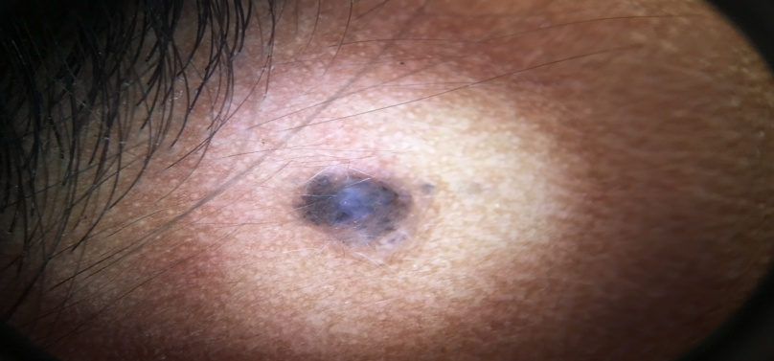
Hemangioma-  cherry red lacunae | Lymphangioma circumscriptum-  Lacuna and hypopyon | Lamellar ichthyosis-  Intercellular space with quadrilateral scales | Reactive perforating collagenoses-  Three zone with central white crust, white areas and violaceous rim
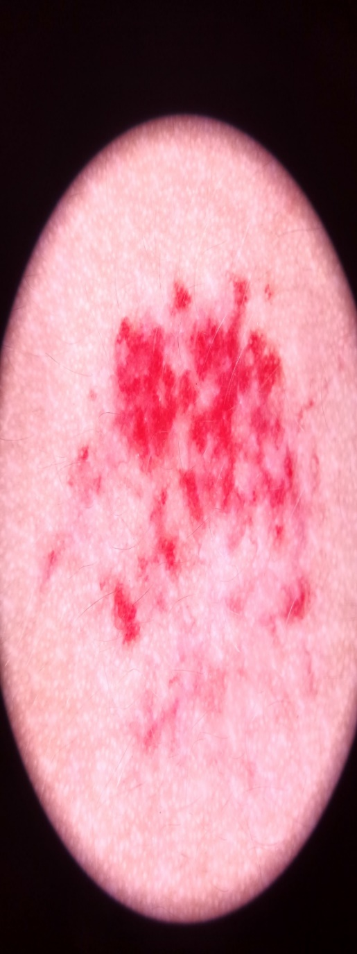 | 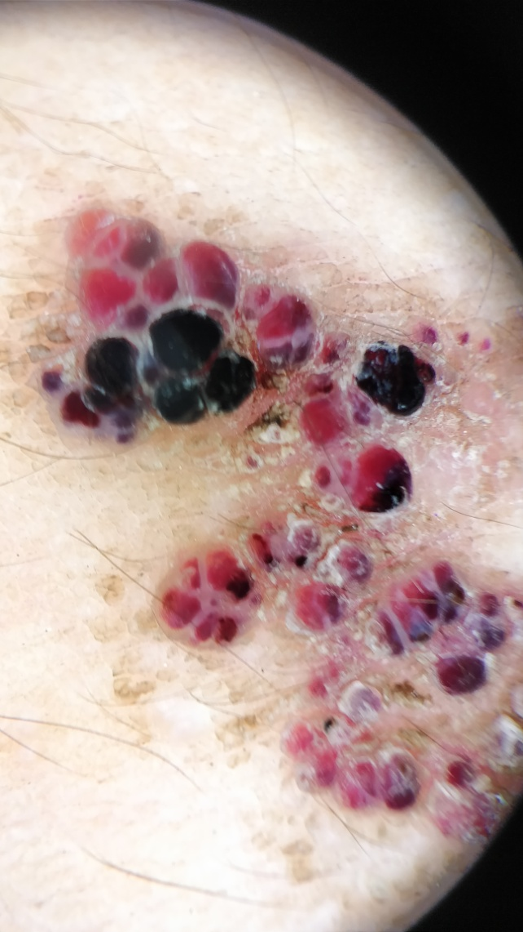 | 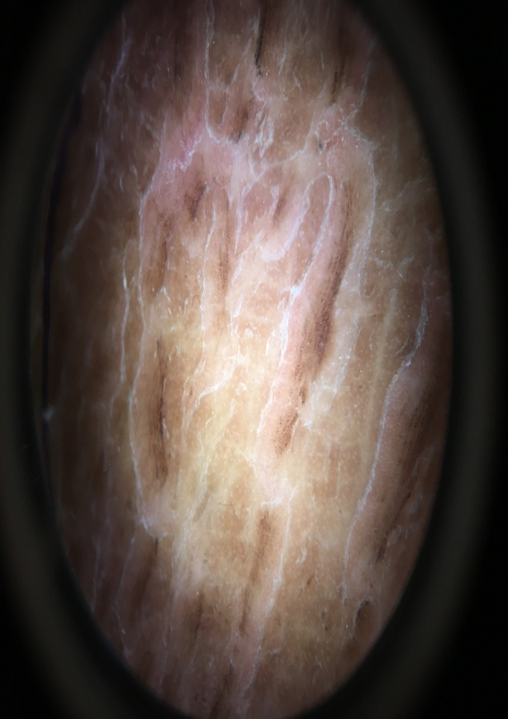 | 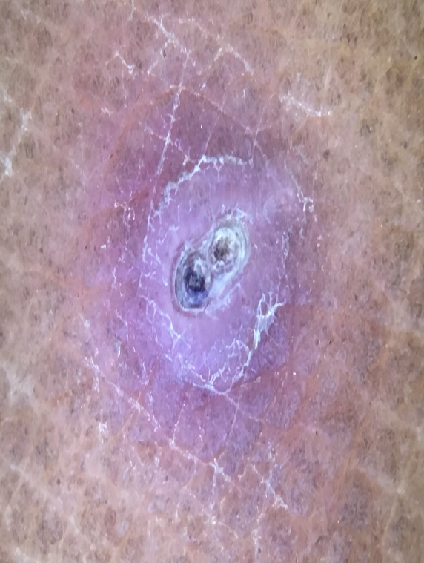

Figure 2 Syndromes |  |  | Hair disorders
Tuberous sclerosis complex  Adenoma sebaceum- multiple yellowish globules | Epidermodysplasia verruciformis- multiple brown dots from wart like lesion on dorsum of hand | Aplasia cutis-  central white structure with hair tuft surrounding “Hair collar sign” | Moniletherix – “Regulalry beaded ribbon sign”
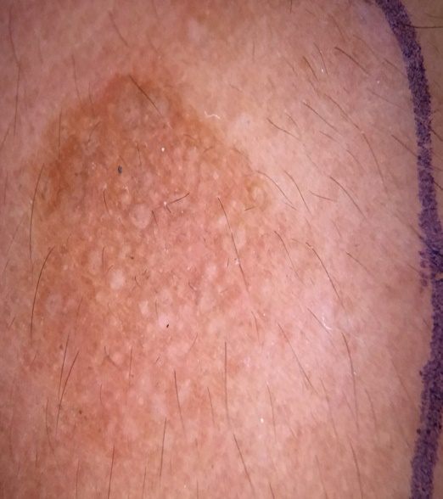 | 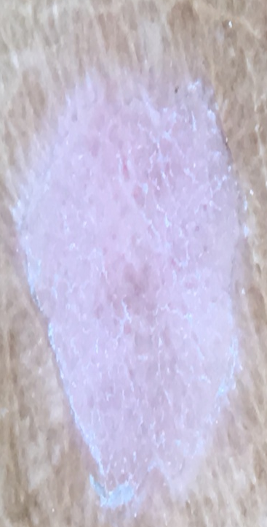 | 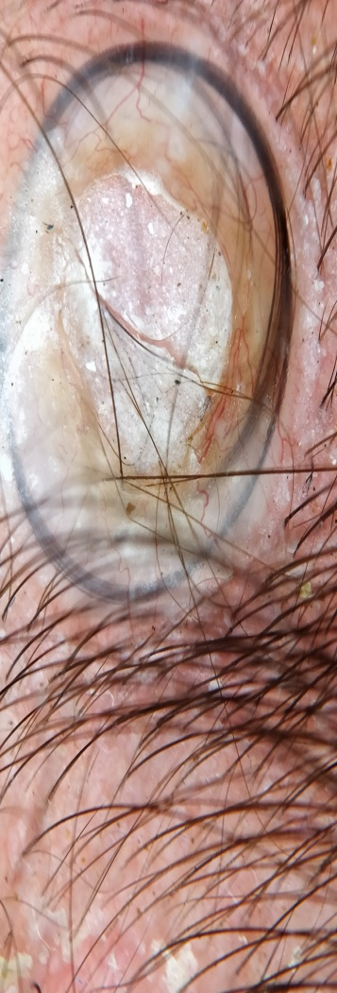 | 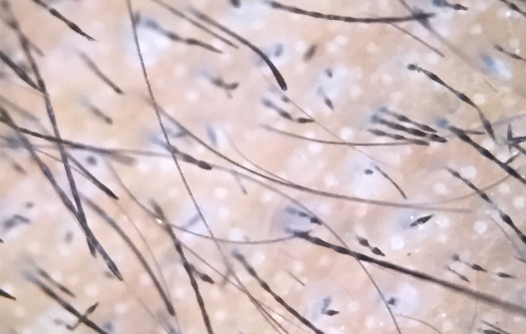

Biography
Dr Prachi Chetankumar Gajjar is a third year resident doctor in Department of Dermatology. She has a keen interest in dermoscopy as well as pediatric dermatology. She has acquired training in research methology organized by Indian council of medical research held at Chennai. Following which she has contributed as an author in few publications in national and international journals. She has also delivered talk on “Clinical trial registry of India” in post graduate orientation programme held in Government medical college, Bhavnagar and on “Mucocutaneous manifestations of connective tissue disease” in Rhematology CME at the same venue. She has also presented E posters and oral presentation in state and national conferences in India.

References
1) Irvine A, Mellerio J. Rooks Textbook of Dermatology.Eight edition.UK: Wiley Blackwell. 2010. 15 Genetics and Genodermatoses; 15.1
2) Nayak SS, Mehta HH, Gajjar PC, Nimbark VN. Dermoscopy of general dermatological conditions in Indian population: A descriptive study. Clin Dermatol Rev 2017;1:41-51
3) Gulia A, Massone C. Advances in dermoscopy for detecting melanocytic lesions. F1000 Med Rep 2012;4:11.
4) OISO, N. and KAWADA, A. (2011), The Dermoscopic Features in Infantile Hemangioma. Pediatric Dermatology, 28: 591-593. doi:10.1111/j.1525- 1470.2011.01385.
5) Gencoglan G, Inanir I, Ermertcan AT. Hypopyon-like features: New dermoscopic criteria in the differential diagnosis of cutaneous lymphangioma circumscriptum and haemangiomas? J Eur Acad Dermatology Venereol. 2012;26(8):1023–5.
6) Damiani L, Aguiar FM, da Silva MVS, Miteva MI, Pinto GM. Dermoscopic Findings of Scalp Aplasia Cutis Congenita. Ski appendage Disord. 2017 Jan;2(3–4):177–9
7) Sharma VK, Chiramel MJ, Rao A. Dermoscopy: A rapid bedside tool to assess monilethrix. Indian J Dermatol Venereol Leprol 2016;82:73-4

