Erythema Gyratum Repens secondary to Acute Myeloblastic leukemia

Alexandre Malek¹ MD, Roy Nasnas¹ MD, PhD
¹Infectious Diseases Department, Saint Joseph University, Hotel Dieu de France Hospital, Beirut, Lebanon

An 80 year-old Caucasian man was admitted to the hospital for prolonged fever, weight loss, and general status alteration. He noted a pruritic skin lesion. As past medical history, he had been treated for Hodgkin lymphoma in 1994 and Non Hodgkin lymphoma in 2004. One year ago, he developed Myelodysplastic Syndrome. Thoraco-abdominopelvic CT scan, gastroscopy and colonoscopy were normal. PPD skin test was negative and pancultures were sterile. The physical examination was normal except the presence of multiple, annular, rapidly growing erythematous plaques over the right thigh (Figure 1, 2). Bone marrow aspirate and biopsy revealed acute myeloblastic leukemia (AML). Diagnosis of Erythema Gyratum Repens (EGR) was made on clinical ground and it was secondary to AML. EGR in 80 % of cases is related to underlying malignancies most notably lung cancer. However, EGR in 20 % is associated with nonneoplastic diseases such as pulmonary tuberculosis, autoimmune or connective tissue conditions.

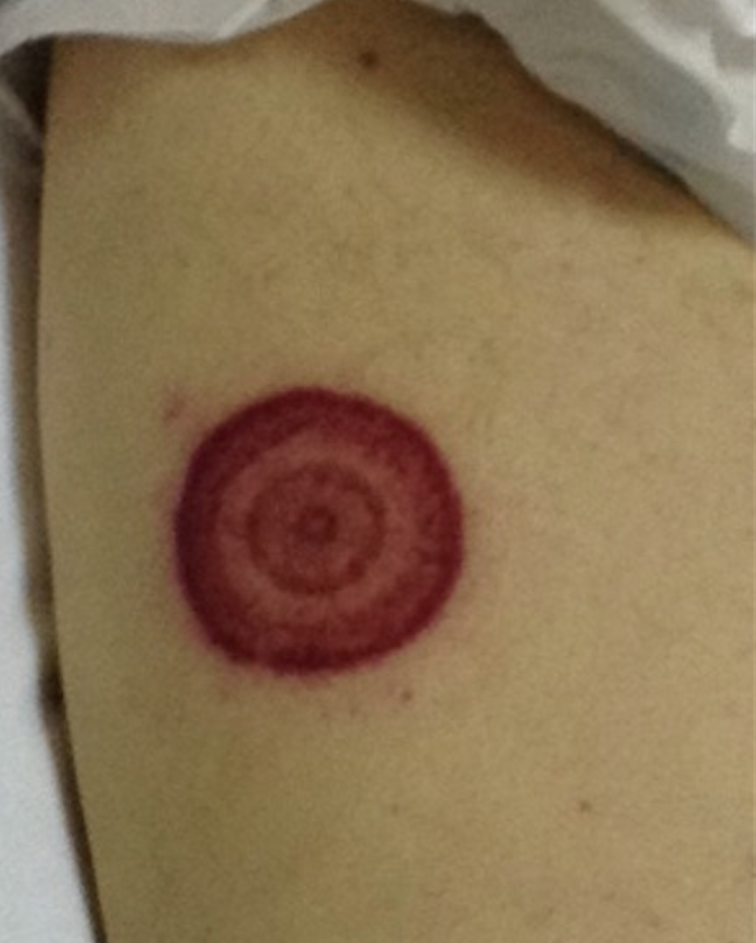

Figure 1: Well-demarcated concentric bands skin lesion on the admission.

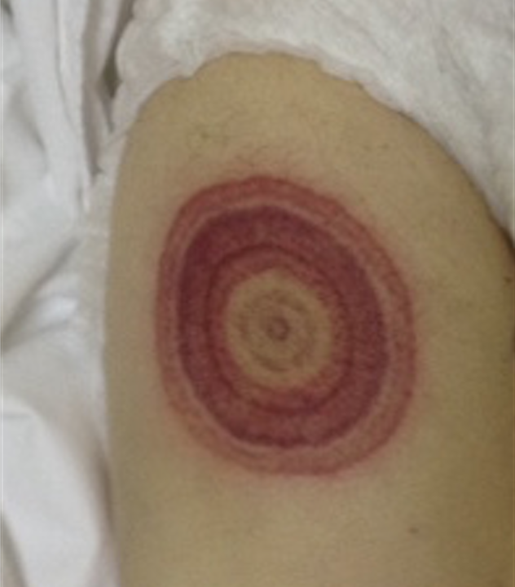

Figure 2: Rapidly growing serpiginous skin lesion on Day 2 of hospitalization.

