Oral albendazole is effective against phthiriasis papebrarum.
Marc MRAD,^{* 1,2} Ribal MERHI¹
¹Universite Pierre et Marie Curie ; INSERM Saint Antoine Research Center, Paris, France.²Dermatology department, CHU NDS, Lebanon.
Introduction:
Treatment of phthiriasis palpebrarum is based on the mechanical ablation of lice and nits after topical Vaseline application [1], shaving of the eyelashes [2], oral ivermectin administration [3], application of pilocarpine gel [4], fluorescein drops [5], yellow mercury oxide ointment [6], permethrin cream [7], lindane lotion [8] or malathion shampoo [9].
The emergence of resistant strains, the risk of major eye damage [10] and the favorable Benzimidazoles outcomes in pediculosis capitis and pubic phthaliasis [11,12], prompted us to use albendazole against ciliary phthiriasis.
We report a case of ciliary phthiriasis resistant to several therapeutic modalities having responded to albendazole per os.
Observations:
A seven-year-old child with no significant personal or family history was seen in our outpatient clinic for ocular pruritus.
The diagnosis of ciliary phthiriasis was made on the physical examination, which identified the presence of small brownish crusts at the base of the eyelashes, associated with visible lice and nits (Fig.1 and 2).
The patient was previously treated with several local applications of permethrin 1% cream and a daily occlusive treatment with vaseline for 2 weeks, with no significant result.
Due to the absence of ivermectin, a dose of 400mg of albendazole per os was administered to the patient (J0), and repeated after seven days (J8).
Complete resolution of the clinical signs and symptoms was noted (Fig.3). No recurrence was observed after a six months follow-up.
Since the presence of ciliary phthiriasis may indicate possible sexual abuse, the hospital's social service was informed for investigations.
Discussion:
Albendazole inhibits polymerization of tubulin into microtubules and has a high affinity for parasitic tubulin, sparing those of the mammalian hosts.
Loss of cytoplasmic microtubules alters glucose absorption by larvae and helminths, causing a decrease in ATP and an energy depletion, resulting in the immobilization and death of the parasite [13].
The principle of oral albendazole is based on the intake of a blood meal containing the insecticide. For this reason the nits are not affected and the treatment must be repeated after 7 days [3].
Given its price, safety, rare and limited side effects, albendazole could be considered as a therapeutic option in ciliary phthiriasis.

Références:
- Workowski KA, Bolan GA, Centers for Disease Control and Prevention. Sexually transmitted diseases treatment guidelines, 2015. MMWR Recomm Rep 2015 ; 64 : 1-137.
- Yoon KC, Park HK, Seo MS, Park YG. Mechanical treatment of phtiriasis palpebrarum. Korean J Ophtalmol 2003 ; 17 : 71-3.
- Burkhart CN, Burkhart CG. Oral ivermectin therapy for phthiriasis palpebrum. Arch Ophtalmol 2000 ; 118 : 134-5.
- Kumar N, Dong B, Jenkins C. Public lice effectively treated with Pilogel. Eye (lond) 2003 ; 17 : 538-9.
- Mathew M, D’Souza P, Mehta DK. A new treatment of phthiriasis palpebrarum. Ann Ophthalmol 1982 ; 14 : 439-41.
- Ashkenazi I, Desatnik HR, Abraham FA. Yellow mercuric oxide: a treatment of choice for phthiriasis palpebrarum. Br J Ophthalmol 1991 ; 75 : 356-8.
- Klaus S, Shvil Y, Mumcuoglu KY. Generalized infestation of a 3 ½-year-old girl with pubic louse. Pediatr Dermatol 1994 ; 11 : 26-8.
- Kincaid MC. Phthirus pubis infestation of the lashes. JAMA 1983 ; 249 : 590.
- Rundle PA, Hughes DS. Phthirus pubis infestation of the eyelids. Br J Ophthalmol 1993 ; 77 : 815-6.
- Pe’er J, BenEzra D. Corneal damage following the use of the pediculocide A-200 Pyrinate. Arch Ophthalmol. 1988 ; 106 : 16-7.
- Namazi MR. Treatment of pediculosis capitis with thiabendazole: a pilot study. Int J Dermatol 2003 ; 42 : 973-6.
- Ayoub N, Merhy M, Tomb R. Treatment of pubic phthiriasis with oral albendazole. Ann Dermatol Venerol 2008 ; 135 : 602-3.
- Dayan AD. Albendazole, mebendazole and praziquantel. Review of non-clinical toxicity and pharmacokinetics. Acta Trop. 2003 ; 86 : 141-59.

Figure 1:
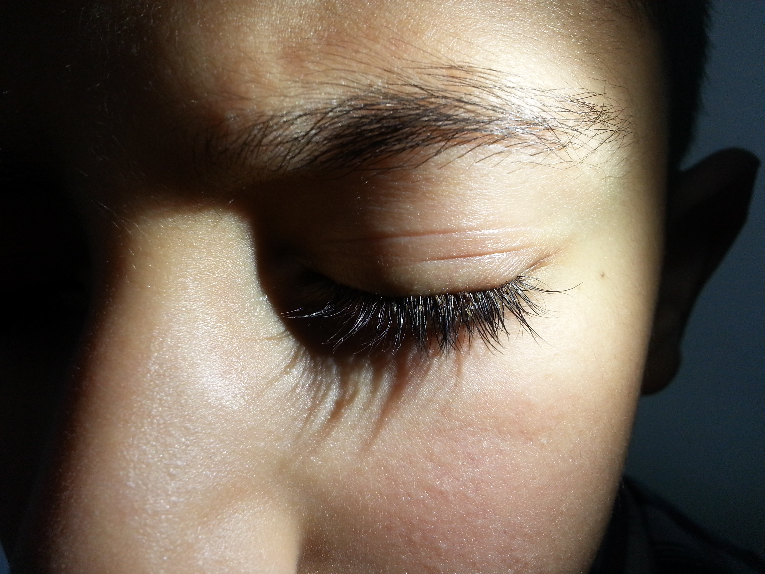
Figure 1: Brownish crusts at the base of the eyelashes, associated with lice and nits
Figure 2:
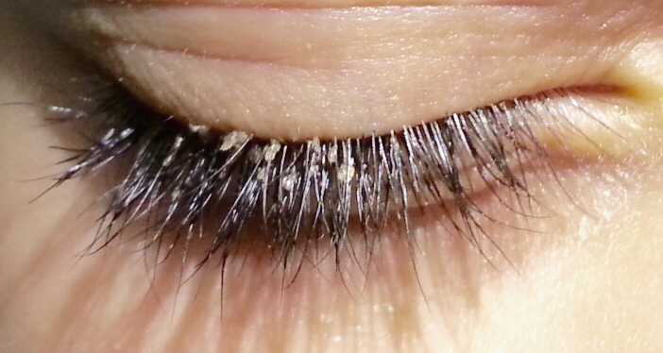
Figure 2: Brownish crusts at the base of the eyelashes, associated with lice and nits

Figure 3:
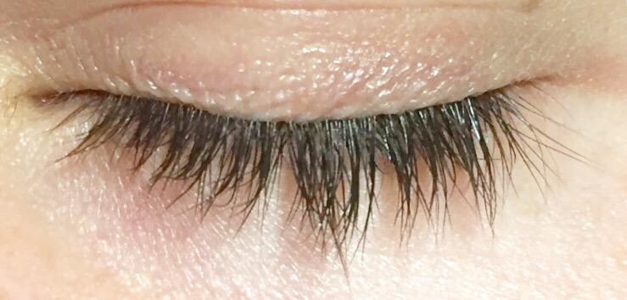
Figure 3: Complete resolution of clinical signs and symptoms.

