Two cases of lichenoid photodermatitis
Junwoo Ko, Department of Dermatology, School of Medicine, Chungnam National University, Daejeon, Korea

Abstract (300 word limit)
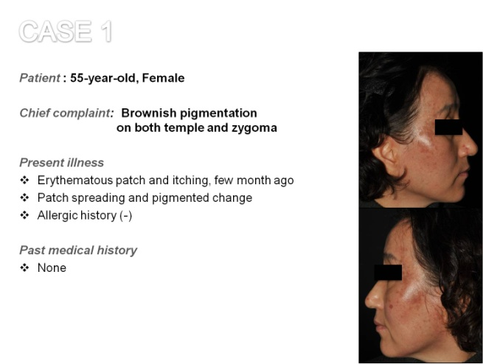
Suddenly occurring acquired hyperpigmentation on sun exposed area is often misdiagnosed as hyperpigmentary disorders due to chronic sun exposure. Lichenoid photodermatitis, a photoallergic reaction with characteristic histology showing lichenoid dermatitis, clinically appears as pigmentary dermatitis. Previous reports have noted a variety of drugs and contact allergens as causable factors. Two female patients presented with erythematous to hyperpigmented scaly patch with itchy and pricking sense on face and neck since few weeks ago. Histopathological examinations showed vacuolar interface dermatitis with lichenoid lymphocytic infiltration. Based on clinical and histological findings, the patients were diagnosed as lichenoid photodermatitis. Personal care products or hair dyes, as suspected contributing factors, were ceased and aggravating erythema showed improvement leaving only hyperpigmentation. In the case of acquired hyperpigmentation with photodistribution, it is necessary to consider lichenoid photodermatitis.

Image

Recent Publications (minimum 5)
- KH Mohan. Acquired macular hyperpigmentation an overview. Journal of Pakistan Association of Dermatologists 2011; 21: 43-54.
- Weschler HL. Dermatitis medicamentosa: a lichen-planus-like eruption due to quinidine. AMA Arch Dermatol Syph 1954; 69: 741–744.
- Morliere P. Drug-induced photosensitivity: phototoxic and photoallergic reaction – a few molecular aspects. Biochimie 1986; 68: 849–855.
- Michelle H. Collazo, Jorge L. Sánchez, Luz D. Figueroa. Defining lichenoid photodermatitis. International Journal of Dermatology 2009; 48: 239–242.
.

 Biography (150 word limit)
Jungwoo Ko graduated from Chungnam National University College of Medicine in 2012 (gained M.D. degree) and worked as a public health doctor in Yeosu and Jincheon counties' public health center from 2012 to 2015. He worked as an intern at Chungnam National University Hospital in 2015 and has been working as a dermatology resident at Chungnam National University Hospital since 2016..

Email: ggoogoong@hanmail.net
Phone: +82-10-8924-5361

Notes/Comments:

