Case Report and Bibliographical Review - Jorge Lobo’s Disease
Michelle Alpino Bittencourt, MD, Dermatologist, Private Office, Brazil

Abstract

Jorge Lobo's disease is a chronic cutaneous and subcutaneous granulomatous fungal infection caused by Lacazia loboi. It was first described by a brazilian dermatologist named Jorge Lobo in 1931. Most human cases are restricted to tropical regions predominantly in the Amazon. Transmission seems to occur through traumatic inoculation of the fungus, consequently the lesions usually occur on the skin of the lower extremities exposed areas. In the present study we report a case of an infected patient who is residente in the North of Mato Grosso, Brazil. In the literature review of Jorge Lobo’s disease we noticed that the clinical presentation is usually polymorphic, with the lesion initially imperceptible, altering over time in size, color and distribution. The diagnosis is made by mycological, clinical, pathological and immunohistochemical examination. So far, it has not been possible to isolate this fungus in culture which makes it difficult to understand the immunological aspects involved in the disease and makes it difficult to know the mechanisms that favor the spread of mycosis and how it occurs. The choice of treatment depends on the distribution of the lesions. A good therapeutic for small or isollated lesions has been surgical excision or cryotherapy treatment. In the present case, considering the extent of the lesion, pharmacological treatment with clofazimine and itraconazole was chosen. After observing the clinical course for about ten months, there was no significant improvement of the cutaneous lesions. For correct and early diagnosis and for the best treatment it is essential to know that this disease is increasingly common outside the tropics. The rarity associated with treatment failures based on extensive review of the literature disease motivated the research regarding the subject and the description of the asssited case.
Images: personal archive
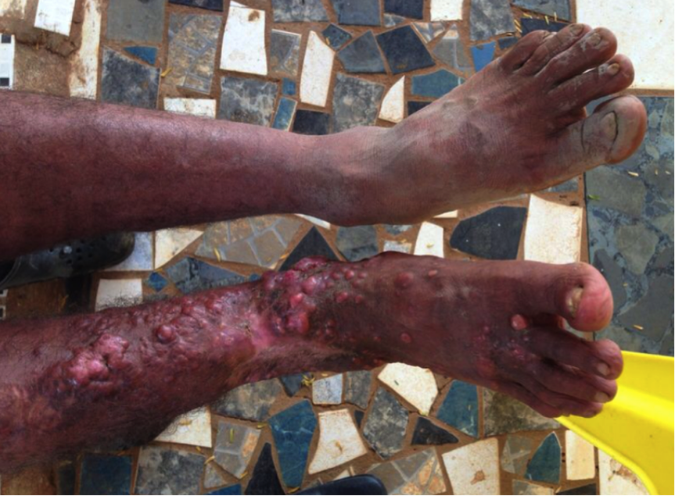
Image 1: RNLS, may 7th 2014.
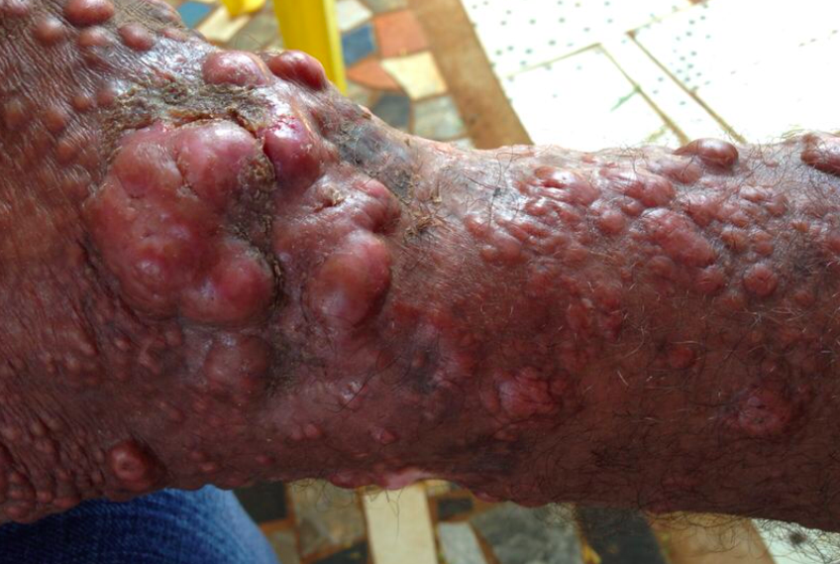
Image 2: RNLS, may 7th 2014.

Recent Publications

- Anderson, AK. Chaduvula, M. Atkinson, SE. Khanolkar-Young, S. Jaind, S. Suneetha L. et al. (2005) Effects of prednisolone treatment on cytokine expression in patients with leprosy type 1 reactions. Infect Immun. n 73, p. 3725- 33.
- Belone, AF. Madeira, S. Rosa, PS. Opromolla, D.V. (2002) Experimental reproduction of the Jorge Lobo’s disease in BALB/c mice inoculated with Lacazialoboi obtained from a previously infected mouse. Mycopathologia, 155:191-194.
- Bermudez, L.; Van Bressem, MF. Reyes-Jaimes, O. Sayegh, AJ. Paniz-Mondolfi, AE. (2009) Lobomycosis in man and lobomycosis-like disease in bottlenose dolphin, Venezuela. Emerg Infect Dis 15: 1301-1303.
- Brito AC, Quaresma, JAS. (2007) Lacaziose (doença de Jorge Lobo): revisão e atualização. An Bras Dermatol 82: 461-474.
- Burns, RA. Roy, JS, Woods, C. Padye, AA. Warnock, DW (2000) Report of the first human case of Lobomycosis in United States. J. Clin Microb. v. 38, n.3, p.183-1285
- Rosa, PS. Soares, CT. Ade, FB, Vilela, R. Ura, S. Filho, MC, Mendonza, L. (2009) Accidental Jorge Lobo’s disease in a worker dealing with Lacazia loboi infected mice: a case report. J Med Case Rep. 3: 67.

 Michelle Alpino Bittencourt, MD
Dr. Michelle Alpino Bittencourt received her medical degree from Londrina State University which is a renowned Medicine School in Brazil. MD with 15 years of experience on treating patients with a variety kind of diseases, Dr. Bittencourt now spends the majority of her profissional time focused on diagnosis and treatment of skin diseases. Dr. Michelle Bittencourt has a strong interest in skin research and how it applies to daily patient care. Her special interest on her field includes skin cancer prevention and treatment, psoriasis, acne and cosmetic dermatology.
Email: bittenmic@yahoo.com
Phone: + 55-44-99727-5700

