Keratitis-Icthyosis-Deafness (KID) syndrome-a rare congenital syndrome
Corresponding Auther: Snoor S. Hadi. M.B.,Ch.B., M.Sc (Dermatology)
Department of Internal Medicine (Dermatology). Azadi General Teaching Hospital. Duhok. Iraq
Abstract
KID syndrome (Keratitis-Icthyosis-Deafness syndrome), first described in 1915 by Frederick Burns who provided a detailed clinical description delineating all the key features of this syndrome.¹ I report a 30 year old female who presented with persistant scaly skin over parts of her body and scalp with diffuse alopecia. There was erythrokeratoderma of face and diffuse hyperkeratotic hyperpigmented infected plaque over pubis. There was history of recurrent episodes of folliculitis over the scalp. There was no evidence of tuberculosis or any malignancy. Eye involvement in the form of impaired vision and irritation were present. There was bilateral sensorineural progressive hearing loss.
It is a great opportunity for me to share an interesting rare case with KID syndrome to add another case to the published cases worldwide and to increases awareness of this unique syndrome, suggesting the proper diagnostic strategy and effective treatments to improve the quality of life as it is a chronic non healing disease.
Keywords: Keratitis-ichthyosis-deafness, Keratitis, deafness, Ichthyosis.

Introduction:
KID syndrome is a rare genetic multi-system disorder with about 200 published cases. Although it is inherited in an autosomal dominant and recessive manner, the majority (>90%) of reported cases have been sporadic.² The vast majority of KID syndrome patients harbor mutations in GJB2, which encodes Connexin 26, a β-type gap junction protein.³

There is considerable variability in the type, extent and severity of cutaneous features in patients with KID syndrome. The first manifestation is often transient erythroderma at birth or during infancy. Later, most patients develop symmetrically distributed, well demarcated, hyperkeratotic plaques with an erythematous base and a rough, ridged or verrucous surface (i.e. erythrokeratoderma); psoriasiform plaques have also been described. The plaques are predominantly localized to the knees, elbows and face (often with radial furrows around the mouth), although the helices, scalp, groin and other skin folds.⁴

It is characterized by defects of the surface of the corneas (keratitis), red, rough thickened plaques of skin (erythrokeratoderma) and sensorineural deafness or severe hearing impairment. The skin on the palms of the hands and soles of the feet and the nails may be affected. KID syndrome belongs to a group of skin disorders marked by dry, scaly skin known as the ichthyoses.⁴
The clinical triad of KID syndrome progressive vascularizing keratitis, sensorineural hearing impairment, and skin manifestations (generalized or localized) are better classified as erythrokeratoderma than as ichthyosis.⁵ Heterozygous missense mutations in the GJB2 gene localized on chromosome 13q11-q12 encoding a gap junction protein called connexin-26 were found to be associated with the KID syndrome.⁶

Case report:
I report a 30 years old female from north of Iraq born of non-consanguineous parents as a full-term normal vaginal delivery. She came from poor socioeconomic culture with low intellectual performance. She started to have symptoms of the disease by age of one year as lesions with pustules at axilla and abdomen which increased in thickness as she grew older. She gave history of dry scaly face which increases in severity by age. She had history of teeth abnormalities which ended by denture. There was history of impaired vision and irritation, but had intact visual acuity and no other abnormal ophthalmological symptom or sign. She had progressive decreasing in hearing since childhood ended by wearing hearing assisted device. Gait was normal. No other congenital abnormality or systemic disease was detected. There was no family history of similar problem.

On examination she showed sparse thin hair over the scalp with follicular atrophy at places and multiple folliculitis lesions with scattered alopecia (Figure 1A).
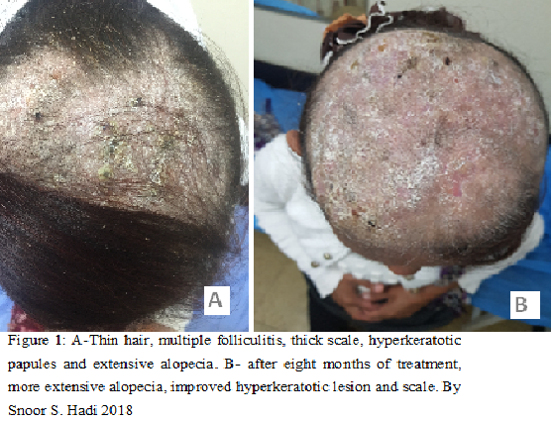

She had thick painful granulomatous and infected plagues in the pubis with no vaginal mucosal involvement (figure 2A).
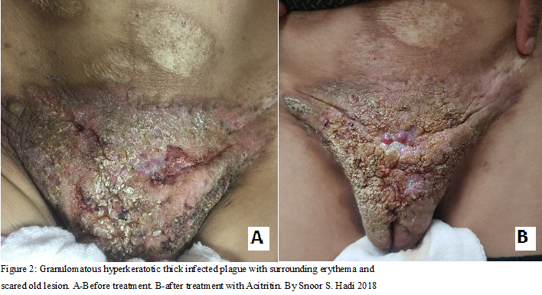

Hypotrichosis of eyebrow and eyelashes with thick face skin and perioral furrows were also present (Figure 3A).
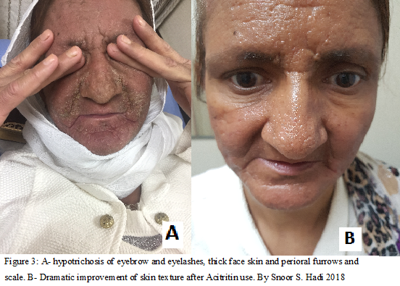 Old scaring lesions with atrophy of both breasts and axilla were noticed which were more prominent at right side (Figure 4).
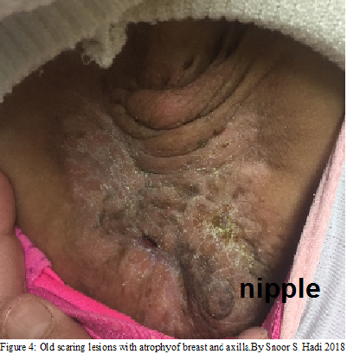
Results of blood tests showed iron deficiency anemia, mild leukocytosis with normal renal and liver function tests. Screening for hepatitis viruses, human immunodeficiency virus, and tuberculosis were negative. Scraping for fungal growth was negative. There was heavy growth of staphylococcus aureus species from a swab taken from pubic lesion. Chest x-ray and abdominal ultrasonography revealed no abnormalities. Punch biopsy taken from two different areas of pubis which showed hyperkeratotic epidermal layer with absent granular layer and inflammatory cell infiltration, no atypia or dysplasia was noticed.
We used genomic DNA of the patient extracted from paraffin-embedded tissue samples for mutation analysis of the GJB2 gene. The DNA was extracted using Quiagen Kit.⁶
PCR was performed using standard conditions with primer pairs covering the coding region of the GJB2 gene (primer sequences and PCR conditions are available on request). The PCR products were purified with the GFXTM PCR DNA Purification Kit (Amersham Biosciences) and directly sequenced using the BigDye® Terminator v1.1 Cycle Sequencing Kit (Applied Biosystems) on an ABI 3100 genetic analyser (Applied Biosystems). The sequencing analysis showed in addition to a known polymorphism (– 34C→T; NCBI ref SNP ID: 15 9578260) a heterozygous 148G→A transition in connexin 26 (Cx26) resulting in substitution of aspartic acid with asparagine in codon 50 (D50N).

Supportive treatment including emollient and bath oils as well as iron and multivitamins were given with topical and systemic antibiotics and systemic Isotretinon tablets 40mg daily for one year but with little improvement of skin lesion. Followed by more powerful retin A derivatives (Acitretin 35 mg daily for two months) with noticeable improvement of face and pubic skin lesions (Figures: 1B, 2B, 3B).
Discussion:
Caceres-Rios et al., analyzed approximately 70 cases, most of them were sporadic, had been reported and found all of them showing cutaneous and auditory abnormalities, 90% sensorineural deafness, 89% erythrokeratoderma, 79% alopecia, 41% reticulated hyperkeratosis of the palms and soles, and 95% had ophthalmologic defects, most of them (79%) had vascularizing keratitis. ⁵ In our case manifestations of skin and auditory were obviously present but the eye manifestations were little.
Palmoplanter keratoderma was absent which may be due to variablility of disease expression between indiviuals affected as both an autosomal dominant form and an autosomal recessive form have been described, and even numerous sporadic cases have also been reported. Heterozygous missense mutations in the GJB2 gene localized on chromosome 13q11-q12 encoding a gap junction protein called connexin-26 were found to be associated with the KID syndrome.⁶ Patients are more susceptible to chronic cutaneous bacterial and mycotic infections. These contribute to alopecia, nail dystrophy, and body odor. Patients with KID syndrome are susceptible to severe sepsis and deaths are reported with increased frequency in these patients.⁷ Our case had neglected lesion in pubic area for years and had been treated as fungal infection for long time, then she was referred to Dermatology Department of Azadi General Teaching Hospital and after full assessment, KID syndrome was set as first differential diagnosis. An increased oncogenic potential with invasive squamous cell carcinoma (SCC) arising within the hyperkeratotic lesions has been reported in several KID patients.³ For that biopsy taken from two different area for suspecting malignancy but histopathology report showed hyperkeratotic lesion with absent granular layer and inflammatory cells inflatrate, but signs of dysplasia or atypia were absent.
Hearing loss, mainly sensorineural, is always present, with variable degrees of compromise. It is congenital but is usually detected during infancy or early childhood and has almost always developed by age seven years. But because of poor socioeconomic status and low intellectual performance our case was neglected for years and profound bilateral sensorineural deafness by otolaryngeologist was set only five years ago.
The main eye symptoms of the KID syndrome are photophobia, irritation, and visual disturbance due to vascularizing keratitis. The eye lesions of the KID syndrome express later than the other alterations, and they may not evolve with symptoms until puberty. Corneal vascularization, which expresses bilaterally but asymmetrically, is very frequent. Recurring corneal erosions, corneal leucomae, Meibomitis, and severe dry eye syndrome are other eye manifestations of KIDs.⁸
Eye manifestations in our patient were limited with only complaining irritation and impaired vision, but no abnormal ophthalmological sign was found by ophthalmologist.
Early diagnosis of KID syndrome is important, and the timely use of hearing aids and speech therapy can prevent damages in the development of speech. Even though the general prognosis seems good, the life-long follow-up of patients is necessary because the KID syndrome can be associated to malignant tumors, particularly SCC.⁸ Recently, the follicular occlusion triad (dissecting cellulitis of the scalp, cystic acne, and hidradenitis suppurativa), follicular tumors, and SCCs have been increasingly recognized as manifestations of KID syndrome.^{3,7}
Management of KID syndrome requires multidisciplinary care by dermatology, ophthalmology, and otolaryngology services. Topical retinoids and keratolytics have limited benefits. There are several reports of substantial improvement in hyperkeratosis with acitretin therapy, and isotretinoin has variable efficacy in treating the follicular occlusion triad in KID patients.^{3,9} Oral antibiotics and antifungal medications are necessary when infections develop and prolonged courses are occasionally required. Close monitoring of the skin and oral mucosa for the development of malignancy is essential. Lubricating and antiinflammatory agents have variable success in managing ocular disease, and cochlear implants have restored hearing in several affected individuals.
References:
- Burns FS. A case of generalized keratoderma with unusual involvement of the eyes and nasal and buccal mucosa. J Cutan Dis. 1915;33:255–60.
- Richard G, Rouan F, Willoughby CE, et al. Missense mutations in GJB2 encoding connexin-26 cause the ectodermal dysplasia keratitis-ichthyosis-deafness syndrome. Am J Hum Genet. 2002;70:1341–8.
- van Steensel MA, van Geel M, Nahuys M, et al. A novel connexin 26 mutation in a patient diagnosed with keratitis- ichthyosis-deafness syndrome. J Invest Dermatol. 2002;118:724–7.
- Jean LB, Joseph LJ, Julie VS. Dermatology. 2014; 3(57) :864-5.
- Caceres-Rios H, Tamayo-Sanchez L, Duran-Mckinster C, et al. Keratitis, ichthyosis, and deafness (KID syndrome): review of the literature and proposal of a new terminology. Pediatr Dermatol 1996;13:105-13.
- Maintz L, Betz RC, Allam JP, Wenzel J, Jaksche A, Friedrichs N, et al. Keratitis-ichthyosis-deafness syndrome in association with follicular occlusion triad. Eur J Dermatol 2005;15:347-52.
- Gilliam A, Williams ML. Fatal septicemia in an infant with keratitis, ichthyosis, and deafness (KID) syndrome. Pediatr Dermatol 2002;19:232-6.
- Gómez-Faiña P, Ruiz-Viñals AT, Buil-Calvo JA, España-Albelda A, Pazos-López M, Castilla-Céspedes M. Patient with severe corneal disease in KID syndrome. Arch Soc Esp Oftalmol 2006;81:225-7.
- Langer K, Konrad K, Wolff K. Keratitis, ichthyosis and deafness (KID) syndrome: Report of three cases and a review of the literature. Br J Dermatol 1990;122:689-97.

