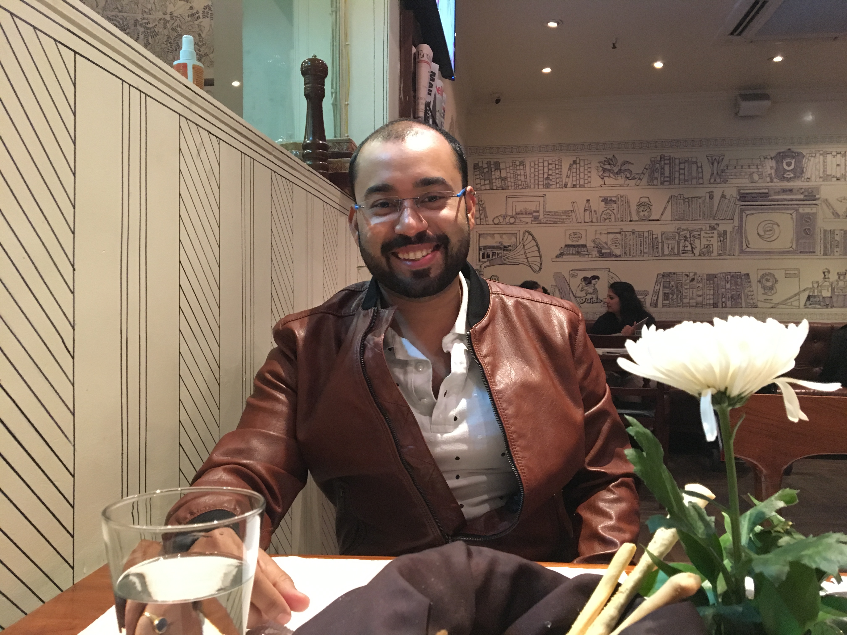

Title: The Importance of Inner Child Regression in Trauma Resolution Therapy

Name: Dr. Gaurav Deka
Founder and Director
Cognial Healers’ Academy, India

The truth about trauma doesn’t lie only in the hurt or the wound, but most importantly in the unconscious replaying of it by the body. As presented by Dr. Norman Doidge, through his book, “The Brain that Changes Itself,” several RCTs with victims and survivors of PTSD, childhood abuse, accidents, loss and abandonment, prove that trauma causes real progressive brain changes: mainly in the hippocampal area with increased amygdala activation eventually affecting ventromedial pre-frontal cortex. It only means that the effect of trauma is because of the interaction of the body or the cells with the environment in an event which the brain is unable to process. This presentation will discuss how Regression Therapy, concentrated in Inner Child work, addresses resolution of trauma by taking the client back to the point of trauma, where the ‘traumatic event’ is located. It is in this traumatic event that a part of the client is still trapped in a time-energy capsule. This traumatized part is called the ‘the wounded inner child.’ It is the wounded inner child which keeps resurfacing in the day to day life of the client, replaying the trauma in every possible set up that mimics the actual traumatic event. In this experiential presentation following a somatic pathway, invoking the cellular memory, in an altered state of consciousness, it will be established how inner child work allows the body to relive the trauma in a controlled set up, move through it and finally end it.

Biography

Dr. Gaurav Deka is a medical doctor, a psychodynamic psychotherapist and a Transpersonal Trauma Resolution Expert. He is the founder of Cognial Healers’ Academy, a premier institute that teaches a certified diploma course in Transformational and Holistic Psychotherapy across India. His degree of qualifications include a bachelor’s degree in medicine (MBBS) from Gauhati Medical College and Hospital, a masters in psychodynamic psychotherapy from Boston University, U.S., two post graduate diplomas in Transpersonal Regression Therapy (TASSO Institute, Netherlands) and Inner Child Integration Therapy (Trisha Caetano) respectively. He is also a member of the Earth Association for Regression Therapy (EARTh).

Presenting author details
Full name: Dr. Gaurav Deka
Contact number: +919599154305
Twitter account: @drgauravdeka
Linked In account: https://www.linkedin.com/in/drgauravdeka/
Session name/ number: NA
Category: Oral Presentation and Workshop

