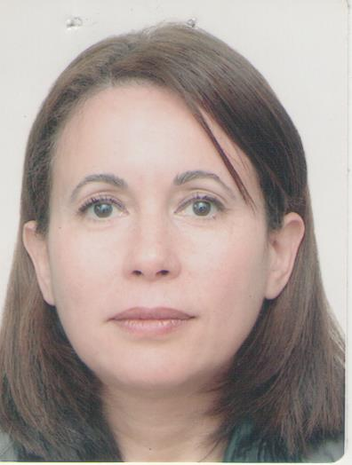

Pre orthodontic trainer: interceptive influence on incisor proclination
A case report
Pr Farida Ammouche Algiers Department of Dentistry
Abstract
The incisor proclination is the most common abnormality observed among our patients. The impact is felt on the esthetic of the smile, essential parameter of the demand for orthodontic treatments. The clinical form and degree of severity depend on the etiological factors and the relevant dentoalveolar or skeletal structures involved in the onset of incisor relationship abnormalities.
The therapeutic approach is chosen taking into account these factors but also the age of the patient and the stage of growth. The use of a trainer device is a good choice for interceptive treatment. The modifications made, have proven the effectiveness of the device but also its efficiency.

Key-words: Incisor proclination, etiological factors, trainer device, interceptive treatment

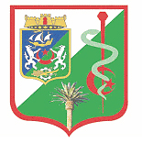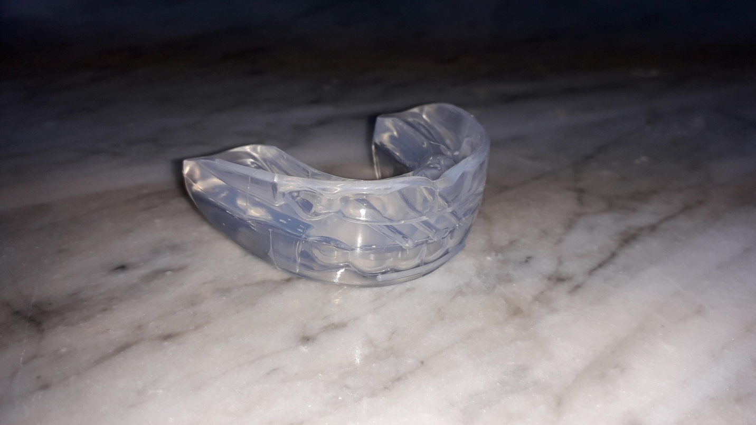
Fig 1 Trainer system
References
- Ammouche F. Role of functional rehabilitation in preventive and interceptive orthodontic management. Santé publique. 2017 ; 29 (5).
- Ammouche F. Eruptive guidance of permanent teeth and education of orofacial functions: Indications of early trainer treatment. MADOH. 2019. 307-309.
- Gipch J. L’orthopédie fonctionnelle et les éducateurs fonctionnels souples. Évolutions ou révolutions ? Id. 2012 ; 29/30 : 4-16.
- Gӧckçe B, Kaya B. Current approchesin myofunctional orthodontics.Musculoskelet
Disord Treat 2016; 2: Vol 2 Issue 3: 6p.
- Pujar P, Pai SM. Effect of preorthodontic trainer in mixed dentition. Hindawi. 2013; 6p.

Biography
Farida Ammouche is an orthodontist and works at the Faculty of Medecine of Algiers, Department of Dentistry as Professor. She holds several degrees in Dentistry and orthodontics.
Full name: Farida Ammouche
University: Algiers Faculty of Medecine Dentisry Department
Designation:Professor
Country:Algeria
Mobile number
Personal email:farida647@hotmail;com
Category: e poster
Research interest: Orthodontics
Date of birth: 24/04/1964
Postal address: 29 Rue Zouaoua, cheraga Algiers 1600 Algeria

