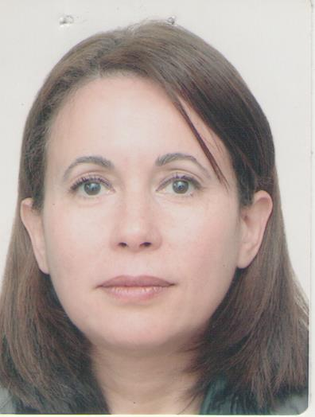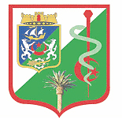

First premolar extraction: frequency and indications
Pr Farida Ammouche Algiers Department of Dentistry
Abstract
Prevalence of permanent teeth extraction was the subject of many studies, different results were found by authors, and most of them concluded that first premolars extraction is more frequent than the other teeth. In Algeria, the need for orthodontic treatment is increasingly important and dental crowding is the principal reason for orthodontic consultation. The assessment of the frequency and criteria for extractions within the orthodontic service of Algiers MUHC showed a big rate of first premolars extraction. Extraction frequency among the total population was 52, 6%, the predominant pattern was to extract 4 teeth (66.5% of cases), and with first premolars in large majority (80.6%).But is their extraction always indicated? Is it possible to maintain these teeth by non extraction treatment or by extracting another group of teeth?
The purpose of this work is to show results of the assessment and to give our conclusions concerning the first premolars extraction and its indications.
Key-words: First premolars, extraction frequency, indications, dental crowding, assessment

Fig 1 Dental extraction frequency
References
- Amat PH. Extractions et orthodontie. Revue Orthop Dento Faciale. 2014 ; 48 :103-116.
- Ammouche.F, Si Ahmed.F. Assessment of therapeutic extraction rates and criteria in orthodontics. Epidemiological study in the dentofacial orthopedics department of theMustapha University Hospital, Algiers. J Dentofacial Anom Orthod 2015;18:314.
- Hong B, MorrisJ, Dietrich T. Frequency variation and cost of dental extractions for adults in secondary care in Great Britains. British Dental Journal. 2019; 226: 679-686.
- De Araujo TM, Caldas LD. Tooth extractions in orthodontics: first or second premolars. Dental Press J Orthod. 2019; vol 24, n°3: 6P.
- Durga S, Rajasekar L, Robin O. Second premolar extraction: A case report. Biomed Pharmacol J.2015; 8.

Biography
Farida Ammouche is an orthodontist and works at the Faculty of medicine of Algiers, Department of Dentistry as Professor. She holds several degrees in dentistry and orthodontics.

Full name: Farida Ammouche
University: Algiers Faculty of Medicine, Dentistry Department
Designation: Professor
Country: Algeria
Mobile number: 00213778974100
Personal Email: farida647@hotmail.com
Category: e poster
Research interest: orthodontics
Date of birth: 24/04/1964
Postal address: 29 rue Zouaoua cheraga Alger 16000 Algeria

