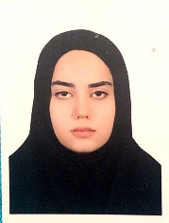


Marginal Discrepancy of Single Implant-Supported Metal Copings Fabricated
By Various CAD/CAM and Conventional Techniques Using Different
Materials
Safoura Ghodsi, Associate Professor, Department of Prosthodontics, Tehran University of Medical Sciences, Tehran, Iran
Marzieh Alikhasi, Professor, Department of Prosthodontics, Tehran University of Medical Sciences, Tehran, Iran
Nika Soltani, DDS, Department of Prosthodontics, School of Dentistry, Tehran University of Medical Sciences, Tehran, Iran

Abstract (300 word limit)

Objective: Framework patterns can be formed using various materials such as wax, acrylic resin, or composite. Frameworks can be fabricated using either conventional or computerized techniques, using additive or subtractive method. This study aimed to compare the marginal adaptation of metal copings fabricated by two computerized technologies (milling and rapid prototyping) and additive conventional methods using different materials.

Materials and Methods: Seventy-two fixture analogs were mounted vertically in acrylic resin. One-piece abutments with 5.5 mm in length and 6 degrees of convergence were secured into the analogs. The experimental frameworks were fabricated using either subtractive CAD/CAM milling (by wax, soft or hard metal), additive rapid prototyping (by wax), or conventional pattern fabrication (by wax [control] or acrylic resin). Wax and acrylic resin patterns were casted in Ni-Cr alloy. Marginal discrepancy was measured in 12 points by video measuring machine. Statistical Analysis One-way ANOVA and posthoc tests were used to detect any significant difference among the groups at α= 0.05.

Results: There was a statistically significant difference among the marginal discrepancy of six groups (p = 0.018). The Tukey test indicated a significant difference between CAD/milling of soft metal and conventional wax pattern groups (p = 0.011); a significant difference was also reported between CAD/milling of wax patterns and control group (p = 0.046).

Conclusions: Frameworks fabricated by conventional wax-up showed the largest marginal gaps, while the marginal gap created by frameworks made of soft metal CAD/milling were the smallest. In addition, frameworks fabricated by rapid prototyping showed clinically acceptable adaptations.

Key words: dental implants, dental marginal adaptation, dental materials, computer-aided design, metal ceramic alloys
Image
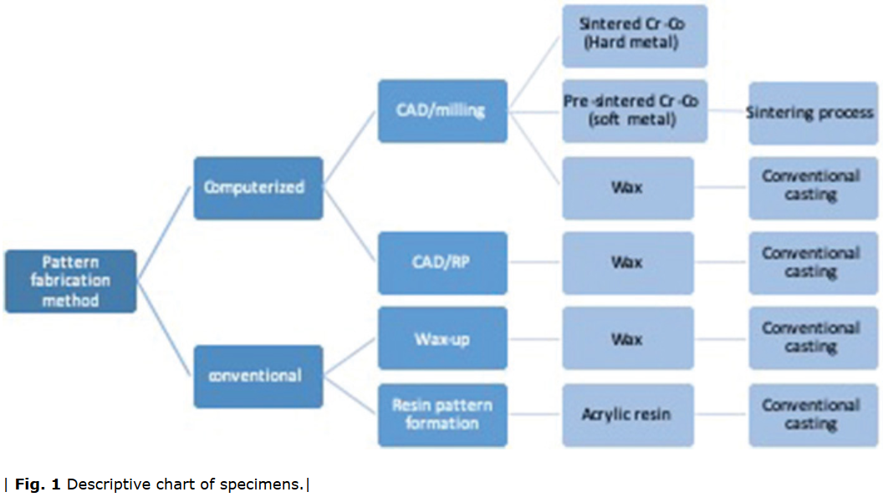

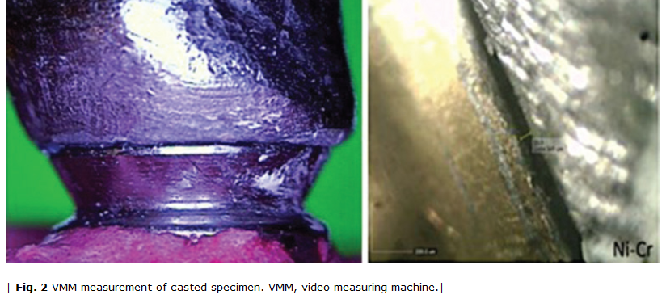
Recent Publications (minimum 5)

- G Saglam, S Cengiz, O Karacaer (2020) Marginal adaptation and fracture resistance of feldspathic and polymer-infiltrated ceramic network CAD/CAM endocrowns for maxillary premolars. Nigerian Journal of Clinical Practice 23:1-6.
- El Ghoul Wiam A, Özcan Mutlu, Ounsi Hani, Tohme Hani, Salameh, Ziad (2020) Effect of different CAD-CAM materials on the marginal and internal adaptation of endocrown restorations: An in vitro study. Journal of Prosthetic Dentistry 123: 128-134.

Lokanathanbalaji Doddy, Sesha Reddy, Sashideepth Reddy, Janapala, Narendra R (2019) Comparative Evaluation of the Marginal Adaptation of Cast Ni-Cr Copings, Direct Metal Laser Sintering Co-Cr Copings, and Computer-aided Design and Computer-aided Manufacturing Zr Copings: An In-vitro Study. Cureus 11.

Leneena Gudugunta, Praffulla Mynampati, Matada Basavarajaiah Jeevan, Sathiyavathi Mahendra Kumar, Anitha Akkaloori, Sai Krishna Tejavath (2019) The marginal discrepancy of lithium disilicate onlays: Computer-aided design versus press. J Conserv Dent 22:336-339.
- Yushu Liu, Hongqiang Ye, Yong Wang, Yijao Zhao, Yuchun Sun, Yongsheng Zhou (2018) Three-Dimension Analysis of Internal Adaptations of Crowns Cast from Resin Patterns Fabricated Using Computer-Aided Design/Computer Assisted Manufacturing Technologies. Int J Prosthodont 31:386-393.

Biography

Nika Soltani is DDS-MPH graduate from Tehran University of Medical Sciences. She is an endodontics resident in Azad University of Medical Sciences.

Presenting author details
Full name (As per the passport): Nika Soltani
University/Industry/Organization name: Tehran University of Medical Sciences
Designation (Director/Prof/Assistant or Associate prof/Researcher/Student): Student
Mobile number (country code – number):00989129284492
Email: soltaninika@yahoo.com
Track number: https://dentistrycongress.dentistryconferences.com/abstract-submission.php (For track number follow this link)
Category (Oral presentation/ Poster presentation/Young researcher forum/E-poster/ Workshop): Oral presentation
Research interest: digital dentistry, laser, oral health
Your profile page URL in your department:
Year of birth: 1995
Linked In/Facebook/twitter account:

Note: Please fill up the Red mark fields so that it would be easier for us to cite your details in the conference particulars. (Please do not forget to fix your photo and Logo above the title)

