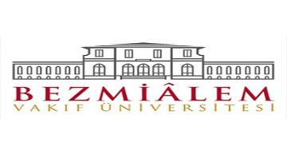
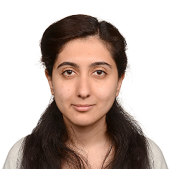

Revascularization of Non-Vital
Immature Permanent Tooth Using
Platelet-Rich-Fibrin: A Case Report
Basak GUNAY, Bezmialem Vakıf University Faculty of Dentistry,Department of Pediatric Dentistry, Istanbul, TURKEY
Pınar Kınay TARAN, Bezmialem Vakıf University Faculty of Dentistry,Department of Pediatric Dentistry, Istanbul, TURKEY

Mustafa Sarp KAYA, Bezmialem Vakıf University Faculty of
Dentistry,Department of Pediatric Dentistry, Istanbul, TURKEY

An eleven-year-old boy with no systemic disease applied for dental examination to our department. Patient history and intraoral exam revealed avulsion of no: 21, 2 years ago. Parent reported that no treatment was performed after the trauma. Clinically, 11 was asymptomatic with a slight discoloration of the crown and radiography showed arrested root development. Necrosis was determined with negative response to vitality test and crown discoloration. Hence revascularization procedure was planned. At the first appointment access cavity was prepared following local analgesia. Necrotic pulp tissue was disinfected using 1.5% NaOCl (20mL, 5 min) followed by saline irrigation. In order to prevent discoloration, a double antibiotic paste without minocycline (ciprofloxacin, metronidazole) was injected into the root canal and restored with glass ionomer. Two weeks later, following 17 % EDTA (20 ml) irrigation an attempt to induce bleeding into the canal by overinsturmenting a K-file failed. Thus it was decided to use platelet rich fibrin (PRF) instead of whole blood for revascularization. For PRF procedure 10 mL of the patient's blood was drawn antecubital fossa and centrifuged. Then, the PRF clot was adapted inside the root canal, and MTA was placed directly over the PRF. The tooth was restored with glass ionomer cement and composite resin. At the recall appointments at 1, 3, 6 and 12 months radiological examination revealed further root development and apical closure in 11.

Key words: Open apex, platelet-rich fibrin, revascularization
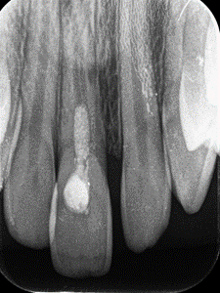
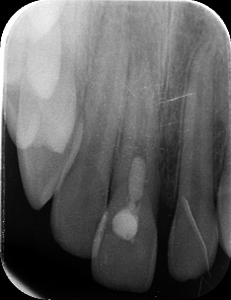
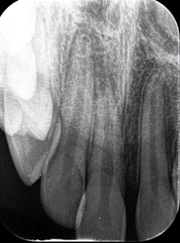

First appointment Second appointment Post treatment 1.month

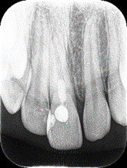
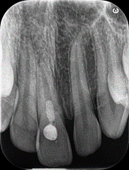
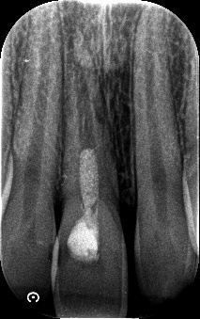
Post treatment 3. month Post treatment 6. month Post treatment 12.month

Recent Publications
- American Association of Endodontists. (2016). AAE Clinical Considerations for a Regenerative Procedure.
- Adhikari, H. D., & Gupta, A. (2018). Report of a case of platelet-rich fibrin-mediated revascularization of immature 12 with histopathological evaluation. Journal of conservative dentistry: JCD,21(6),691
- Nagaveni, N. B., Pathak, S., Poornima, P., & Joshi, J. S. (2016). Revascularization induced maturogenesis of non-vital immature permanent tooth using platelet-rich-fibrin: a case report. Journal of Clinical Pediatric Dentistry, 40(1), 26-30.
- Ray Jr, H. L., Marcelino, J., Braga, R., Horwat, R., Lisien, M., & Khaliq, S. (2016). Long‐term follow up of revascularization using platelet‐rich fibrin. Dental Traumatology, 32(1), 80-84.
- Bakhtiar, H., Esmaeili, S., Tabatabayi, S. F., Ellini, M. R., Nekoofar, M. H., & Dummer, P. M. (2017). Second-generation platelet concentrate (platelet-rich fibrin) as a scaffold in regenerative endodontics: a case series. Journal of endodontics, 43(3), 401-408.

Biography
Basak Gunay graduated from Istanbul University Faculty of Dentistry. Basak Gunay is research assistant in Bezmialem Vakıf University Faculty of Dentistry,Department of Pediatric Dentistry
Presenting author details
Full name (As per the passport): Basak Gunay
University/Industry/Organization name: Bezmialem Vakıf University
Designation (Director/Prof/Assistant or Associate prof/Researcher/Student): Resident
Country: Turkey
Mobile number (country code – number):+905072929002
Email:dtbasakgunay@gmail.com
Track number: https://dentists.dentistryconferences.com/ (For track number follow this link Pediatric Dentistry
Category (Oral presentation/ Poster presentation/Young researcher forum/E-poster):E-poster
Research interest: Pulp revascularization
Your profile page URL in your department:
Year of birth:1990
Linked In/Facebook/twitter account:

Note: Please fill up the Red mark fields so that it would be easier for us to cite your details in the conference particulars. (Please do not forget to fix your photo and Logo above the title)

