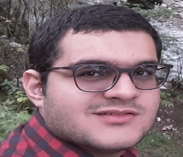
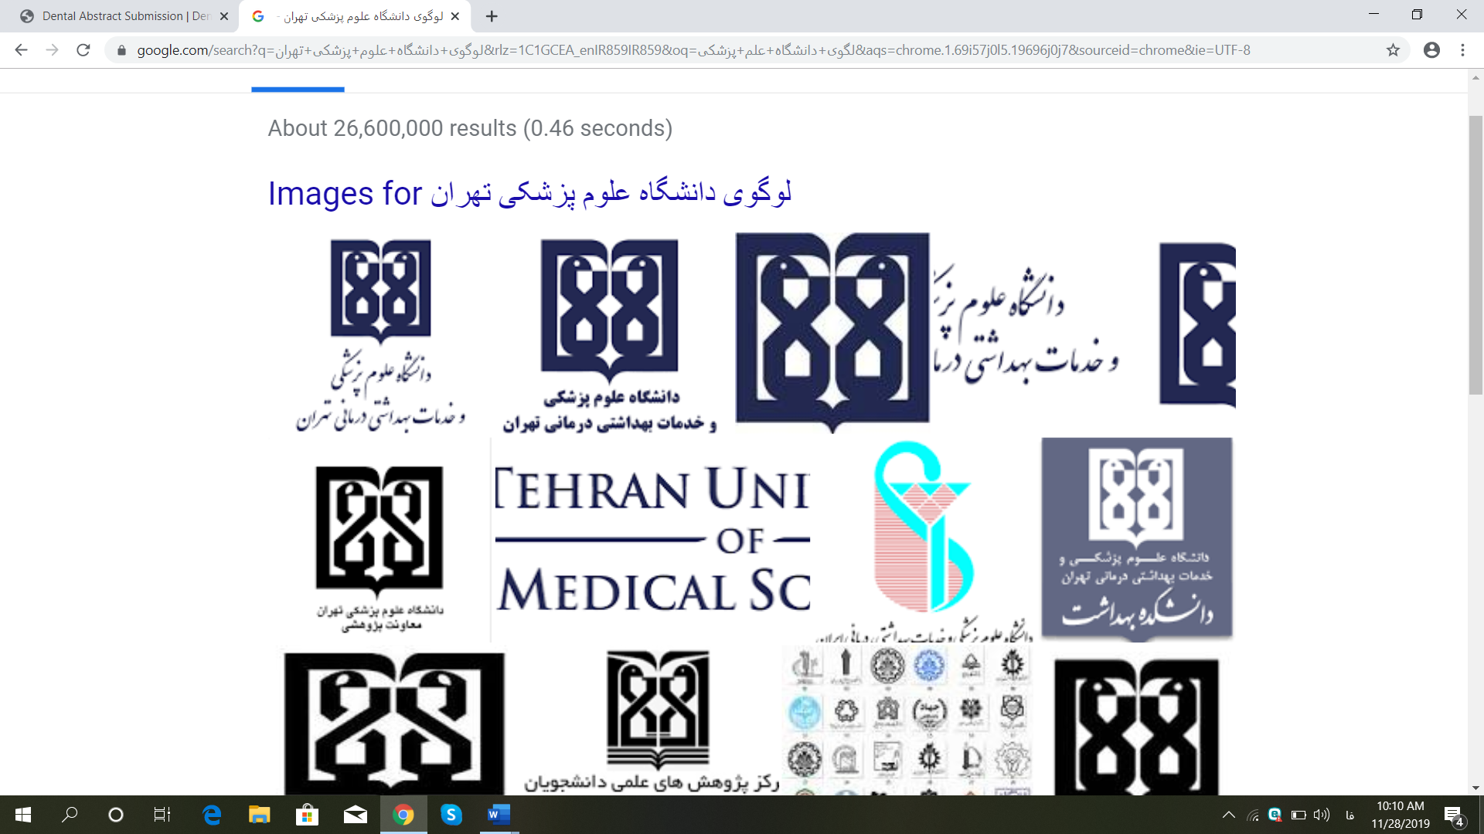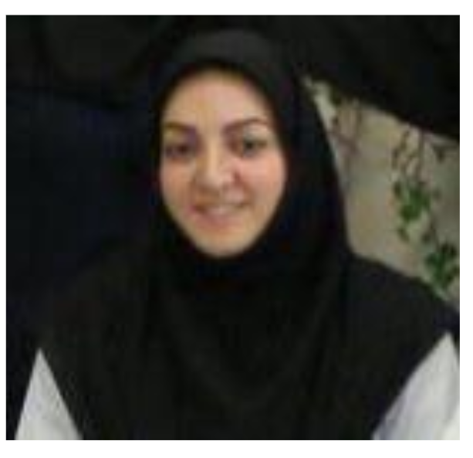
Recent Publications:
1. Immunohistochemical evaluation of angiogenesis and cell proliferation in tongue squamous cell carcinoma
2. P53 protein expression in dental follicle, dentigerous cyst, odontogenic keratocyte and inflammatory subtypes of cysts: An immunohistochemical study
3. Interlukin-6 secreted by oral cancer associated fibroblast accelerated VEGF in tumor and stromal cells
4. An extrafollicular Adenomatoid Odontogenic Tumor mimicking a periapical cyst
5. Correlation of Bcl-2 and COX-2 expression in oral Lichen Planus
Key words:
Intra oral leiomyosarcoma, leiomyosarcoma
Abstract:
Reactive lesions such as Irritation Fibroma, Pyrogenic Granuloma and etc. are prevalent in mandible and maxilla and dentists or dentistry specialists encounter them commonly. Malignant lesions sometimes mimic their clinical features. It is important to refer oral lesions that clinically are benign to pathology department. The aim of this article is to describe a case of leiomyosarcoma of the mandible with immunohistochemical analysis that is useful in making the final diagnosis. A 40-year-old woman was referred to Pathology clinic of Tehran university of medical sciences, for assessment of a firm and fixed lesion, approximately 50-mm diameter on the right side of the mandible. This lesion demonstrated a rapid growth in the last 3 months. A surgeon excised this lesion because he thought it is a reactive lesion. After a month, the patient went to the clinic again with the complaint of recurrence and re-enlargement of the lesion. The radiographic examination showed a lytic radiolucent lesion with facial and lingual cortical bone destruction. We provided an excisional biopsy. There was a neoplasm composed of interlacing fascicles of spindle-shaped cells. An obvious cell pleiomorphism was observed and nuclei were large and hyperchromatic. All of the neoplastic cells expressed Vimentin, Smooth Muscle Actin and Desmin and 25% of them expressed S100 and β-catenin. These findings were correlated with the diagnosis of intra oral leiomyosarcoma.

Dr Nazanin Mahdavi, DDS, M.Sc., Associate professor of oral and maxillofacial pathology department, Tehran university of medical sciences, Iran
Seyyed Abolfazl Tabatabaei Zadeh, dentistry student, Tehran university of medical sciences, Iran

An unusual case of leiomyosarcoma mimicking reactive lesions in mandibular ridge in a 40-year-old woman in a 40-year-old woman

