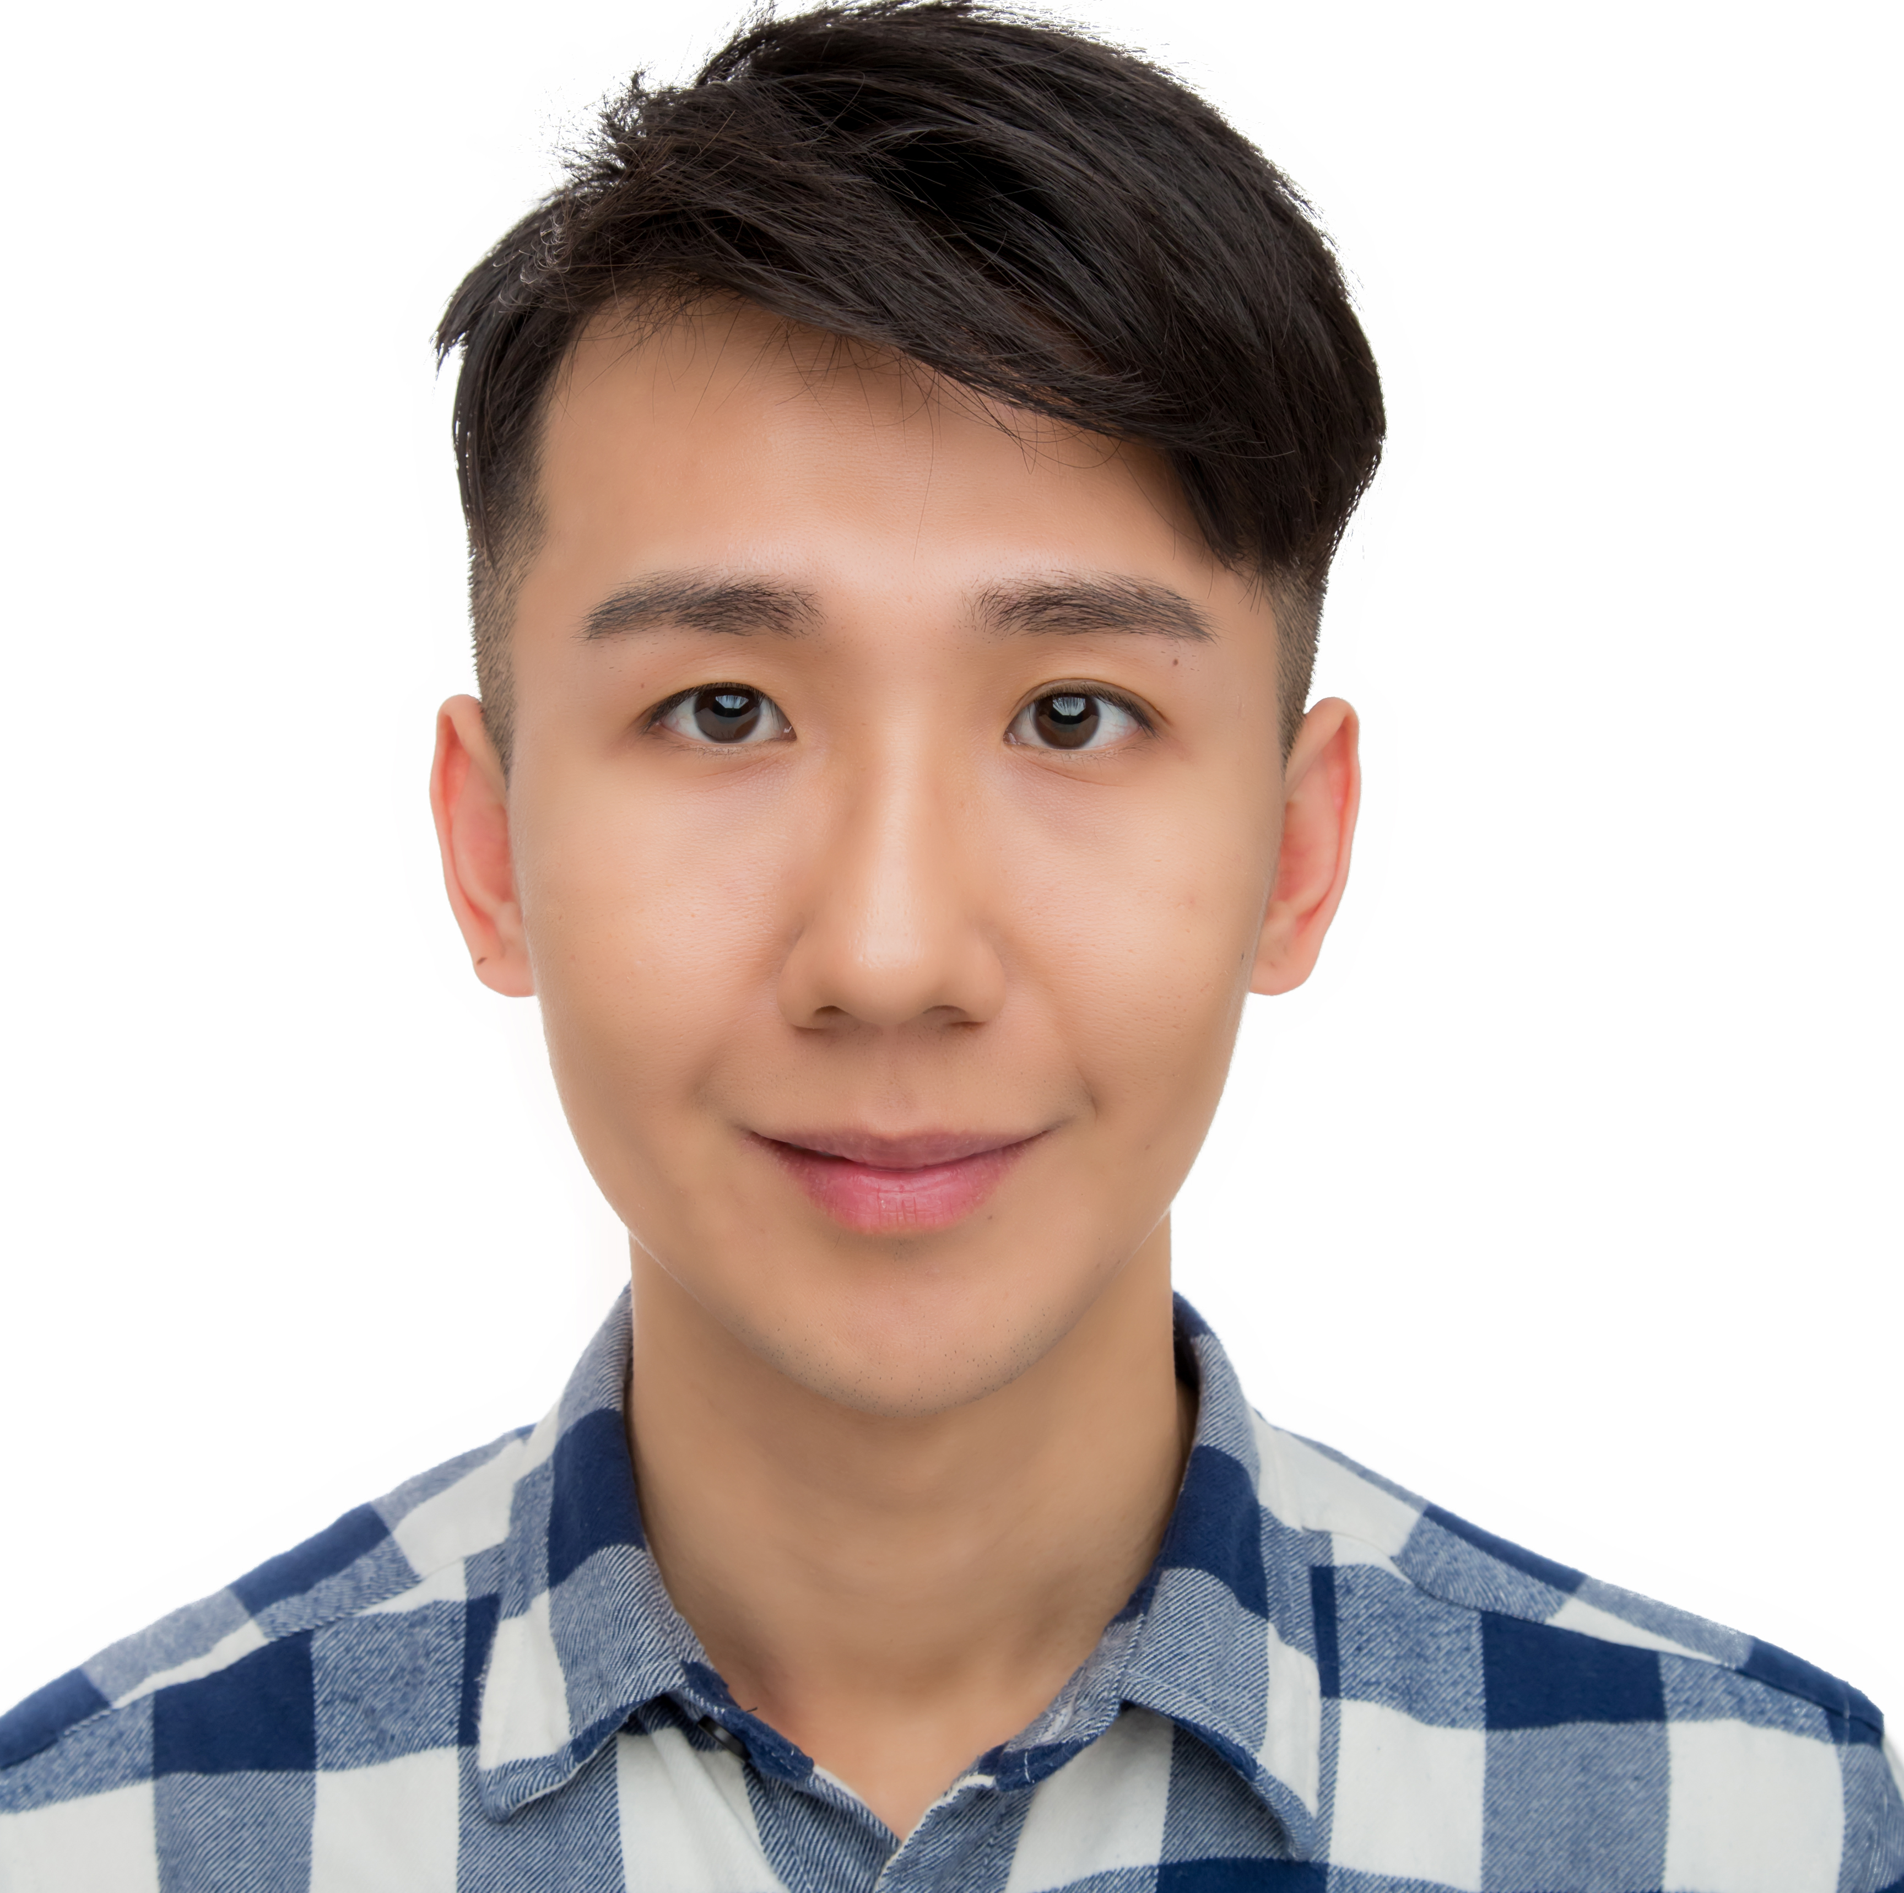 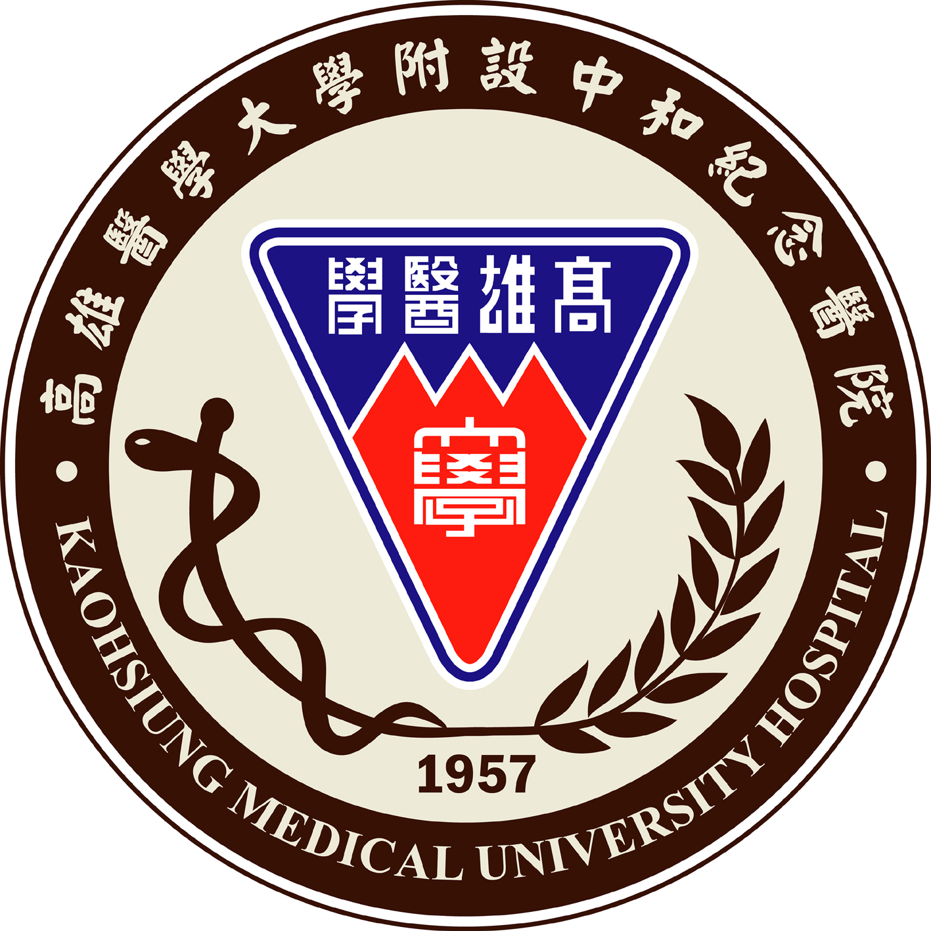 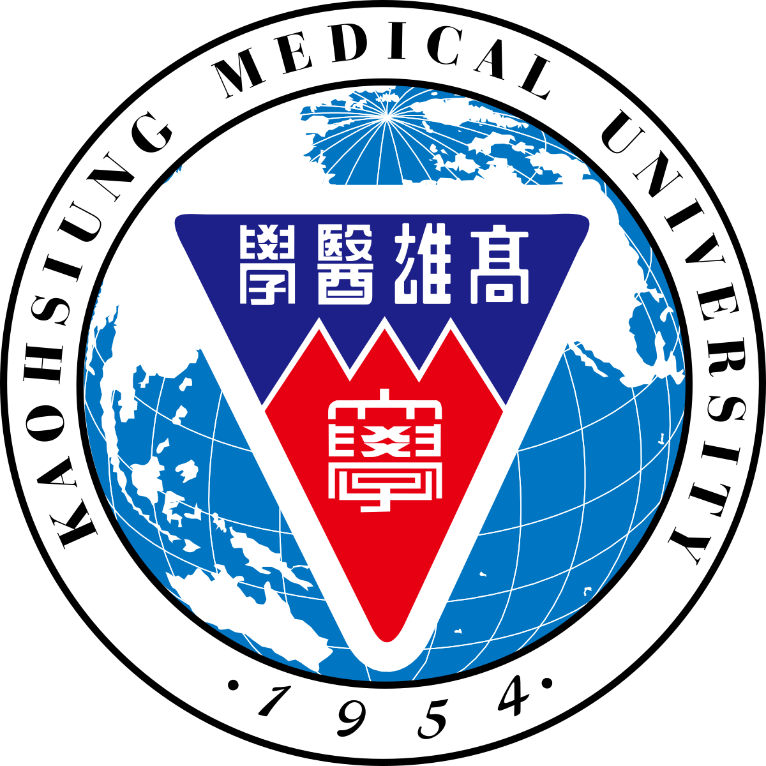 Kaohsiung Medical University

Conservative Management of Dental Caries in Oligodontia Patient
WenSheng Tsai, D.D.S, Kaohsiung Medical University Hospital, Kaohsiung, Taiwan, ChingYu Huang, D.D.S, Kaohsiung Medical University Hospital, Kaohsiung, Taiwan, Szuyu Hsiao, PhD, Kaohsiung Medical University Hospital, Kaohsiung, Taiwan

Abstract
Introduction： Oligondontia is a rare disease. There are several common features, such as delayed eruption, taurodontism. It’s important to consider differently from normal patients while making treatment plan.
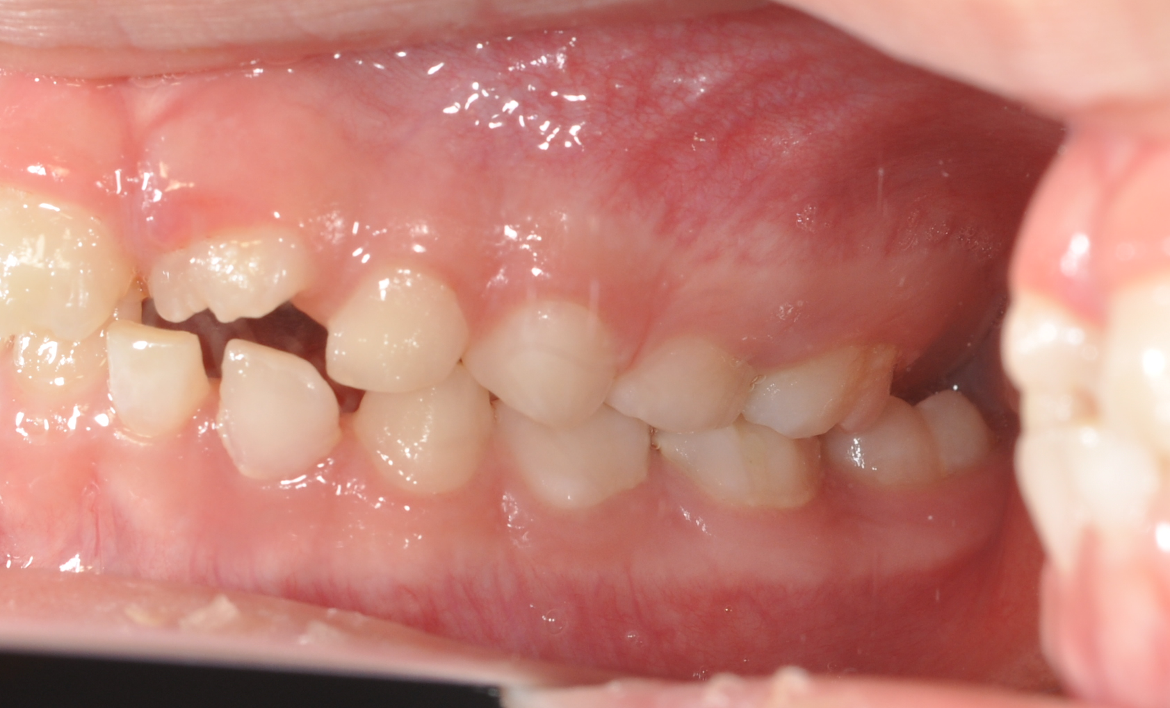
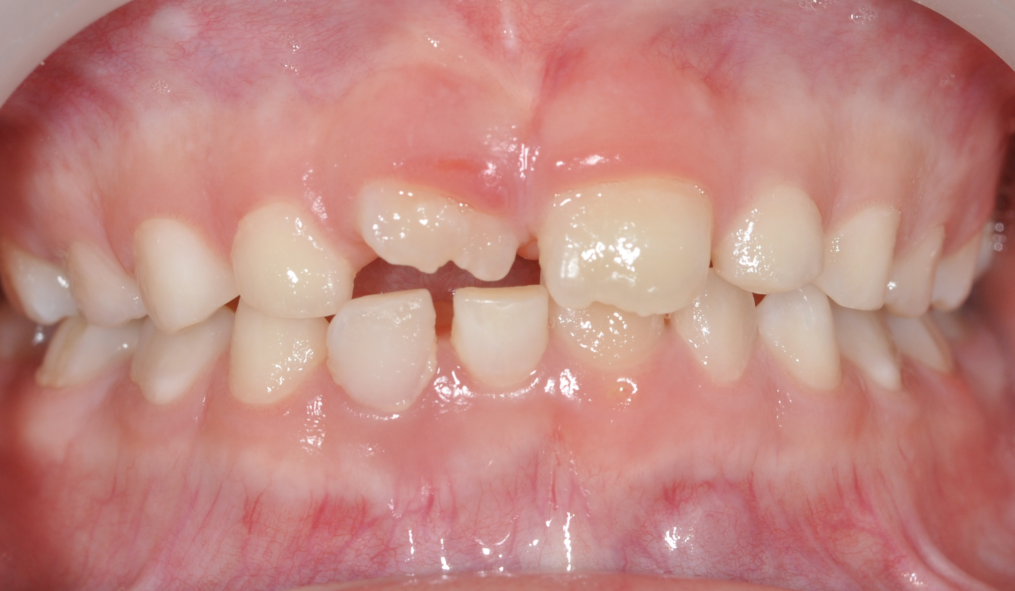
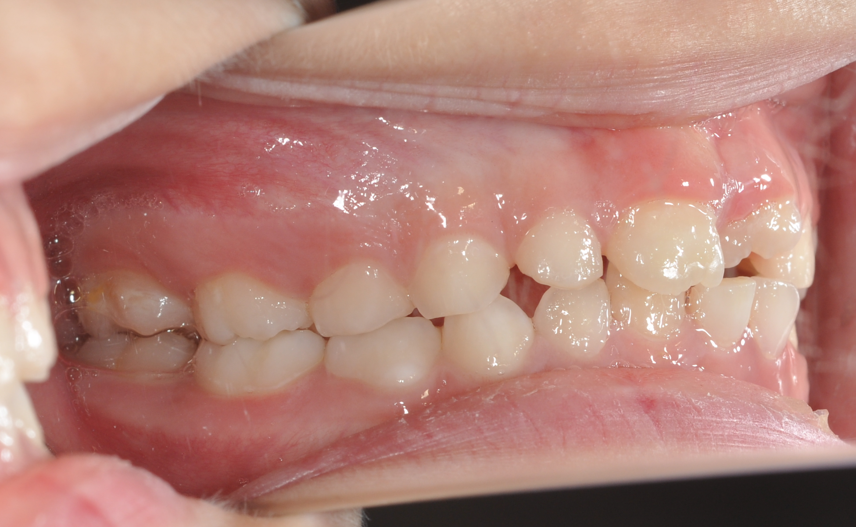
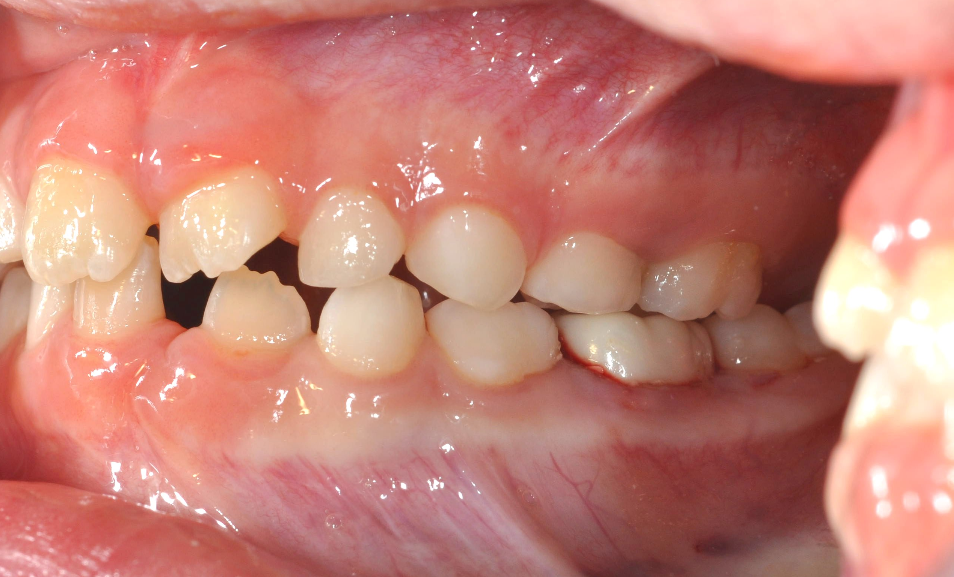
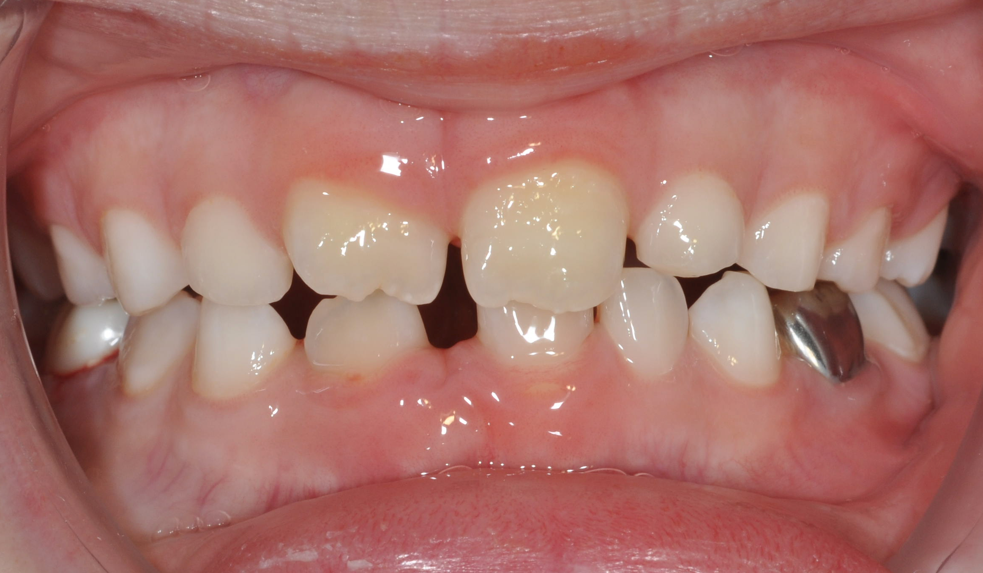
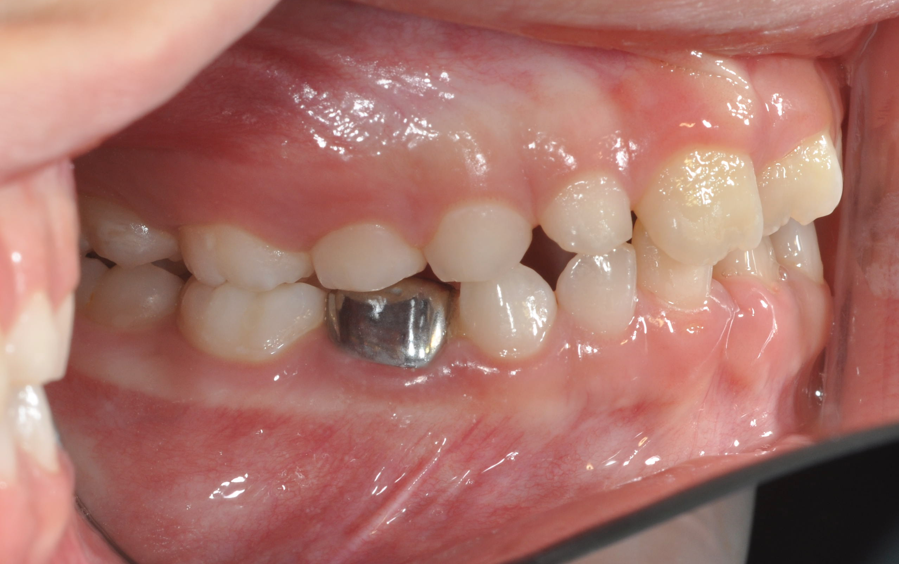
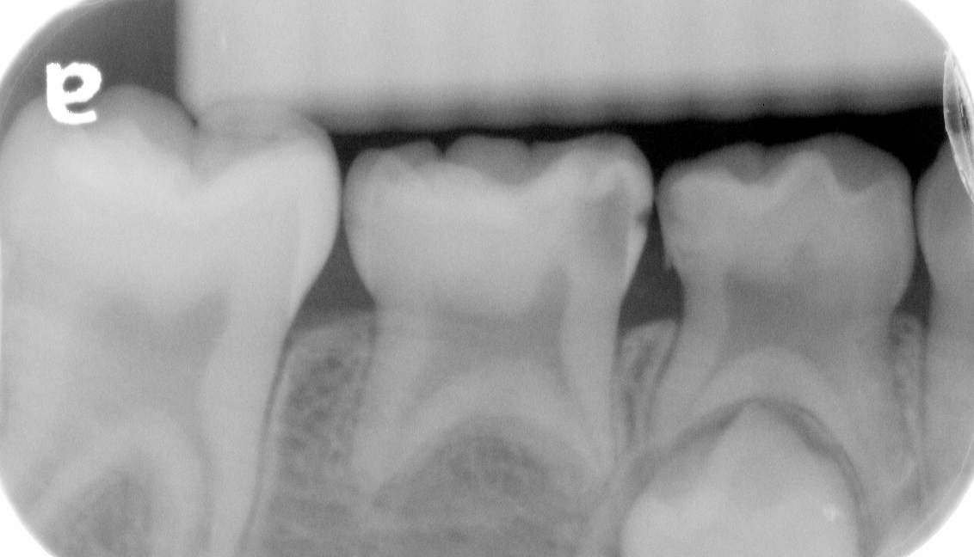
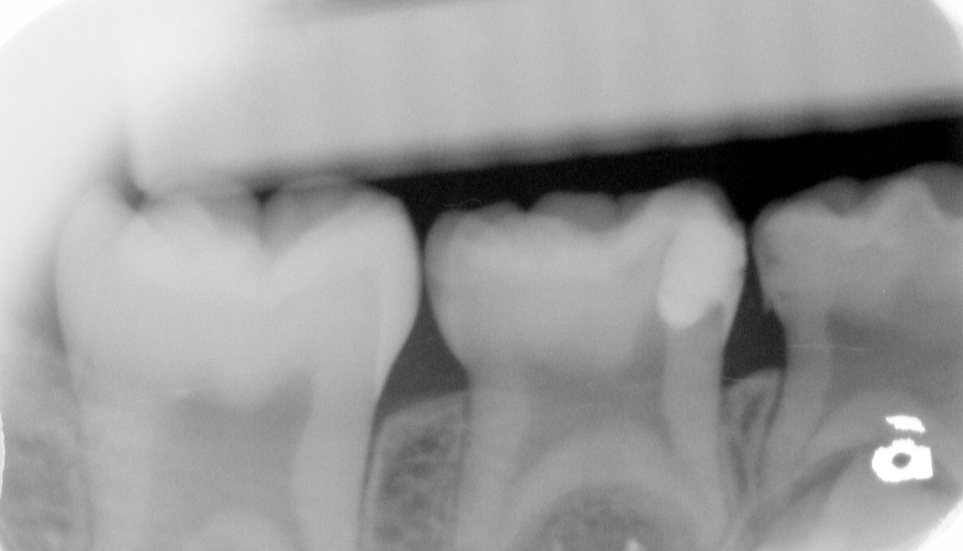
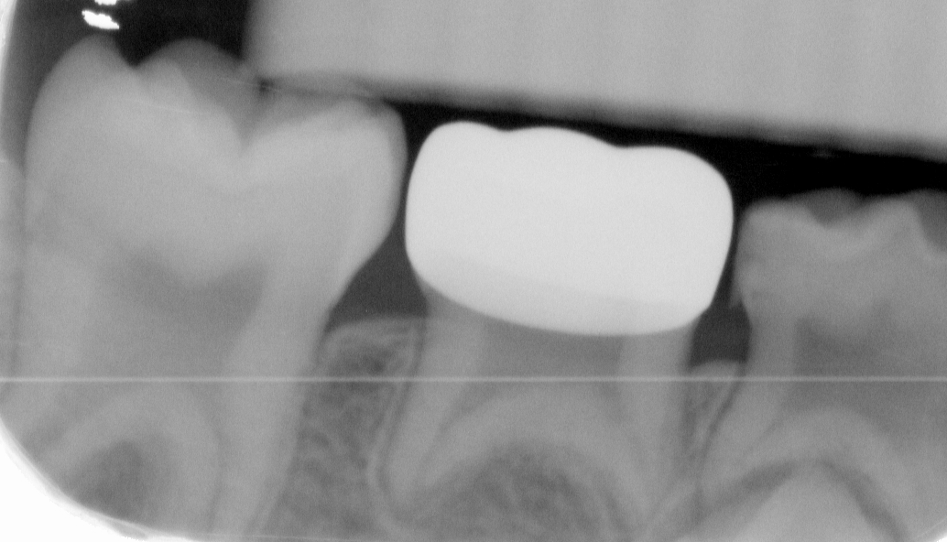
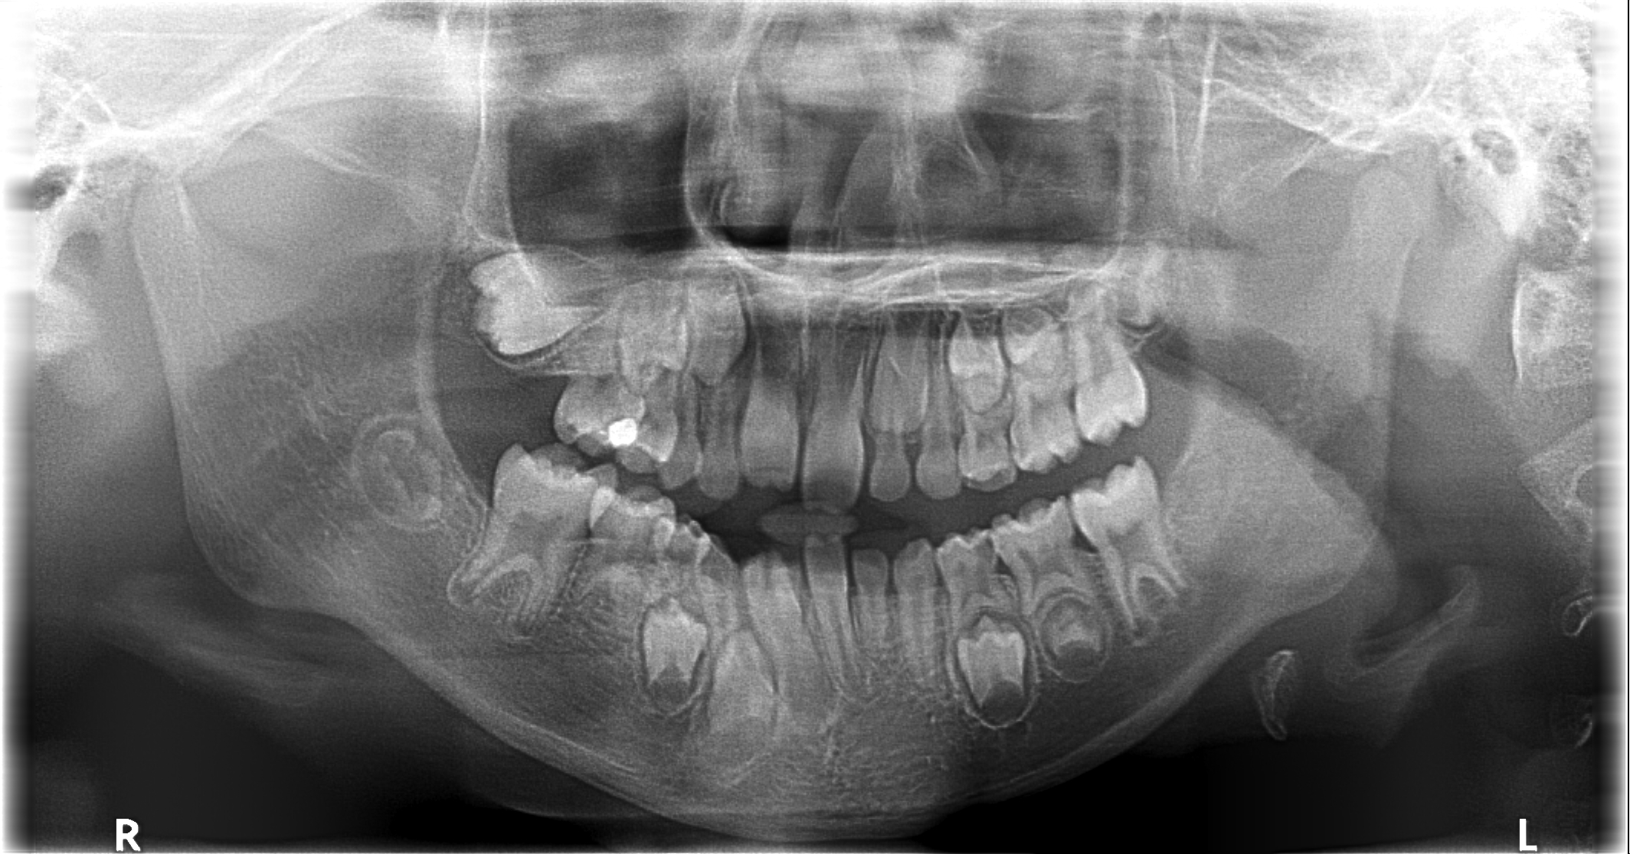
Case report： This case was diagnosed oligodontia in early mixed dentition. Oral examination revealed decayed lower right second primary molar. However, the tooth germ of the succedaneous premolar was absent. Due to absence of permanent tooth, keeping the primary molar was our main goal. After confirming the pulp vitality, complete excavation and MTA capping were performed. Afterwards, the tooth was restored with Zirconia crown due to the concern of esthetic. Besides, there was a decay at lower left first primary molar. Because the lower left first premolar existed, we restored the tooth with SSC and waited for its exfoliation. After 2 months follow up, both primary teeth were symptoms free and gingival healthy were detected.

Key words: Oligodontia, Zirconia crown, MTA-Capping, Direct pulp capping, Stainless Steel Crown

Image

Presenting author details
Full name (As per the passport): WenSheng Tsai
University/Industry/Organization name: Kaohsiung Medical University Hospital
Designation(Director/Prof/Assistant or Associate prof/Researcher/Student): Student
Country: Taiwan
Mobile number (country code – number): 886+0981033931
Email: vincentorys@hotmailocm
Track number: Track 7-3
Category: Poster presentation
Research interest: Case report
Your profile page URL in your department:
Year of birth:
Linked In/Facebook/twitter account:

Note: Please fill up the Red mark fields so that it would be easier for us to cite your details in the conference particulars. (Please do not forget to fix your photo and Logo above the title)

