Title: Immediate implant placement in fresh extraction socket 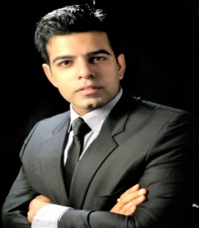
Name: Dr. Rajat Sachdeva
Dr.Sachdeva's Dental Institute, India
Abstract
According to Branemark, a two stage surgery was believed mandatory in order to contribute towards a stress free healing period for the implants to osseointegrate. Also, the original principles statedꟷ after tooth extraction it’s mandatory to wait for 6-12 months in order to allow complete healing of alveolar bone. However, during the healing period, a considerable amount of alveolar bone can be lost as a result of bone resorption.
Certainly, with series of advances in the implant dentistry in past decades has led to alterations in the original protocol. Immediate implant placement in a fresh extraction socket has been signified to accomplish a desired result i.e. prevention of bone resorption. Immediate implant placement in fresh extraction socket prevent undue resorption tend to occur post extraction & maintenance of gingival form & interdental papilla.

Introduction

Tooth loss especially in the anterior region can be a traumatic experience. Implant placement in the aesthetic region can be challenging at times for the clinicians because along with the implant placement soft tissue management is a task.

Attempts to shorten the overall treatment period & numerous advantages over placing the implant in healed bone have led to introduction of such approach into the dental practice. This concept has become the treatment of choice.
Case
A 28 year old male presented to Dr. Sachdeva’s Dental Institute with a chief complaint of mobile tooth in upper front tooth region. On clinical & radiographic evaluation tooth was grade II mobile with horizontal crown fracture & periapical radiolucency with root resorption. The patient was explained about his situation, alternative treatment plans & the proposed treatment which included immediate implant placement with immediate loading. The patient was quite conscious for his esthetics & was keen for the earliest & less time consuming possible restoration & thus agreed to the proposed treatment plan.
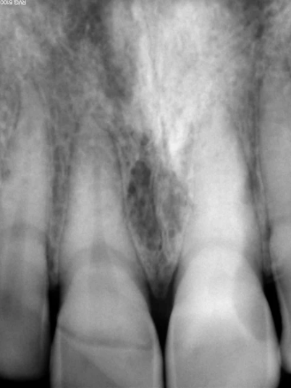
- Pre-operative radiograph with horizontal crown fracture & slight root resorption.
- After precise treatment planning Osstem endosseous implant measuring 4.0 x 13mm in dimension was selected. Injecting with 2% lidocaine with 1: 1, 00,000 adrenaline local anesthetic the treatment was executed.
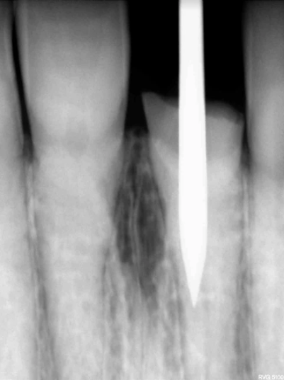
- Using tooth as a guide, the procedure was executed. & the osteotomy site was created 3-5 mm apical to the tooth. The site was evaluated for osseous defects. All four walls were intact. The socket was thoroughly debrided.

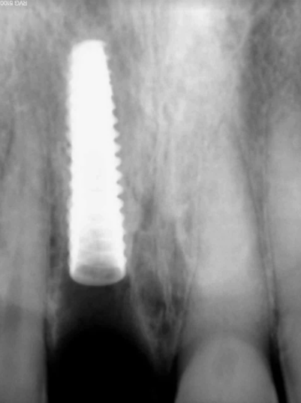
- After sequential drilling & atraumatic extraction of the tooth, implant was inserted into the osteotomy site 3-5 mm apical to the socket with torque achieved 45 Ncm. This depicted the adequate primary stability & immediate loading of implant.

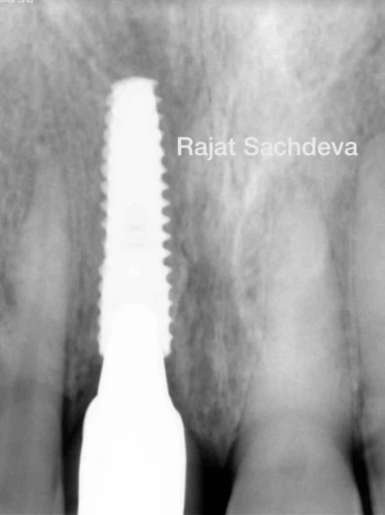
- Post operative periapical radiograph with former.

Impression was made by open tray impression technique using hydrophilic polyvinylsiloxane impression material (honigum). The patient was prescribed amoxicillin 500mg, tds for 5 days & analgesic ibuprofen 800mg every 4-6 hours & post-operative instructions were rendered. The impression was then sent to the laboratory.

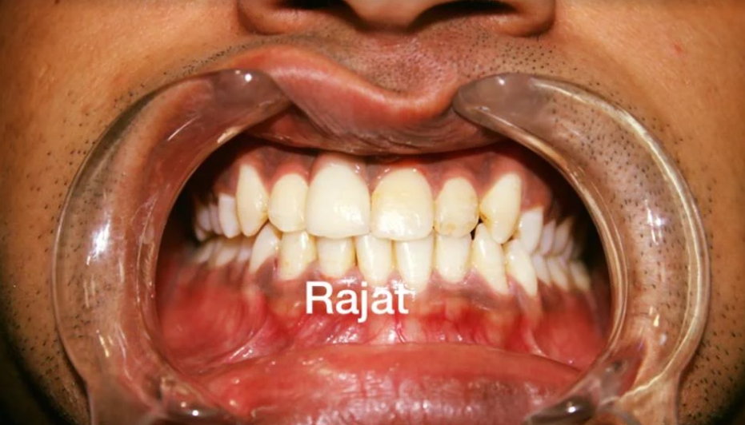

- Patient was recalled next day & was delivered zirconia FP-2 prosthesis.

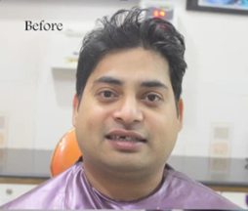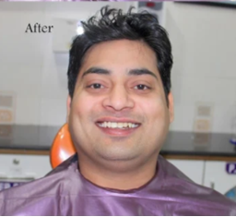

- Happy patient after delivery of the prosthesis.

Discussion

Immediate implant placement is usually indicated inꟷ non-restorable asymptomatic tooth, traumatic tooth with minimal bone loss, endodontic lesion difficult to treat, fractured root etc.
Contraindications include site with signs of active infection like-pain, swelling, pus discharge, tenderness etc, inadequate bone apical to the extraction socket, periodontally compromised adjacent teeth, huge osseous defect related to the tooth planned for extraction etc.
Precise planning prior to the surgery & skilful manoeuvre of surgical procedures is highly important for a predictable outcome without causing any iatrogenic trauma or damage. This can be achieved by accurate evaluation of radiographs, diagnostic impressions, CBCT, use of stereolithographic stents, conventional stents & also at times tooth can be used as a guide.
According to favourable findings in research & clinical trials, immediate implant placement is appropriate for single rooted or bi-rooted teeth. To predict a successful outcome it’s of great significance to achieve good primary stability & maximum bone to implant contact (BIC). Since extraction of multiple rooted molars while preserving intra-alveolar septum is a challenge in order to provide the optimal environment for maximum BIC & implant stability. Furthermore, the challenge involves site anatomy, biomechanical issues & occlusion. The outcome is usually compromised specially in maxillary molars because of larger sockets & poor bone quality.
Immediate implant placement in maxillary molars surely is a challenge but is not impossible. Preservation of alveolar bone proper, particularly of labial & lingual plates can let one achieve maximum BIC & implant stability.
The success rate of immediate implant placement in maxilla is 66-95% & in mandible 98%.

Conclusion

The success of immediate implant placement lies in the dexterity of the clinician. For a predictable outcome, the apex of the implant should be engaged 3-5mm apical to the extraction socket in order to achieve adequate primary stability. The overall reduction in treatment period & preservation of soft & hard tissues make it a treatment of choice nowadays.

Biography:
Dr Rajat Kr. Sachdeva is the director and founder of: 1. DAYA FOUNDATION humanitarian, a non-profit NGO (Non-Governmental Organization registered in delhi to improve dental education, healthcare) 2. Dr.Sachdeva’s Dental Institute best dental implant clinic in Ashok Vihar (institute carrying domestic & international certificate courses for the dental practitioners) Dr.Rajat is an acclaimed Laser Aesthetic & Implant Dental expert, an Inspirational, passionate and life changing speaker with master's degree in Community Dentistry. He is a Fellow of International Congress of Oral Implantologists (FICOI, USA), International College of Continuing Dental Education (FICCDE, Singapore) and a Fellow of Pierre Fauchard Academy (FPFA) & having with 12 years of experience in private dental practice. Fellowship from the American Academy of Dentofacial Esthetics/Implant Dentistry, New York, USA. Fellow the International Institute of Replacement Therapy, 2012 and presented over 1000 cases in various implant modalities. Certificates In Restorative Dentistry 2004 (London). Advanced Training In Occlusion, Tmj & Headaches, The Institute Of L D Pankey Association. Did Master Training In Implantology With Ce 1500 Hours Of Training From The Tatum Implant & Reconstructive Surgery Institute Has An Extensive Experience And Has Modified Techniques In Bone Grafting, Vascularized Segmental Osteotomies, Sinus Grafting And Bone Expansion.
He is a certified Digital Smile Design cosmetic dentist and has trained with the inventor Dr. Christain Coachman himself. He is a board member of the Faculty of General Dental Practice as well as committee member for the British Dental Association; He regularly publishes articles in well-known journals and has presented his work internationally. He is Passionate in sharing the step-by-step strategies that can be implemented immediately to make massive changes to your Practice progress. He regularly conducts basic and advanced training program for Indian and International delegates. After completing his graduation in dental sciences, he did postgraduate diploma in Aesthetic Dentistry To be able to provide the best services to his patients he has also done post graduate diploma in Health & Hospital Management & specialized certification in Implantology accredited from American School of implant dentistry. He has gained vast clinical experience during his resident ships in various private & government hospitals including Maulana Azad Institute of Dental Sciences, Delhi & AIIMS. He is a consultant Dental Implantologist in various multispeciality hospitals and dental clinics, as well & is known for dental implants in India

